Dynamic Water Balance at MDV

Qing Zhan

19/07/2020

# dVol = Qin-Qout  
  
require(lubridate)

## Loading required package: lubridate

##   
## Attaching package: 'lubridate'

## The following object is masked from 'package:base':  
##   
## date

library(readr)  
require(dplyr)

## Loading required package: dplyr

##   
## Attaching package: 'dplyr'

## The following objects are masked from 'package:lubridate':  
##   
## intersect, setdiff, union

## The following objects are masked from 'package:stats':  
##   
## filter, lag

## The following objects are masked from 'package:base':  
##   
## intersect, setdiff, setequal, union

setwd("C:\\Users\\QingZ\\PhD-Qing\\GitProject\\Mark_Dintel_Vliet\\Modelling\\Advection-Diffusion-Production\\Waterbalance")# Set the working directory  
  
#### Data preparation ####  
# WL: Water depths  
# Up: Upstream of sluice  
# Down: Downstream of sluice  
  
WL_Down_Vliet <- read_csv("WL_Down_Vliet.csv",col_types = cols(Datum = col_datetime(format = "%d-%m-%Y %H:%M:%S"), Eenheid = col_skip(),Serie = col_skip(), X5 = col_skip()))

## Warning: Missing column names filled in: 'X5' [5]

## Warning: 106734 parsing failures.  
## row col expected actual file  
## 1 -- 5 columns 4 columns 'WL_Down_Vliet.csv'  
## 2 -- 5 columns 4 columns 'WL_Down_Vliet.csv'  
## 3 -- 5 columns 4 columns 'WL_Down_Vliet.csv'  
## 4 -- 5 columns 4 columns 'WL_Down_Vliet.csv'  
## 5 -- 5 columns 4 columns 'WL_Down_Vliet.csv'  
## ... ... ......... ......... ...................  
## See problems(...) for more details.

WL_Down_Dintel <- read_csv("WL_Down_Dintel.csv",col_types = cols(Datum = col_datetime(format = "%d-%m-%Y %H:%M:%S"), Eenheid = col_skip(),Serie = col_skip(), X5 = col_skip()))

## Warning: Missing column names filled in: 'X5' [5]

## Warning: 143850 parsing failures.  
## row col expected actual file  
## 1 -- 5 columns 4 columns 'WL_Down_Dintel.csv'  
## 2 -- 5 columns 4 columns 'WL_Down_Dintel.csv'  
## 3 -- 5 columns 4 columns 'WL_Down_Dintel.csv'  
## 4 -- 5 columns 4 columns 'WL_Down_Dintel.csv'  
## 5 -- 5 columns 4 columns 'WL_Down_Dintel.csv'  
## ... ... ......... ......... ....................  
## See problems(...) for more details.

names(WL_Down_Vliet) <- c("Datum", "WL_Down_Vliet")  
names(WL_Down_Dintel) <- c("Datum", "WL_Down_Dintel")  
# Water depth measurements at downstream of Dintel and Vliet as indicator of Water depth dynamics in Volkerakmeer  
  
WL_Up_Vliet <- read_csv("WL_Up_Vliet.csv",col_types = cols(Datum = col_datetime(format = "%d-%m-%Y %H:%M:%S"), Eenheid = col_skip(),Serie = col_skip(), X5 = col_skip()))

## Warning: Missing column names filled in: 'X5' [5]

## Warning: 5561 parsing failures.  
## row col expected actual file  
## 1 -- 5 columns 4 columns 'WL_Up_Vliet.csv'  
## 2 -- 5 columns 4 columns 'WL_Up_Vliet.csv'  
## 3 -- 5 columns 4 columns 'WL_Up_Vliet.csv'  
## 4 -- 5 columns 4 columns 'WL_Up_Vliet.csv'  
## 5 -- 5 columns 4 columns 'WL_Up_Vliet.csv'  
## ... ... ......... ......... .................  
## See problems(...) for more details.

WL_Up_Dintel <- read_csv("WL_Up_Dintel.csv",col_types = cols(Datum = col_datetime(format = "%d-%m-%Y %H:%M:%S"), Eenheid = col_skip(),Serie = col_skip(), X5 = col_skip()))

## Warning: Missing column names filled in: 'X5' [5]

## Warning: 107055 parsing failures.  
## row col expected actual file  
## 1 -- 5 columns 4 columns 'WL_Up_Dintel.csv'  
## 2 -- 5 columns 4 columns 'WL_Up_Dintel.csv'  
## 3 -- 5 columns 4 columns 'WL_Up_Dintel.csv'  
## 4 -- 5 columns 4 columns 'WL_Up_Dintel.csv'  
## 5 -- 5 columns 4 columns 'WL_Up_Dintel.csv'  
## ... ... ......... ......... ..................  
## See problems(...) for more details.

names(WL_Up_Vliet) <- c("Datum", "WL_Up_Vliet")  
names(WL_Up_Dintel) <- c("Datum", "WL_Up_Dintel")  
# Water depth measurements at upstream of Dintel and Vliet as indicator of Water depth dynamics in Mark-Dintel-Vliet system  
  
# Gastel (Molenbeak) water depth measurements  
WL_Gastel <- read_csv("WL_Gastel.csv",col_types = cols(Datum = col_datetime(format = "%d-%m-%Y %H:%M:%S"), Eenheid = col_skip(),Serie = col_skip(), X5 = col_skip()))

## Warning: Missing column names filled in: 'X5' [5]

## Warning: 657340 parsing failures.  
## row col expected actual file  
## 1 -- 5 columns 4 columns 'WL_Gastel.csv'  
## 2 -- 5 columns 4 columns 'WL_Gastel.csv'  
## 3 -- 5 columns 4 columns 'WL_Gastel.csv'  
## 4 -- 5 columns 4 columns 'WL_Gastel.csv'  
## 5 -- 5 columns 4 columns 'WL_Gastel.csv'  
## ... ... ......... ......... ...............  
## See problems(...) for more details.

names(WL_Gastel) <- c("Datum", "WL_Gastel")  
  
# Inflow discharges:  
HF_Qin_MarkCanal <- read_csv("HF_Qin_MarkCanal.csv",col_types = cols(Datum = col_datetime(format = "%d-%m-%Y %H:%M:%S"), Eenheid = col_skip(),Serie = col_skip(), X5 = col_skip()))

## Warning: Missing column names filled in: 'X5' [5]

## Warning: 105920 parsing failures.  
## row col expected actual file  
## 1 -- 5 columns 4 columns 'HF_Qin_MarkCanal.csv'  
## 2 -- 5 columns 4 columns 'HF_Qin_MarkCanal.csv'  
## 3 -- 5 columns 4 columns 'HF_Qin_MarkCanal.csv'  
## 4 -- 5 columns 4 columns 'HF_Qin_MarkCanal.csv'  
## 5 -- 5 columns 4 columns 'HF_Qin_MarkCanal.csv'  
## ... ... ......... ......... ......................  
## See problems(...) for more details.

names(HF_Qin_MarkCanal) <- c("Datum","Qin_MarkCanal")  
  
HF_Qin_Oranjeboombrug <- read_csv("HF_Qin_Oranjeboombrug.csv",col_types = cols(Datum = col_datetime(format = "%d-%m-%Y %H:%M:%S"), Eenheid = col_skip(),Serie = col_skip(), X5 = col_skip()))

## Warning: Missing column names filled in: 'X5' [5]

## Warning: 97692 parsing failures.  
## row col expected actual file  
## 1 -- 5 columns 4 columns 'HF_Qin_Oranjeboombrug.csv'  
## 2 -- 5 columns 4 columns 'HF_Qin_Oranjeboombrug.csv'  
## 3 -- 5 columns 4 columns 'HF_Qin_Oranjeboombrug.csv'  
## 4 -- 5 columns 4 columns 'HF_Qin_Oranjeboombrug.csv'  
## 5 -- 5 columns 4 columns 'HF_Qin_Oranjeboombrug.csv'  
## ... ... ......... ......... ...........................  
## See problems(...) for more details.

names(HF_Qin_Oranjeboombrug) <- c("Datum","Qin_Oranjeboombrug")  
  
HF_Qin_BlauweKamer <- read_csv("HF_Qin_BlauweKamer.csv",  
 col_types = cols(Datum = col_datetime(format = "%d-%m-%Y %H:%M:%S"), Eenheid = col_skip(),Serie = col_skip(), X5 = col_skip()))

## Warning: Missing column names filled in: 'X5' [5]

## Warning: 722945 parsing failures.  
## row col expected actual file  
## 1 -- 5 columns 4 columns 'HF_Qin_BlauweKamer.csv'  
## 2 -- 5 columns 4 columns 'HF_Qin_BlauweKamer.csv'  
## 3 -- 5 columns 4 columns 'HF_Qin_BlauweKamer.csv'  
## 4 -- 5 columns 4 columns 'HF_Qin_BlauweKamer.csv'  
## 5 -- 5 columns 4 columns 'HF_Qin_BlauweKamer.csv'  
## ... ... ......... ......... ........................  
## See problems(...) for more details.

names(HF_Qin_BlauweKamer) <- c("Datum","Qin_BlauweKamer")  
  
HF_Qin_Molenbeak <- read_csv("HF_Qin_Molenbeak.csv",  
 col_types = cols(Datum = col_datetime(format = "%d-%m-%Y %H:%M:%S"), Eenheid = col_skip(),Serie = col_skip(), X5 = col_skip()))

## Warning: Missing column names filled in: 'X5' [5]

## Warning: 588013 parsing failures.  
## row col expected actual file  
## 1 -- 5 columns 4 columns 'HF_Qin_Molenbeak.csv'  
## 2 -- 5 columns 4 columns 'HF_Qin_Molenbeak.csv'  
## 3 -- 5 columns 4 columns 'HF_Qin_Molenbeak.csv'  
## 4 -- 5 columns 4 columns 'HF_Qin_Molenbeak.csv'  
## 5 -- 5 columns 4 columns 'HF_Qin_Molenbeak.csv'  
## ... ... ......... ......... ......................  
## See problems(...) for more details.

names(HF_Qin_Molenbeak) <- c("Datum","Qin_Molenbeak")  
  
# Outflow discharges:  
HF_Qout_Dintelsas <- read_csv("HF_Qout_Dintelsas.csv",  
 col_types = cols(Datum = col_datetime(format = "%d-%m-%Y %H:%M:%S"), Eenheid = col_skip(),Serie = col_skip(), X5 = col_skip()))

## Warning: Missing column names filled in: 'X5' [5]

## Warning: 299449 parsing failures.  
## row col expected actual file  
## 1 -- 5 columns 4 columns 'HF_Qout_Dintelsas.csv'  
## 2 -- 5 columns 4 columns 'HF_Qout_Dintelsas.csv'  
## 3 -- 5 columns 4 columns 'HF_Qout_Dintelsas.csv'  
## 4 -- 5 columns 4 columns 'HF_Qout_Dintelsas.csv'  
## 5 -- 5 columns 4 columns 'HF_Qout_Dintelsas.csv'  
## ... ... ......... ......... .......................  
## See problems(...) for more details.

names(HF_Qout_Dintelsas) <- c("Datum", "Qout_Dintelsas")  
  
HF_Qout_Vliet <- read_csv("HF_Qout_Vliet.csv",  
 col_types = cols(Datum = col_datetime(format = "%d-%m-%Y %H:%M:%S"), Eenheid = col_skip(),Serie = col_skip(), X5 = col_skip()))

## Warning: Missing column names filled in: 'X5' [5]

## Warning: 315749 parsing failures.  
## row col expected actual file  
## 1 -- 5 columns 4 columns 'HF_Qout_Vliet.csv'  
## 2 -- 5 columns 4 columns 'HF_Qout_Vliet.csv'  
## 3 -- 5 columns 4 columns 'HF_Qout_Vliet.csv'  
## 4 -- 5 columns 4 columns 'HF_Qout_Vliet.csv'  
## 5 -- 5 columns 4 columns 'HF_Qout_Vliet.csv'  
## ... ... ......... ......... ...................  
## See problems(...) for more details.

names(HF_Qout_Vliet) <- c("Datum", "Qout_Vliet")  
  
# Integrating dataset #  
sTime_numeric <- seq(HF_Qin_MarkCanal$Datum[1]%>%as.numeric,HF_Qin_MarkCanal$Datum[length(HF_Qin_MarkCanal$Datum)]%>%as.numeric, by=3600) #hourly interval  
  
WaterBudget_MDV <- data.frame(Datum = ymd_hms("1970-01-01 00:00:00")+sTime_numeric,WL_Down_Dintel=NA,WL_Down_Vliet=NA,WL_Up_Dintel=NA,WL_Up_Vliet=NA,WL_Gastel=NA,Qin_MarkCanal=NA,Qin_BlauweKamer=NA,Qin_Molenbeak=NA,Qin_Oranjeboombrug=NA,Qout_Dintelsas=NA,Qout_Vliet=NA)  
  
WaterBudget_MDV$WL_Down_Dintel <- approx(WL_Down_Dintel$Datum%>%as.numeric,WL_Down_Dintel$WL_Down_Dintel,xout=WaterBudget_MDV$Datum%>%as.numeric)$y

## Warning in regularize.values(x, y, ties, missing(ties)): collapsing to  
## unique 'x' values

WaterBudget_MDV$WL_Down_Vliet <- approx(WL_Down_Vliet$Datum%>%as.numeric,WL_Down_Vliet$WL_Down_Vliet,xout=WaterBudget_MDV$Datum%>%as.numeric)$y

## Warning in regularize.values(x, y, ties, missing(ties)): collapsing to  
## unique 'x' values

WaterBudget_MDV$WL_Up_Dintel <- approx(WL_Up_Dintel$Datum%>%as.numeric,WL_Up_Dintel$WL_Up_Dintel,xout=WaterBudget_MDV$Datum%>%as.numeric)$y

## Warning in regularize.values(x, y, ties, missing(ties)): collapsing to  
## unique 'x' values

WaterBudget_MDV$WL_Up_Vliet <- approx(WL_Up_Vliet$Datum%>%as.numeric,WL_Up_Vliet$WL_Up_Vliet,xout=WaterBudget_MDV$Datum%>%as.numeric)$y  
WaterBudget_MDV$WL_Gastel <- approx(WL_Gastel$Datum%>%as.numeric,WL_Gastel$WL_Gastel, xout = WaterBudget_MDV$Datum%>%as.numeric)$y

## Warning in regularize.values(x, y, ties, missing(ties)): collapsing to  
## unique 'x' values

WaterBudget_MDV$Qin_MarkCanal <- approx(HF_Qin_MarkCanal$Datum%>%as.numeric,HF_Qin_MarkCanal$Qin_MarkCanal,xout = WaterBudget_MDV$Datum%>%as.numeric)$y

## Warning in regularize.values(x, y, ties, missing(ties)): collapsing to  
## unique 'x' values

WaterBudget_MDV$Qin_BlauweKamer <- approx(HF_Qin_MarkCanal$Datum%>%as.numeric,HF_Qin_MarkCanal$Qin_MarkCanal,xout = WaterBudget_MDV$Datum%>%as.numeric)$y

## Warning in regularize.values(x, y, ties, missing(ties)): collapsing to  
## unique 'x' values

WaterBudget_MDV$Qin_Molenbeak <- approx(HF_Qin_Molenbeak$Datum%>%as.numeric,HF_Qin_Molenbeak$Qin_Molenbeak,xout = WaterBudget_MDV$Datum%>%as.numeric)$y  
WaterBudget_MDV$Qin_Oranjeboombrug <- approx(HF_Qin_Oranjeboombrug$Datum%>%as.numeric,HF_Qin_Oranjeboombrug$Qin_Oranjeboombrug,xout = WaterBudget_MDV$Datum%>%as.numeric)$y

## Warning in regularize.values(x, y, ties, missing(ties)): collapsing to  
## unique 'x' values

WaterBudget_MDV$Qout_Vliet <- approx(HF_Qout_Vliet$Datum%>%as.numeric,HF_Qout_Vliet$Qout_Vliet,xout = WaterBudget_MDV$Datum%>%as.numeric)$y

## Warning in regularize.values(x, y, ties, missing(ties)): collapsing to  
## unique 'x' values

WaterBudget_MDV$Qout_Dintelsas <- approx(HF_Qout_Dintelsas$Datum%>%as.numeric,HF_Qout_Dintelsas$Qout_Dintelsas,xout = WaterBudget_MDV$Datum%>%as.numeric)$y

## Warning in regularize.values(x, y, ties, missing(ties)): collapsing to  
## unique 'x' values

#### Compare the measurements at Dintel and Vliet downsteram as indicator of water depth dynamics at Volkerakmeer ####  
plot(WaterBudget_MDV$Datum, WaterBudget_MDV$WL_Down_Dintel)  
lines(WaterBudget_MDV$Datum, WaterBudget_MDV$WL_Down_Vliet, col=2)

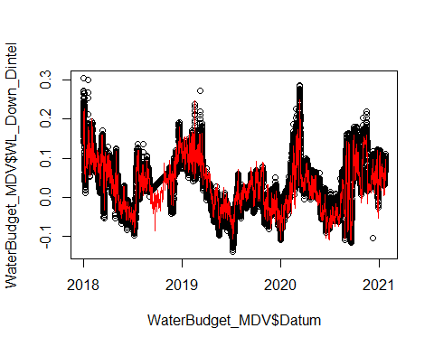

plot(WaterBudget_MDV$WL_Down_Dintel, WaterBudget_MDV$WL_Down_Vliet)  
lines(-2:2,-2:2,col=2) # 1:1 line

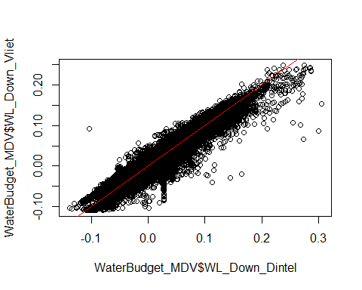

#### Compare depth measurements inside MDV system  
plot(WaterBudget_MDV$Datum, WaterBudget_MDV$WL_Up_Dintel)  
lines(WaterBudget_MDV$Datum, WaterBudget_MDV$WL_Up_Vliet, col=2)  
lines(WaterBudget_MDV$Datum, WaterBudget_MDV$WL_Gastel,col=3)

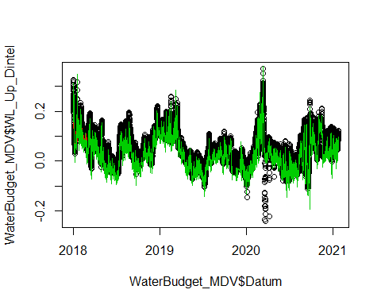

#### Closing the water balance by adjusting the inflows at Gastel (Molenbeak)  
Surface <- 50*(114-0)*40+50*(640-114)*50+50*(666-640)*100+50*(743-666)*40+50*(760-743)*26+50*(1117-760)*30 # m^2  
WaterBudget_MDV$dt <- c(1, diff(as.numeric(WaterBudget_MDV$Datum))) # seconds  
range(WaterBudget_MDV$dt)

## [1] 1 3600

WaterBudget_MDV <- WaterBudget_MDV[which(WaterBudget_MDV$dt!=0),]  
WaterBudget_MDV$dV <- c(0, diff(WaterBudget_MDV$WL_Up_Dintel))*Surface # m^3  
  
#### Calculting the rest discharge to close the water budget ####  
WaterBudget_MDV$Q_diff <- WaterBudget_MDV$dV/WaterBudget_MDV$dt # m3/s  
  
#### Calculation of discharge at Gastel  
WaterBudget_MDV$Gaste_Calcuted <- WaterBudget_MDV$Q_diff-(WaterBudget_MDV$Qin_MarkCanal+WaterBudget_MDV$Qin_BlauweKamer+WaterBudget_MDV$Qin_Oranjeboombrug-WaterBudget_MDV$Qout_Dintelsas-WaterBudget_MDV$Qout_Vliet)  
  
#### Compare it with Measurements at Molenbeak ####  
plot(WaterBudget_MDV$Datum,WaterBudget_MDV$Gaste_Calcuted, type = "l",ylim = c(-100,100))   
lines(WaterBudget_MDV$Datum,WaterBudget_MDV$Qin_Molenbeak, col=2)

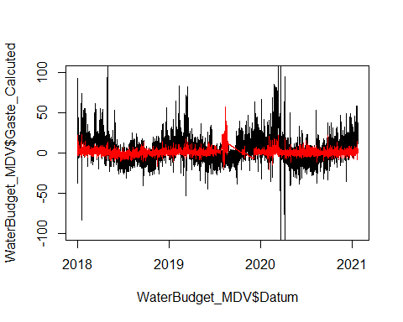

#### Calculating the water level in Vliet based on Inflowsa and Outflows we have

WaterBudget_MDV$dV_Cal = (WaterBudget_MDV$Qin_MarkCanal+WaterBudget_MDV$Qin_BlauweKamer+WaterBudget_MDV$Qin_Molenbeak+WaterBudget_MDV$Qin_Oranjeboombrug-WaterBudget_MDV$Qout_Dintelsas-WaterBudget_MDV$Qout_Vliet)*WaterBudget_MDV$dt  
  
WaterBudget_MDV$WL_Cal = NA  
WaterBudget_MDV$WL_Cal[1]=WaterBudget_MDV$WL_Up_Dintel[1]  
for (t in 2:nrow(WaterBudget_MDV)) {  
 WaterBudget_MDV$WL_Cal[t] = WaterBudget_MDV$WL_Cal[t-1]+WaterBudget_MDV$dV_Cal[t-1]/Surface  
}   
  
plot(WaterBudget_MDV$Datum,WaterBudget_MDV$WL_Cal)  
lines(WaterBudget_MDV$Datum, WaterBudget_MDV$WL_Up_Dintel, col=2)  
  
legend("topright",legend = c("Calculation","Measurements"),col=1:2,text.col = 1:2,lty=1)

