WaterBudget_MDV

QingQing

18/03/2021

#### Reading data

# dVol = Qin-Qout  
  
require(lubridate)

## Loading required package: lubridate

##   
## Attaching package: 'lubridate'

## The following object is masked from 'package:base':  
##   
## date

library(readr)  
require(dplyr)

## Loading required package: dplyr

##   
## Attaching package: 'dplyr'

## The following objects are masked from 'package:lubridate':  
##   
## intersect, setdiff, union

## The following objects are masked from 'package:stats':  
##   
## filter, lag

## The following objects are masked from 'package:base':  
##   
## intersect, setdiff, setequal, union

setwd("C:\\Users\\QingZ\\PhD-Qing\\GitProject\\Mark_Dintel_Vliet_Project_Shared\\Modelling\\Waterbalance")# Set the working directory  
  
#### Data preparation ####  
# WL: Water depths  
# Up: Upstream of sluice  
# Down: Downstream of sluice  
  
WL_Down_Vliet <- read_csv("WL_Down_Vliet.csv",col_types = cols(Datum = col_datetime(format = "%d-%m-%Y %H:%M:%S"), Eenheid = col_skip(),Serie = col_skip(), X5 = col_skip()))

## Warning: Missing column names filled in: 'X5' [5]

## Warning: 106734 parsing failures.  
## row col expected actual file  
## 1 -- 5 columns 4 columns 'WL_Down_Vliet.csv'  
## 2 -- 5 columns 4 columns 'WL_Down_Vliet.csv'  
## 3 -- 5 columns 4 columns 'WL_Down_Vliet.csv'  
## 4 -- 5 columns 4 columns 'WL_Down_Vliet.csv'  
## 5 -- 5 columns 4 columns 'WL_Down_Vliet.csv'  
## ... ... ......... ......... ...................  
## See problems(...) for more details.

WL_Down_Dintel <- read_csv("WL_Down_Dintel.csv",col_types = cols(Datum = col_datetime(format = "%d-%m-%Y %H:%M:%S"), Eenheid = col_skip(),Serie = col_skip(), X5 = col_skip()))

## Warning: Missing column names filled in: 'X5' [5]

## Warning: 143850 parsing failures.  
## row col expected actual file  
## 1 -- 5 columns 4 columns 'WL_Down_Dintel.csv'  
## 2 -- 5 columns 4 columns 'WL_Down_Dintel.csv'  
## 3 -- 5 columns 4 columns 'WL_Down_Dintel.csv'  
## 4 -- 5 columns 4 columns 'WL_Down_Dintel.csv'  
## 5 -- 5 columns 4 columns 'WL_Down_Dintel.csv'  
## ... ... ......... ......... ....................  
## See problems(...) for more details.

names(WL_Down_Vliet) <- c("Datum", "WL_Down_Vliet")  
names(WL_Down_Dintel) <- c("Datum", "WL_Down_Dintel")  
# Water depth measurements at downstream of Dintel and Vliet as indicator of Water depth dynamics in Volkerakmeer  
  
WL_Up_Vliet <- read_csv("WL_Up_Vliet.csv",col_types = cols(Datum = col_datetime(format = "%d-%m-%Y %H:%M:%S"), Eenheid = col_skip(),Serie = col_skip(), X5 = col_skip()))

## Warning: Missing column names filled in: 'X5' [5]

## Warning: 5561 parsing failures.  
## row col expected actual file  
## 1 -- 5 columns 4 columns 'WL_Up_Vliet.csv'  
## 2 -- 5 columns 4 columns 'WL_Up_Vliet.csv'  
## 3 -- 5 columns 4 columns 'WL_Up_Vliet.csv'  
## 4 -- 5 columns 4 columns 'WL_Up_Vliet.csv'  
## 5 -- 5 columns 4 columns 'WL_Up_Vliet.csv'  
## ... ... ......... ......... .................  
## See problems(...) for more details.

WL_Up_Dintel <- read_csv("WL_Up_Dintel.csv",col_types = cols(Datum = col_datetime(format = "%d-%m-%Y %H:%M:%S"), Eenheid = col_skip(),Serie = col_skip(), X5 = col_skip()))

## Warning: Missing column names filled in: 'X5' [5]

## Warning: 107055 parsing failures.  
## row col expected actual file  
## 1 -- 5 columns 4 columns 'WL_Up_Dintel.csv'  
## 2 -- 5 columns 4 columns 'WL_Up_Dintel.csv'  
## 3 -- 5 columns 4 columns 'WL_Up_Dintel.csv'  
## 4 -- 5 columns 4 columns 'WL_Up_Dintel.csv'  
## 5 -- 5 columns 4 columns 'WL_Up_Dintel.csv'  
## ... ... ......... ......... ..................  
## See problems(...) for more details.

names(WL_Up_Vliet) <- c("Datum", "WL_Up_Vliet")  
names(WL_Up_Dintel) <- c("Datum", "WL_Up_Dintel")  
# Water depth measurements at upstream of Dintel and Vliet as indicator of Water depth dynamics in Mark-Dintel-Vliet system  
  
# Gastel (Molenbeak) water depth measurements  
WL_Gastel <- read_csv("WL_Gastel.csv",col_types = cols(Datum = col_datetime(format = "%d-%m-%Y %H:%M:%S"), Eenheid = col_skip(),Serie = col_skip(), X5 = col_skip()))

## Warning: Missing column names filled in: 'X5' [5]

## Warning: 657340 parsing failures.  
## row col expected actual file  
## 1 -- 5 columns 4 columns 'WL_Gastel.csv'  
## 2 -- 5 columns 4 columns 'WL_Gastel.csv'  
## 3 -- 5 columns 4 columns 'WL_Gastel.csv'  
## 4 -- 5 columns 4 columns 'WL_Gastel.csv'  
## 5 -- 5 columns 4 columns 'WL_Gastel.csv'  
## ... ... ......... ......... ...............  
## See problems(...) for more details.

names(WL_Gastel) <- c("Datum", "WL_Gastel")  
  
# Water level inside MDV system  
WL_Down_Rooskensdonk <- read_csv("C:\\Users\\QingZ\\PhD-Qing\\GitProject\\Mark_Dintel_Vliet_Project_Shared\\Modelling\\Waterbalance\\WL_Down_Rooskensdonk.csv",col_types = cols(Datum = col_datetime(format = "%d-%m-%Y %H:%M:%S"), Eenheid = col_skip(),Serie = col_skip(), X5 = col_skip()))

## Warning: Missing column names filled in: 'X5' [5]

## Warning: 96622 parsing failures.  
## row col expected actual file  
## 1 -- 5 columns 4 columns 'C:\Users\QingZ\PhD-Qing\GitProject\Mark_Dintel_Vliet_Project_Shared\Modelling\Waterbalance\WL_Down_Rooskensdonk.csv'  
## 2 -- 5 columns 4 columns 'C:\Users\QingZ\PhD-Qing\GitProject\Mark_Dintel_Vliet_Project_Shared\Modelling\Waterbalance\WL_Down_Rooskensdonk.csv'  
## 3 -- 5 columns 4 columns 'C:\Users\QingZ\PhD-Qing\GitProject\Mark_Dintel_Vliet_Project_Shared\Modelling\Waterbalance\WL_Down_Rooskensdonk.csv'  
## 4 -- 5 columns 4 columns 'C:\Users\QingZ\PhD-Qing\GitProject\Mark_Dintel_Vliet_Project_Shared\Modelling\Waterbalance\WL_Down_Rooskensdonk.csv'  
## 5 -- 5 columns 4 columns 'C:\Users\QingZ\PhD-Qing\GitProject\Mark_Dintel_Vliet_Project_Shared\Modelling\Waterbalance\WL_Down_Rooskensdonk.csv'  
## ... ... ......... ......... .............................................................................................................................  
## See problems(...) for more details.

names(WL_Down_Rooskensdonk) <- c("Datum", "WL_Down_Rooskensdonk")  
  
WL_Down_Oosterhout <- read_csv("C:\\Users\\QingZ\\PhD-Qing\\GitProject\\Mark_Dintel_Vliet_Project_Shared\\Modelling\\Waterbalance\\WL_Down_Oosterhout.csv",col_types = cols(Datum = col_datetime(format = "%d-%m-%Y %H:%M:%S"), Eenheid = col_skip(),Serie = col_skip(), X5 = col_skip()))

## Warning: Missing column names filled in: 'X5' [5]

## Warning: 107001 parsing failures.  
## row col expected actual file  
## 1 -- 5 columns 4 columns 'C:\Users\QingZ\PhD-Qing\GitProject\Mark_Dintel_Vliet_Project_Shared\Modelling\Waterbalance\WL_Down_Oosterhout.csv'  
## 2 -- 5 columns 4 columns 'C:\Users\QingZ\PhD-Qing\GitProject\Mark_Dintel_Vliet_Project_Shared\Modelling\Waterbalance\WL_Down_Oosterhout.csv'  
## 3 -- 5 columns 4 columns 'C:\Users\QingZ\PhD-Qing\GitProject\Mark_Dintel_Vliet_Project_Shared\Modelling\Waterbalance\WL_Down_Oosterhout.csv'  
## 4 -- 5 columns 4 columns 'C:\Users\QingZ\PhD-Qing\GitProject\Mark_Dintel_Vliet_Project_Shared\Modelling\Waterbalance\WL_Down_Oosterhout.csv'  
## 5 -- 5 columns 4 columns 'C:\Users\QingZ\PhD-Qing\GitProject\Mark_Dintel_Vliet_Project_Shared\Modelling\Waterbalance\WL_Down_Oosterhout.csv'  
## ... ... ......... ......... ...........................................................................................................................  
## See problems(...) for more details.

names(WL_Down_Oosterhout) <- c("Datum", "WL_Down_Oosterhout")  
  
WL_Up_Oosterhout <- read_csv("C:\\Users\\QingZ\\PhD-Qing\\GitProject\\Mark_Dintel_Vliet_Project_Shared\\Modelling\\Waterbalance\\WL_Up_Oosterhout.csv",col_types = cols(Datum = col_datetime(format = "%d-%m-%Y %H:%M:%S"), Eenheid = col_skip(),Serie = col_skip(), X5 = col_skip()))

## Warning: Missing column names filled in: 'X5' [5]

## Warning: 106789 parsing failures.  
## row col expected actual file  
## 1 -- 5 columns 4 columns 'C:\Users\QingZ\PhD-Qing\GitProject\Mark_Dintel_Vliet_Project_Shared\Modelling\Waterbalance\WL_Up_Oosterhout.csv'  
## 2 -- 5 columns 4 columns 'C:\Users\QingZ\PhD-Qing\GitProject\Mark_Dintel_Vliet_Project_Shared\Modelling\Waterbalance\WL_Up_Oosterhout.csv'  
## 3 -- 5 columns 4 columns 'C:\Users\QingZ\PhD-Qing\GitProject\Mark_Dintel_Vliet_Project_Shared\Modelling\Waterbalance\WL_Up_Oosterhout.csv'  
## 4 -- 5 columns 4 columns 'C:\Users\QingZ\PhD-Qing\GitProject\Mark_Dintel_Vliet_Project_Shared\Modelling\Waterbalance\WL_Up_Oosterhout.csv'  
## 5 -- 5 columns 4 columns 'C:\Users\QingZ\PhD-Qing\GitProject\Mark_Dintel_Vliet_Project_Shared\Modelling\Waterbalance\WL_Up_Oosterhout.csv'  
## ... ... ......... ......... .........................................................................................................................  
## See problems(...) for more details.

names(WL_Up_Oosterhout) <- c("Datum", "WL_Up_Oosterhout")  
  
# Inflow discharges:  
HF_Qin_MarkCanal <- read_csv("HF_Qin_MarkCanal.csv",col_types = cols(Datum = col_datetime(format = "%d-%m-%Y %H:%M:%S"), Eenheid = col_skip(),Serie = col_skip(), X5 = col_skip()))

## Warning: Missing column names filled in: 'X5' [5]

## Warning: 105920 parsing failures.  
## row col expected actual file  
## 1 -- 5 columns 4 columns 'HF_Qin_MarkCanal.csv'  
## 2 -- 5 columns 4 columns 'HF_Qin_MarkCanal.csv'  
## 3 -- 5 columns 4 columns 'HF_Qin_MarkCanal.csv'  
## 4 -- 5 columns 4 columns 'HF_Qin_MarkCanal.csv'  
## 5 -- 5 columns 4 columns 'HF_Qin_MarkCanal.csv'  
## ... ... ......... ......... ......................  
## See problems(...) for more details.

names(HF_Qin_MarkCanal) <- c("Datum","Qin_MarkCanal")  
  
HF_Qin_Oranjeboombrug <- read_csv("HF_Qin_Oranjeboombrug.csv",col_types = cols(Datum = col_datetime(format = "%d-%m-%Y %H:%M:%S"), Eenheid = col_skip(),Serie = col_skip(), X5 = col_skip()))

## Warning: Missing column names filled in: 'X5' [5]

## Warning: 97692 parsing failures.  
## row col expected actual file  
## 1 -- 5 columns 4 columns 'HF_Qin_Oranjeboombrug.csv'  
## 2 -- 5 columns 4 columns 'HF_Qin_Oranjeboombrug.csv'  
## 3 -- 5 columns 4 columns 'HF_Qin_Oranjeboombrug.csv'  
## 4 -- 5 columns 4 columns 'HF_Qin_Oranjeboombrug.csv'  
## 5 -- 5 columns 4 columns 'HF_Qin_Oranjeboombrug.csv'  
## ... ... ......... ......... ...........................  
## See problems(...) for more details.

names(HF_Qin_Oranjeboombrug) <- c("Datum","Qin_Oranjeboombrug")  
  
HF_Qin_BlauweKamer <- read_csv("HF_Qin_BlauweKamer.csv",  
 col_types = cols(Datum = col_datetime(format = "%d-%m-%Y %H:%M:%S"), Eenheid = col_skip(),Serie = col_skip(), X5 = col_skip()))

## Warning: Missing column names filled in: 'X5' [5]

## Warning: 722945 parsing failures.  
## row col expected actual file  
## 1 -- 5 columns 4 columns 'HF_Qin_BlauweKamer.csv'  
## 2 -- 5 columns 4 columns 'HF_Qin_BlauweKamer.csv'  
## 3 -- 5 columns 4 columns 'HF_Qin_BlauweKamer.csv'  
## 4 -- 5 columns 4 columns 'HF_Qin_BlauweKamer.csv'  
## 5 -- 5 columns 4 columns 'HF_Qin_BlauweKamer.csv'  
## ... ... ......... ......... ........................  
## See problems(...) for more details.

names(HF_Qin_BlauweKamer) <- c("Datum","Qin_BlauweKamer")  
  
HF_Qin_Molenbeak <- read_csv("HF_Qin_Molenbeak.csv",  
 col_types = cols(Datum = col_datetime(format = "%d-%m-%Y %H:%M:%S"), Eenheid = col_skip(),Serie = col_skip(), X5 = col_skip()))

## Warning: Missing column names filled in: 'X5' [5]

## Warning: 588013 parsing failures.  
## row col expected actual file  
## 1 -- 5 columns 4 columns 'HF_Qin_Molenbeak.csv'  
## 2 -- 5 columns 4 columns 'HF_Qin_Molenbeak.csv'  
## 3 -- 5 columns 4 columns 'HF_Qin_Molenbeak.csv'  
## 4 -- 5 columns 4 columns 'HF_Qin_Molenbeak.csv'  
## 5 -- 5 columns 4 columns 'HF_Qin_Molenbeak.csv'  
## ... ... ......... ......... ......................  
## See problems(...) for more details.

names(HF_Qin_Molenbeak) <- c("Datum","Qin_Molenbeak")  
  
# Outflow discharges:  
HF_Qout_Dintelsas <- read_csv("HF_Qout_Dintelsas.csv",  
 col_types = cols(Datum = col_datetime(format = "%d-%m-%Y %H:%M:%S"), Eenheid = col_skip(),Serie = col_skip(), X5 = col_skip()))

## Warning: Missing column names filled in: 'X5' [5]

## Warning: 299449 parsing failures.  
## row col expected actual file  
## 1 -- 5 columns 4 columns 'HF_Qout_Dintelsas.csv'  
## 2 -- 5 columns 4 columns 'HF_Qout_Dintelsas.csv'  
## 3 -- 5 columns 4 columns 'HF_Qout_Dintelsas.csv'  
## 4 -- 5 columns 4 columns 'HF_Qout_Dintelsas.csv'  
## 5 -- 5 columns 4 columns 'HF_Qout_Dintelsas.csv'  
## ... ... ......... ......... .......................  
## See problems(...) for more details.

names(HF_Qout_Dintelsas) <- c("Datum", "Qout_Dintelsas")  
  
HF_Qout_Vliet <- read_csv("HF_Qout_Vliet.csv",  
 col_types = cols(Datum = col_datetime(format = "%d-%m-%Y %H:%M:%S"), Eenheid = col_skip(),Serie = col_skip(), X5 = col_skip()))

## Warning: Missing column names filled in: 'X5' [5]

## Warning: 315749 parsing failures.  
## row col expected actual file  
## 1 -- 5 columns 4 columns 'HF_Qout_Vliet.csv'  
## 2 -- 5 columns 4 columns 'HF_Qout_Vliet.csv'  
## 3 -- 5 columns 4 columns 'HF_Qout_Vliet.csv'  
## 4 -- 5 columns 4 columns 'HF_Qout_Vliet.csv'  
## 5 -- 5 columns 4 columns 'HF_Qout_Vliet.csv'  
## ... ... ......... ......... ...................  
## See problems(...) for more details.

names(HF_Qout_Vliet) <- c("Datum", "Qout_Vliet")  
  
# Integrating dataset #  
sTime_numeric <- seq(HF_Qin_MarkCanal$Datum[1]%>%as.numeric,HF_Qin_MarkCanal$Datum[length(HF_Qin_MarkCanal$Datum)]%>%as.numeric, by=3600) #hourly interval  
  
WaterBudget_MDV <- data.frame(Datum = ymd_hms("1970-01-01 00:00:00")+sTime_numeric,WL_Down_Dintel=NA,WL_Down_Vliet=NA,WL_Up_Dintel=NA,WL_Up_Vliet=NA,WL_Gastel=NA, WL_Down_Oosterhout=NA,WL_Up_Oosterhout=NA, WL_Down_Rooskensdonk=NA, Qin_MarkCanal=NA, Qin_BlauweKamer=NA, Qin_Molenbeak=NA, Qin_Oranjeboombrug=NA, Qout_Dintelsas=NA, Qout_Vliet=NA)  
  
WaterBudget_MDV$WL_Down_Dintel <- approx(WL_Down_Dintel$Datum%>%as.numeric,WL_Down_Dintel$WL_Down_Dintel,xout=WaterBudget_MDV$Datum%>%as.numeric)$y

## Warning in regularize.values(x, y, ties, missing(ties)): collapsing to  
## unique 'x' values

WaterBudget_MDV$WL_Down_Vliet <- approx(WL_Down_Vliet$Datum%>%as.numeric,WL_Down_Vliet$WL_Down_Vliet,xout=WaterBudget_MDV$Datum%>%as.numeric)$y

## Warning in regularize.values(x, y, ties, missing(ties)): collapsing to  
## unique 'x' values

WaterBudget_MDV$WL_Up_Dintel <- approx(WL_Up_Dintel$Datum%>%as.numeric,WL_Up_Dintel$WL_Up_Dintel,xout=WaterBudget_MDV$Datum%>%as.numeric)$y

## Warning in regularize.values(x, y, ties, missing(ties)): collapsing to  
## unique 'x' values

WaterBudget_MDV$WL_Up_Vliet <- approx(WL_Up_Vliet$Datum%>%as.numeric,WL_Up_Vliet$WL_Up_Vliet,xout=WaterBudget_MDV$Datum%>%as.numeric)$y  
WaterBudget_MDV$WL_Gastel <- approx(WL_Gastel$Datum%>%as.numeric,WL_Gastel$WL_Gastel, xout = WaterBudget_MDV$Datum%>%as.numeric)$y

## Warning in regularize.values(x, y, ties, missing(ties)): collapsing to  
## unique 'x' values

WaterBudget_MDV$WL_Up_Oosterhout <- approx(WL_Up_Oosterhout$Datum%>%as.numeric,WL_Up_Oosterhout$WL_Up_Oosterhout,xout = WaterBudget_MDV$Datum%>%as.numeric)$y

## Warning in regularize.values(x, y, ties, missing(ties)): collapsing to  
## unique 'x' values

WaterBudget_MDV$WL_Down_Oosterhout <- approx(WL_Down_Oosterhout$Datum%>%as.numeric,WL_Down_Oosterhout$WL_Down_Oosterhout,xout = WaterBudget_MDV$Datum%>%as.numeric)$y # inside the MDV system

## Warning in regularize.values(x, y, ties, missing(ties)): collapsing to  
## unique 'x' values

WaterBudget_MDV$WL_Down_Rooskensdonk <- approx(WL_Down_Rooskensdonk$Datum%>%as.numeric,WL_Down_Rooskensdonk$WL_Down_Rooskensdonk,xout = WaterBudget_MDV$Datum%>%as.numeric)$y

## Warning in regularize.values(x, y, ties, missing(ties)): collapsing to  
## unique 'x' values

### Inflows and outflows  
WaterBudget_MDV$Qin_MarkCanal <- approx(HF_Qin_MarkCanal$Datum%>%as.numeric,HF_Qin_MarkCanal$Qin_MarkCanal,xout = WaterBudget_MDV$Datum%>%as.numeric)$y

## Warning in regularize.values(x, y, ties, missing(ties)): collapsing to  
## unique 'x' values

WaterBudget_MDV$Qin_BlauweKamer <- approx(HF_Qin_MarkCanal$Datum%>%as.numeric,HF_Qin_MarkCanal$Qin_MarkCanal,xout = WaterBudget_MDV$Datum%>%as.numeric)$y

## Warning in regularize.values(x, y, ties, missing(ties)): collapsing to  
## unique 'x' values

WaterBudget_MDV$Qin_Molenbeak <- approx(HF_Qin_Molenbeak$Datum%>%as.numeric,HF_Qin_Molenbeak$Qin_Molenbeak,xout = WaterBudget_MDV$Datum%>%as.numeric)$y  
WaterBudget_MDV$Qin_Oranjeboombrug <- approx(HF_Qin_Oranjeboombrug$Datum%>%as.numeric,HF_Qin_Oranjeboombrug$Qin_Oranjeboombrug,xout = WaterBudget_MDV$Datum%>%as.numeric)$y

## Warning in regularize.values(x, y, ties, missing(ties)): collapsing to  
## unique 'x' values

WaterBudget_MDV$Qout_Vliet <- approx(HF_Qout_Vliet$Datum%>%as.numeric,HF_Qout_Vliet$Qout_Vliet,xout = WaterBudget_MDV$Datum%>%as.numeric)$y

## Warning in regularize.values(x, y, ties, missing(ties)): collapsing to  
## unique 'x' values

WaterBudget_MDV$Qout_Dintelsas <- approx(HF_Qout_Dintelsas$Datum%>%as.numeric,HF_Qout_Dintelsas$Qout_Dintelsas,xout = WaterBudget_MDV$Datum%>%as.numeric)$y

## Warning in regularize.values(x, y, ties, missing(ties)): collapsing to  
## unique 'x' values

## Calculation of discharge at Molenbeak (Gastel) by Roosendaal discharge based on catchment-discharge relationship  
HF_Qin_Roosendaal_2 <- read_csv("HF_Qin_Roosendaal_2.csv",  
 col_types = cols(Datum = col_datetime(format = "%d-%m-%Y %H:%M:%S"), Eenheid = col_skip(),Serie = col_skip(), X5 = col_skip()))

## Warning: Missing column names filled in: 'X5' [5]

## Warning: 105259 parsing failures.  
## row col expected actual file  
## 1 -- 5 columns 4 columns 'HF_Qin_Roosendaal_2.csv'  
## 2 -- 5 columns 4 columns 'HF_Qin_Roosendaal_2.csv'  
## 3 -- 5 columns 4 columns 'HF_Qin_Roosendaal_2.csv'  
## 4 -- 5 columns 4 columns 'HF_Qin_Roosendaal_2.csv'  
## 5 -- 5 columns 4 columns 'HF_Qin_Roosendaal_2.csv'  
## ... ... ......... ......... .........................  
## See problems(...) for more details.

names(HF_Qin_Roosendaal_2) <- c("Datum", "Qin_Roosendaal_2")  
  
WaterBudget_MDV$Qin_Roosendaal <- approx(HF_Qin_Roosendaal_2$Datum%>%as.numeric, HF_Qin_Roosendaal_2$Qin_Roosendaal_2, xout = WaterBudget_MDV$Datum%>%as.numeric)$y

## Warning in regularize.values(x, y, ties, missing(ties)): collapsing to  
## unique 'x' values

Roosendaal_CatchmentArea <- 2277 # 1 ha = 10000 m2  
Molenbeek_CatchmentArea <- 1709 # 1 ha = 10000 m2  
  
WaterBudget_MDV$Qin_Molenbeak_Corr <- WaterBudget_MDV$Qin_Roosendaal/Roosendaal_CatchmentArea*Molenbeek_CatchmentArea

#### Compare the measurements at Dintel and Vliet downsteram as indicator of water depth dynamics at Volkerakmeer

plot(WaterBudget_MDV$Datum, WaterBudget_MDV$WL_Down_Dintel)  
lines(WaterBudget_MDV$Datum, WaterBudget_MDV$WL_Down_Vliet, col=2)

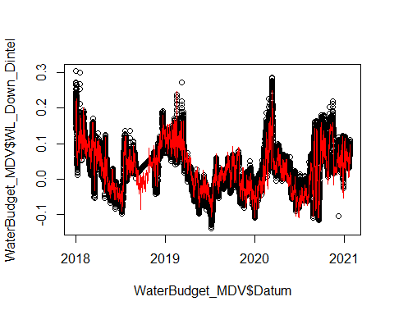

plot(WaterBudget_MDV$WL_Down_Dintel, WaterBudget_MDV$WL_Down_Vliet)  
lines(-2:2,-2:2,col=2) # 1:1 line

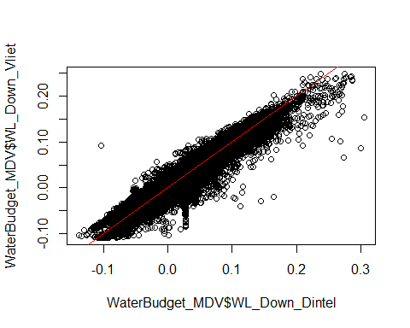

#### Compare depth measurements inside MDV system  
plot(WaterBudget_MDV$Datum, WaterBudget_MDV$WL_Up_Dintel)  
lines(WaterBudget_MDV$Datum, WaterBudget_MDV$WL_Up_Vliet, col=2)  
  
lines(WaterBudget_MDV$Datum, WaterBudget_MDV$WL_Gastel,col=3)  
  
lines(WaterBudget_MDV$Datum, WaterBudget_MDV$WL_Down_Oosterhout, col=2)  
  
lines(WaterBudget_MDV$Datum, WaterBudget_MDV$WL_Up_Vliet, col=2)

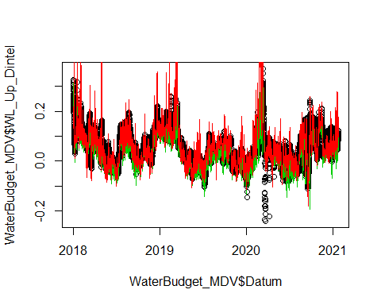

#### Trunc data from hourly to daily

WaterBudget_MDV$Daily <- trunc(WaterBudget_MDV$Datum, "days")  
WB_MDV_Day <- aggregate(WaterBudget_MDV[,2:18],by=list(as.character(WaterBudget_MDV$Daily)),mean)  
names(WB_MDV_Day)[1] <- "Datum"  
WB_MDV_Day$Datum <- ymd(WB_MDV_Day$Datum)  
  
#### analysis summer and the rest period separately  
WB_MDV_Day$period <- ifelse(month(WB_MDV_Day$Datum)%in%5:9,"Summer","No summer")  
WB_MDV_Day$period <- factor(WB_MDV_Day$period, levels = c("Summer","No Summer"))

#### Closing the water balance by adjusting the inflows at Gastel (Molenbeak)

Surface <- 50*(114-0)*40+50*(640-114)*50+50*(666-640)*100+50*(743-666)*40+50*(760-743)*26+50*(1117-760)*30 # m^2  
WB_MDV_Day$dt <- c(1, diff(as.numeric(WB_MDV_Day$Datum))*86400) # seconds  
  
WB_MDV_Day$dV <- c(0, diff(WB_MDV_Day$WL_Down_Oosterhout)*(50*(114-0)*40)+diff(WB_MDV_Day$WL_Down_Rooskensdonk)*50*((640-114)*50+(666-640)*100)+diff(WB_MDV_Day$WL_Gastel)*50*((743-666)*40+(760-743)*26+(1117-760)*30)) # m^3  
  
#### Calculting the rest discharge to close the water budget ####  
WB_MDV_Day$dQ <- WB_MDV_Day$dV/WB_MDV_Day$dt # m3/s  
  
#### Calculation of discharge at polders  
WB_MDV_Day$Q_Polder <- WB_MDV_Day$dQ-(WB_MDV_Day$Qin_MarkCanal+WB_MDV_Day$Qin_BlauweKamer+WB_MDV_Day$Qin_Oranjeboombrug+WB_MDV_Day$Qin_Molenbeak_Corr-WB_MDV_Day$Qout_Dintelsas-WB_MDV_Day$Qout_Vliet)  
  
mean(WB_MDV_Day$Q_Polder, na.rm = T)

## [1] 4.837534

sd(WB_MDV_Day$Q_Polder, na.rm = T)

## [1] 12.62892

# summer discharge  
mean(WB_MDV_Day$Q_Polder[which(month(WB_MDV_Day$Datum)%in%c(5:9))],na.rm = T)

## [1] -3.77742

sd(WB_MDV_Day$Q_Polder[which(month(WB_MDV_Day$Datum)%in%c(5:9))],na.rm = T)

## [1] 7.318447

# no summer discharge  
mean(WB_MDV_Day$Q_Polder[-which(month(WB_MDV_Day$Datum)%in%c(5:9))],na.rm = T)

## [1] 10.82884

sd(WB_MDV_Day$Q_Polder[-which(month(WB_MDV_Day$Datum)%in%c(5:9))],na.rm = T)

## [1] 12.07099

#### Compare it with Measurements at Molenbeak ####  
plot(WB_MDV_Day$Datum,WB_MDV_Day$Q_Polder, type = "l", ylab="Discharge (m3/s)", xlab="", main="Polder")   
  
abline(v=ymd("2018-05-01","2018-09-30","2019-05-01","2019-09-30","2020-05-01","2020-09-30"), col="red", lty=2)  
  
# Discharge data from report  
Q_df <- read.csv("C:\\Users\\QingZ\\PhD-Qing\\GitProject\\Mark_Dintel_Vliet\\Modelling\\Advection-Diffusion-Production\\Waterbalance\\Q_df.csv")  
Q_df$Date <- ymd("2019-01-01","2019-02-01","2019-03-01","2019-04-01","2019-05-01","2019-06-01","2019-07-01","2019-08-01","2019-09-01","2019-10-01","2019-11-01","2019-12-01")  
  
points(Q_df$Date, Q_df$f..Ground.water+Q_df$g..rest.heading+Q_df$h..PolderOut,col="red",pch=19)  
  
points(Q_df$Date, Q_df$h..PolderOut,col="green",pch=19)

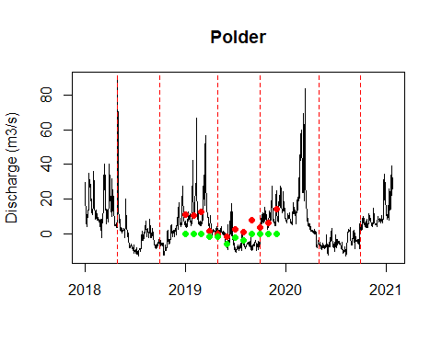

#### Q vs delta water levels

# for Oosterhout:  
plot(WaterBudget_MDV$WL_Up_Oosterhout-WaterBudget_MDV$WL_Down_Oosterhout,WaterBudget_MDV$Qin_MarkCanal, main = "Oosterhout",xlab = "delta water level (m)", ylab = "discharge (m3/s)")

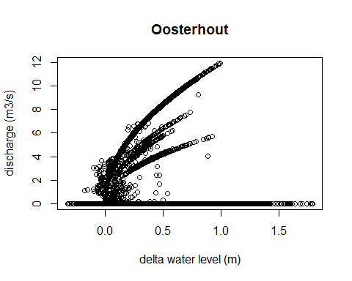

summary(lm(WaterBudget_MDV$Qin_MarkCanal~WaterBudget_MDV$WL_Up_Oosterhout-WaterBudget_MDV$WL_Down_Oosterhout))

##   
## Call:  
## lm(formula = WaterBudget_MDV$Qin_MarkCanal ~ WaterBudget_MDV$WL_Up_Oosterhout -   
## WaterBudget_MDV$WL_Down_Oosterhout)  
##   
## Residuals:  
## Min 1Q Median 3Q Max   
## -4.963 -2.830 -1.841 3.228 10.745   
##   
## Coefficients:  
## Estimate Std. Error t value Pr(>|t|)   
## (Intercept) 4.11201 0.04543 90.52 <2e-16 ***  
## WaterBudget_MDV$WL_Up_Oosterhout -2.64346 0.08066 -32.77 <2e-16 ***  
## ---  
## Signif. codes: 0 '***' 0.001 '**' 0.01 '*' 0.05 '.' 0.1 ' ' 1  
##   
## Residual standard error: 3.466 on 26855 degrees of freedom  
## Multiple R-squared: 0.03846, Adjusted R-squared: 0.03842   
## F-statistic: 1074 on 1 and 26855 DF, p-value: < 2.2e-16

plot(WaterBudget_MDV$WL_Up_Dintel-WaterBudget_MDV$WL_Down_Dintel, WaterBudget_MDV$Qout_Dintelsas, main = "Dintel",xlab = "delta water level (m)", ylab = "discharge (m3/s)")

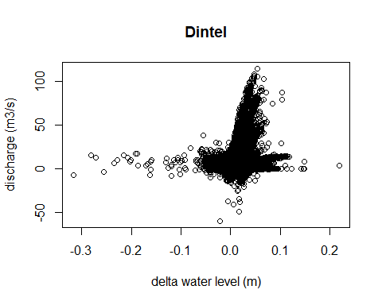

summary(lm(WaterBudget_MDV$Qout_Dintelsas~(WaterBudget_MDV$WL_Up_Dintel-WaterBudget_MDV$WL_Down_Dintel)))

##   
## Call:  
## lm(formula = WaterBudget_MDV$Qout_Dintelsas ~ (WaterBudget_MDV$WL_Up_Dintel -   
## WaterBudget_MDV$WL_Down_Dintel))  
##   
## Residuals:  
## Min 1Q Median 3Q Max   
## -85.738 -6.691 -1.882 4.554 84.917   
##   
## Coefficients:  
## Estimate Std. Error t value Pr(>|t|)   
## (Intercept) 6.69925 0.08917 75.13 <2e-16 ***  
## WaterBudget_MDV$WL_Up_Dintel 74.57375 1.08567 68.69 <2e-16 ***  
## ---  
## Signif. codes: 0 '***' 0.001 '**' 0.01 '*' 0.05 '.' 0.1 ' ' 1  
##   
## Residual standard error: 11.29 on 26855 degrees of freedom  
## Multiple R-squared: 0.1494, Adjusted R-squared: 0.1494   
## F-statistic: 4718 on 1 and 26855 DF, p-value: < 2.2e-16

plot(WaterBudget_MDV$WL_Gastel-WaterBudget_MDV$WL_Down_Vliet, WaterBudget_MDV$Qout_Vliet, main = "Vliet",xlab = "delta water level (m)", ylab = "discharge (m3/s)")

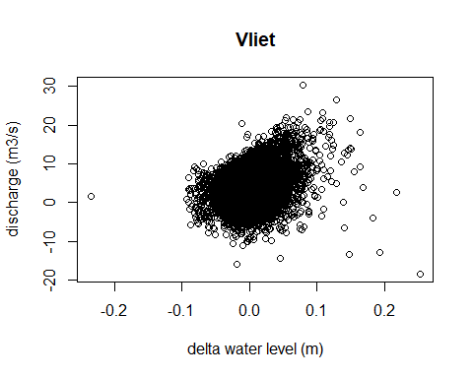

summary(lm(WaterBudget_MDV$Qout_Vliet~(WaterBudget_MDV$WL_Gastel-WaterBudget_MDV$WL_Down_Vliet)))

##   
## Call:  
## lm(formula = WaterBudget_MDV$Qout_Vliet ~ (WaterBudget_MDV$WL_Gastel -   
## WaterBudget_MDV$WL_Down_Vliet))  
##   
## Residuals:  
## Min 1Q Median 3Q Max   
## -25.444 -1.992 -0.254 1.665 26.119   
##   
## Coefficients:  
## Estimate Std. Error t value Pr(>|t|)   
## (Intercept) 1.88753 0.02004 94.19 <2e-16 ***  
## WaterBudget_MDV$WL_Gastel 15.24660 0.29867 51.05 <2e-16 ***  
## ---  
## Signif. codes: 0 '***' 0.001 '**' 0.01 '*' 0.05 '.' 0.1 ' ' 1  
##   
## Residual standard error: 3.104 on 26854 degrees of freedom  
## (1 observation deleted due to missingness)  
## Multiple R-squared: 0.08846, Adjusted R-squared: 0.08842   
## F-statistic: 2606 on 1 and 26854 DF, p-value: < 2.2e-16