Missing values in each column:

Age 0

Height 0

Weight 0

family_history_with_overweight 0

FAVC 0

FCVC 0

NCP 0

SMOKE 0

CH2O 0

SCC 0

FAF 0

TUE 0

CALC 1

Gender_Male 0

CAEC_Frequently 0

CAEC_Sometimes 0

CAEC_no 0

MTRANS_Bike 0

MTRANS_Motorbike 0

MTRANS_Public_Transportation 0

MTRANS_Walking 0

dtype: int64

KNN Metrics:

Accuracy: 0.8156028368794326

ROC-AUC: 0.9431095718267329

Confusion Matrix:

[[50 4 0 0 0 2 0]

[15 30 6 0 0 6 5]

[ 0 2 69 2 0 2 3]

[ 0 0 0 57 0 0 1]

[ 0 0 0 0 63 0 0]

[ 1 10 4 1 0 38 2]

[ 0 3 3 3 1 2 38]]

Classification Report:

{'0': {'precision': 0.7575757575757576, 'recall': 0.8928571428571429, 'f1-score': 0.819672131147541, 'support': 56.0}, '1': {'precision': 0.6122448979591837, 'recall': 0.4838709677419355, 'f1-score': 0.5405405405405406, 'support': 62.0}, '2': {'precision': 0.8414634146341463, 'recall': 0.8846153846153846, 'f1-score': 0.8625, 'support': 78.0}, '3': {'precision': 0.9047619047619048, 'recall': 0.9827586206896551, 'f1-score': 0.9421487603305785, 'support': 58.0}, '4': {'precision': 0.984375, 'recall': 1.0, 'f1-score': 0.9921259842519685, 'support': 63.0}, '5': {'precision': 0.76, 'recall': 0.6785714285714286, 'f1-score': 0.7169811320754718, 'support': 56.0}, '6': {'precision': 0.7755102040816326, 'recall': 0.76, 'f1-score': 0.7676767676767676, 'support': 50.0}, 'accuracy': 0.8156028368794326, 'macro avg': {'precision': 0.8051330255732321, 'recall': 0.8118105063536495, 'f1-score': 0.8059493308604097, 'support': 423.0}, 'weighted avg': {'precision': 0.8081439671854546, 'recall': 0.8156028368794326, 'f1-score': 0.8093936164181754, 'support': 423.0}}

Random Forest Metrics:

Accuracy: 0.950354609929078

ROC-AUC: 0.9967373419601057

Confusion Matrix:

[[54 2 0 0 0 0 0]

[ 0 59 0 0 0 3 0]

[ 0 2 74 2 0 0 0]

[ 0 0 1 57 0 0 0]

[ 0 0 0 0 63 0 0]

[ 0 6 0 0 0 49 1]

[ 0 0 0 0 0 4 46]]

Classification Report:

{'0': {'precision': 1.0, 'recall': 0.9642857142857143, 'f1-score': 0.9818181818181818, 'support': 56.0}, '1': {'precision': 0.855072463768116, 'recall': 0.9516129032258065, 'f1-score': 0.900763358778626, 'support': 62.0}, '2': {'precision': 0.9866666666666667, 'recall': 0.9487179487179487, 'f1-score': 0.9673202614379085, 'support': 78.0}, '3': {'precision': 0.9661016949152542, 'recall': 0.9827586206896551, 'f1-score': 0.9743589743589743, 'support': 58.0}, '4': {'precision': 1.0, 'recall': 1.0, 'f1-score': 1.0, 'support': 63.0}, '5': {'precision': 0.875, 'recall': 0.875, 'f1-score': 0.875, 'support': 56.0}, '6': {'precision': 0.9787234042553191, 'recall': 0.92, 'f1-score': 0.9484536082474226, 'support': 50.0}, 'accuracy': 0.950354609929078, 'macro avg': {'precision': 0.9516520328007652, 'recall': 0.9489107409884464, 'f1-score': 0.9496734835201591, 'support': 423.0}, 'weighted avg': {'precision': 0.9525876152989927, 'recall': 0.950354609929078, 'f1-score': 0.950864368187805, 'support': 423.0}}

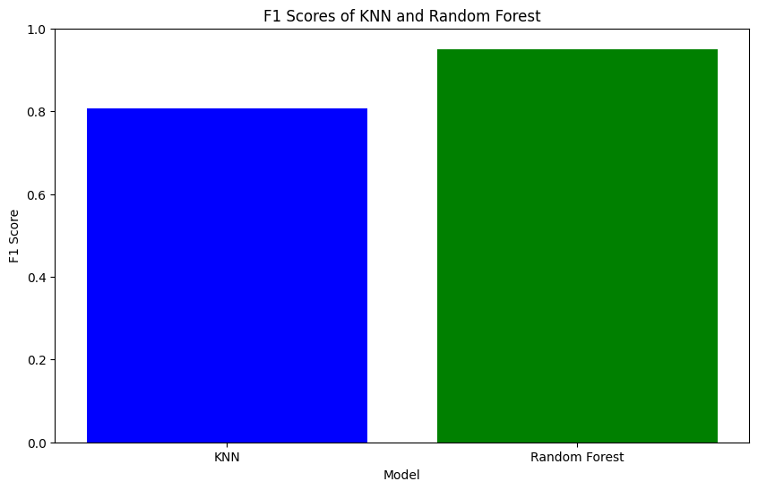

### U-Net Workflow:

1. Input Image: An image (e.g., medical scan) is provided to the U-Net model.
2. Downsampling: The image is passed through the contracting path, which captures context and compresses the image information.
3. Bottleneck: At the bottom of the "U", the network has the lowest resolution feature maps but contains the most abstract representations.
4. Upsampling: The feature maps are upsampled and combined with the corresponding high-resolution feature maps from the contracting path via skip connections.
5. Output: The network outputs a segmentation map, with each pixel in the original image classified into one of the predefined classes (e.g., tissue, organ, object).

U-Net is positioned within the Convolutional Neural Networks (CNNs) category and is specialized for image segmentation.

