CHAINLANCE
Decentralized Freelance Marketplace with Milestone Escrow
Project Proposal & Software Requirements Specification (SRS) Report
Requirements Engineering & Architecture Baseline
Document Version: 1.0
Status: Baseline for implementation
Prepared For: Undergraduate portfolio / blockchain engineering project
Prepared By: Nirasha Wickamasinghe
Date: 12 August 2026
Purpose This document establishes the agreed Phase 01 project scope and testable requirements that will guide design, implementation, validation, security testing, deployment, documentation, and portfolio presentation. It is a living baseline: changes should be recorded through versioned revisions rather than silently changing implementation goals.

Document Control
Field | Value
Project | ChainLance — Decentralized Freelance Marketplace with Milestone Escrow
Document | Project Proposal and Software Requirements Specification (SRS)
Version | 1.0
Phase | Phase 01 — Requirements Engineering & Architecture Baseline
Status | Approved baseline for repository bootstrap and detailed design
Primary environment | Local Hardhat network → Ethereum Sepolia testnet
Primary implementation style | Monorepo-style web + API + blockchain packages
Change policy | Changes to scope or requirements must be versioned and reflected in traceability/tests

Revision History
Version | Date | Change | Owner
0.1 | 12 Aug 2026 | Initial planning baseline | Project owner
1.0 | 12 Aug 2026 | Professional Phase 01 proposal + SRS baseline | Project owner / engineering review

Table of Contents
1. Executive Summary
2. Project Proposal
3. Software Requirements Specification Overview
4. Stakeholders, Actors and User Characteristics
5. System Context and Architecture Baseline
6. Domain Model
7. Use-Case Model
8. Functional Requirements
9. Non-Functional Requirements
10. Business Rules and State Models
11. Data and Integration Requirements
12. Security and Threat Model
13. Validation and Error-Handling Requirements
14. Testing and Quality Strategy
15. Technology Stack and Engineering Rationale
16. Deployment and Environment Strategy
17. Phase-Wise Implementation Plan
18. GitHub Repository and Development Workflow
19. Definition of Done and Success Measures
20. Requirement Traceability Baseline
21. Future Roadmap / Explicitly Out of Scope
22. References
Appendix A — Detailed User Stories & Acceptance Criteria
Appendix B — Phase 02 Entry Checklist

1. Executive Summary
ChainLance is a portfolio-focused Ethereum decentralized application (dApp) that addresses a common trust problem in online freelancing: clients need confidence that payment is released only for accepted work, while freelancers need confidence that agreed funds are reserved and cannot be arbitrarily withheld. ChainLance uses smart-contract-controlled milestone escrow for payment rules and combines it with an off-chain web platform for profiles, proposals, search, notifications, event indexing, and a practical user experience.
The project is deliberately designed as a hybrid Web3 system. The blockchain is the authoritative source for agreement ownership, deposited funds, milestone state, dispute outcomes, and payment execution. The API/database are authoritative only for non-consensus application data such as profile metadata and search projections. This separation prevents a compromised frontend or backend from directly overriding escrow ownership or payment rules.
Phase 01 Decision Do not begin feature implementation until the requirements, state transitions, security invariants, acceptance criteria, and initial architecture in this document are accepted as the baseline. Phase 02 begins with repository bootstrap and development-environment setup.

2. Project Proposal

2.1 Problem Statement
Traditional freelance marketplaces act as trusted intermediaries for identity, agreements, payment custody, dispute workflows, and reputation. A portfolio-grade blockchain project should not attempt to decentralize every feature; instead, it should apply blockchain where independent verification and deterministic value transfer are valuable. ChainLance focuses on the escrow and settlement layer while retaining conventional web infrastructure for performance-sensitive and privacy-sensitive application features.

2.2 Proposed Solution
- Clients publish projects and define milestone budgets and deadlines.
- Freelancers discover projects and submit proposals using off-chain application services.
- After a client selects a freelancer, an on-chain escrow agreement is created/funded.
- Freelancers submit milestone completion with a reference/evidence hash; clients approve valid work.
- Smart contracts enforce one-time payment release and prohibit invalid state transitions.
- Either party may open a dispute for an eligible milestone; an authorized arbitrator resolves the MVP dispute.
- Completed projects allow counterparties to create bounded, project-linked reputation records.
- A Node.js event indexer projects blockchain events into PostgreSQL for fast search/history while preserving chain state as the source of truth.

2.3 Project Objectives
ID | Objective
O-01 | Demonstrate secure Solidity smart-contract design with explicit state machines and access control.
O-02 | Demonstrate practical Ethereum wallet integration, message signing, transaction signing, network handling, and user-friendly transaction states.
O-03 | Demonstrate full-stack engineering by integrating React/TypeScript, Node.js/Express, PostgreSQL, blockchain RPC, event indexing, and automated tests.
O-04 | Demonstrate security engineering through invariants, threat modeling, negative tests, and reentrancy/authorization protections.
O-05 | Produce a deployable and documented portfolio repository suitable for technical review in blockchain engineering interviews.
O-06 | Preserve a learning path for the originally required Truffle/Ganache/Web3.js stack while making the primary portfolio implementation use maintained tooling.

2.4 Scope — Minimum Viable Product (MVP)
Capability | MVP Scope
Identity | Ethereum wallet connection plus nonce-based Sign-In with Ethereum (SIWE)-style authentication for API sessions.
Profiles | Off-chain profile metadata keyed by wallet address.
Projects | Create, view, browse, filter, and close project postings.
Proposals | Freelancers submit, update/withdraw where allowed, and clients accept one proposal.
Escrow | Native test ETH deposited into a smart-contract-controlled agreement.
Milestones | Defined amounts, lifecycle state, submission evidence reference, client approval, one-time payment.
Disputes | Open dispute on eligible milestone, submit references, authorized MVP arbitrator resolves.
Reputation | Review only after completed/settled eligible project; no self-review; no duplicate review.
History | Transaction/event history and current agreement state visible in the web app.
Indexing | Backend processes confirmed smart-contract events into queryable projections.
Testing | Contract, backend, integration, E2E, invariant/security checks with CI quality gates.
Deployment | Local development and Ethereum Sepolia testnet demonstration.

2.5 Project Deliverables
- Solidity smart contracts, deployment modules/scripts, ABI artifacts, automated tests, and verification instructions.
- React/TypeScript frontend with MetaMask wallet support and clear transaction UX.
- Node.js/Express API with SIWE-style authentication, validation, database migrations, indexing worker, and health endpoints.
- Architecture, threat model, API specification, SRS, testing evidence, deployment guide, screenshots/demo, and portfolio README.
- Sepolia deployment addresses and reproducible local development setup.

2.6 Success Criteria
ID | Measure | Target
SC-01 | Critical escrow requirements have automated tests | 100% of critical acceptance scenarios represented by tests
SC-02 | Smart-contract critical paths | No unresolved high/critical findings in project security review checklist
SC-03 | Escrow accounting | All invariant/property tests pass for deposit, release and refund accounting
SC-04 | CI reliability | Clean checkout can lint, compile, test and build without manual code changes
SC-05 | Testnet demonstration | A complete client → freelancer → milestone → payment workflow succeeds on Sepolia
SC-06 | Documentation | Fresh developer can follow README to run local system and execute tests
SC-07 | Portfolio quality | README clearly explains architecture trade-offs, security controls, limitations and future work

2.7 Assumptions and Constraints
- The MVP is educational/portfolio software and does not claim to replace legally enforceable freelance contracts or regulated escrow services.
- Only test assets are used during development and public demonstration; mainnet real-value deployment is outside Phase 01–MVP.
- Users are responsible for wallet key custody; ChainLance never stores private keys or seed phrases.
- One wallet may act as both client and freelancer on different projects; roles are contextual rather than permanent identities.
- The MVP uses a single supported EVM network at a time and native test ETH for escrow.
- Off-chain storage may be unavailable temporarily without granting the backend authority to move escrow funds.
- The initial arbitrator is a controlled role for learning; DAO/community arbitration is future scope.

2.8 High-Level Risks
Risk | Impact | Mitigation
Smart-contract defect causes incorrect payment | Critical | Small contract surface, CEI pattern, ReentrancyGuard where appropriate, strict authorization, unit/invariant tests, manual security review before testnet.
Scope creep | High | Freeze MVP and place new ideas in roadmap unless a requirement change is explicitly approved.
RPC/provider instability | Medium | Retry/read-fallback strategy, confirmation tracking, observable indexer lag, provider abstraction.
Chain reorganization causes stale indexed state | Medium | Process confirmed events; store block/hash cursor; support replay/reconciliation.
Wallet phishing/signature misuse | High | SIWE-compatible domain/nonce/expiry checks; human-readable signing; never request private keys.
Portfolio judged as “blockchain for everything” | Medium | Document clear on-chain/off-chain ownership rationale and limitations.

3. Software Requirements Specification Overview

3.1 Purpose
This SRS defines the functional behavior, quality attributes, business rules, data ownership boundaries, integration interfaces, security controls, validation rules, testing expectations, and implementation phases for the ChainLance MVP. Requirements use stable identifiers so they can later be mapped to source code, automated tests, issues, and release evidence.

3.2 Requirement Language and Priority
Term | Meaning
Shall | Mandatory requirement for the stated release.
Should | Important but may be deferred with documented justification.
May | Optional or enhancement behavior.
Must | Priority label for MVP-critical behavior.
Should | Priority label for desirable behavior.
Could | Future/optional behavior.

3.3 Definitions and Acronyms
Term | Definition
dApp | Decentralized application that interacts with blockchain smart contracts.
EOA | Externally Owned Account controlled by a private key.
EVM | Ethereum Virtual Machine.
Escrow | Funds held under contract-defined release/refund conditions.
Milestone | A priced unit of work within an agreement.
SIWE | Sign-In with Ethereum (ERC-4361) pattern for off-chain authentication using wallet signatures.
RPC | Remote Procedure Call interface used to read/send Ethereum network requests.
ABI | Application Binary Interface describing callable smart-contract functions/events.
Indexer | Service that processes blockchain events into queryable off-chain projections.
Invariant | A property that must remain true across all valid state transitions.
Reorg | Blockchain reorganization that can replace recently observed blocks/events.

4. Stakeholders, Actors and User Characteristics
Actor / Stakeholder | Goals | Key Capabilities / Constraints
Client | Hire a freelancer and control milestone acceptance without exposing escrow to backend custody. | Creates project, reviews proposals, funds agreement, approves or disputes milestones, rates counterparty.
Freelancer | Know that funds are reserved and receive payment after accepted milestones. | Submits proposals and milestone evidence, views locked funds, opens disputes, receives payment, rates counterparty.
Arbitrator (MVP) | Resolve a disputed milestone using the rules and referenced evidence. | Can resolve only active disputes; cannot freely transfer unrelated escrow.
Platform Service | Provide usable Web2 services around verifiable on-chain settlement. | Authenticates wallet sessions, manages metadata, indexes events, exposes API/search, sends notifications.
Project Maintainer | Build, test, secure, deploy and document the system. | Owns code quality, CI, deployment configuration and environment secrets; never holds user keys.
Portfolio Reviewer / Interviewer | Assess engineering depth and decision quality. | Needs reproducible setup, architecture explanation, tests, security rationale and clear limitations.

4.1 User Characteristics
- Primary end-users may understand wallets but should not need Solidity/EVM knowledge to perform normal tasks.
- The UI shall translate transaction states into understandable language while still exposing contract address, network, transaction hash, and block confirmation details for advanced users.
- Failure messages shall distinguish user rejection, insufficient funds, wrong network, contract revert, RPC/network failure, and application validation errors.

5. System Context and Architecture Baseline
The architecture follows a deliberate trust boundary: the frontend and API can improve usability, but neither is allowed to bypass the smart contract’s rules for escrowed value. MetaMask signs transactions; an RPC provider relays them to the EVM network; smart contracts enforce settlement; an indexer builds read-optimized projections for the web application.
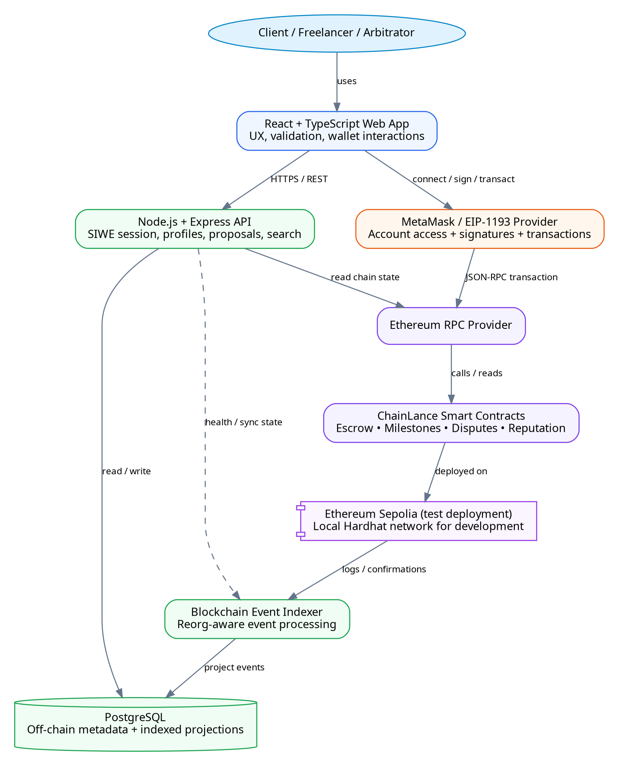
Figure 1. ChainLance high-level system context and hybrid Web3 architecture.

5.1 Authority and Data Ownership
Data / Decision | Authoritative Source | Rationale
Escrow balance | Smart contract / chain state | Funds must not depend on backend/database integrity.
Client/freelancer addresses | Smart contract agreement | Authorization and settlement identities.
Milestone state | Smart contract | Prevents UI/API from inventing approval/payment.
Dispute resolution result | Smart contract | Controls final settlement.
Project profile text / biography | PostgreSQL | Mutable, searchable, not consensus-critical.
Proposal narrative | PostgreSQL | Private/large mutable app content; accepted terms are anchored by agreement.
Search/filter projections | PostgreSQL index | Performance optimization derived from source events/data.
Transaction history display | Indexed events + direct chain reconciliation | Fast UX with ability to verify source transaction.

5.2 Trust Boundaries
- Browser <-> wallet: the application may request signatures/transactions but never reads private keys.
- Browser <-> API: all privileged off-chain requests require a verified wallet-bound session and server-side authorization.
- API/indexer <-> RPC: blockchain reads are untrusted external inputs until chain ID, contract address, event signature, confirmation policy, and cursor consistency are verified.
- Smart contract <-> arbitrary caller: every public/external state-changing function must remain secure when called directly by a script, not only through ChainLance UI.

6. Domain Model
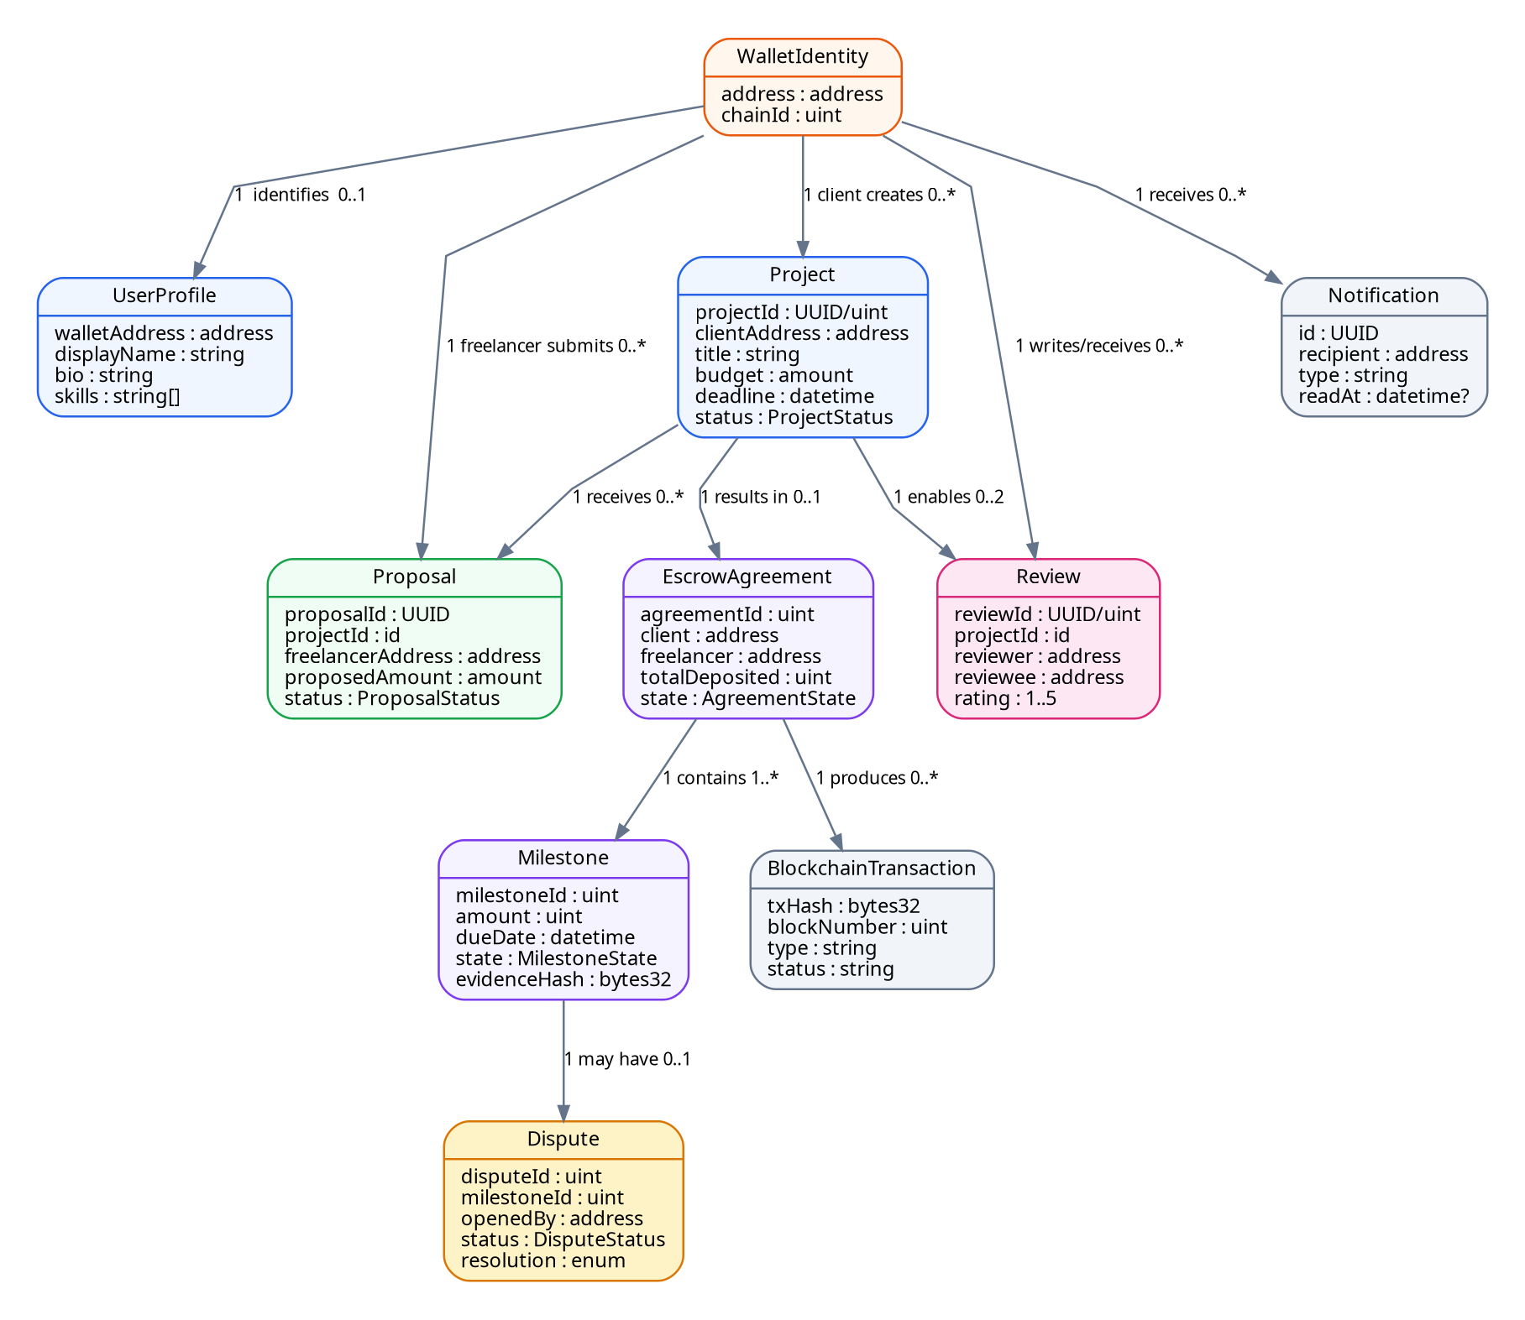
The domain model separates user identity, project marketplace data, escrow settlement state, and derived operational data. Some classes are conceptual and may be split between Solidity structs/events and relational entities during detailed design.

Figure 2. ChainLance conceptual domain model and primary entity relationships.

6.1 Core Domain Entities
Entity | Purpose | Primary Location
WalletIdentity | Canonical blockchain identity used for signing and authorization. | On-chain address / session subject
UserProfile | Human-readable profile, skills and portfolio metadata. | Off-chain database
Project | Client-created opportunity and desired milestone plan. | Off-chain draft; accepted agreement identifiers anchored on-chain
Proposal | Freelancer offer for a project. | Off-chain database
EscrowAgreement | On-chain relationship between selected client/freelancer and funded value. | Smart contract
Milestone | Amount and lifecycle rules for one deliverable. | Smart contract + indexed projection
Dispute | Controlled exception path for a milestone. | Smart contract + off-chain evidence references
Review | Project-linked reputation record. | MVP may use on-chain eligibility/event plus indexed/off-chain text
BlockchainTransaction | Observed transaction metadata for UX/audit. | Derived/indexed
Notification | User-facing application notification. | Off-chain database

7. Use-Case Model
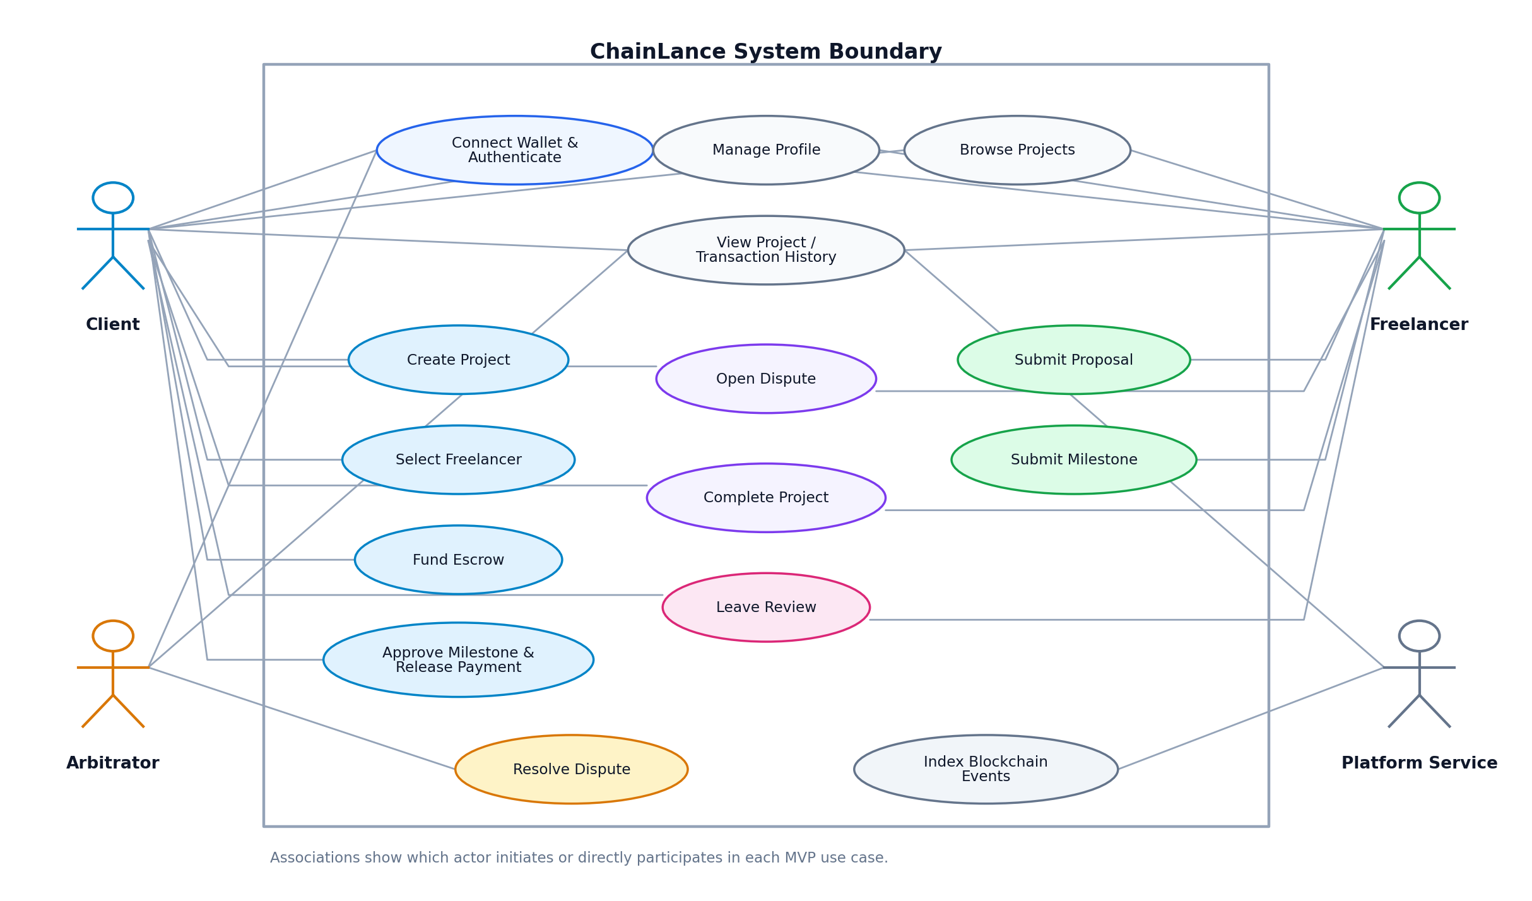
Figure 3. ChainLance MVP use-case diagram showing the primary actors and system interactions.

7.1 Use-Case Catalogue
ID | Use Case | Primary Actor | Goal
UC-01 | Connect Wallet & Authenticate | Client/Freelancer/Arbitrator | Establish wallet identity and authenticated application session.
UC-02 | Manage Profile | Client/Freelancer | Create/update off-chain public profile.
UC-03 | Create Project | Client | Publish project and milestone requirements.
UC-04 | Browse Projects | Client/Freelancer | Search/view suitable projects.
UC-05 | Submit Proposal | Freelancer | Offer terms for an open project.
UC-06 | Select Freelancer | Client | Accept one eligible proposal.
UC-07 | Fund Escrow | Client | Lock agreed native test ETH for the agreement.
UC-08 | Submit Milestone | Freelancer | Mark eligible milestone submitted with evidence reference.
UC-09 | Approve & Release | Client | Approve submitted work and trigger one-time payment.
UC-10 | Open Dispute | Client/Freelancer | Place eligible submitted milestone into dispute.
UC-11 | Resolve Dispute | Arbitrator | Choose allowed settlement outcome.
UC-12 | Complete Project | Client/Freelancer/System | Finalize after all milestones are settled.
UC-13 | Leave Review | Client/Freelancer | Create one eligible review for counterparty.
UC-14 | View History | All users | Inspect project, event and transaction history.
UC-15 | Index Events | Platform Service | Project confirmed contract logs into query model.

7.2 Detailed Core Use Cases

UC-01 — Connect Wallet & Authenticate
Preconditions: User has an EVM-compatible wallet.
Main flow: 1) App discovers wallet provider. 2) User selects/connects account. 3) API issues one-time nonce. 4) App requests human-readable SIWE-compatible signature. 5) API validates address, domain/origin expectations, nonce, chain/session fields and signature. 6) API creates address-bound session.
Alternate/failure paths: User rejects connection/signature; nonce expired/reused; unsupported chain; invalid signature.
Postconditions: Authenticated session is bound to verified wallet address; nonce cannot be reused.

UC-07 — Fund Escrow
Preconditions: Client selected a freelancer; agreement terms are frozen; wallet on supported network.
Main flow: 1) Client reviews final milestone amounts. 2) Client submits funding transaction. 3) Contract validates caller/value/state. 4) Contract records funding and emits event. 5) UI waits for receipt; indexer later projects confirmed event.
Alternate/failure paths: Insufficient funds; wrong value; duplicate funding; user rejects; transaction reverts.
Postconditions: Agreement enters funded/active state exactly once and contract balance/accounting reflects deposit.

UC-09 — Approve & Release Milestone
Preconditions: Milestone is submitted, funded and not disputed/paid.
Main flow: 1) Client reviews evidence. 2) Client approves. 3) Contract checks authorization/state. 4) State is updated before external value transfer. 5) Payment is transferred/withdrawable according to chosen pattern. 6) Event is emitted.
Alternate/failure paths: Non-client caller; duplicate approval; disputed milestone; transfer failure.
Postconditions: Milestone becomes paid only once; released amount equals milestone amount; accounting invariant holds.

UC-10/11 — Dispute and Resolution
Preconditions: Eligible milestone is submitted and unsettled.
Main flow: 1) Client or freelancer opens dispute. 2) Contract locks normal approval path. 3) Parties provide off-chain evidence references. 4) Authorized arbitrator resolves with one allowed outcome. 5) Contract records decision and performs/permits corresponding settlement.
Alternate/failure paths: Unauthorized resolver; already resolved; invalid outcome; unrelated milestone.
Postconditions: Exactly one terminal resolution; no further normal approval/payment after resolution.

UC-13 — Leave Review
Preconditions: Project completed/settled and caller was a counterparty.
Main flow: 1) User chooses rating/comment. 2) System verifies relationship and eligibility. 3) Review is stored/emitted according to detailed design. 4) Duplicate key prevents second review by same reviewer for project/counterparty.
Alternate/failure paths: Self-review; unrelated wallet; incomplete project; duplicate review.
Postconditions: Review is traceable to an eligible project interaction and cannot be duplicated.

8. Functional Requirements
Each requirement below is intentionally phrased so that it can be verified by an automated test, an integration test, or a documented inspection. “Must” items define the MVP baseline.

8.1 Wallet and Authentication
FR-AUTH-01 — Provider discovery [Must; Test]
The web application shall discover available EVM wallet providers using a standards-aligned provider interface and shall support MetaMask as the primary tested wallet.
FR-AUTH-02 — Explicit account consent [Must; Test]
The application shall not assume wallet access before the user explicitly approves account connection.
FR-AUTH-03 — Network validation [Must; Test]
Before a state-changing action, the application shall verify that the active wallet chain matches the configured ChainLance network and shall block or guide correction when it does not.
FR-AUTH-04 — Nonce authentication [Must; Test]
The API shall issue a cryptographically unpredictable, single-use authentication nonce associated with a short validity period.
FR-AUTH-05 — Signature verification [Must; Test]
The API shall verify the signed authentication message and bind the resulting session to the recovered/validated Ethereum account.
FR-AUTH-06 — Replay prevention [Must; Test]
A nonce shall be invalid after successful use, expiration, or explicit invalidation; re-submission shall not create a new session.
FR-AUTH-07 — Session logout [Must; Test]
The user shall be able to terminate the off-chain session without requiring an on-chain transaction.

8.2 Profiles, Projects and Proposals
FR-MKT-01 — Profile management [Must; Test]
An authenticated wallet shall be able to create and update its own profile metadata, subject to server-side validation and size limits.
FR-MKT-02 — Project creation [Must; Test]
An authenticated client shall be able to create a project containing title, description, skill tags, expected deadline, budget information and one or more milestone definitions.
FR-MKT-03 — Milestone sum validation [Must; Test]
Before proposal acceptance/funding, the agreed milestone amounts shall sum exactly to the agreed total escrow amount.
FR-MKT-04 — Project discovery [Must; Test]
Users shall be able to list, search and filter open projects without requiring a blockchain transaction.
FR-MKT-05 — Proposal submission [Must; Test]
An authenticated freelancer shall be able to submit one active proposal per project unless the prior proposal is withdrawn/rejected according to policy.
FR-MKT-06 — Proposal ownership [Must; Test]
A user shall be able to modify/withdraw only proposals created by the same authenticated wallet and only while the proposal/project state allows it.
FR-MKT-07 — Proposal selection [Must; Test]
Only the project client shall be able to select an eligible proposal; selection shall freeze the terms used to prepare the escrow agreement.

8.3 Escrow Agreement and Funding
FR-ESC-01 — Agreement parties [Must; Test]
The on-chain agreement shall record the client and freelancer addresses used for authorization.
FR-ESC-02 — Funding authorization [Must; Test]
Only the designated client shall be allowed to fund the normal MVP escrow agreement unless future design explicitly introduces third-party funding.
FR-ESC-03 — Exact funding [Must; Test]
The funding transaction shall provide the exact required amount or follow a clearly specified overpayment-refund rule; the MVP baseline uses exact-value funding.
FR-ESC-04 — Single funding transition [Must; Test]
A fully funded agreement shall reject duplicate attempts to re-enter the initial funding state.
FR-ESC-05 — Event emission [Must; Test]
Successful agreement creation/funding shall emit events containing stable identifiers and indexed actor fields needed by the indexer.
FR-ESC-06 — Direct-call safety [Must; Test]
All escrow rules shall remain enforceable when the contract is called directly without the ChainLance frontend/API.

8.4 Milestones and Settlement
FR-MILE-01 — Milestone lifecycle [Must; Test]
Each milestone shall follow only the state transitions defined in Section 10; invalid transitions shall revert.
FR-MILE-02 — Submission authorization [Must; Test]
Only the agreement freelancer shall be able to submit an eligible milestone as completed.
FR-MILE-03 — Submission reference [Must; Test]
Milestone submission shall allow a bounded evidence/content reference or hash rather than storing large work artifacts directly on-chain.
FR-MILE-04 — Approval authorization [Must; Test]
Only the agreement client shall be able to approve a normally submitted milestone.
FR-MILE-05 — One-time payout [Must; Test]
A milestone amount shall never be paid more than once, regardless of repeated calls, reentrancy attempts, frontend retries, or transaction replays.
FR-MILE-06 — Exact payout [Must; Test]
The value settled to the freelancer for a normal approved milestone shall equal that milestone’s configured amount.
FR-MILE-07 — Terminal-state protection [Must; Test]
Paid or refunded milestones shall reject further submission, approval, dispute, or payment actions except read-only queries.
FR-MILE-08 — Completion calculation [Must; Test]
A project shall be eligible for completed status only when every milestone is in an allowed terminal settled state.

8.5 Disputes
FR-DSP-01 — Dispute eligibility [Must; Test]
Only the project client or freelancer shall be able to open a dispute for an eligible unsettled milestone.
FR-DSP-02 — Dispute lock [Must; Test]
Opening a dispute shall prevent the normal client-approval/payment path until resolution.
FR-DSP-03 — Resolution authorization [Must; Test]
Only an authorized arbitrator role/address shall be able to execute MVP dispute resolution.
FR-DSP-04 — Bounded outcomes [Must; Test]
The smart contract shall accept only explicitly defined resolution outcomes and shall reject arbitrary fund destinations.
FR-DSP-05 — Single resolution [Must; Test]
A resolved dispute shall not be resolved a second time.
FR-DSP-06 — Dispute audit event [Must; Test]
Opening and resolving a dispute shall emit events suitable for public audit and indexer projection.

8.6 Reputation and History
FR-REP-01 — Eligibility [Must; Test]
A user shall be able to review only an eligible counterparty from a completed/settled project.
FR-REP-02 — No self-review [Must; Test]
The system shall reject a review where reviewer and reviewee are the same address.
FR-REP-03 — No duplicate [Must; Test]
The system shall enforce at most one review from a reviewer to the eligible counterparty for a given project.
FR-REP-04 — Bounded rating [Must; Test]
Ratings shall be constrained to the documented scale (MVP: integer 1–5).
FR-HIST-01 — Transaction visibility [Must; Test]
The UI shall expose transaction hash, network, status, relevant contract address, and business action for tracked on-chain actions.
FR-HIST-02 — Current-state verification [Must; Test]
Critical agreement screens shall be able to reconcile indexed data with direct chain reads when required to avoid acting on stale projections.

8.7 Event Indexing and API
FR-IDX-01 — Known-contract filtering [Must; Test]
The indexer shall process only configured ChainLance contract addresses and expected event signatures for the configured chain.
FR-IDX-02 — Idempotency [Must; Test]
Processing the same blockchain log more than once shall not create duplicate business records.
FR-IDX-03 — Cursor integrity [Must; Test]
The indexer shall persist a processing cursor containing enough block/hash information to detect inconsistency or replay from a safe point.
FR-IDX-04 — Confirmation policy [Must; Test]
The indexer shall distinguish pending/unconfirmed observations from confirmed events according to environment configuration.
FR-IDX-05 — Reconciliation [Must; Test]
The platform shall provide a procedure to rebuild or reconcile indexed projections from blockchain events.
FR-API-01 — Request validation [Must; Test]
All API mutation endpoints shall validate input shape, bounds and authorization server-side; frontend validation alone is insufficient.
FR-API-02 — Consistent errors [Must; Test]
The API shall return a documented structured error format with stable machine-readable codes for validation/authentication/conflict/internal failures.

9. Non-Functional Requirements
ID | Category | Requirement / Target
NFR-SEC-01 | Security | No private key, seed phrase, raw wallet secret or signing key shall be requested, transmitted, logged or stored by ChainLance.
NFR-SEC-02 | Security | State-changing smart-contract functions shall enforce caller authorization and state preconditions on-chain.
NFR-SEC-03 | Security | Value-transfer paths shall use checks-effects-interactions and/or established reentrancy protections appropriate to the selected payment pattern.
NFR-SEC-04 | Security | Authentication shall use single-use nonces and verify message origin/domain, address, chain/session fields and expiry as applicable.
NFR-PERF-01 | Performance | Normal off-chain list/search API requests should target p95 server response under 500 ms in the development/test dataset, excluding external RPC latency.
NFR-PERF-02 | Performance | The frontend shall avoid repeated RPC polling when indexed/cached data is appropriate and shall batch/read efficiently where possible.
NFR-REL-01 | Reliability | Frontend/API/database failure shall not grant any actor additional ability to move escrowed funds.
NFR-REL-02 | Reliability | Indexer operations shall be idempotent and recoverable after restart.
NFR-OBS-01 | Observability | API/indexer shall expose structured logs and health/readiness status without logging secrets or full sensitive authentication material.
NFR-USE-01 | Usability | Core flows shall display human-readable transaction lifecycle states: awaiting wallet, submitted, pending confirmation, confirmed, failed/reverted.
NFR-USE-02 | Usability | Critical destructive/value actions shall require a clear review/confirmation step showing project, counterparty and amount.
NFR-A11Y-01 | Accessibility | Core web flows should meet WCAG-informed keyboard, label, focus and contrast practices; accessibility checks are part of UI review.
NFR-MNT-01 | Maintainability | TypeScript strict mode and lint/format rules shall be enabled for web/API packages; Solidity formatting/linting rules shall be documented.
NFR-MNT-02 | Maintainability | Shared contract addresses, ABI outputs and shared types shall have one documented source/generation path to reduce drift.
NFR-TST-01 | Testability | Every Must functional requirement shall map to at least one verification method before MVP release.
NFR-CMP-01 | Compatibility | Primary browser testing shall cover current Chromium-based desktop flow with MetaMask; additional browsers may be added as a release matrix.
NFR-PRV-01 | Privacy | Only data required for the feature shall be stored; sensitive evidence content should remain off-chain and the public nature of wallet/activity data shall be disclosed.
NFR-DEP-01 | Reproducibility | A fresh checkout shall use documented environment variables and package-lock files to reproduce local build/test behavior.

10. Business Rules and State Models

10.1 Core Business Rules
BR-01: A project client and selected freelancer are represented by Ethereum addresses; the same address shall not occupy both roles in the same funded agreement unless a future requirement explicitly allows it.
BR-02: The sum of milestone amounts must equal the funded agreement amount before activation.
BR-03: Only eligible counterparties may change milestone business state; backend staff cannot bypass contract authorization.
BR-04: A milestone has exactly one economic terminal outcome: paid to freelancer or refunded according to an allowed resolution/cancellation rule.
BR-05: The sum of locked + released-to-freelancer + refunded-to-client funds must equal total accepted deposits for an agreement, excluding explicitly modeled fees if fees are introduced later.
BR-06: The MVP platform fee is 0%; any fee model requires a new versioned requirement and accounting invariant.
BR-07: A dispute must reference one agreement milestone and may not move funds belonging to another agreement/milestone.
BR-08: Ratings are integers from 1 through 5 and are linked to a real eligible project relationship.
BR-09: Off-chain deletion/editing of metadata cannot erase the historical blockchain transaction/event record.
BR-10: Testnet assets have no production monetary claim; the project must clearly identify the active network in the UI.

10.2 Milestone State Model
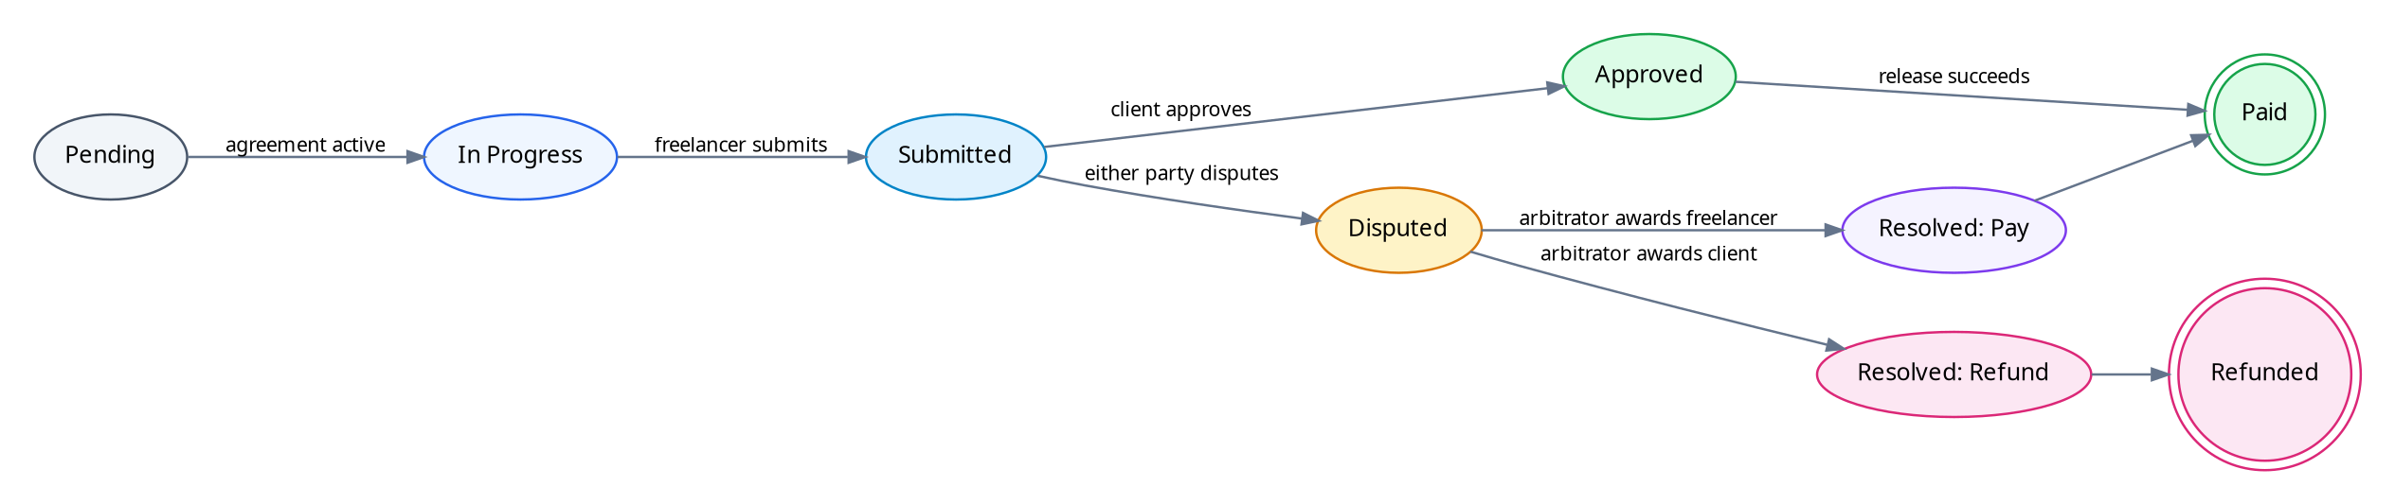
Figure 4. Proposed MVP milestone lifecycle and dispute settlement branches.
Key invariant Once a milestone reaches Paid or Refunded, no callable path may make it economically payable/refundable again. This invariant must be tested both with normal unit cases and adversarial/repeated-call scenarios.

11. Data and Integration Requirements

11.1 Initial Relational Data Model (Off-Chain)
Table / Aggregate | Representative Fields | Notes
users | wallet_address (PK), display_name, bio, skills, created_at, updated_at | Wallet address is normalized/checksummed at boundaries; profile fields validated.
auth_nonces | nonce_hash, wallet_hint?, expires_at, used_at | Prefer storing a hash where practical; single-use.
projects | id, client_address, title, description, status, budget_display, deadline | Marketplace representation; agreement reference added after acceptance.
proposals | id, project_id, freelancer_address, amount, message, status | Unique active-proposal rule enforced.
agreements_projection | chain_id, contract_address/id, client, freelancer, state, deposited | Derived from chain/acceptance; not allowed to override contract truth.
milestones_projection | agreement, milestone_id, amount, state, evidence_ref | Derived on-chain state for fast views.
disputes_projection | agreement, milestone_id, opened_by, state, outcome | Derived events plus off-chain evidence metadata.
reviews | project_id, reviewer, reviewee, rating, comment, eligibility_anchor | Unique reviewer/project/counterparty constraint.
chain_events | chain_id, tx_hash, log_index, block_number, block_hash, event_name, payload | Unique key supports idempotency/replay.
indexer_cursors | chain_id, contract_scope, block_number, block_hash | Supports restart/reorg detection.

11.2 External Interfaces
Interface | Direction | Requirement
EIP-1193 wallet provider | Web <-> wallet | Account access, chain changes, signatures and transaction submission must use supported provider methods/events.
Ethereum JSON-RPC | Web/API/Indexer <-> RPC | Reads, receipts, logs, chain ID and transaction interactions; errors/timeouts handled explicitly.
REST API | Web <-> Express | JSON over HTTPS in deployed environments; versioned endpoint prefix recommended (/api/v1).
PostgreSQL | API/Indexer <-> DB | Transactions/constraints used for uniqueness and indexer idempotency.
Future object/IPFS storage | Web/API <-> storage | Evidence files are not MVP chain storage; hashes/references must be integrity-checkable if introduced.

11.3 Initial API Surface (Design Baseline)
POST /api/v1/auth/nonce
POST /api/v1/auth/verify
POST /api/v1/auth/logout
GET /api/v1/profiles/:address
PUT /api/v1/profile
POST /api/v1/projects
GET /api/v1/projects
GET /api/v1/projects/:id
POST /api/v1/projects/:id/proposals
GET /api/v1/projects/:id/proposals
POST /api/v1/projects/:id/select-proposal
GET /api/v1/agreements/:id
GET /api/v1/agreements/:id/history
POST /api/v1/reviews
GET /api/v1/health
GET /api/v1/indexer/status
State-changing escrow/milestone/dispute settlement remains a direct wallet → smart-contract transaction. The API may prepare metadata or transaction parameters but shall not act as a custodial signer for users.

12. Security and Threat Model

12.1 Protected Assets
- Escrowed test ETH and accounting integrity.
- Authorization roles and project/milestone state.
- Authentication sessions and nonces.
- Integrity of accepted project terms and evidence references.
- User profile/proposal data and operational secrets (database credentials, RPC keys where applicable).
- Deployment authority keys used only for development/testnet contract administration.

12.2 Threats and Required Controls
Threat | Example Failure | Required Control / Test
Reentrancy | Malicious recipient recursively triggers release | Update state before interaction; suitable ReentrancyGuard/payment pattern; attacker contract test.
Broken access control | Freelancer/client/random wallet calls privileged function | Address/role checks in contract; negative tests for every privileged function.
Double settlement | Retry/duplicate call pays milestone twice | Terminal-state flag/state machine + accounting invariant + repeated-call tests.
Replay authentication | Captured login signature reused | One-time nonce, expiry, domain/session verification, consumed nonce test.
Wrong-chain transaction | User signs on unintended chain | Display/verify chain ID before state-changing actions; reject unsupported chain.
Stale indexer state | UI shows outdated milestone and enables action | Contract revalidates state; critical UI may reconcile direct chain read; indexer lag shown.
Reorg inconsistency | Indexed confirmed-looking event disappears | Block/hash cursor, confirmation threshold, replay/reconciliation procedure.
Malicious/oversized input | Profile/proposal or evidence reference abuses API | Schema validation, bounds, sanitization/encoding, rate controls as appropriate.
Secret leakage | RPC/DB/deployer secret logged or committed | Environment variables, .gitignore, secret scanning, redacted logs, least privilege.
Frontend compromise | UI crafts unauthorized transaction | On-chain authorization and state checks remain authoritative.

12.3 Smart-Contract Security Invariants
- INV-01 — totalDeposited = totalLocked + totalReleased + totalRefunded (for the modeled no-fee MVP).
- INV-02 — a milestone cannot be both Paid and Refunded.
- INV-03 — terminal milestone settlement can happen at most once.
- INV-04 — only the designated client can normally approve a submitted milestone.
- INV-05 — only the designated freelancer can submit its milestone.
- INV-06 — only an authorized arbitrator can execute a dispute outcome and only for an active dispute.
- INV-07 — no valid function may transfer more value than is allocated/locked for the target milestone/agreement.
- INV-08 — a completed project has no unsettled milestone.

13. Validation and Error-Handling Requirements
Boundary | Examples of Required Validation
Frontend | Required fields, amount formatting, wallet/network presence, confirmation summaries; improves UX but is never the security boundary.
API | Schema/types, lengths, enum values, wallet ownership/session, authorization, uniqueness/conflict checks, pagination limits.
Smart contract | msg.sender authorization, msg.value, addresses, IDs, state transition, amount accounting, deadline policy, one-time settlement.
Indexer | Chain ID, configured contract, event signature/schema, block/log uniqueness, confirmation and cursor consistency.

13.1 Standard Error Categories
VALIDATION_ERROR — Input is syntactically/semantically invalid.
UNAUTHENTICATED — No valid wallet-bound application session.
FORBIDDEN — Authenticated wallet lacks permission.
CONFLICT — Current resource/chain state conflicts with requested action.
WRONG_NETWORK — Wallet/application chain mismatch.
TRANSACTION_REJECTED — User rejected wallet request.
CONTRACT_REVERTED — On-chain precondition/authorization/logic rejected transaction.
RPC_UNAVAILABLE — Provider/network request failed or timed out.
INDEXER_LAG — Indexed projection is known to be behind configured tolerance.
INTERNAL_ERROR — Unexpected server failure; logs use correlation ID, not secrets.

14. Testing and Quality Strategy

14.1 Test Layers
Layer | Scope | Examples
Solidity unit tests | Individual contract functions, roles, events, state transitions | Funding, submit, approve, dispute, resolve, duplicate-call rejection.
Invariant/property tests | Economic/state properties across action sequences | Deposit = locked + released + refunded; no double settlement.
Adversarial contract tests | Attacker contracts and unexpected call behavior | Reentrancy receiver, reverting receiver, unauthorized direct caller.
API unit tests | Service logic and validation | Nonce lifecycle, auth middleware, project/proposal rules, error mapping.
Database/integration tests | Constraints, transactions and indexer idempotency | Duplicate event handling, unique proposal/review rules, replay/reconciliation.
Web component tests | Rendering and business state UI | Wrong network, pending tx, error states, form validation.
End-to-end tests | Browser-to-API and local-chain critical flows | Create project → accept proposal → fund → submit → approve → history.
Testnet smoke tests | Deployed configuration and wallet workflow | Sepolia transaction flow using test assets.

14.2 CI Quality Gates
- Install using locked dependencies.
- Static formatting/lint checks.
- TypeScript type-check.
- Solidity compile.
- Contract unit + invariant/security tests.
- API unit/integration tests.
- Frontend unit/component tests.
- Production build for web and API.
- Optional coverage report with minimum thresholds introduced after baseline stabilizes.
- No deployment step from untrusted pull requests with protected secrets.

14.3 Acceptance-Test Examples
Scenario | Given / When / Then
One-time payment | Given a funded 0.30 ETH milestone in Submitted state; when the client approves it; then exactly 0.30 ETH is settled to the freelancer and a repeated approval/payment call reverts.
Unauthorized approval | Given a submitted milestone; when a wallet other than the client calls approval; then the transaction reverts and no state/balance changes.
Dispute lock | Given a submitted milestone; when either counterparty opens a dispute; then normal approval is rejected until a valid resolution.
Authentication replay | Given a successful signed nonce login; when the same signed message/nonce is submitted again; then authentication fails.
Indexer idempotency | Given an event already projected; when the same txHash/logIndex is processed again; then no duplicate business record is created.

15. Technology Stack and Engineering Rationale

15.1 Primary Portfolio Stack
Layer | Planned Technology | Rationale
Smart contracts | Solidity 0.8.x + OpenZeppelin Contracts 5.x | Industry-standard EVM language plus maintained reusable access/security utilities.
Contract toolchain | Hardhat 3 + TypeScript + viem integration | Maintained compile/test/deploy workflow; supports Solidity and TypeScript tests.
Wallet | MetaMask via EIP-1193-compatible provider; EIP-6963 discovery | Standards-aligned wallet integration and multi-provider-aware discovery.
Frontend | React + TypeScript + Vite | Component-driven UI, strong typing and fast development/build workflow.
Backend | Node.js + TypeScript + Express | Fits required JavaScript ecosystem while allowing typed service/indexing code.
Authentication | SIWE-compatible flow (ERC-4361) | Standardized wallet-based off-chain authentication with nonce replay protection.
Database | PostgreSQL + migration/ORM layer (Prisma candidate) | Relational integrity, uniqueness and transactional indexer/application writes.
Blockchain client | viem (primary candidate) | Typed EVM client suitable for modern TypeScript applications; final choice frozen in detailed design.
Testing | Hardhat test stack + Node test runner/Vitest candidate + Playwright | Layered contract/API/web/E2E testing.
CI/CD | GitHub Actions | Automated quality gates and reproducible portfolio evidence.
Containers | Docker / Compose where useful | Repeatable API/database local environment.
Network | Local Hardhat + Ethereum Sepolia | Fast deterministic development then public testnet demonstration.

15.2 Legacy Learning / Course Compatibility Track
The original learning requirements include Truffle, Ganache and Web3.js. Because those tools are legacy/sunset in the current ecosystem, they should be preserved as a separate learning exercise/branch or migration note rather than becoming the long-term architecture of the portfolio implementation. The primary codebase should remain modern and maintainable.
Legacy Tool | Learning Purpose | Portfolio Treatment
Truffle | Understand classic migrations, artifacts and contract workflow. | Optional legacy branch or tagged tutorial milestone; document migration to Hardhat.
Ganache | Understand deterministic local EVM accounts/network. | Use for legacy exercise; primary local network is Hardhat.
Web3.js | Understand classic JavaScript contract/provider APIs. | Use in legacy exercise; primary client uses modern typed alternative.

16. Deployment and Environment Strategy
Environment | Purpose | Key Characteristics
Local developer | Feature development and deterministic tests | Hardhat local network; local PostgreSQL/Compose; seeded accounts; no real funds.
CI ephemeral | Automated verification | Fresh dependency install, compile/test/build; isolated DB/service containers; no production deployment secrets.
Sepolia test | Public portfolio demonstration | Verified chain/network configuration, test ETH only, published addresses, reproducible deployment module.
Future production | Explicitly outside MVP | Requires independent security review/audit, operational key design, monitoring, legal/regulatory analysis and production hosting decisions.

16.1 Configuration Principles
- No hard-coded private keys, RPC secrets or database passwords in source control.
- Commit a safe .env.example with descriptions and validation; ignore real .env files.
- Contract addresses and chain IDs shall be environment-specific and validated at startup/build time.
- Deployment scripts/modules shall be idempotent or clearly produce/version deployment artifacts.
- Frontend shall visibly identify the configured network and contract address/version in an About/technical details area.

17. Phase-Wise Implementation Plan
Phase | Focus | Exit Deliverable | Status
01 | Requirements & Architecture | This document, scope baseline, actors, use cases, domain model, security/testing requirements | Current
02 | Repository Bootstrap | Create GitHub repo; monorepo/workspaces; web/api/blockchain skeletons; formatting/lint/typecheck; env validation; CI hello pipeline | Next
03 | Contract Specification & Tests First | Freeze contract storage/state/events/errors; write core failing tests/invariants; decide single-contract vs factory/per-project architecture | Planned
04 | Escrow Core Implementation | Agreement creation/funding; milestone state; approval/payment; events; access control; adversarial tests | Planned
05 | Disputes & Reputation | Dispute role/outcomes; review eligibility; terminal accounting tests | Planned
06 | API & Database | SIWE auth; profiles/projects/proposals; migrations; validation; structured errors; tests | Planned
07 | Event Indexer | Event schema; cursor/idempotency; reorg/replay design; projections; status endpoints; tests | Planned
08 | Frontend & Wallet UX | Wallet discovery/connect; auth; project flows; transaction states; accessibility/component tests | Planned
09 | Integration & E2E | Local full-stack workflow; Playwright; chain/API reconciliation; failure scenarios | Planned
10 | Security Hardening | Threat-model review, attacker tests, invariant expansion, dependency/secret checks, manual checklist | Planned
11 | Sepolia Deployment | Deploy/verify contracts; configured API/web; smoke test; publish deployment information | Planned
12 | DevOps & Packaging | Docker/Compose, CI refinement, coverage/artifacts, release tags | Planned
13 | Documentation & Portfolio | README, architecture/security docs, screenshots/demo, CV bullets, interview talking points | Planned
14 | Legacy Stack Learning Track | Recreate selected core flow with Truffle/Ganache/Web3.js and document migration differences | Optional after core

18. GitHub Repository and Development Workflow

18.1 Repository Creation
- Create a new GitHub repository named `chainlance` (public is preferable for a portfolio unless coursework rules require private access).
- Initialize it with no generated application code if you plan to create the local workspace first; include a short description such as “Ethereum milestone escrow freelance marketplace — Solidity, Hardhat, React, Node/Express”.
- Clone the repository locally and create Phase 02 scaffolding from a dedicated feature branch.
- Use a protected `main` branch once the initial CI pipeline is stable; merge feature branches only after local checks pass.
- Add LICENSE only after choosing the intended open-source license; do not copy a license blindly if university/IP constraints exist.

18.2 Recommended Repository Layout
chainlance/
├── apps/
│ ├── web/ # React + TypeScript frontend
│ └── api/ # Node.js + Express API/indexer entrypoints
├── blockchain/
│ ├── contracts/ # Solidity contracts
│ ├── test/ # Unit, invariant, adversarial tests
│ ├── ignition/ # Hardhat deployment modules
│ └── hardhat.config.ts
├── packages/
│ ├── contract-artifacts/ # Generated/exported ABI/address contract package
│ └── shared/ # Shared types/validation where safe
├── docs/
│ ├── requirements/
│ ├── architecture/
│ ├── security/
│ └── testing/
├── .github/workflows/
├── .env.example
├── .gitignore
├── README.md
└── package.json

18.3 Branch and Commit Convention
Purpose | Example
Feature branch | feature/escrow-funding
Bug fix branch | fix/indexer-duplicate-event
Documentation | docs/phase-01-srs
Conventional commit | feat: add escrow funding state validation
Test commit | test: add duplicate milestone payment cases
Security fix | fix: prevent unauthorized dispute resolution
Documentation commit | docs: add ChainLance SRS and architecture diagrams

18.4 What to Commit After Phase 01
- `docs/requirements/ChainLance_Project_Proposal_and_SRS_Phase_01.docx` (and later an optional repository-friendly Markdown summary).
- `docs/architecture/` exported diagrams if you want figures reviewable directly on GitHub.
- A short root README containing project purpose, status (“Phase 01 completed”), planned stack, and roadmap link.
- No generated node_modules, real .env files, wallet keys, seed phrases, deployment private keys, or editor-specific secret settings.
Suggested first documentation commit docs: add Phase 01 project proposal and SRS

19. Definition of Done and Success Measures

19.1 Feature Definition of Done
- Requirement/acceptance criterion is identified.
- Implementation follows agreed architecture or records an approved change.
- Positive and negative tests are added at the correct layer.
- Authorization and validation paths are covered for state-changing operations.
- Errors are handled and user-facing behavior is understandable.
- Lint/typecheck/compile/tests pass locally and in CI.
- No secrets are committed and new environment variables are added to `.env.example`.
- Relevant documentation/README/API notes are updated.
- For contract changes: events/errors/storage/state-transition impacts are reviewed and security invariants still pass.

19.2 MVP Release Definition of Done
- All Must functional requirements have verification evidence.
- No unresolved known critical/high security defect in the project review checklist.
- End-to-end happy path and selected failure paths pass on local environment.
- Sepolia smoke test completes with test ETH only.
- Contract addresses/network are documented and reproducible deployment instructions exist.
- CI passes from a clean checkout.
- README explains architecture, on-chain/off-chain split, security assumptions, limitations and demo steps.
- Portfolio screenshots/demo avoid exposing private keys, seed phrases, real credentials or sensitive browser data.

20. Requirement Traceability Baseline
The following sample traceability table establishes the format that will be expanded during implementation. GitHub issues and test names should include requirement IDs where practical.
Requirement | Use Case | Planned Component | Verification
FR-AUTH-04/05/06 | UC-01 | API auth service + web wallet auth | API unit/integration tests for nonce expiry/reuse/signature; E2E login.
FR-ESC-02/03/04 | UC-07 | Escrow smart contract | Solidity authorization/value/state tests.
FR-MILE-04/05/06 | UC-09 | Escrow/milestone smart contract | Unit + repeated-call + invariant + adversarial tests.
FR-DSP-01..06 | UC-10/11 | Dispute module/contract | Role/state/outcome tests + E2E dispute flow.
FR-REP-01..04 | UC-13 | Reputation service/contract design | Eligibility/self/duplicate/bounds tests.
FR-IDX-02/03/05 | UC-15 | Indexer + DB | Duplicate-log, restart, replay/rebuild integration tests.
NFR-REL-01 | Multiple | Smart contracts / architecture | Demonstrate direct contract state safety while API unavailable.

21. Future Roadmap / Explicitly Out of Scope

21.1 Explicitly Out of MVP Scope
- Ethereum mainnet or real-money commercial escrow service.
- Custom blockchain, custom cryptocurrency, or speculative token economy.
- Cross-chain bridge/multi-chain settlement.
- Upgradeable/proxy contracts unless a later design explicitly justifies the operational risk.
- DAO/community arbitration.
- ERC-20 stablecoin settlement.
- Production-grade KYC/AML, fiat payment rails, tax handling, or legal escrow licensing.
- AI freelancer matching or automated dispute judgment.
- Permanent storage of large work deliverables directly on-chain.

21.2 Candidate Enhancements After MVP
- ERC-20 payment support with safe token-transfer handling.
- IPFS/object-storage evidence anchoring and content hashing.
- EIP-712 structured agreement signatures where they add value beyond transaction consent.
- Decentralized/committee arbitration with staking/reputation design.
- Layer-2 deployment and gas/UX comparison.
- Contract analytics dashboard and richer indexer projections.
- Smart-account/ERC-1271 authentication support.
- Formal/static analysis tools and external security review.

22. References
The implementation should re-check current documentation when each phase starts because Web3 tooling changes rapidly. These references support the Phase 01 technology/security baseline.
[1] Hardhat. Getting started with Hardhat 3. Official source (accessed 12 Aug 2026).
[2] Hardhat. Testing overview — Solidity and TypeScript tests. Official source (accessed 12 Aug 2026).
[3] OpenZeppelin. OpenZeppelin Contracts 5.x. Official source (accessed 12 Aug 2026).
[4] OpenZeppelin. Access Control. Official source (accessed 12 Aug 2026).
[5] MetaMask. Ethereum Provider API — MetaMask Connect EVM. Official source (accessed 12 Aug 2026).
[6] Ethereum Improvement Proposals. EIP-1193: Ethereum Provider JavaScript API. Official source (accessed 12 Aug 2026).
[7] Ethereum Improvement Proposals. EIP-6963: Multi Injected Provider Discovery. Official source (accessed 12 Aug 2026).
[8] Ethereum Improvement Proposals. ERC-4361: Sign-In with Ethereum. Official source (accessed 12 Aug 2026).
[9] ethereum.org. Ethereum Networks — Sepolia guidance. Official source (accessed 12 Aug 2026).
[10] OWASP Smart Contract Security. SCWE-046: Reentrancy Attacks. Official source (accessed 12 Aug 2026).

Appendix A — Detailed User Stories & Acceptance Criteria

US-01
As a user, I want to connect my wallet and authenticate by signing a one-time message so that I can use application features without a password.
Acceptance criteria
- Given no wallet permission, the app requests consent rather than silently reading accounts.
- A successful valid signature creates a session bound to the signing wallet.
- An expired or already-used nonce cannot create a session.
- Changing to a different account invalidates or requires refreshing wallet-bound authorization as designed.

US-02
As a client, I want to create a project with milestones so that freelancers can understand the work and payment breakdown.
Acceptance criteria
- At least one milestone is required.
- Amounts must be positive and valid; deadlines follow the selected policy.
- The client wallet is recorded as project owner.
- Invalid data is rejected server-side even if submitted directly to the API.

US-03
As a freelancer, I want to submit a proposal so that the client can consider my offer.
Acceptance criteria
- Only authenticated wallets can submit.
- A freelancer cannot create duplicate active proposals contrary to policy.
- A user cannot edit another wallet’s proposal.
- Closed/accepted projects reject new proposals.

US-04
As a client, I want to lock the agreed funds before work starts so that the freelancer can verify funding.
Acceptance criteria
- Only the designated client can fund.
- Exact expected test ETH is accepted.
- Successful funding emits a stable event.
- Duplicate funding does not create a second deposit obligation.

US-05
As a freelancer, I want to submit a milestone so the client can review it.
Acceptance criteria
- Only the designated freelancer can submit.
- Only an eligible non-terminal milestone can be submitted.
- Evidence reference/hash is bounded and recorded according to design.
- Submission event is emitted and projected.

US-06
As a client, I want to approve accepted work so the freelancer receives the milestone payment.
Acceptance criteria
- Only the client can approve.
- Only a submitted, non-disputed, funded milestone is eligible.
- Payment amount equals milestone allocation.
- Second payment attempt fails and invariant remains true.

US-07
As either project party, I want to dispute an unsettled milestone so that the normal payment path is paused while a decision is made.
Acceptance criteria
- Only the client/freelancer can open an eligible dispute.
- Normal approval/payment cannot continue while disputed.
- Only authorized arbitrator can resolve.
- Resolution can only choose allowed outcome(s) and is terminal.

US-08
As a project counterparty, I want to rate the other party after completion so that reputation reflects real work relationships.
Acceptance criteria
- Review requires eligible completed/settled project.
- Reviewer and reviewee must differ.
- At most one review per reviewer/project/counterparty.
- Rating is 1–5.

Appendix B — Phase 02 Entry Checklist
- ☐ Phase 01 SRS saved in GitHub docs/requirements and version tagged/committed.
- ☐ MVP scope and out-of-scope list accepted.
- ☐ Choice still pending: single shared escrow contract vs factory/per-project contracts — analyze before implementing storage layout.
- ☐ Choice still pending: direct push payment vs pull/withdraw payment pattern — decide with failure/reentrancy analysis.
- ☐ Choice still pending: exact reputation on-chain/off-chain split — freeze before coding review storage/events.
- ☐ Repository created and cloned.
- ☐ Node/package-manager versions selected and recorded.
- ☐ Monorepo/workspace structure created.
- ☐ Hardhat 3 blockchain package initialized.
- ☐ React/TypeScript web package initialized.
- ☐ Node/Express/TypeScript API package initialized.
- ☐ PostgreSQL local environment planned.
- ☐ .env.example and environment validation added before any secret-dependent feature.
- ☐ Formatting, lint, typecheck and CI baseline working.
- ☐ Root README states project status and links to this SRS.
Phase 02 recommendation The first code commit should be infrastructure-only: repository/workspace skeleton, formatting/typechecking, a minimal Hardhat compile/test, minimal Express health route, minimal React page, and CI. Do not implement escrow business logic until the smart-contract architecture decision record and test specification are completed in Phase 03.

— End of ChainLance Phase 01 Requirements Baseline —

