Production Analytics Architecture
Collections Analytics — Part 5 Deliverable

1. Purpose and scope
This document specifies how the Phase 1 golden-dataset pipeline (currently a notebook plus a set of SQL scripts run by hand) becomes a production system that the leadership team can trust every day, without an analyst re-running notebooks or re-validating numbers.
The design covers the seven layers from raw ingestion to the executive dashboard, the contracts that keep each layer trustworthy, and the operational concerns (lineage, incremental processing, late data, backfills, quality checks, monitoring, anomaly detection) that Part 5 of the brief asks for explicitly.
Everything here is a direct productionisation of the logic already implemented in 00_load_csvs_FINAL.sql, sqlserver_pipeline.sql, 05_business_analytics_17.sql, and the Phase 1 notebook. No new business logic is introduced — this document says how the existing logic runs on a schedule, gets checked, and gets monitored, not what the logic is.

2. Pipeline architecture
Raw sources flow through six transformation layers to a single executive dashboard. Orchestration keeps the pipeline running as one DAG; data quality and monitoring run alongside every stage.
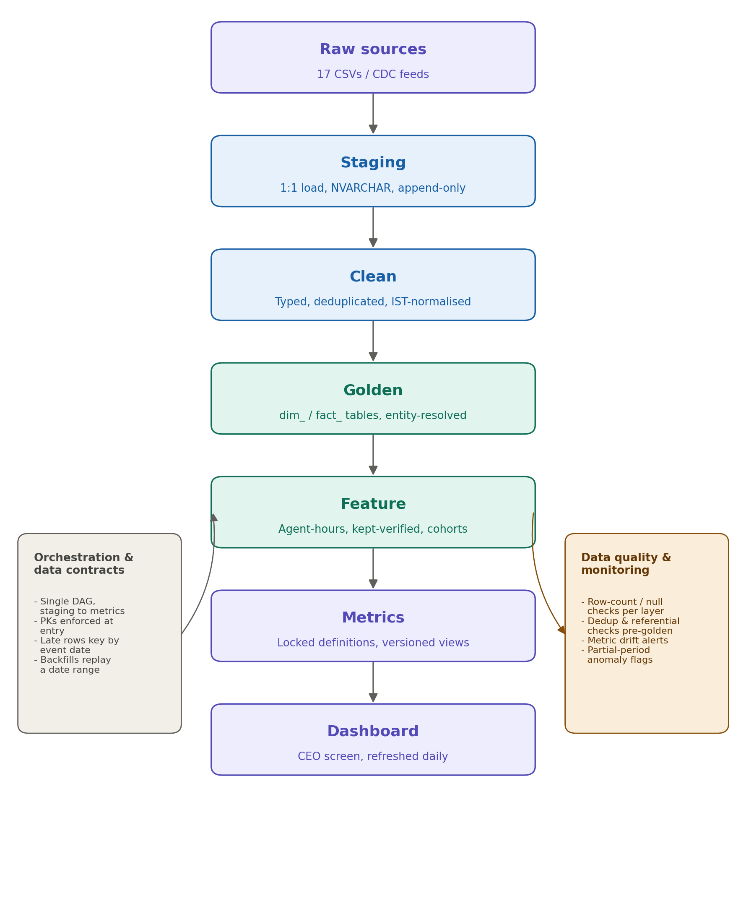

Layer summary
Layer | What it is | Maps to
Raw | Source files/feeds, untouched | 17 CSVs (accounts.csv, payments.csv, ...)
Staging | 1:1 load, all columns as text, append-only | stg_* tables
Clean | Typed, deduplicated, timezone-normalised | 00b_typed_staging.sql step
Golden | Entity-resolved dimensions + corrected facts | dim_*, fact_* tables
Feature | Derived signals reused by multiple metrics | session_hours, kept_verified, cohort tags
Metrics | Locked, versioned business definitions | metric_* views, 05_business_analytics_17.sql
Dashboard | Single CEO-facing screen | Executive Dashboard deliverable

Each arrow in the diagram is a contract boundary: a layer may only read from the layer directly above it, and every field crossing a boundary has a declared name, type, and null policy. This is what lets the data-quality layer check whether clean received what staging promised, instead of eyeballing row counts.

3. Layer-by-layer detail

3.1 Raw
- Immutable. Files are never edited or re-uploaded in place; a corrected file is a new dated object (accounts_2026-08-09.csv), never an overwrite.
- Retained indefinitely (or per compliance policy) since it is the only source of truth for reprocessing.

3.2 Staging (stg_*)
- One staging table per source file, same columns, all NVARCHAR — deliberately untyped so a malformed value never blocks the load (matches the current 00_load_csvs_FINAL.sql approach).
- Append-only with a _load_batch_id and _loaded_at column added on ingest (not present in the current manual script — required for production so re-running never silently loses the previous batch).
- Primary key at this layer is (source natural key, _load_batch_id) — duplicates across batches are expected and preserved; they are resolved downstream, not here.

3.3 Clean
- Applies the transforms already written once and reused per the notebook's reusable cleaning functions: exact-dedup, type casts, timezone-to-IST normalisation (to_ist() / the DATEADD CASE logic in sqlserver_pipeline.sql).
- Output is one clean table per source, same grain as staging, now typed, with obviously-broken rows (unparseable timestamps, impossible values) routed to a _rejected side table rather than dropped silently.
- This is where the cleaning-ledger numbers already produced by hand (cleaning_ledger.csv) get generated automatically — each clean job emits (raw, rejected, corrected, output) counts as its own log line.

3.4 Golden (dim_*, fact_*)
- Entity resolution and business-rule correction happen here: agent 30k-to-1k identity collapse, borrower dedup to 11k, payment retry/duplicate correction, PTP kept-verification, targeting dedup — exactly the logic already in sqlserver_pipeline.sql.
- Grain and primary key are declared per table (e.g. fact_payment grain = one row per economically distinct payment event; PK = payment_id after dedup, uniqueness enforced by a check, not by convention).
- This is the layer every downstream consumer — feature, metrics, ad hoc analyst SQL — is required to read from. Nobody queries stg_* for business questions.

3.5 Feature
- Reusable derived columns/tables that more than one metric needs, computed once so metrics stay simple views: session_hours, kept_verified, is_recovery, borrower_link, cohort/vintage tags, targeted-vs-never-targeted flags.
- Rule of thumb for what belongs here vs. in a metric view: if two metric_* queries would otherwise repeat the same CASE/join logic, it moves to feature.

3.6 Metrics
- Pure views over golden + feature, one view per business definition, matching 05_business_analytics_17.sql and the metric_* / analysis_* views already in sqlserver_pipeline.sql (naive-vs-true recovery, monthly MoM, PTP rate, PTP-kept rate, selection bias, etc.).
- Definitions are versioned, not just named. If a definition changes (e.g. PTP-kept verification window moves from 7 to 10 days), it ships as metric_ptp_kept_v2, old dashboards keep pointing at v1 until explicitly migrated, and the memo/dashboard states which version is live. This prevents the exact failure this assignment was built to catch — a silent redefinition making a number improve.

3.7 Dashboard
- Reads only from the metrics layer, never from golden or feature directly, so the one-screen, 60-second-read promise can't be undermined by an ad hoc join sneaking business logic into the visualisation layer.

4. Data contracts
A contract is declared per table at the layer boundary it sits behind (staging to clean, clean to golden, golden to feature/metrics). Each contract states schema, grain, primary key, freshness SLA, and owner.

Example — fact_payment contract
Field | Value
Grain | One row per economically distinct payment
Primary key | payment_id (post-dedup, post-retry-collapse)
Required non-null | account_id, amount, payment_status, event_ist
Freshness SLA | 24h from source file arrival
Breaking change requires | New versioned table/view, not an in-place schema change

Contracts are enforced by the data-quality layer (Section 6), not by hope.

5. Lineage, incremental processing, late data, backfills

Lineage
Every row in golden and feature carries _source_batch_id tracing back to the staging batch(es) that produced it. This answers which raw file produced this number without re-deriving it — necessary the first time a leadership number is challenged, which per this assignment's own premise, it will be.

Incremental processing
Staging-to-clean-to-golden runs incrementally by _load_batch_id / event date, not full-table rebuild, except where a correction genuinely requires reprocessing history (e.g. an entity-resolution rule change). Metrics views are always computed fresh from golden — they are views, not materialised snapshots, so they never drift from the golden layer's current state.

Late-arriving data
Events are keyed and partitioned by event_ist (business event time), not by the time they were loaded. A payment that arrives three days late still lands in the correct month's fact_payment partition and the correct metric_monthly_recovery bucket — this is why event_ist derivation happens in Clean, before anything downstream keys off it. Any metric already published for a period that a late row would change is re-emitted with a _recomputed_at marker rather than silently overwritten, so a dashboard consumer can tell a number moved.

Backfills
A backfill re-runs the DAG for a specified date range, reading the same raw files, through clean, golden, feature, metrics. Because every layer is keyed by event date and staging is append-only, a backfill never has to touch raw and never loses the pre-backfill golden output (kept as a versioned snapshot until the backfill is validated against the DQ checks in Section 6).

6. Data quality checks
Checks run at every layer boundary and block promotion to the next layer on failure — fail closed, not fail open. A bad load should stall, not quietly ship a wrong number to the CEO screen.
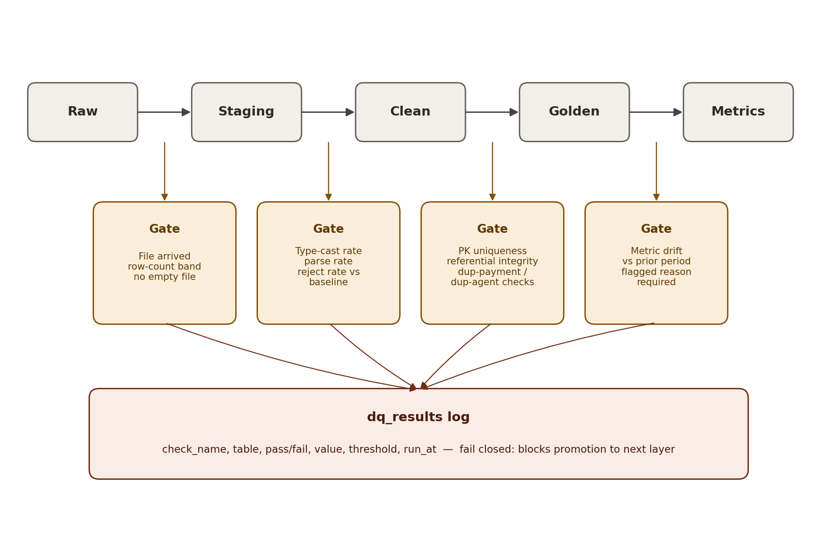
Boundary | Checks
Raw to Staging | File arrived, row count within historical band, no fully-empty file
Staging to Clean | Type-cast success rate per column, timestamp parse rate, reject rate vs historical baseline
Clean to Golden | Primary-key uniqueness post-dedup, referential integrity (e.g. every fact_payment.account_id exists in dim_account), duplicate-payment-id count, duplicate-success-reference count (the forensics checks already written into Q3 of 05_business_analytics_17.sql, now run automatically every load)
Golden to Metrics | Metric output doesn't move more than a set threshold period-over-period without a flagged reason (drift detector, Section 7)

Every check writes a row to a dq_results log (check_name, table, pass/fail, value, threshold, run_at) — this is the Data Quality Report deliverable, generated continuously instead of written once.

7. Monitoring and anomaly detection
- Freshness monitoring: alert if any table misses its declared SLA (Section 4).
- Volume monitoring: alert if a table's row count deviates from its trailing 4-week band by more than a set threshold (catches a partial file, a broken vendor feed, or — as this dataset's own August data shows — a partial month before it's misread as a collapse).
- Metric drift monitoring: alert if a metric_* view's output moves sharply between runs with no corresponding volume or freshness alert — the automated version of the manual forensics work in Theme 4 of 05_business_analytics_17.sql (duplicate payments, agent identity collapse, timezone misclassification).
- Definition-change monitoring: any edit to a metric_* view definition triggers a required version bump and a diff report comparing old vs new output on the same underlying data, so no metric definition can be silently changed to make a number look better.

8. Summary
The production system is the same six transformations already validated in Phase 1 — dedup, entity-resolve, timezone-normalise, attribute payments correctly, unify disposition codes, verify PTPs — wrapped in: append-only staging, versioned golden/metric layers, event-time partitioning for late data, boundary-enforced data-quality gates, and drift/volume/freshness monitoring. Nothing here changes what the numbers mean; it changes how confident leadership can be that the number on the dashboard tomorrow was computed the same way as the number today.

