Water Quality Prediction Using Machine Learning Classification Algorithm
Michael Wiryaseputra

Abstract— A water quality prediction was generated for predicting if the water is safe to drink or not . This experiment was also conducted to compare the machine learning model performance between Decision Tree, Random Forest, XGBoost, and Logistic Regression to determine the most suitable technique for predicting Water Quality. The result of this experiment is XGBoost Algorithm gave the best accuracy at ‘71.23 ’ %
Index Terms— Logistic regression, xgboost, decision tree, random forest, classification algorithm, machine learning, water quality research
——————————  ——————————

1 Introduction

Water quality plays an important role in any aquatic system, e.g., it can influence the growth of aquatic organisms and reflect the degree of water pollution. Water quality prediction is one of the purposes of model development and use, which aims to achieve appropriate management over a period of time. Water quality prediction is to forecast the variation trend of water quality at a certain time in the future. Accurate water quality prediction plays a crucial role in environmental monitoring, ecosystem sustainability, and human health. Moreover, predicting future changes in water quality is a prerequisite for early control of intelligence aquaculture in the future. Therefore, water quality prediction has great practical significance .
In this project, the machine learning classification algorithm I will use are: Decision tree, Random forest, XGBoost, and Logistic regression. A decision tree is a decision support tool that uses a tree-like model of decisions and their possible consequences, including chance event outcomes, resource costs, and utility. Random forests is an ensemble learning method for classification, regression and other tasks that operates by constructing a multitude of decision trees at training time. XGBoost, which stands for Extreme Gradient Boosting, is a scalable, distributed gradient-boosted decision tree (GBDT) machine learning library. It provides parallel tree boosting and is the leading machine learning library for regression, classification, and ranking problems. Logistic Regression is a statistical model that models the probability of an event taking place by having the log-odds for the event be a linear combination of one or more independent variables.

2 Research method

2.1 Data Acquisition
The dataset used in this research are collected from some water condition checking. It contained 3276 samples and the dataset has 10 parameters, they are : ph, Hardness, Solids, Chloramines, Sulfate, Conductivity, Organic Carbon, Trihalomethanes, Turbidity, Pottability. This dataset was obtained from kaggle : https://www.kaggle.com/datasets/adityakadiwal/water-potability

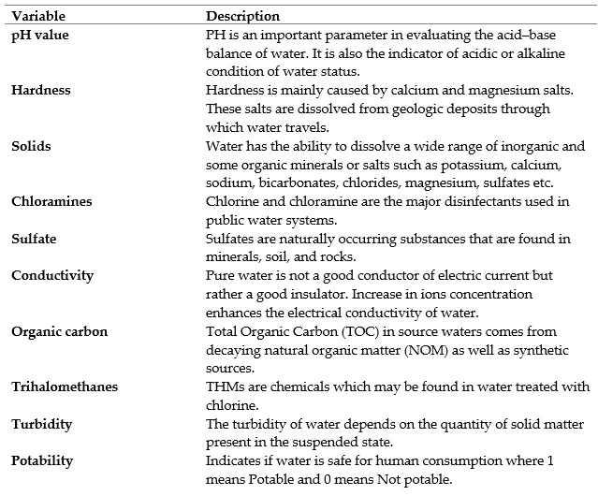

Table 1. Water Potability Dataset Description

2.2 Data Preprocessing
The processing phase is very important in data analysis to improve the data quality. In this phase, The first thing we have to do is checking null valuie then remove outlier in the dataset using Z-Score and check the outlier using boxplot.

2.3 Machine Learning Model Building
For this purpose, Decision Tree, Random Forest, XGBoost and Logistic Regression Algorithm will be used to predict the water quality

2.3.1 Decision Tree
Decision Trees (DTs) are a non-parametric supervised learning method used for classification and regression. The goal is to create a model that predicts the value of a target variable by learning simple decision rules inferred from the data features. A tree can be seen as a piecewise constant approximation.

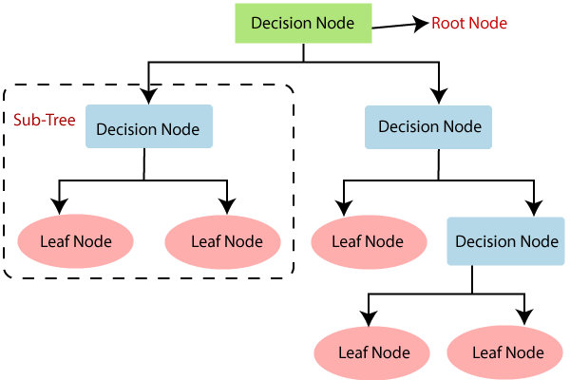

Fig 1. Decision Tree

2.3.2 Random Forest
A random forest is a meta estimator that fits a number of classifying decision trees on various sub-samples of the dataset and uses averaging to improve the predictive accuracy and control over-fitting.
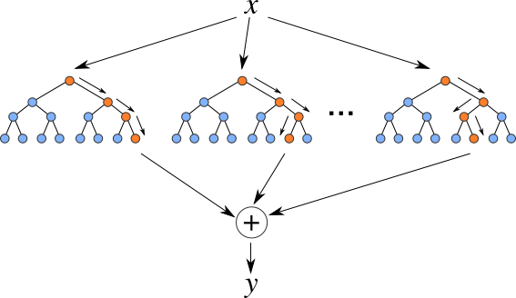

Fig 2. Random Forest

2.3.3 XGBoost
XGBoost is an optimized distributed gradient boosting library designed to be highly efficient, flexible and portable. It implements machine learning algorithms under the Gradient Boosting framework. XGBoost provides a parallel tree boosting (also known as GBDT, GBM) that solve many data science problems in a fast and accurate way. The same code runs on major distributed environment (Hadoop, SGE, MPI) and can solve problems beyond billions of examples.
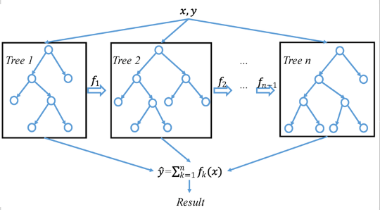

Fig 3. XGBoost

2.3.4 Logistic Regression
In statistics, the logistic model (or logit model) is a statistical model that models the probability of an event taking place by having the log-odds for the event be a linear combination of one or more independent variables. In regression analysis, logistic regression (or logit regression) is estimating the parameters of a logistic model (the coefficients in the linear combination). Formally, in binary logistic regression there is a single binary dependent variable, coded by an indicator variable, where the two values are labeled "0" and "1", while the independent variables can each be a binary variable (two classes, coded by an indicator variable) or a continuous variable (any real value).
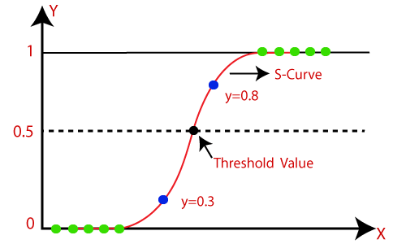

Fig 4. Logistic Regression

Performance Measurement
The performance measure to evalute the model, namely, Confusion Matrix, ROC Curve, Precision, Recall, and f-1 score have been used to evaluate the classification algorithm model. The used performance measures were defined as follows:

- Confusion Matrix :
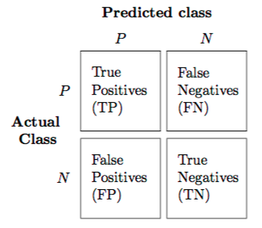

Fig 5. Confusion Matrix

- ROC Curve :
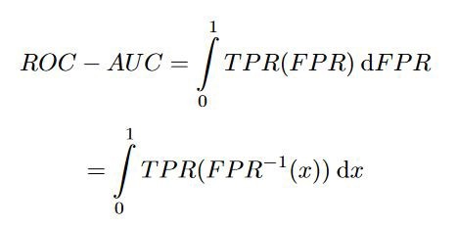

- Precision :
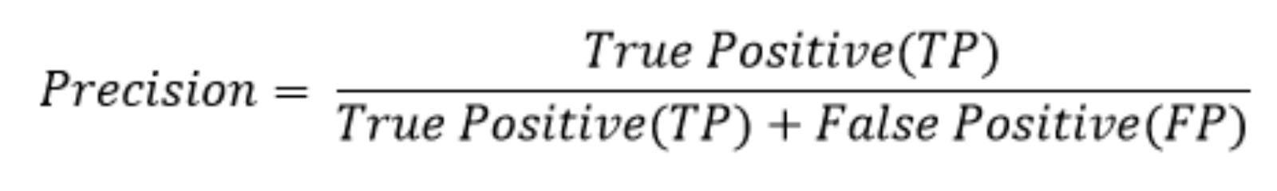

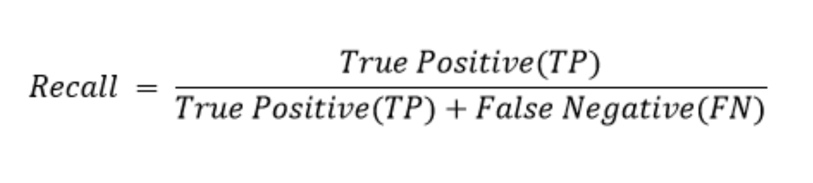
- Recall :

- F-1 score :
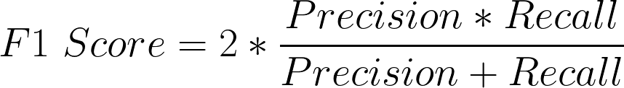

- Support :

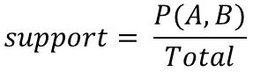

3 Results and discussion

3.1 Data Acquisition
Data acquisition is the stage where data collection is done what is needed. The data used in this study are: water quality dataset with csv format. obtained through the kaggle site.

3.2 Data Preprocessing
Data preprocessing is a technique used to transform raw data into a useful and efficient format. In this part, the steps taken are to check and fill in the null value in the php, sulfate, trihalomethanes column with a mean value.

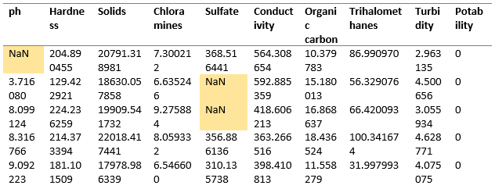
Table 2. Water Quality Dataset

After checking the missing value, the next step is check the outliers using boxplot in the dataset, then remove it using Z-Score. the application of the z score in this study, the z value is less than 2
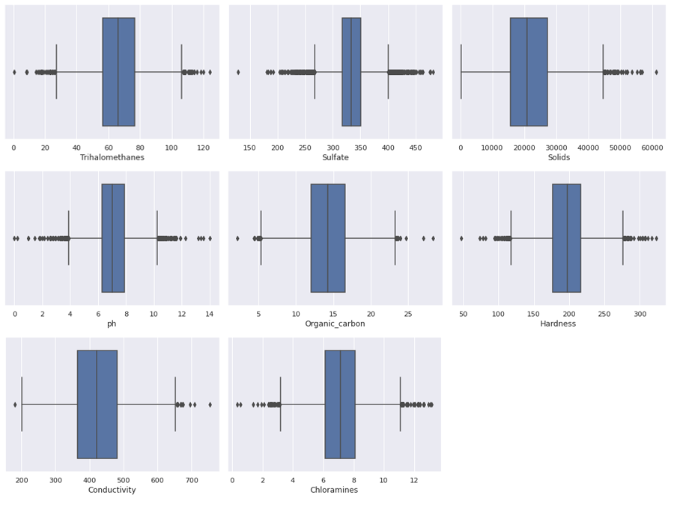

Fig 6. Outliers in each column

Viewing the clean data using correlations (relationships) between variables. The relationship between variables is useful for determining what variables are used for modeling. The following is a map of the correlation between variables:
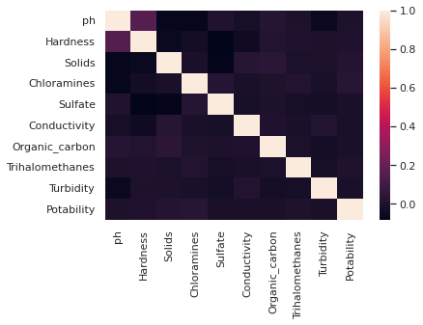

Fig 7. Map of Correlation Between Variables

3.3 Machine Learning Model Building
For this purpose, Decision Tree, Random Forest, XGBoost and Logistic Regression Algorithm will be used to predict the water quality. Here are the performance each algorithm :
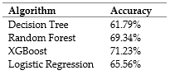

Table 3. Accuracy of each algorithm

3.3 Visualize XGBoost Performance
the model that has been designed using the XGBoost algorithm gets an accuracy of 71.23% and produces a number of predictions of 15 True Positive, 140 True Negative, 3 False Positive, 58 False Negative.

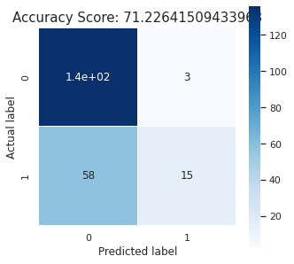

Fig 8. XGBoost Confusion Matrix

Substitute these values ​​into the equation to find out the value of precision, recall, and f1-score. Here's the calculation.

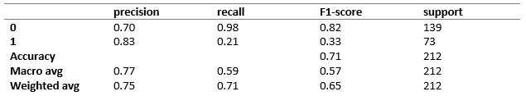

Table 4. XGBoost Classification Report

The ROC curve is a graphical representation of the relationship between sensitivity and 1-specificity. In medical research the ROC curve is widely used to describe diagnostic accuracy and determine the optimal cut-off value. The accuracy of the diagnosis is derived from the area under the ROC curve and the optimal cut-off is used to identify positive and negative conditions in the diagnosis. Here is the ROC Curve for XGBoost algorithm performance.

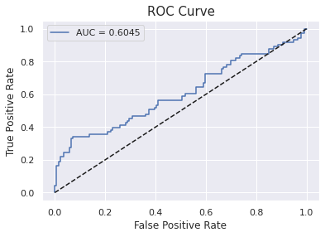
Fig 9. XGBoost ROC Curve

Feature importance indicates how much each feature contributes to the model prediction. Basically, it determines the degree of usefulness of a specific variable for a current model and prediction. Here is the feature importance for XGBoost algorithm :

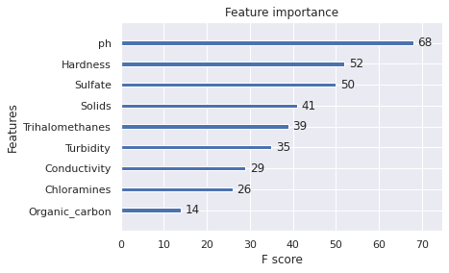
Fig 10. XGBoost Feature Importance

4 Conclusion
Prediction of water quality with the best performance is using the XGBoost algorithm with an accuracy of 71.23%. Thus, the XGBoost algorithm can predict water quality with fairly good results. This model is expected to be a reference for predicting water quality
References
- J.S. Bridle, “Probabilistic Interpretation of Feedforward Classification Network Outputs, with Relationships to Statistical Pattern Recognition,” Neurocomputing—Algorithms, Architectures and Applications, F. Fogelman-Soulie and J. Herault, eds., NATO ASI Series F68, Berlin: Springer-Verlag, pp. 227-236, 1989. (Book style with paper title and editor)
- Amir Hamzeh Haghiabi, Ali Heidar Nasrolahi, Abbas Parsaie; Water quality prediction using machine learning methods. Water Quality Research Journal 1 February 2018; 53 (1): 3–13. doi: https://doi.org/10.2166/wqrj.2018.025
- Chen, Y.; Song, L.; Liu, Y.; Yang, L.; Li, D. A Review of the Artificial Neural Network Models for Water Quality Prediction. Appl. Sci. 2020, 10, 5776. https://doi.org/10.3390/app10175776
- Theyazn H. H Aldhyani, Mohammed Al-Yaari, Hasan Alkahtani, Mashael Maashi, "Water Quality Prediction Using Artificial Intelligence Algorithms", Applied Bionics and Biomechanics, vol. 2020, Article ID 6659314, 12 pages, 2020. https://doi.org/10.1155/2020/6659314
- Cahyani, Q. R., Finandi, M. J. ., Rianti, J., Arianti, D. L., & Putra, A. D. P. (2022). Diabetes Risk Prediction using Logistic Regression Algorithm. JOMLAI: Journal of Machine Learning and Artificial Intelligence, 1(2), 107–114. https://doi.org/10.55123/jomlai.v1i2.598
- Rodelyn Avila, Beverley Horn, Elaine Moriarty, Roger Hodson, Elena Moltchanova, Evaluating statistical model performance in water quality prediction, Journal of Environmental Management, Volume 206, 2018, Pages 910-919, ISSN 0301-4797, https://doi.org/10.1016/j.jenvman.2017.11.049

