NammaMart Pipeline Execution Evidence
  - Nirmal | FDAIE Module 2 | 22 October 2026
Both corrected NammaMart DAG tests completed successfully in the local Astro Airflow environment. The selected run graphs show successful task execution through audit and verify_run. This document accompanies the assignment code repository.
Pipeline | Run result | Duration
ETL nammamart_etl_nirmal | Success | 10.828 seconds
ELT nammamart_elt_nirmal | Success | 11.168 seconds
Durations are from the selected 22 October runs. The UI displays local time at UTC plus 05:30. These are manual DAG test runs, not proof of an automated 9 AM scheduled run.

Airflow service overview
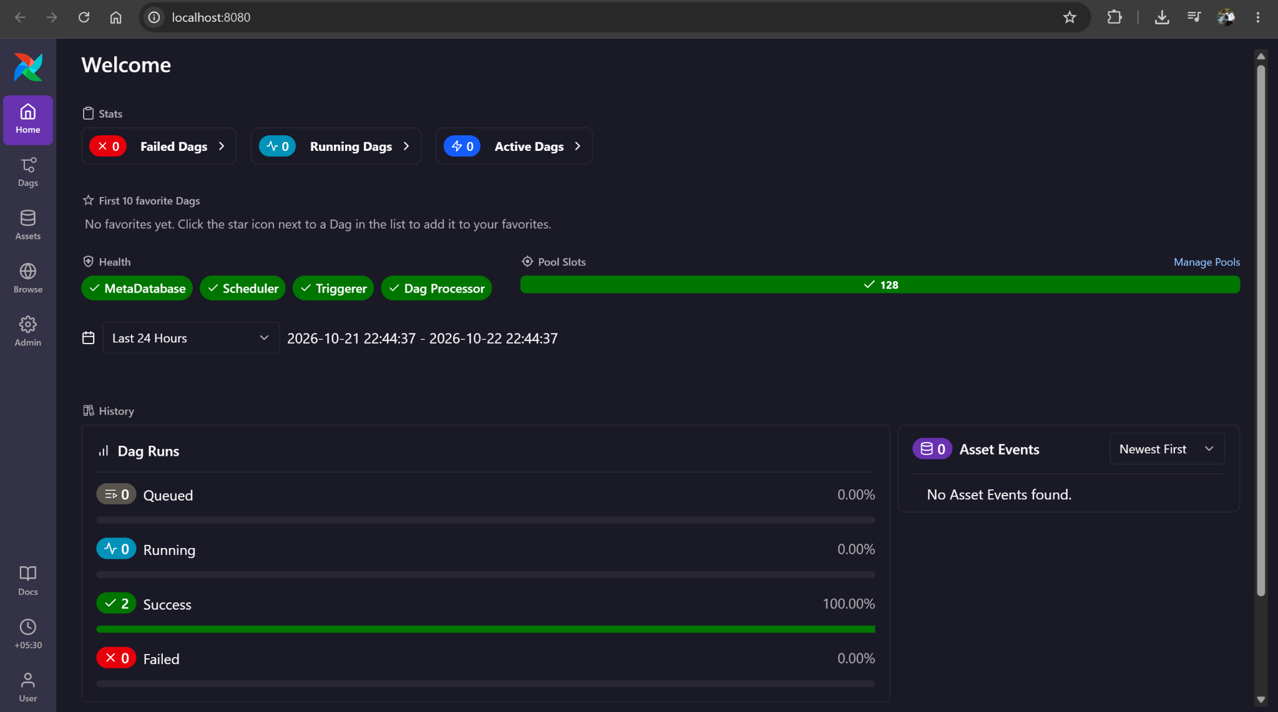
Figure 1 Airflow reports healthy services and two successful runs in the selected overview period.
Remaining submission evidence includes schedule and next-run verification, quarantine and warehouse query results, and the controlled observability experiments required by the assignment.

ETL successful run
DAG nammamart_etl_nirmal. Run identifier manual__2026-10-22T17:12:58.874621+00:00. The selected run started at 22:42:57 and ended at 22:43:08 in the displayed local timezone.
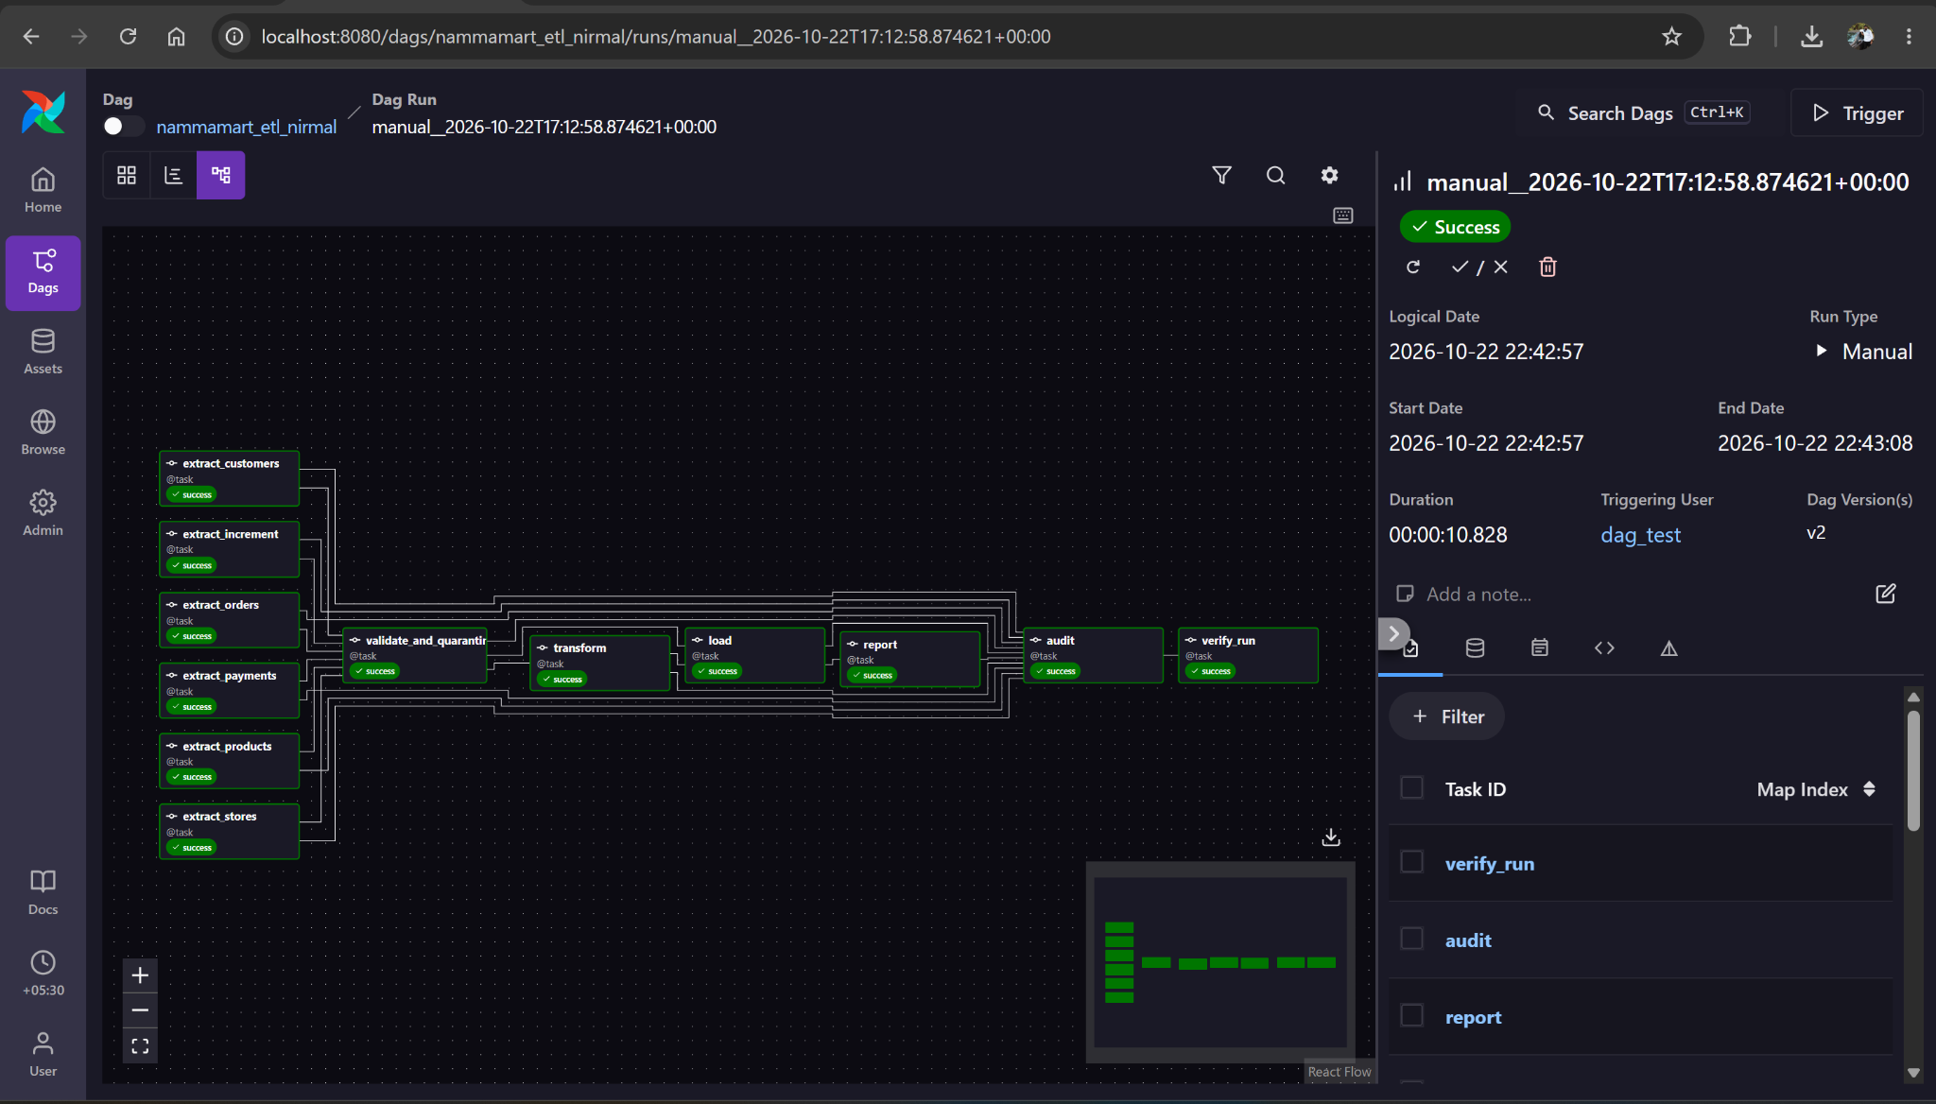
Figure 2 The current ETL graph shows all tasks successful, including audit and verify_run.
The graph covers six source extracts, validation and quarantine, transformation, warehouse loading, reporting, audit and final run verification. The shared execution log reports all 10 required upstream tasks succeeded.
This screenshot establishes successful normal execution. It does not establish failure handling, idempotency, financial reconciliation accuracy or schedule compliance on its own.

ELT successful run
DAG nammamart_elt_nirmal. Run identifier manual__2026-10-22T17:13:48.049822+00:00. The selected run started at 22:43:46 and ended at 22:43:58 in the displayed local timezone.
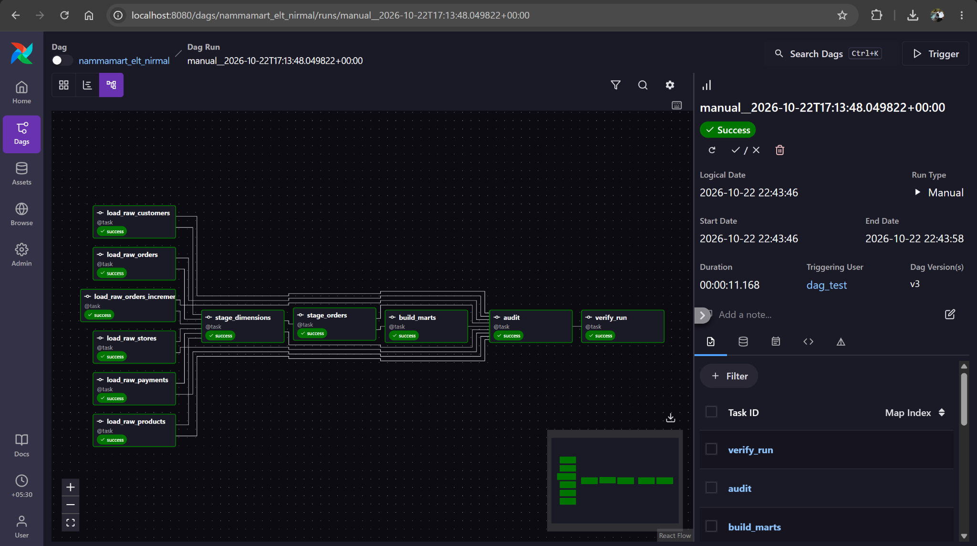
Figure 3 The current ELT graph shows all tasks successful, including audit and verify_run.
The graph covers six raw ingestion tasks, dimension staging, order staging, mart creation, audit and final run verification. The shared execution log reports all 9 required upstream tasks succeeded.
The ELT log reports 2,550 current staged orders, of which 672 failed critical checks and 1,878 were valid. Reported all-period revenue is INR 938,774.10. These counts come from the supplied run log; they are not visible in the graph screenshot.
September-only revenue must be queried with an explicit September date filter. The all-period total must not be labelled as September revenue.

Supporting DAG overviews
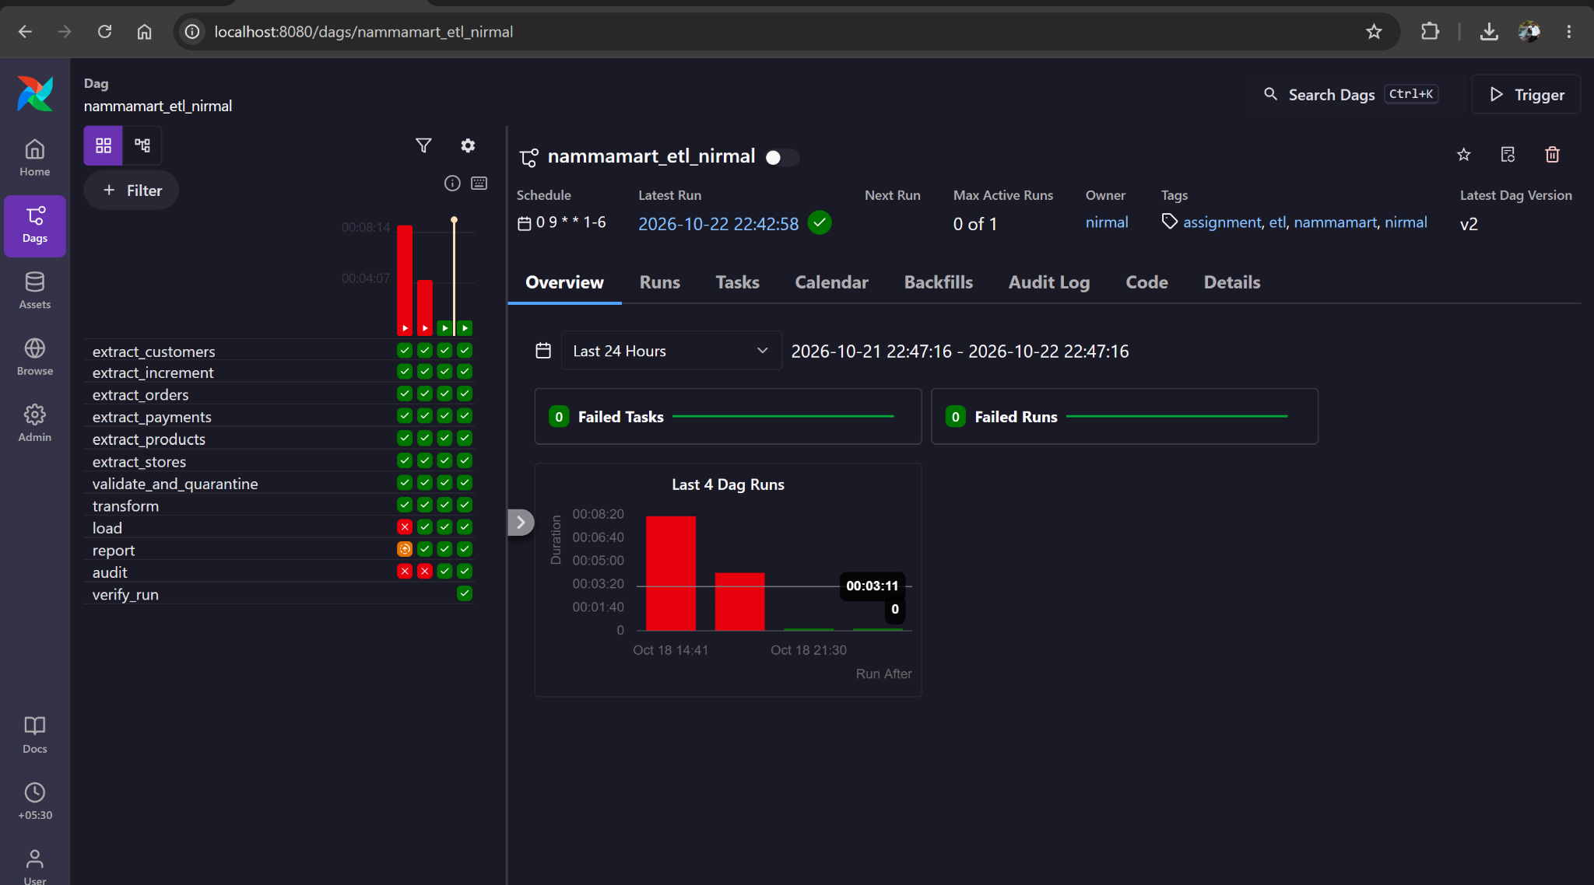
Figure 4 ETL overview identifies the successful latest run and the configured cron expression. Older failure cells belong to earlier runs.
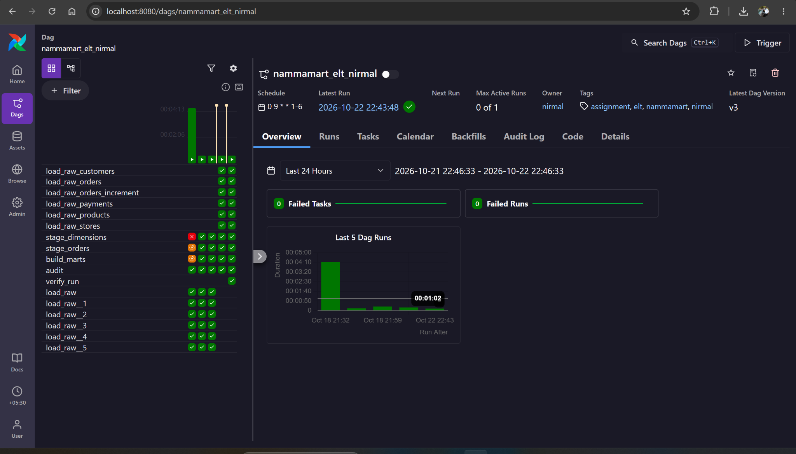
Figure 5 ELT overview identifies the successful latest run. Both overview screenshots show paused toggles and blank next-run values; scheduling evidence remains to be captured.

