**Bangla Grammar Pattern Detection Using Dynamic Programming Approach**

By:

**Aroni Saha Prapty**

Roll: 1507068

&

**MD. Rifat Anwar**

Roll: 1507066

A thesis submitted in partial fulfillment of the requirements for the degree of

“Bachelor of Science in Computer Science and Engineering”

**Supervisor:**

**Dr. K.M. Azharul Hasan**

Professor Signature

Department of Computer Science and Engineering

Khulna University of Engineering & Technology

Department of Computer Science and Engineering

Khulna University of Engineering & Technology

Khulna 9203, Bangladesh

February, 2020

**Acknowledgement**

The first thank is to the almighty creator who has permitted and blessed us to carry outthis study and without whose instruction nothing is possible. The physical and mental fitness also helped us to complete the work which is another supreme favor of God.

We would like to express my deepest sense of gratitude and heartfelt respect and thanks to our honorable teacher and supervisor Prof. Dr. K. M. Azharul Hasan, Department of Computer Science & Engineering, Khulna University of Engineering & Technology who has been a tremendous mentor to us and his continuous guidance, kind advises, sincere motivations and compassionate care has helped us greatly throughout this thesis work.

We thank all the teachers of the Department of Computer Science and Engineering who helped us providing guidelines to perform the work. We would also like to thank our friends and family for their cordial support.

**Authors**

**Abstract**

Generating and recognizing the grammar pattern for any natural language is one of the most important and emerging topics in the field of natural language processing. For connecting with civilized world through communication it plays a leading role. Comparing with other techniques, parsing has eminent role in natural language processing. For procreating and recognizing the pattern of Bangla sentence, Context Free Grammar is developed based on the rules of Bangla grammar. This proposed Bangla parser is applied on a specific domain which is Air Traffic Management System implementing dynamic programming parsing algorithm. Most commonly CYK parsing algorithm is used in accordance with adopted parsing grammar for avoiding the problem of ambiguity and left recursion. A syntactical mistake can be recognized by checking parse table if it has no entry for terminal. The correctness of the sentence is identified if it is successfully parsed and reached the start symbol based on the grammatical rules of Bangla language.

**Contents**

|  |
| --- |
| **Page** |

|  |  |
| --- | --- |
| Title Page  Acknowledgement  Abstract  Contents  List of Tables  List of Figures  **CHAPTER 1 Introduction**  1.1 Introduction  1.2 Problem Statement  1.3 Objectives  1.4 Scope  1.5 Organization of Thesis  **CHAPTER 2 Literature Review**  2.1 Introduction  2.2 What Is NLP  2.2.1 Applications of NLP  2.2.2 Steps of NLP  2.3 Background  2.3.1 Context Free Grammar  2.3.2 Chomsky Normal Form  2.3.3 CYK Algorithm  2.4 Related Works  2.5 Discussion  **CHAPTER 3 CYK Based Parsing on Specific Domain**  3.1 Introduction  3.2 Development of Context Free Grammar  3.3 Building CNF from CFG  3.3.1 Removing Start Symbol from Right Hand Side  3.3.2 Removing Null Productions  3.3.3 Removing Terminal with Non-Terminal or Terminal  3.3.4 Removing Two or More Non-Terminals from R.H.S  3.4 Dynamic Parsing: CYK Parsing Algorithm  3.4.1 Dynamic Parsing of Declarative Sentence  3.4.2 Dynamic Parsing of Imperative Sentence  3.4.3 Dynamic Parsing of WH Question  3.4.3 Dynamic Parsing of Yes-No Answer Type Question  3.5 Pseducode  **CHAPTER 4 CYK Based Parsing on Specific Domain**  4.1 Introduction  4.2 Data Collection  4.3 Result Analysis  4.4 Comparison between Dynamic Parsing and Other Parsing  **CHAPTER 5 Conclusion**  5.1 Summary  5.2 Limitations  5.2 Future Works  References | i  ii  iii  iv  vi  vii  **1**  1  2  2  3  3  **4**  4  4  5  5  6  6  7  8  11  11  **12**  12  13  17  17  18  19  19  20  21  23  24  27  29  30  30  30  38  43  **44**  44  44  44  **46** |

**List of Tables**

**Table No. Description Page**

3.1 Noun Phrase Identification 14

3.2 Verb Phrase Identification 15

3.3 POS Tag Description 15

3.4 Complete Production Rule 16

4.1 Input Data Table 30

4.2 Performance Measurement 42

**List of Figures**

**Figure No. Description Page**

2.1 Left Most Derivation 6

2.2 Right Most Derivation 6

2.3 Bottom Row Construction 10

2.4 2nd Row Construction 10

2.5 Top Row Construction 10

3.1 Parse Tree for Bangla Sentence 13

3.2 Bottom Row Construction 22

3.3 2nd Row Construction 22

3.4 2ndRow Construction 23

3.5 TopRow Construction 23

3.6 BottomRow Construction 23

3.7 TopRow Construction 23

3.8 Bottom Row Construction 25

3.9 2nd Row Construction 25

3.10 Top Row Construction 25

3.11 Bottom Row Construction 27

3.12 2nd Row Construction 27

3.13 Top Row Construction 27

4.1 Output for Declarative Sentence 41

4.2 Output for Imperative Sentence 41

4.3 Output for Yes-No Answer Type question 42

4.4 Output for WH question 42

4.5 Output for Improper Input 42

**CHAPTER 1**

**Introduction**

**1.1 Introduction**

To express the feelings and communicate with others, language is an effective system of sounds, gestures, signs and symbols. Communicating through a language one should understand the language, know about the proper structure of the language and use the correct grammatical form of that language for appropriate meaning. Bangla is one of most powerful Indo-Iranian languages that is internationally recognized and spoken by more than 250 million [9]. But in the field of Natural Language Processing it has not given the priority for using in computational linguistics. Grammar checking is important for any kind of language to express the sentiments and retrieve information. For this it should be syntactically and semantically correct.

For checking syntax correctly parsing is one of the best methods. Parsing is an activity of breaking down sentences into parts to check the grammatical correctness of a given sentence using specific algorithm for the given context free grammar. Predictive parsing is one of the most used parsing algorithms [1] [2] that has some issues on ambiguity and left factoring when the given grammar is left recursive. Shift reduce parsing has overcome those issues but still conflicts when a state requests for both shift and reduce actions or more than one distinct reduce actions [11] which can be handled by left factoring for top down parsing. For avoiding left factoring and ambiguity issue and checking correctness of Bangla sentence we apply basic idea of the dynamic parser CYK algorithm where parse tree follows the path from bottom to top according to the context free grammar and if it can reach the start symbol it is considered that the sentence is grammatically correct. This process is challenging for Bangla language because one sentence which has same semantic meaning can be represented in different patterns as there is no fixed structure and even same word can be represented as different way [3] and for this the meaning of the sentence will change. CFG for Bangla language is huge hence we develop CFGs for affixed domain. We select Air traffic management system (ATMS) as our domain to check the grammar pattern. The scheme is applicable to recognize grammar [1], text conversion [4], machine translation [7], syntax analysis [8], questions answering and so on.

**1.2 Problem Statement**

Bangla Grammar pattern detection is nothing but find the structure a sentence following the context free grammar rules. As Bangla language is huge in form so we take a specific domain that is Air Traffic Management System (ATMS) and develop a CFG (context free grammar) for this grammar. There are many approaches for find the correctness of the Bangla sentence. Such as predictive parsing, shift reduce parsing, unsupervised morphological parsing but each has some issue for ambiguity and left factoring if the grammar is left recursive. To overcome this issue a dynamic programming algorithm named CYK (Cocke – Younger - Kasami) parsing algorithm is used to check the correctness of Bangla sentence. The motive of this work is to make machine to understand the natural language

**1.3 Objective:**

Bangla Grammar Recognition is a part of Natural Language Processing and language processing is huge field of research to make the machine capable of understanding the human spoken languages. The process of understanding the natural language is a very difficult job for machine. In this work we have worked with Bangla language processing which is very immature research area. Many have tried with English or other language processing but works with Bangla language processing is very rare. Our research work has several objectives to be full filled and several of them have been mentioned in the following section:

* Input a sentence in Bangla language and determine whether the sentence is grammatically right or wrong.
* Tokenizing the input sentence and categorizing the tokens into Bangla Parts of Speech.
* Implement with CYK algorithm for matching purpose.
* Prepare machine to produce an effective result on the basis of Natural Language Understanding.

**1.4 Scope**

In our thesis we have worked for Bangla language to check whether the input sentence is grammatically correct or wrong. As natural language processing is a branch of artificial intelligence and the interaction between human and computer through natural language. To understand the natural language it should be syntactically and semantically right. The scopes of our thesis are:

* Selected Domain**:** ‘Air Traffic Management System’ shorted as ‘ATMS’.Only considers conversation about local Air services.
* Selected Language:For Bangla Language.
* Selected IDE for Development**:** Python 3.7. It is very easy for handling Bangla Language.
* Selected Software:We used Pycharm Community Edition 2018.3.4 x64 to run Python IDE

**1.5 Organization of Thesis**

The remaining part of this thesis consists of the parts as follows:

**Chapter 2:** It represents literature review that describes some of the related works on Bangla grammar pattern recognition.

**Chapter 3:** Mechanism of syntactic analysis on Bangla language is discussed in this chapter.

**Chapter 4:** The experimental outcomes and performance evaluation of ourmethod are explained in this chapter.

**Chapter 5:** The future scope of this work and the conclusive words aboutthe method are outlined in this chapter.

**Chapter 2**

**Literature Review**

**2.1 Introduction**

In recent decades, natural language processing has great impact on various research fields. So study on this topic has started from the very beginning. But very few research works are done in Bangla language. So our main aim is to perform on Bangla language and check weather an input sentence is grammatically right or wrong. For this a context free grammar is developed for a domain named air traffic management system (ATMS) using CYK parsing algorithm.

**2.2 What Is NLP**

NLP is the combination of Artificial Intelligence, machine learning and linguistics that allows us to interact to machines as if they were human.

In this 21st century industrial estimates that only 20% data are presented in a structured form. Data is generated in form of speak, images, massages and in many more forms. Majority of data is accessed in textual form which is highly unstructured in nature. In order to produce significant and actionable information from data, it is necessary to acquire knowledge about text analysis and natural language processing. Text mining is the process of deriving information from natural language. It usually involves the process of structuring input text deriving patterns in structured data and finally evaluates an interpreting output. On the other hand natural language processing refers an artificial intelligence method of communicating with intelligent system using human languages. Nowadays there are many fields of real life where NLP can be implemented for data mining and information gathering.

**2.2.1 Applications of NLP**

* Machine translation
* Sentiment analysis
* Speech recognition
* Spell checking
* Keyword searching
* Information extraction
* Implementation of Chabot
* Question answering

**2.2.2 Steps of NLP**

NLP is divided into two major components:

* Natural Language Understanding
* Natural Language Generation

Natural language Understanding means the mapping of given input into natural language for useful representation and analyzing those aspects of the language. On the other hand Natural Language Generation is a process of producing meaningful phrases and sentences in the form of natural language for some internal representation .Natural Language Understanding is harder than natural Language Generation because it takes lot of times and things in a particular language specially for intelligent devices. Steps of Natural Language Processing are given below:

* Tokenization
* Stemming
* Lemmatization
* POS Tag
* Name Entity Recognition
* Chunking

**2.3 Background**

**2.3.1 Context Free Grammar**

To generate the pattern of strings context free grammar is used and it is a set of recursive rules. To describe context free language, compiler design and programming language context free grammar is used. Context free language is constrained by specific rules and it is a set of strings of symbol which is generated by context free grammar. Context-free-grammar consists of the following quadruple (N, T, R, S):

* S: S is a start and special non-terminal symbol of the production.
* N: It is a set of non-terminal symbols.
* T: It is a set of terminal symbols.
* R: It is a set of production rules, where non-terminal symbols of the left side of the production are replaced by the non-terminal symbol or terminal symbol of the right side of the production.

Let consider the following rules of grammar:

S -> S*S | S + S | x | y | z

Here, S is a start symbol which is non-terminal and x, y, z are the set of terminal symbols.

**Derivation Tree of x + y * z**

S S

S * S S + S

x + y z x y * z

Figure 2.1: Left Most Derivation Figure 2.2: Right Most Derivation

**2.3.2 Chomsky Normal Form**

A context free grammar is considered as CNF if the left hand side of the production rule consists of either two non-terminal symbols or one terminal symbol or both.

Suppose: *S -> AB | a*

This production rule is in the form of CNF. If the grammar is not in the CNF form then the following rules are applied to convert the grammar in CNF form:

* If the start symbol is S then new start symbol is So,so the new production rule is *So-> S*.
* Then Null production should be eliminated.

*So -> S*

*S -> BAS*

*B -> b|∈*

*A -> B | aC*

Put ∈ to the right side of the production of S. Then the following production is:

*So -> S*

*S -> BAS |AS|BA|S*

*B -> b*

*A -> B | aC*

* If there are any unit productions then it should be eliminated. Such that:

*S -> S* and *A ->B* are unit productions and they replaced by the right hand side of the production S and B respectively.

*So -> BAS | AS |BA*

*S -> BAS|AS|BA*

*B -> b*

*A -> b | aC*

* If there are more than two non-terminals in the right side of the production then it should be replaced as the form of CNF. Such that:

*S -> BAS* should be replaced in the following way:

*So -> PA |AS |BA*

*S -> PA |AS |BA*

*B -> b*

*A -> b |aC*

*P -> BS*

* If the right side of the production contains one terminal and one non-terminal symbol then terminal symbol is replaced by a non-terminal symbol.

*So -> PA | AS |BA*

*S -> PA | AS |BA*

*B -> b; A -> b| XC*

*P -> BS; X -> a*

**2.3.3 CYK Algorithm**

There are two types of parsing. These are:

1. Top-down parsing: Parsing from top to bottom also known as goal driven parsing.
2. Bottom-up parsing: Parsing from bottom to top also known as data-driven parsing.

Naive VS Dynamic Programming:

* Naive: It enumerates everything.
* Backtracking: If there are partial solutions it discards it.
* Dynamic Programming: If there are partial solutions it saves it in the table.

Configuring the parsing techniques CYK is bottom up parsing using dynamic programming approach.

CKY algorithm is known as the parsing and recognition algorithm. Recognition is a process that decides if there are any memberships in a particular language. Parsing is a combination of recognition which analyzes the input to generate a data according to the production of the grammar and produces a parse tree. CKY algorithm is a bottom up parsing algorithm that means it generates the parse tree starting from the leave nodes. This algorithm is mostly used for recognition (existence of a parse tree) and probabilistic parsing (most probable parse tree). CKY algorithm is applicable if the CNG is in the form of CNF.

CYK parsing algorithm is recognized when the language is defined by the context free grammar and is in the form of CNF. It is harder to handle if it is not in the form of CNF. So it uses dynamic programming approach compositionally to build solution from sub solutions.

* We have to consider all possible consecutive sequence of production rules that is made of letters and sets R ∈ P[i, j] if the production rule can be obtained from non-terminal R.
* It sequentially go through the length will start from one upto the total words in the sentence.
* If the length is two or greater than two it creates the partition of words according to the number of rows and checks if it matches any production rule.
* When the process is completed and if the string generates the start symbol it is considered that the sentence is recognized by the grammar.

Consider the following CNF form of the grammar G.

*S -> AA*

*A -> a | AB*

*B -> b*

*C -> AB | AC*

Is string “aab” belongs to the grammar?

Construction of Triangular Table:

Zm,n =(**Zm, m , Zm+1, n** ), (**Zm, m+1 , Zm+2, n** ) … (**Zm, n-1 , Zn, n )…………(1)**

The length of the bottom row is one, second from the bottom row length is two and top row the length is the total word in the input sentence (string ‘w’).

Zm,n is the set of variables K such that *P -> wm* is the production rule of grammar G.So, the previously computed n pair sets:

|  |
| --- |
| (1,3) |
| (1,2) | (2,3) |
| {A}  (1,1) | {A}  (2,2) | {B}  (3,3) |

|  |
| --- |
| (1,3) |
| {S}  (1,2) | { A,C}  (2,3) |
| {A}  (1,1) | {A}  (2,2) | {B}  (3,3) |

a a b a a b

Figure 2.3: Bottom Row Construction Figure 2.4: 2nd Row Construction

|  |
| --- |
| {S}  (1,3) |
| {S}  (1,2) | { A,C}  (2,3) |
| {A}  (1,1) | {A}  (2,2) | {B}  (3,3) |

a a b

Figure 2.5: Top Row Construction

Figure- 2.4 is constructed by using context free grammar G. The construction process of Figure: 2.5 using equation 1 is given below:

Z1 , 2 = (Xm , m ,Xm+1 , n) = (X1 , 1 , X2 , 2) 🡺 {A}{A} = {AA}={S}

Z2 , 3 = (Xm , m ,Xm+1 , n) = (X2 , 2 , X3 , 3) 🡺 {A}{B} = {A,C}

There are two production rules that construct {AB}. So, Z2 , 3 = {A, C};

The construction process of Figure: 2.6 using equation 1 is given below:

Z1 , 3 =(Zm , m ,Zm+1 , n) (Zm , m+1 ,Zm+2 , n)

= (Z1 , 1 ,Z2 , 3) , (Z1 , 2 ,Z3 , 3)

= {A}{A,C} U { S}{B}

= {AA,AC,SB}

={S}

From the calculation it reaches to the start symbol so the string “aab” belongs to the following grammar G.

**2.4 Related Works**

For parsing Bangla sentence predictive parser is applied in [1][2]that cannot work for ambiguous grammar. To check the rule probability and word probability of a Bangla sentence CYK parsing algorithm is used in [3] to fit it the most probable structure of the sentence. For mapping and translating Bangla language with other natural languages predicate preserving parser is discussed in [4].Using the basic of linguistic knowledge builder the Head Driven Phase Structure Grammar is described in [5] that can handle semantics of Bangla sentence. For parsing a Bangla sentence an unsupervised morphological technique is proposed in [6]. Another Bangla morphological analysis is done in [7] for final state technology. Syntactical analysis of a context sensitive Bangla text is done in [8] for machine translation using NLP conversion toolkit. LR parsing is used in [9] for parsing Bangla grammar which is time consuming and cannot handle all left recursive grammar. For avoiding ambiguity and left factoring shift reduced parser is used in [10] but conflicts for a state that requests more than one specific reduce actions or both shift and reduce actions.

**2.5 Discussion**

After analyzing the parsing techniques we see that CYK parsing algorithm gives the better result from other parsing because it can deals with the ambiguity issue, left factoring if the grammar is left recursive and it is not time consuming at all. So we implement the CYK parsing algorithm for getting the better performance of our work.

**Chapter 3**

**CYK Based Parsing on Specific Domain**

**3.1 Introduction**

Our purpose is to detect the correctness of any natural language and for this parsing is one the best techniques. Parse tree is a tree that graphically represents the derivation of the grammar of the input string and the process is called parsing. We have worked with Bangla language to check the appropriateness of a sentence using a bottom-up parsing algorithm for a specific domain named “Air Traffic Management system”. In our experiment the proposed algorithm is based on idea of **Cocke-Younger-Kasami** parsing algorithm. The **Cocke-Younger-Kasami** algorithm (also called CYK or CKY) is a bottom-up parsing algorithm for **Context-Free-Grammars** (also called CFGs) which follows a dynamic approach for parsing. An input sentence is given to our system and the system generates a parse tree according to the context free grammar for this specific domain. The validity of the sentence is determined if the parse tree generates start symbol.

The reason of choosing CYK parsing algorithm is as follows:

* The parsing is not affected by the ambiguity of CFG grammar.
* It can handle left recursive (LR) grammars.
* The CFG does not need to be left factored.

To implement CYK parsing algorithm for Bangla language, we need CFG rules.

**3.2 Development of Context Free Grammar**

Context-Free-Grammar or Phrase-structure Grammar is extensively used for modeling the formation of any natural language. It comprises set of production or rules, each of which explicits the form that tokens of the language can be systematized. For the following sentence a parse tree is generated according to CFG.

**আমি ঢাকার বিমানের টিকিট চাই**

*S -> NP VP;*

*NP -> Pronoun | Noun |Pronoun Adjective Noun;*

*VP -> TV;*

*Adjective -> Adjective Adj| Adj;*

*Pronoun -> আমি;*

*Noun -> টিকিট ;*

*Adj -> বিমানের | ঢাকার ;*

*TV-> চাই;*

The formal grammar that is used in natural language processing is known as generative grammar. Here the formal grammatical rules of Bangla language is used where each terminal symbol has POS tags itself and goal is reach the start symbol.

S

NP VP

Pronoun Adjective Noun VP

আমি Adjective টিকিট TV

Adj Adj চাই

ঢাকার বিমানের

**Figure 3.1:** **A parse Tree for “আমি ঢাকার বিমানের টিকিট চাই”**

For convenient and compact format representation of parse tree bracketed notation is used. For the given example bracketed notation is: [S[NP[Pronoun আমি][Adjective[Adjective[Adjঢাকার]][Adj বিমানের]][Noun টিকিট]][VP[TVচাই ]]]

Any sentence in the formal language that can be obtained from production rules defined by CFG is referred as **grammatical** sentence. Besides sentences that cannot be derived by CFG is acknowledges as **ungrammatical** sentences. It is difficult to explain the whole structure of a natural language (say, Bangla) but a simplified model can be generated based on the context. By utilizing formal language to build up natural languages is defined as **generative grammar** as the sentences of the language is generated by CFG. The proposed grammar for ATMS domain contains non-terminals like NP (noun phrase), VP (verb phrase), AP (adjective phrase). The terminal symbol can be derived from the non-terminal symbols. Noun phrase contains noun or pronoun as a head word. Noun phrase can be single noun or accompanied by determiners, modifiers or some complements. Adjective phrase contains one more adjectives and can be accompanied by modifiers, determiners or other words. The verb phrase contains one or more words beside the verb. Verb can be transitive verb or intransitive verb. The following table-I, table-II, table-III contain some specimens of noun phrase and verb phrase and the POS tag description with example.

Table 3.1: Noun Phrase Identification

|  |  |  |
| --- | --- | --- |
| **SL. No** | **Noun Phrase** | **Identifying Noun** |
| 1. | ঢাকার টিকেট | টিকেট |
| 2. | ঢাকা থেকে খুলনা | ঢাকা,খুলনা |
| 3. | যাতায়াতের মালামাল | মালামাল |

Table 3.2: Verb Phrase Identification

|  |  |  |
| --- | --- | --- |
| **SL. No** | **Verb Phrase** | **Identifying Verb** |
| 1. | টিকিট চাই | চাই |
| 2. | পাসপোর্ট দেখান | দেখান |
| 3. | বিমান দেরিতে ছাড়বে | ছাড়বে |

Table 3.3: POS Tag Description

|  |  |  |  |
| --- | --- | --- | --- |
| **SL. No** | **Parts-Of-Speech** | **Symbol** | **Example** |
| 1. | Noun | Noun | বিমান, মালামাল |
| 2. | Pronoun | Pronoun | আমি, আপনি |
| 3. | Adjective | Adjective | ভালো, অতি আরামদায়ক |
| 4. | Transitive, Intransitive Verb | TV, IV | যাবো, খাবো (TV)  যেতে, দিতে (IV) |
| 5. | Adverb | Adv | দ্রুত, ধীরে |
| 6. | Conjunction | Conj | এবং, ও |
| 7. | Preposition | Pre | থেকে, হতে |
| 8. | Modifiers | Modifiers | একটি |
| 9. | Negative Word | Neg | না,নেই |
| 10. | WH Question | Wh | কি, কখন,কবে |
| 11. | Yes No Question | Aux | কি |

This POS tag symbol is used in table-IV where all the production rules are combined for parsing the Bangla sentences for the fixed ATMS domain.

Table 3.4: Complete Production Rules

|  |
| --- |
| S ->NP VP| NP VP Aux| NP Wh VP| WH NP VP| Adverb VP| NP WH  NP -> Pronoun Noun| Det Noun| Pronoun NP| Pronoun Aux|Adjective Noun| Adjective NP| NP NP| Noun Noun| Noun| NP Noun| Noun Aux| NP Aux| Noun Aux Noun| NP Aux Noun| Pronoun NP| NP Adjective| Pronoun| Pronoun Aux Pronoun| Pronoun Aux Adjective Noun| Pronoun Aux NP| Pronoun Wh| Wh Noun| Pronoun Wh Noun| Wh Noun Noun| Pronoun Wh NP| Wh Noun Pronoun| Pronoun Adjective Noun| Modifier Noun| Pronoun Modifier Noun| Noun Adjective Noun| Noun Modifier Noun| Pronoun Modifier Noun| Noun NP| Noun Aux NP| Noun Aux Adjective Noun| Adjective Det Noun| Pronoun| Aux Pronoun| Pronoun Aux Pronoun Noun|Pronoun Noun Noun| Pronoun Noun Wh| NP Wh| Pronoun Noun Wh| Noun Conj Noun|Pronoun Conj Noun| Pronoun Conj Pronoun| Pronoun Noun Conj Noun| Adjective Noun Wh|Adjective Noun Conj| Pronoun Aux Pronoun Noun| Pronoun Pronoun| Pronoun Pronoun Noun| Pronoun Noun Adjective Noun| Pronoun Aux NP| Pronoun Aux Noun| Adjective Noun Adjective Noun| Noun Adjective Noun Conj| Noun Pronoun Conj Pronoun| Noun Pronoun Adjective| Noun Noun Conj Pronoun| Noun Noun Conj Pronoun| Pronoun Adjective| Pronoun Pronoun conj Pronoun| Modifier Conj Adjective| Noun Pre Noun| Noun Pre| AP Noun| Pronoun Aux Adverb| Adverb Noun| Noun Adverb  VP -> IV TV| Noun IV| TV| Adverb TV| TV Aux| Adjective Noun TV| Noun TV| Noun Noun TV| Adverb IV| IV IV TV| Noun Aux Adverb IV| Adverb IV IV TV| Adverb IV IV| Adjective Noun Aux Adverb IV| Noun Aux Adverb IV IV| Noun Aux Adverb IV| Pronoun IV| Wh Noun Pronoun IV| Noun TV| Adjective Noun TV| Modifier Noun TV| Adjective Noun IV|Noun VP| Noun IV TV| Noun Adjective Noun IV| TV Aux| VP Aux| IV TV Aux| Adverb TV Aux| Noun Adjective Noun IV| Wh TV| Adverb TV| Noun Conj Noun IV| Pronoun Aux VP| Noun IV TV Neg| Noun TV Neg| TV Neg| Noun TV Adverb| IV TV Adverb| Pronoun Adjective TV| Pronoun IV TV Neg| Noun TV TV| Pronoun TV TV| Pronoun TV TV Neg| TV Adjective Noun|IV TV Adjective Noun|TV Adjective Pronoun| IV TV Adjective Pronoun| Adjective Noun TV Neg|Adjective TV| Adverb IV TV|Modifier Noun IV| Det Noun IV| IV TV Neg  AP -> Adjective Noun| Adjective Pronoun| Adjective Neg| AP Adjective |

CYK parsing cannot work with CFG rules. To work with CYK parsing, we need to convert CFG rules to **Chomsky-Normal-Form**.

**3.3 Building CNF from CFG**

Chomsky-Normal-Form (also called CNF) can be seen as a subset of Context-Free-Grammar. A CFG can be said to be in CNF if it satisfies one of the conditions mentioned below:

* A Non-Terminal symbol will generate a Terminal symbol (e.g.; A -> a;)
* A Non-Terminal symbol can generate two Non-Terminal symbols (e.g.; A -> DF;)
* The symbol designated as the Start symbol will generate ε (e.g.; Start -> ε;)

Now consider a CFG rule in ATMS in Bangla.

The CFG rule is as follows:

*S -> NP VP| NP VP S;*

*NP -> Pronoun Noun;*

*VP -> IV IV TV;*

*IV -> ε| পেতে;*

*TV -> চাই;*

*Pronoun -> Pronoun আমি;*

*Noun -> টিকিট;*

Now with the help of it, the steps of the transformation of CFG to CNF will be discussed.

**3.3.1 Removing Start Symbol from Right Hand Side**

If the start symbol (Here; S) can be found at the right-hand side of any of the production rules, then a new production rule will be created as:

*S0 -> S;* # Here the start symbol is changed from S to S0.

After adding the rule, the resulting grammar rule will look like the following:

*S0 -> S;*

*S -> NP VP| NP VP S;*

*NP -> Pronoun Noun;*

*VP -> IV IV TV;*

*IV -> ε| পেতে;*

*TV -> চাই;*

*Pronoun -> Pronoun আমি;*

*Noun -> টিকিট;*

**3.3.2 Removing Null Productions**

Observing the production rules, we see the rule IV -> *ε.* After removing this, the grammar

rule becomes:

S0 -> S;

*S -> NP VP| NP VP S;*

*NP -> Pronoun Noun;*

*VP -> IV IV TV| IV TV| TV;*

*IV -> পেতে;*

*TV -> চাই;*

*Pronoun -> Pronoun আমি;*

*Noun -> টিকিট;*

Now we have two unit production rules *S0 -> S*; and *VP -> TV*; Remove unit product S and TV with their production rule yield the given grammar as:

S0 -> *NP VP| NP VP S*;

*S -> NP VP| NP VP S;*

*NP -> Pronoun Noun;*

*VP -> IV IV TV| IV TV| চাই;*

*IV -> পেতে;*

*TV -> চাই;*

*Pronoun -> Pronoun আমি;*

*Noun -> টিকিট;*

**3.3.3 Removing Terminal Symbols Attached with Non-Terminal or Terminal symbols**

The production rule ‘*Pronoun -> Pronoun আমি* ’ is found in the CFG rule we have taken as an example. Here, terminal symbol ‘*আমি* ’ is with a Non-Terminal symbol ‘*Pronoun’*. This rule can be festered as:

*Pronoun -> Pronoun X0;*

*X0 -> আমি;*

Now, our grammar rule looks as follows:

S0 -> *NP VP*;

*S -> NP VP;*

*NP -> Pronoun Noun;*

*VP -> IV IV TV| IV TV| চাই;*

*IV -> পেতে;*

*TV -> চাই;*

*Pronoun -> Pronoun X0;*

*X0 -> আমি;*

*Noun -> টিকিট;*

**3.3.4 Remove Two or More Non-Terminals from RHS**

If a production rule exists like (e.g.; A -> BCD); then it can be decomposed as:

*A -> X1 D;*

*X1 -> BC;*

The example CFG we are using for our ATMS, there are three production rules like

(e.g.; ‘A –> BCD’) are ‘S0 -> NP VP S’, ‘S -> NP VP S’ and ‘VP -> IV IV TV’. These

rules can be decomposed as:

*S0 -> X1 S;*

*X1 -> NP VP;*

*S -> X1 S;*

*VP -> X2 TV;*

*X2 -> IV IV;*

So, the final result of our example grammar rule in the CNF form is:

S0 -> *NP VP|* X1 S;

*S -> NP VP|* X1 S*;*

X1 -> NP VP;

*NP -> Pronoun Noun;*

*VP ->* X2 TV *| IV TV| চাই;*

X2 -> IV IV;

*IV -> পেতে;*

*TV -> চাই;*

*Pronoun -> Pronoun X0;*

*X0 -> আমি;*

*Noun -> টিকিট;*

This is the final CNF form from our example CFG rules.

**3.4 Dynamic Parsing: CYK Parsing Algorithm**

For implementing the Dynamic-Parsing, context free grammar (CFG) isgenerated for the specific domain and CFG is converted toChomsky normal form (CNF). Then a triangular table is madeof using CNF according to the idea of CYK parsing algorithm.The size of the parse tree depends on the number of terminalsymbols in the input sentence. During parsing terminal symbolis replaced by the left side of the produced grammar and thenumber of replacements of the terminal symbol depends on thenumber is row. After passing through the entire input for eachrow one column is reduced from the last and at the very last ifthe terminal symbols can be replaced by the start symbol; thenit is considered that the given input is valid. We will discuss this idea by four types of sentences; These are:

* Declarative Sentence (Grammar rules like: *S -> NP VP;* )
* Imperative Sentence (Grammar rules like: *S -> NP VP;* )
* Yes-No Questions (Grammar rules like: *S -> NP Aux VP| NP VP Aux;* )
* WH Questions (Grammar rules like: *S -> NP WH VP| NP VP WH;* )

**3.4.1 Dynamic Parsing of Declarative Sentence**

To illustrate the process of dynamic parsing of declarative sentence first we take an example in

ATMS in Bangla language. That is:

**‘আমি ঢাকা যাব’**

The CNF form of the rule for parsing the sentence is:

*S -> NP VP;*

*NP ->Pronoun Noun| Noun| Pronoun;*

*VP ->TV;*

*Pronoun -> আমি;*

*Noun -> ঢাকা;*

*TV -> যাব;*

The bottom row is constructed using the grammar G in figure-3.2.

From the equation (1) we found:

**Zm,n = (Zm,m Zm+1,n), ( Zm,m+1 Zm+2,n)…… (Zm,n-1, Zn,n)**

Z1, 2 = (Zm , m ,Zm+1 , n) = (Z1 , 1 , Z2 , 2)

= {NP, Pronoun} {NP, Noun}

= {NP NP, NP Noun, Pronoun NP, Pronoun Noun}

= {NP}

Steps:

* Looking for rules of productions that generate ‘NP NP, NP Noun, Pronoun NP, Pronoun Noun.’
* There is one production, that is ‘NP -> Pronoun Noun’.
* Z1,2 = {NP}

Z2, 3 = (Zm , m ,Zm+1 , n)

= (Z2 , 2 , Z3 , 3)

= {NP, Noun} {VP, TV}

= {NP VP, NP TV, Noun VP, Noun TV} = {S}

Steps:

* Looking for rules of productions that generate ‘NP VP, NP TV, Noun VP, Noun TV’.
* There are one productions, that is ‘S -> NP VP’.
* Z2,3 = {S}

The construction of Z1, 2 and Z2, 3 is shown respectively in figure-3.3 and figure-3.4.

Z1, 3 = (Zm , m,Zm+1 , n) (Zm , m+1 ,Zm+2 , n)

= (Z1 , 1 ,Z2 , 3) , (Z1 , 2 ,Z3 , 3)

= {NP, Pronoun} {S} U {NP} {VP, TV}

= {NP S, Pronoun S, NP VP, NP TV}

= {S}

Steps:

* Looking for rules of productions that generate ‘NP S, Pronoun S, NP VP, NP TV.’
* There is one production, that is ‘S -> NP VP’.
* Z1,3 = {S}

The construction of Z1, 3 is shown in figure-3.5.

As Start symbol ‘S’ is generated so the given input sentence is grammatically correct.

|  |
| --- |
| (1,3) |
| NP  (1,2) | (2,3) |
| NP, Pronoun  (1,1) | NP, Noun  (2,2) | VP, TV  (3,3) |

|  |
| --- |
| (1,3) |
| (1,2) | (2,3) |
| NP, Pronoun  (1,1) | NP, Noun  (2,2) | VP, TV  (3,3) |

**আমি ঢাকা যাব আমি ঢাকা যাব**

Figure 3.2: Bottom Row Construction Figure 3.3: 2nd Row Construction

|  |
| --- |
| (1,3) |
| NP  (1,2) | S  (2,3) |
| NP, Pronoun  (1,1) | NP, Noun  (2,2) | VP, TV  (3,3) |

|  |
| --- |
| S  (1,3) |
| NP  (1,2) | S  (2,3) |
| NP, Pronoun  (1,1) | NP, Noun  (2,2) | VP, TV  (3,3) |

**আমি ঢাকা যাব আমি ঢাকা যাব**

Figure 3.4: 2nd Row Construction Figure 3.5: Top Row Construction

**3.4.2 Dynamic-Parsing of Imperative Sentence**

To illustrate the process of dynamic-parsing of imperative sentence again we take an

example in ATMS in Bangla language. That is:

**‘টিকিট চাই’**

The context free grammar (CFG) of the sentence is:

*S -> NP VP; Noun -> টিকিট;*

*NP -> Noun; TV -> চাই;*

*VP -> TV;*

|  |
| --- |
| 1,2 |
| 1,1  NP, Noun | 2,2  VP, TV |

|  |
| --- |
| 1,2  S |
| 1,1  NP, Noun | 2,2  VP, TV |

টিকিট চাই টিকিট চাই

Figure 3.6: Bottom Row Construction Figure 3.7: Top Row Construction

The construction of Z1, 1, Z1, 2 are done by using CFG and shown in figure-3.6. From the equation (1) we found;

**Zm,n = (Zm,m Zm+1,n), ( Zm,m+1 Zm+2,n)…… (Zm,n-1, Zn,n)**

Z1, 2 = (Zm , m ,Zm+1 , n) = (Z1 , 1 , Z2 , 2)

= {NP, Noun} {VP, TV}

= {NP VP, NP TV, Noun VP, Noun TV}

= {S}

Steps:

* Looking for rules of productions that generate ‘NP VP, NP TV, Noun VP, Noun TV’.
* There are two productions, that is ‘S -> NP VP’.
* Z1,2 = {S}

The construction Z1, 2 is shown in figure 3.7. As Start symbol ‘S’ is generated so the given input sentence is grammatically correct.

**3.4.3 Dynamic-Parsing of WH-Question**

Illustrating the process of dynamic-parsing of WH-Question sentence first we take an example in

ATMS for Bangla language. That is:

**‘আপনি কোথায় যাবেন’**

The CNF form of the rule for parsing the sentence is:

*S -> NP VP| Wh VP;*

*NP -> Pronoun;*

*VP ->TV| Wh TV ;*

*Wh -> কোথায় ;*

*Pronoun -> আপনি;*

*WH -> কোথায়;*

*TV -> যাবেন;*

|  |
| --- |
| 1,3 |
| 1,2 | 2,3 |
| 1,1  NP, Pronoun | 2,2  Wh | 3,3  VP, TV |

|  |
| --- |
| 1,3 |
| 1,2  Φ | 2,3  S, VP |
| 1,1  NP, Pronoun | 2,2  Wh | 3,3  VP, TV |

আপনি কোথায় যাবেন আপনি কোথায় যাবেন

Figure 3.8: Bottom Row Construction Figure 3.9: 2nd Row Construction

|  |
| --- |
| 1,3  S |
| 1,2  Φ | 2,3  S, VP |
| 1,1  NP, Pronoun | 2,2  Wh | 3,3  VP, TV |

আপনি কোথায় যাবেন

Figure 3.10: Top Row Construction

From the above equation (1) we found:

**Zm,n = (Zm,m Zm+1,n), ( Zm,m+1 Zm+2,n)…… (Zm,n-1, Zn,n)**

Z1, 2 = (Zm , m ,Zm+1 , n) = (Z1 , 1 , Z2 , 2)

= {NP, Pronoun} {WH}

= {NP WH, Pronoun WH} = {Φ}

Steps:

* Looking for rules of productions that generate ‘NP WH, Pronoun WH’.
* There are no productions..
* Z1,2 = { Φ }

Z2, 3 = (Zm , m ,Zm+1 , n) = (Z2 , 2 , Z3 , 3)

= {WH} {VP, TV}

= {WH VP, WH TV}

Steps:

* Looking for rules of productions that generate ‘WH VP, WH TV’.
* There are two productions, that is ‘S, VP’.
* Z2,3 = {S, VP}

Z1 , 3 = (Zm , m,Zm+1 , n) (Zm , m+1 ,Zm+2 , n)

= (Z1 , 1 ,Z2 , 3) , (Z1 , 2 ,Z3 , 3)

= {NP, Pronoun} {S, VP} U { Φ } {VP, TV}

= {NP S, NP VP, Pronoun S, Pronoun VP }

= {S}

As Start symbol ‘S’ is generated so the given input sentence is grammatically correct.

Steps:

* Looking for rules of productions that generate ‘NP S, NP VP, Pronoun S, Pronoun VP’
* There is one production, that is ‘S’.
* Z1,3 = {S}

Construction of Z1, 2 , Z2 , 3, Z1 , 3  are shown in figure- 3.8, figure-3.9 and figure-3.10 respectively.

**3.4.4 Dynamic-Parsing of Yes-No Answer Type Question**

Illustrating the process of dynamic-parsing of Yes-NO-Question sentence first we take

an example in ATMS in Bangla language. That is:

**‘আপনি যাবেন কি’**

The CNF form of the rule for parsing the sentence is:

*S -> NP VP; Pronoun -> আপনি;*

*Aux ->কি; NP ->Pronoun;*

*TV -> যাবেন; VP -> TV| TV Aux;*

|  |
| --- |
| 1,3 |
| 1,2 | 2,3 |
| 1,1  NP, Pronoun | 2,2  VP, TV | 3,3  Aux |

|  |
| --- |
| 1,3 |
| 1,2  S | 2,3  VP |
| 1,1  NP, Pronoun | 2,2  VP, TV | 3,3  Aux |

আপনি যাবেন কি আপনি যাবেন কি

Figure 3.11: Bottom Row Construction Figure 3.12: 2nd Row Construction

|  |
| --- |
| 1,3  S |
| 1,2  S | 2,3  VP |
| 1,1  NP, Pronoun | 2,2  VP, TV | 3,3  Aux |

আপনি যাবেন কি

Figure 3.13: Top Row Construction

From the above equation (1) we found;

**Zm,n = (Zm,m Zm+1,n), ( Zm,m+1 Zm+2,n)…… (Zm,n-1, Zn,n)**

Z1 , 2 = (Zm , m ,Zm+1 , n) = (Z1 , 1 , Z2 , 2)

= {NP, Pronoun} {VP, TV}

= {NP VP, NP TV, Pronoun VP, Pronoun TV}

={S}

Steps:

* Looking for rules of productions that generate ‘NP WH, Pronoun WH’.
* There is one production, that is ‘S’.
* Z1,2 = {S}

Z2, 3 = (Zm , m ,Zm+1 , n) = (Z2 , 2 , z3 , 3)

= {VP, TV} {Aux}

= {VP Aux, TV Aux }

= {VP}

Steps:

* Looking for rules of productions that generate ‘VP Aux, TV Aux’.
* There are one production, that is ‘VP’.
* Z2,3 = {VP}

(Zm , m,Zm+1 , n) (Zm , m+1 ,Zm+2 , n) = (Z1 , 1 ,Z2 , 3) , (Z1 , 2 ,Z3 , 3)

= {NP, Pronoun} {VP} U {S} {Aux}

= {NP VP, Pronoun VP, S Aux}

= {S}

Steps:

* Looking for rules of productions that generate ‘NP VP, Pronoun VP, S Aux.’
* There is one production, that is ‘S’.
* Z1,3 = {S}

As Start symbol ‘S’ is generated so the given input sentence is grammatically correct.

Construction of Z1, 2 , Z2 , 3, Z1 , 3  are shown in figure- 3.11, figure-3.12 and figure-3.13 respectively.

**3.5 Pseudocode**

**let** us take the input sentence S which consists of z charecters, that is: a1…az

**let** the CNF form of the grammar hold *m* nonterminal symbols *X*1 ... *Xm*.

**let** the start symbol be St.

**let** *Q*[*n*,*n*,*m*] be the array consists of Booleans and initialized the elements with ‘false’.

**for every** *s* : 1 … *z*

**for every** unit production *Xv* -> *as*

**set** the value of *Q*[*1*,*s*,*v*] to true

**for every** *L* : 2 … *N*  *# Determines span length*

**for every** *s* : 1 … ((*N*-*L)*+1)  *# Determines the start of the span*

**for every** *q* : 1 … *L*-1  *# Determines the divisions of the span*

**for every** production *Xb* -> *Xc* *Xd*

**if** *Q*[*q*,*s*,*c*] and *Q*[*L*-*q*,*s*+*q*,*d*] **then** fix *Q*[*L*,*s*,*b*] = true

**if** *Q*[z,*1*,*1*] is equal to true **then**

*S* is recognized by the language

**else**

*S* is not recognized by the language

**Chapter 4**

**Experiment Results and Analysis**

**4.1 Introduction**

At the stage of the implementation of this thesis, we successfully implemented CYK parsing algorithm. We are able to handle the issue of ambiguity and left factoring if the grammar is left recursive. This parsing algorithm is faster than the other parsing techniques because the context free grammar is converted into CNF for avoiding harder calculations.

**4.2 Data Collection Process**

In this chapter, we have done our implementation and analysis the result. In Bangla language there are many native forms of the same sentence. But we have avoided the native form and worked on the simple form of the language that is understand and used by everyone. We have collected four type of sentences that are declarative, imperative, yes-no answer type question and WH questions and the data is collected from the various kind of people related to the domain.

Table 4.1: Input Data Table

|  |  |  |
| --- | --- | --- |
| Serial No | Input Sentence | Sentence Type |
|  | আমি গতকালের ফ্লাইট মিস করেছি | Declarative |
|  | শনিবার কোনো ফ্লাইট নাই | Declarative |
|  | আগামীকাল রাতে ঢাকার ফ্লাইট বাতিল করা হয়েছে | Declarative |
|  | আমি সন্ধ্যায় যেতে চাচ্ছি | Declarative |
|  | আমি টিকিট বুকিং করতে চাই | Declarative |
|  | টিকিট বুকিং করা যাবে | Declarative |
|  | আমি রাতের বিমানে যাব | Declarative |
|  | আমি ঢাকার টিকেট চাই | Declarative |
|  | আমি বিমানের সময়সূচী জানতে চাই | Declarative |
|  | আমি পরশু সকালের টিকিট চাই | Declarative |
|  | আমি অগ্রীম টিকিট চাই | Declarative |
|  | আগামীকালকের টিকিট কাটতে চাচ্ছি | Declarative |
|  | আমি বিকালে যাব না | Declarative |
|  | দুই ঘন্টা পর বিমান আসবে | Declarative |
|  | আমার পাসপোর্ট নাই | Declarative |
|  | আমি ঢাকার টিকিট কাটব | Declarative |
|  | আমার টিকিট লাগবে কালকের | Declarative |
|  | আপনি যেতে পারেন | Declarative |
|  | আপনাকে ধন্যবাদ | Declarative |
|  | বিমান আসতে দুই ঘন্টা দেরি হবে | Declarative |
|  | আমি টিকেটটি বাতিল করতে চাই | Declarative |
|  | আমি রাতের ফ্লাইটে যেতে চাচ্ছি | Declarative |
|  | আমি সকালে যেতে চাই | Declarative |
|  | আমার সিলেটের বিমানের টিকেট চাই | Declarative |
|  | আমার পাসপোর্ট হারিয়ে গিয়েছে | Declarative |
|  | আপনার পাসপোর্টের মেয়াদ শেষ হয়েছে | Declarative |
|  | আপনার পাসপোর্টের মেয়াদ উত্তীর্ণ হয়েছে | Declarative |
|  | আমার জরুরী টিকিট দরকার | Declarative |
|  | আমাকে যেতে দিন | Declarative |
|  | আপনি যেতে পারেন | Declarative |
|  | আপনি বিশ কেজি ওজন বহন করতে পারবেন না | Declarative |
|  | অল্প সময় পর বিমান চলে আসবে | Declarative |
|  | আমি বিমানে নাস্তা চাই | Declarative |
|  | আপনি সিটবেল্ট পরিধান করুন | Declarative |
|  | আপনি মাস্ক ব্যবহার করুন | Declarative |
|  | আপনার মালামালের বেশি ওজন হয়েছে | Declarative |
|  | আপনার মালামাল বেশি হয়েছে | Declarative |
|  | আপনি ভুল তথ্য দিয়েছেন | Declarative |
|  | আপনি ভুল তথ্য প্রদান করেছেন | Declarative |
|  | আপনার যাত্রা শুভ হোক | Declarative |
|  | আপনার পাসপোর্ট টি জাল পাওয়া গেছে | Declarative |
|  | আপনার পাসপোর্ট টি নকল পাওয়া গেছে | Declarative |
|  | আপনি মালামাল গ্রহণ করুন | Declarative |
|  | আপনার মালামাল সাবধানে রাখুন | Declarative |
|  | আপনার মালামাল উপরে রাখুন | Declarative |
|  | আপনি ভুল আসন গ্রহণ করেছেন | Declarative |
|  | আপনি সর্বোচ্চ ২০কেজি মালামাল নিতে পারেন | Declarative |
|  | আমি ব্যাগ হারিয়ে ফেলেছি | Declarative |
|  | আমাকে অক্সিজেন মাস্ক দিন | Declarative |
|  | আমার জরুরী টিকিট চাই | Declarative |
|  | আপনার মালামাল গুছিয়ে নিন | Declarative |
|  | আপনি আসন গ্রহণ করুন | Declarative |
|  | আমি টিকিট বুকিং করব | Declarative |
|  | আমি টিকিট বুকিং করতে চাই | Declarative |
|  | ফ্লাইট ছাড়তে দেরি হবে | Declarative |
|  | ফ্লাইট দুই ঘন্টা পরে আসবে | Declarative |
|  | আপনার টিকিটের মেয়াদ অতিক্রান্ত হয়েছে | Declarative |
|  | আপনার ভ্রমণ শুভ হোক | Declarative |
|  | আমাকে বিজনেসক্লাস টিকিট দিন | Declarative |
|  | আমাকে বিমানের সময়সূচি জানান | Declarative |
|  | আপনি দেরি করে ফেলেছেন | Declarative |
|  | আমি পরশু সকালের দুইটি টিকিট চাই | Declarative |
|  | আমি অগ্রীম টিকিট চাই | Declarative |
|  | আপনার পাসপোর্ট ভুল আছে | Declarative |
|  | আমাকে ওয়াশরুম দেখিয়ে দিন | Declarative |
|  | আপনার ফ্লাইট বাতিল হয়েছে | Declarative |
|  | আজকে কোনো ফ্লাইট নেই | Declarative |
|  | আপনার পাসপোর্টের মেয়াদ শেষ হয়েছে | Declarative |
|  | আপনার পাসপোর্টের মেয়াদ অতিক্রান্ত হয়েছে | Declarative |
|  | আপনার টিকিটের মেয়াদ শেষ হয়েছে | Declarative |
|  | বিমান ছাড়তে দেরি হতে পারে | Declarative |
|  | আমার টিকিট লাগবে না কালকের | Declarative |
|  | বিমানের অবতরণ করতে দেরি হবে | Declarative |
|  | আপনি সাথে নিয়েছেন বেশি ওজন | Declarative |
|  | আমার সাথে ব্যাগ আছে | Declarative |
|  | বেশি ওজন আপনি সাথে নিয়েছেন | Declarative |
|  | বিমান পৌছাতে দেরি হতে পারে | Declarative |
|  | আপনার বিমান ভ্রমন শুভ হোক | Declarative |
|  | আমি কি ঢাকা যাওয়ার টিকেট আজকে পেতে পারি? | Yes-No Question |
|  | আমি কি এখন কোনো ফ্লাইট পেতে পারি? | Yes-No Question |
|  | আমি কি এখন কোনো ঢাকা যাওয়ার ফ্লাইট পেতে পারি? | Yes-No Question |
|  | আমি কি খুলনা যাওয়ার ফ্লাইট বাতিল করতে পারি? | Yes-No Question |
|  | আগামীকাল ঢাকা থেকে রাজশাহী কোনো ফ্লাইট হবে? | Yes-No Question |
|  | বিমানে কি কোনো ছবি তোলা যাবে? | Yes-No Question |
|  | কালকে সকালে কি ফ্লাইট আছে? | Yes-No Question |
|  | আমি কি খাবার নিতে পারি? | Yes-No Question |
|  | আমার ফ্লাইট বাতিল হয়েছে কি? | Yes-No Question |
|  | কালকে সকালের টিকিট কি পাওয়া যাবে? | Yes-No Question |
|  | রাতের টিকিট কি পাওয়া যাবে এখন? | Yes-No Question |
|  | টিকিট কি বুকিং করা যাবে? | Yes-No Question |
|  | কাল যশোর থেকে যাওয়ার কোন কোন ফ্লাইট আছে? | Yes-No Question |
|  | আপনি কি আজকের ফ্লাইটে যাবেন? | Yes-No Question |
|  | আগামীকালের টিকিট কি পাওয়া যাবে? | Yes-No Question |
|  | আজকের টিকিট বাতিল করা যাবে? | Yes-No Question |
|  | আজকে কি কোন শিডিউল দেরি আছে? | Yes-No Question |
|  | আপনি কি জানালার পাশের আসন চান? | Yes-No Question |
|  | বিমানে কি খাবার দেয়া হয়? | Yes-No Question |
|  | আমি কি আগামীকাল রাতের টিকেটটি ক্যান্সেল করতে পারি? | Yes-No Question |
|  | বিমানে কি নাস্তা দিবে? | Yes-No Question |
|  | বিমান কি দেরিতে ছাড়বে? | Yes-No Question |
|  | ভোরের টিকিট কি এখন পাওয়া যাবে? | Yes-No Question |
|  | আমি কি জানালার ধারের সিট টি পেতে পারি? | Yes-No Question |
|  | আপনাদের টিকিট সেবা কি অনলাইনে পাওয়া যাবে? | Yes-No Question |
|  | আপনাদের টিকিট কি ফেরতযোগ্য? | Yes-No Question |
|  | সব তথ্য সঠিক আছে কি? | Yes-No Question |
|  | আপনি কি আমাকে সিটবেল্ট বাধতে সাহায্য করতে পারবেন? | Yes-No Question |
|  | আপনি কি জানালার পাশের আসন চান? | Yes-No Question |
|  | বিমানে কি নাস্তার ব্যবস্থা আছে? | Yes-No Question |
|  | পরিবহনে বেশি সময় লাগতে পারে কি? | Yes-No Question |
|  | কোনো সময়সূচী দেরি আছে কি? | Yes-No Question |
|  | আপনার পাসপোর্ট দেখতে পারি কি? | Yes-No Question |
|  | ফিরতি টিকিট কি এখন বুকিং করে রাখবেন? | Yes-No Question |
|  | আপনি কি বিজনেসক্লাস টিকিট চান? | Yes-No Question |
|  | কোনো ফ্লাইট কি দেরিতে আছে? | Yes-No Question |
|  | আপনি কি টিকিট বুকিং করবেন? | Yes-No Question |
|  | আমার ফ্লাইট কি বাতিল হয়েছে? | Yes-No Question |
|  | ঢাকা যাওয়ার টিকিট আমি কি আজকে পেতে পারি? | Yes-No Question |
|  | কালকের সকালে কি টিকিট পাওয়া যাবে? | Yes-No Question |
|  | কি যেতে পারি? | Yes-No Question |
|  | আজকের টিকিট কাটতে কি পারি? | Yes-No Question |
|  | আমি কি সাথে খাবার নিতে পারি? | Yes-No Question |
|  | কালকে কি সকালে টিকিট আছে? | Yes-No Question |
|  | আপনার পাসপোর্ট নম্বর কত? | WH Questions |
|  | আপনি কখন যেতে চান? | WH Questions |
|  | ফ্লাইট কখন আসবে? | WH Questions |
|  | আপনি কখন যেতে চান? | WH Questions |
|  | আপনাদের মালামাল মূল্য কত? | WH Questions |
|  | আপনি কোন সময় ভ্রমণ করবেন? | WH Questions |
|  | আগামীকাল সকালে ঢাকা যাওয়ার দুইটা টিকেটের দাম কত? | WH Questions |
|  | ফ্লাইট কয়টায় ছাড়বে? | WH Questions |
|  | অবতরণের সময় কখন? | WH Questions |
|  | সর্বোচ্চ কত ওজন সাথে নেওয়া যাবে? | WH Questions |
|  | সর্বোচ্চ কত ওজন রাখা যাবে? | WH Questions |
|  | ব্যাগের ওজন কত? | WH Questions |
|  | কখন ছাড়বে বিমান? | WH Questions |
|  | বিমান কখন আসবে? | WH Questions |
|  | আমি ব্যাগ কোথায় রাখব? | WH Questions |
|  | আপনাদের আজকে কয়টা ফ্লাইট আছে? | WH Questions |
|  | আপনি কোন শ্রেণী টিকিট চান? | WH Questions |
|  | আপনাদের বিমান কখন আছে? | WH Questions |
|  | আগামীকাল রাতের খুলনা যাওয়ার টিকেট কখন পাওয়া যাবে? | WH Questions |
|  | ঢাকা থেকে চট্টগ্রামের শিডিউল কি? | WH Questions |
|  | ঢাকা থেকে সৈয়দপুরের ভাড়া কত? | WH Questions |
|  | বিমানের শিডিউল কি? | WH Questions |
|  | কখন বিমান ছাড়বে? | WH Questions |
|  | আপনি কোথায় যেতে চান? | WH Questions |
|  | আপনি কখন খুলনা যেতে চান? | WH Questions |
|  | আজ রাতে যশোরের ফ্লাইট কয়টায়? | WH Questions |
|  | শনিবার কখন ঢাকা যাবার টিকিট পাওয়া যাবে? | WH Questions |
|  | টিকিটের দাম কত? | WH Questions |
|  | কোন বিমানের টিকেট চান | WH Questions |
|  | আপনি কোথায় যাবেন? | WH Questions |
|  | ওয়াশরুম কোথায়? | WH Questions |
|  | কত সময় পৌঁছাতে লাগবে? | WH Questions |
|  | সিট কোনটা খালি আছে? | WH Questions |
|  | কে যাবে? | WH Questions |
|  | আপনার ফ্লাইট কখন? | WH Questions |
|  | আপনার কয়টা টিকিট লাগবে? | WH Questions |
|  | কখন যেতে চান? | WH Questions |
|  | আমি আমার ব্যাগ কোথায় রাখব? | WH Questions |
|  | পরবর্তী ফ্লাইট কখন ছাড়বে? | WH Questions |
|  | আপনার কোন শ্রেণীর টিকিট চাই? | WH Questions |
|  | কোথায় যাবেন আপনি? | WH Questions |
|  | আজ রাতে কয়টায় ঢাকার ফ্লাইট? | WH Questions |
|  | আমি কখন ও কোথায় ঢাকা যাওয়ার টিকিট পাব? | WH Questions |
|  | আপনি টিকিট কয়টা চান? | WH Questions |
|  | নম্বর পাসপোর্ট কত? | WH Questions |
|  | সিট খালি আছে কোনটা? | WH Questions |
|  | ফ্লাইট আপনার কখন? | WH Questions |
|  | আপনাদের বিমান আছে কখন? | WH Questions |
|  | আপনি যেতে চান কখন? | WH Questions |
|  | কখন সময়সূচী আছে বিমানের? | WH Questions |
|  | বোর্ডিং পাসটি দেখান | Imperative |
|  | প্লেনের সময়সূচী জানান | Imperative |
|  | পাসপোর্ট দেখান | Imperative |
|  | জানালার পাশের সিট চাই | Imperative |
|  | মালামাল জমা করে দিন | Imperative |
|  | দুপুরে নিরামিষ খাবার দিবেন | Imperative |
|  | টিকিট দেখান | Imperative |
|  | ঢাকা যাব | Imperative |
|  | আজকে যাব না | Imperative |
|  | রাতের বিমানে যাব | Imperative |
|  | ঢাকা যেতে চাই | Imperative |
|  | বিমানের সময়সূচী জানতে চাই | Imperative |
|  | অগ্রীম টিকিট চাই | Imperative |
|  | নাস্তা চাই | Imperative |
|  | খাবার পেতে চাই | Imperative |
|  | একটা ঢাকার টিকিট দিবেন | Imperative |
|  | সিটবেল্ট বাধতে সাহায্য করুন | Imperative |
|  | বিমানের সময়সূচী জানান | Imperative |
|  | পাসপোর্ট জমা দিন | Imperative |
|  | সিট বুকিং করুন | Imperative |
|  | সিট গ্রহণ করুন | Imperative |
|  | প্লেন দেরিতে ছাড়বে কিনা জানতে চাই | Imperative |
|  | দয়াকরে সিটবেল্ট বেধে নিন | Imperative |
|  | সিট জানালার পাশের চাই | Imperative |
|  | খাবার নিরামিষ দিবেন | Imperative |
|  | যাব না আজকে | Imperative |
|  | বিমানে রাতের যাব | Imperative |
|  | যেতে চাই ঢাকা | Imperative |

**4.3 Result Analysis**

We have made an interface to check the validity of our work. The user have to put a Bangla sentence as input and using the parsing technique internally it will generates an output weather the input is in the grammar or not.

The four types of sentences are:

1. Declarative Sentence
2. Imperative Sentence
3. Yes-no answer type sentences
4. WH question
5. **Declarative Sentence**:
6. আপনার মালামালের ওজন বেশি হয়ে গিয়েছে।
7. আপনার বিমান ভ্রমন শুভ হোক।

**Production Rules:**

*NP -> Pronoun Noun| Det Noun| Pronoun NP| Adjective NP| NP NP| Noun Noun| Noun| NP Noun| Pronoun NP| NP Adjective| Pronoun| Pronoun Adjective Noun| Modifier Noun| Pronoun Modifier Noun| Noun Adjective Noun| Noun Modifier Noun| Pronoun Modifier Noun| Noun NP| Adjective Det Noun| Pronoun Noun Adjective Noun| Pronoun Pronoun| Pronoun Pronoun Noun| Pronoun Noun Noun| Noun Conj Noun|Pronoun Conj Noun| Pronoun Conj Pronoun| Pronoun Noun Conj Noun| Noun Conj Noun|Pronoun Conj Noun| Pronoun Conj Pronoun| Pronoun Noun Conj Noun| Adjective Noun Conj| Adjective Noun Adjective Noun| Noun Adjective Noun Conj| Noun Pronoun Conj Pronoun| Noun Pronoun Adjective| Noun Noun Conj Pronoun| Noun Noun* *Conj Pronoun| Pronoun Adjective| Pronoun Pronoun conj Pronoun| Modifier Conj Adjective| Noun Pre Noun| Noun Pre| AP Noun*

*VP -> IV TV| Noun IV| TV| Adverb TV| Adjective Noun TV| Noun TV| Noun Noun TV| Adverb IV| IV IV TV| Adjective Noun TV| Noun TV| Noun Noun TV| Adverb IV| IV IV TV| Pronoun IV| Noun TV| Adjective Noun TV| Modifier Noun TV|Adjective Noun IV|Noun VP| Noun IV TV| Noun Adjective Noun IV| Noun Adjective Noun IV| Pronoun IV TV Neg| Noun TV TV| Proun TV TV| Pronoun TV TV Neg| TV Adjective Noun|IV TV Adjective Noun|TV Adjective Pronoun| IV TV Adjective Pronoun| Adjective Noun TV Neg|Adjective TV*

*S -> NP VP*

1. **Imperative Sentence:**

This type of sentence is used to convey request or order and most of the time subject is hidden. For example:

1. আসনে বসুন।
2. টিকিট দেখান।

**Production Rules:**

*NP -> Noun| Adjective Noun| AP Noun| Adverb Noun*

*VP ->TV| IV TV| Adverb TV*

*S -> NP VP| Adverb VP*

1. **Yes-No Answer Type Questions:**

One can answer in yes or no in this type of question. For example:

1. আপনি কি সংরক্ষণ আসনটি করতে চান?
2. আপনি কি নাস্তা নেবেন?

**Production Rules:**

*NP -> Noun Aux| NP Aux| Noun Aux Noun| NP Aux Noun| Pronoun Aux| Pronoun Aux Pronoun| Pronoun Aux Adjective Noun| Pronoun Aux NP| Noun Aux NP| Noun Aux Adjective* Noun| *Pronoun Aux Pronoun| Pronoun Aux Pronoun Noun| Pronoun Aux NP| Pronoun Aux Noun| Pronoun Aux Pronoun Noun| Aux Noun Pre| Aux Noun Pre Noun*

*VP -> TV Aux| Noun Aux Adverb IV| Adjective Noun Aux Adverb IV| Noun Aux Adverb IV IV| Noun Aux Adverb IV| Adjective Noun Aux Adverb IV| Noun Aux Adverb IV IV| Noun Aux Adverb IV| Pronoun Aux VP| IV TV| Noun IV| TV| Adverb TV| Noun TV Neg| TV Neg| Noun TV Adverb| IV TV Adverb*

*S->NP VP| NP VP Aux*

**d) WH Questions:**

1. বিমানে উঠার দরজাটি কোথায়?
2. আপনি কখন যেতে চান?

**Production Rules:**

*NP -> Wh| Wh Noun| Pronoun Wh Noun| Wh Noun Noun| Pronoun Wh NP| Wh Noun Pronoun| Pronoun Noun Wh| NP Wh| Pronoun Noun Wh| Noun Pre Wh|Noun Pre Noun Wh| Pronoun Modifier Noun| Noun NP| Noun Pre Noun| Noun Pre| AP Noun*

*VP-> Wh Noun Pronoun IV| Wh TV| Adverb TV| Noun Conj Noun IV| Wh IV TV| IV TV| Noun IV| TV| Adverb TV*

*S-> NP VP| NP Wh| NP Wh VP| Wh NP VP*

The figure-4.1, figure-4.2, figure-4.3, figure-4.4, are outputs of our system of declarative sentence, imperative sentence, yes-no answer type question and WH question. But the figure-4.5 is the output of improper input. As the input sentence cannot reach to the start symbol according the developed context free grammar so the system detects that the input is improper.

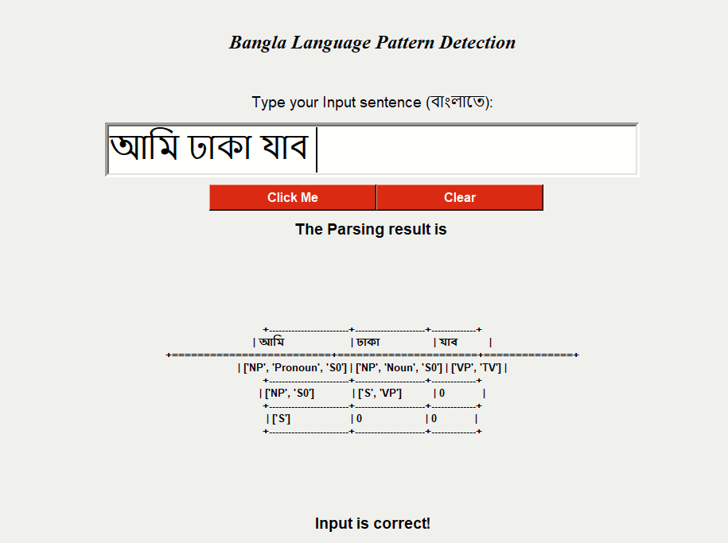 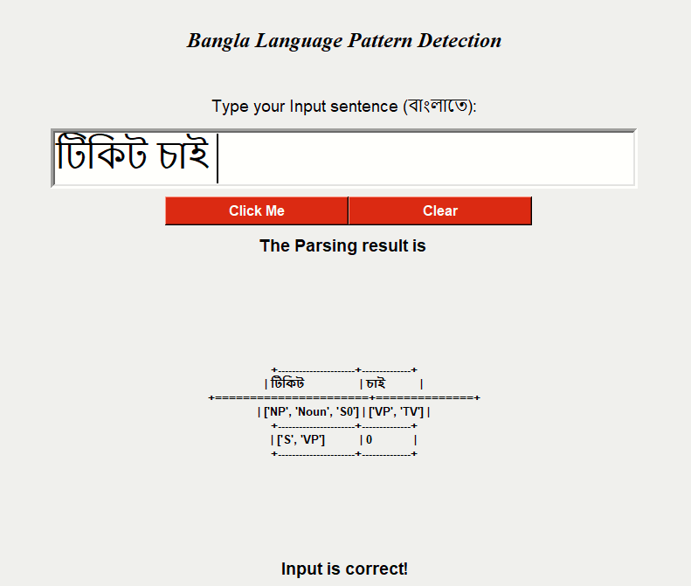

Figure 4.1: Output for Declarative Sentence Figure 4.2: Output for Imperative Sentence

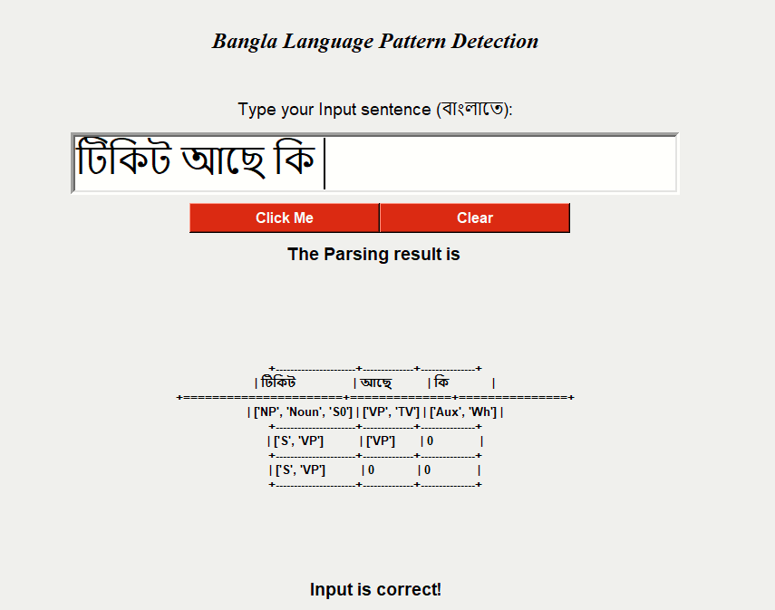 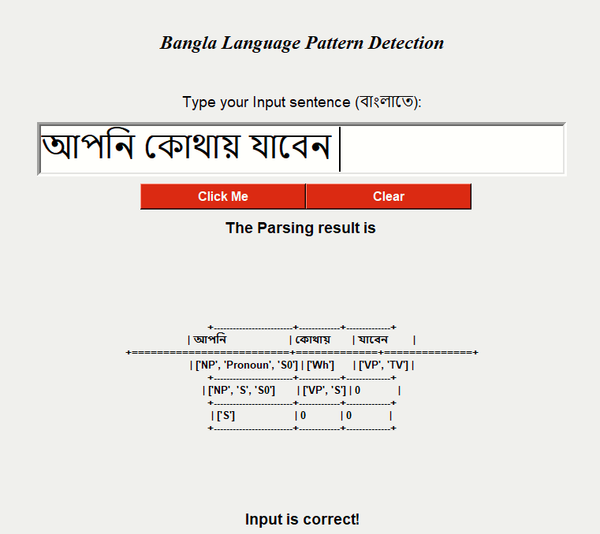

Figure 4.3: Output for Yes-No Answer Type Question Figure 4.4: Output for WH Question

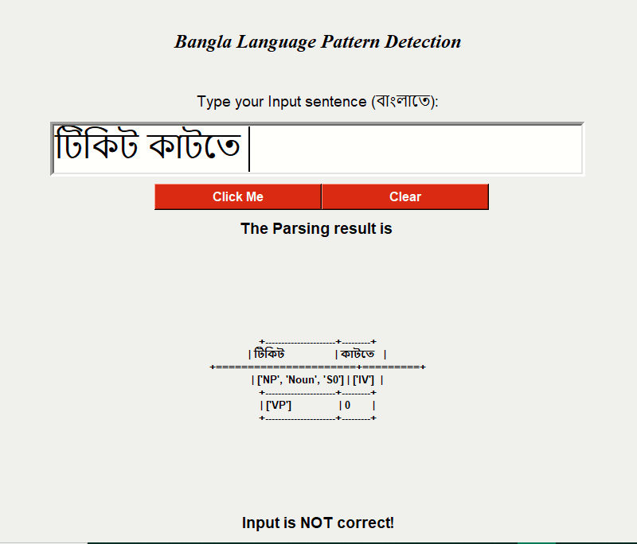

Figure 4.5: Output for improper input

Table 4.2. Performance Measurement

|  |  |  |
| --- | --- | --- |
| **Serial No.** | **Sentence Type** | **Performance** |
| 1. | Declarative | 80% |
| 2. | Imperative | 75% |
| 3. | Yes-No Answer Type Questions | 68% |
| 4. | WH-Questions | 65% |

**4.4 Comparison between Dynamic Parsing and Other Paring Approach**

We have studied about some parsing techniques such as predictive parsing, shift reduced parsing and related work using those parsing. There are some issues arising in predictive and shift reduce parsing.

Issues in Predictive Parsing:

* Ambiguity: Having more than one parse tree for given input string.
* Left recursive: A production of grammar is said to have left recursion if the leftmost variable of its RHS is same as variable of its LHS. A grammar containing a production having left recursion is called as Left Recursive Grammar.
* Lest factoring: It consists in prefixes which are common to two or more productions.

For predictive parser we have to handle those issues otherwise parsing is not possible.

Issues in Shift Reduced Parsing:

* The Shift-Reduce Conflict is the most common type of conflict found in grammars. It is caused when the grammar allows a rule to be reduced for particular token, but, at the same time, allowing another rule to be shifted for that same token.

Reason for Applying Dynamic Programming Approach:

* At once builds the sub-solution and combined them to produce answer.
* Have no difficulty for ambiguity
* Have no issue on left recursion and left factoring
* Faster
* No issue on backtracking

**Chapter 5**

**Conclusion**

**5.1 Summary**

Parsing is an effective and most used technique for generating pattern. Parsing Bangla grammar is difficult as there are no fixed rule, ambiguity issue and huge collection of word and undefined structure of sentences. Having these complex issues we build our CFG base on specific ATMS domain set. We use dynamic programming where ambiguity does not create any issue. User gives a sentence as input in the system and system generates output and verifies the correctness of syntax on the basis of bottom up parsing algorithm. The CFG can cover various aspects of Bangla sentences related to ATMS domain except nontraditional format. For making it more dynamic and appropriate more production rule will be generated in future for various structures that can cover any Bangla sentence outside of the related domain.

**5.2 Limitations**

As Bangla language has huge number of structure and pattern so it is difficult to check all those structure and pattern. To avoid those issues we selected a domain named ATMS but still this system of checking correctness has some pitfall. It cannot check the dependencies between subject and verb. This system accepts all the subject and verb regarding to their dependencies.

**5.3 Future Works**

* We will design more rules for each and every possible sentence related to Air Traffic Management System.
* More effectively patterns will be modified for accurate output.
* Till now a sentence is checked whether it is grammatically right or wrong. Next a paragraph will be targeted as input to check the validity according to the grammar.
* The given input sentence accepts those sentences which is generated from the developed context free grammar but does not check any kind of dependencies between subject and verb. To get more accurate result dependencies will be checked.
* To get error free result the probabilistic parsing CYK or dependency parsing will be included.

**References**

1. K. M. A. Hasan, A. Mondal, and A. Saha, “A context free grammar and its predictive parser for Bangla grammar recognition,” In the Proceedings of ICCIT*,* pp. 87 – 91, 2010.
2. K. M. Azharul Hasan, A. Mahmud, A. Mondal, and A. Saha,“Recognizing Bangla grammar using predictive parser,” International Journal of Computer Science & InformationTechnology, 3(6), pp.317-326, 2011.
3. A. Khatun, and M.M. Hoque, "Statistical Parsing of Bangla Sentences by CYK Algorithm", "International Conference on Electrical, Computer and  
   Communication Engineering (ECCE)", February 16-18, 2017.
4. M. N. Y. Ali, S. Ripon, and S. M. Allayear, “UNL based Bangla natural text conversion: Predicate preserving parser approach,” International Journal of Computer Science Issues, 9(3), pp. 259–265, 2012.
5. Md Asfaqul Islam, K M Azharul Hasan, Md Mizanur Rahman, “ Basic HPSG Structure for Bangla Grammar,” In the Proceedings of ICCIT*,* pp. 185-189, 2012.
6. S. Dasgupta, V. Ng, “Unsupervised morphological parsing of Bangla” Language Resources and Evaluation, *40*, pp. 311–330, 2006.
7. Abu Zaher Md. Faridee, Francis M. Tyers, “Development of a morphological analyzer for Bangla”, In Proceedings of the First International Workshop on Free/Open-Source Rule-Based Machine Translation, p. 43-50, 2009.
8. M. M. Anwar, M. Z. Anwar, and M. A. A. Bhuiyan, “Syntax analysis and machine translation of Bangla sentences,” International Journal of Computer Science and Network Security, 9(8), pp. 317–326, 2009.
9. Al-Mahmud, Bishnu Sarker, K M Azharul Hasan, “Parsing Bangla Grammar Using Context Free Grammar (CFG),” In Technical Challenges and Design Issues in Bangla Language Processing, IGI Global, pp. 137-154, 2013.
10. Rafsan Zani Rabbi, Mohammad Insanur Rahman Shuvo, K.M. Azharul Hasan “Bangla Grammar Pattern Recognition Using Shift Reduce Parser” 5th International Conference on Informatics, Electronics and Vision (ICIEV), pp.229 – 234, 2016.
11. Aho, A. V., Sethi, R., & Ullman, J. D. (2002). Compilers principles, techniques and tools. New York: Pearson Education.
12. Ali, M. N. Y., Ripon, S., & Allayear, S. M. (2012). UNL based Bangla natural text conversion: Predicate preserving parser approach. Interna­tional Journal of Computer Science Issues, 9(3), 259–265.
13. Anwar, M. M., Anwar, M. Z., & Bhuiyan, M. A. A. (2009). Syntax analysis and machine transla­tion of Bangla sentences. International Journal of Computer Science and Network Security, 9(8), 317–326.
14. Anwar, M. M., Shume, N. S., & Bhuiyan, M. A. A. (2010). Structural analysis of Bangla sentences of different tenses for automatic Bangla machine translator. International Journal of Computer Sci­ence and Information Security, 8(9).
15. Dasgupta, S., & Ng, V. (2006). Unsupervised morphological parsing of Bengali. Language Re­sources and Evaluation, 40, 311–330.
16. Faridee, A. Z. M., & Tyers, F. M. (2009). Devel­opment of a morphological analyzer for Bengali. In Proceedings of the First International Work­shop on Free/Open-Source Rule-Based Machine Translation,(pp. 43-50). IEEE.
17. Ghosh, A., Das, A., Bhaskar, P., & Bandyopadhyay, S. (2010). Bengali parsing system. Paper presented at ICON NLP Tool Contest 2010.
18. Haque, M. N., & Khan, M. (2005). Parsing Bangla using LFG: An introduction. BRAC University Journal, 2(1), 105–110.
19. Mehedy, L., Arifin, N., & Kaykobad, M. (2003). Bangla syntax analysis: A comprehensive ap­proach. In Proceedings of International Confer­ence on Computer and Information Technology (ICCIT),(pp. 287-293). ICCIT.
20. Murshed, M. M. (1998). Parsing of Bengali natural language sentences. In Proceedings of Interna­tional Conference on Computer and Information Technology(ICCIT),(pp. 185-189). ICCIT.