GASTRONOMIQUE PASTRY INC
Lava Cake 3 Inch
ITEM #GP2118
KEEP FROZEN
Ingredients
Eggs, sugar, wheat flour, margarine, dark chocolate.
LOT CODE: 72722
BEST BEFORE: 2025/09/23
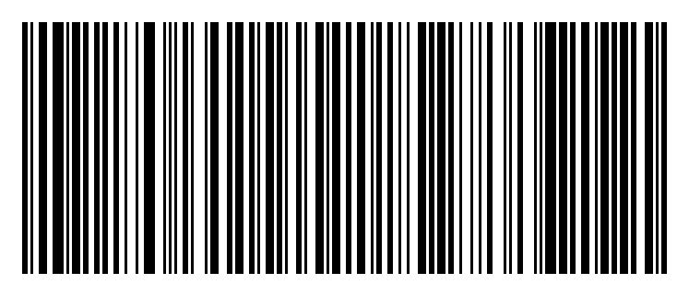
(01)10627146285749(15)250923(10)72722

