### 

**A COMPREHENSIVE SYSTEM FOR SCHEDULING MEDICAL APPOINTMENTS AND SERVICES USING ARTIFICIAL INTELLIGENCE**

**Health and Safety:**

Today, it is commonly acknowledged that all patients must have timely and simple access to healthcare facilities in order for a healthcare process to be effective. Patient wait times can be decreased while expensive staff and facility medical resources are used more effectively thanks to appointment scheduling (AS). A healthcare application of appointment scheduling tasks under uncertainty tries to create an appointment system that optimizes a particular quality standard. Patient satisfaction and reduced wait times in public hospitals are the main goals of healthcare management programmers. Managing a large number of outpatients can present a number of challenges for healthcare facilities. For example, a protracted waiting time for a therapy has a poor effect on the patient's experience and may lower the standard of care. Healthcare facilities like hospitals and clinics typically see an increase in the number of individuals who require their services. To accept additional patients and maintain their clientele, hospitals must implement swift and efficient healthcare facilities.

**Engineering standards:**

It is now widely accepted that for a healthcare process to be effective, all patients must have timely and easy access to healthcare services. Appointment scheduling (AS) allows for the efficient utilization of expensive staff and facility medical resources while reducing patient wait times. The goal of a healthcare application of uncertain appointment scheduling duties is to optimize a specific quality standard through the creation of an appointment system. In public hospitals, decreasing wait times and improving patient satisfaction are the primary objectives of healthcare management programmers. For healthcare institutions, overseeing a sizable outpatient population can provide a variety of difficulties. For instance, a lengthy wait period for therapy has a negative impact on the patient's experience and could degrade the quality of service. The number of people in need of the services provided by healthcare facilities, such as hospitals and clinics, usually rises. Hospitals need to put in place quick and effective healthcare facilities in order to take in new patients and keep their current patient base.

# ABSTRACT

The goal of this project was to use a combination of PHP, MySQL, HTML, CSS, and JavaScript to develop and implement an Artificial Intelligence-enabled hospital appointment scheduling system. The system provided a user-friendly and effective platform for patients, physicians, and hospital personnel in an effort to overcome the issues with conventional appointment scheduling systems.

The user interface was created using HTML and CSS, and JavaScript was used to add interaction to allow for a multi-step booking modal. jQuery and PHP were used in conjunction with a MySQL database to store and retrieve appointment data in order to meet the backend needs. Utilizing PHP, the logic to prevent booking conflicts was put into place. In addition, a machine learning model was developed utilizing Python and AI data to forecast the number of people who will join the feature.

The incorporation of AI components sought to improve scheduling, lessen traffic, predict a patient's future number of visits, and offer users a seamless experience. The project's implementation demonstrated how diverse technologies may be successfully combined to produce a smart appointment booking system for improved healthcare services.

**LIST OF FIGURES**

|  |  |
| --- | --- |
| **FIGURES** | **DETAILS** |
| **Fig-1** | Front page of a web page |
| **Fig-2** | Booking section in a web page |
| **Fig-3** | Web page appointment section |
| **Fig-4** | In this page we can see the number of patients can booked the slots on different dates. |
| **Fig-5** | Backend side admin login page |
| **Fig-6** | Booking Status of a patients |
| **Fig-7** | This Graph include in future predictions of number patients will be increase. |

**INTRODUCTION**

Today, it is commonly acknowledged that all patients must have timely and simple access to healthcare facilities in order for a healthcare process to be effective. Patient wait times can be decreased while expensive staff and facility medical resources are used more effectively thanks to appointment scheduling (AS). A healthcare application of appointment scheduling tasks under uncertainty tries to create an appointment system that optimizes a particular quality standard. Patient satisfaction and reduced wait times in public hospitals are the main goals of healthcare management programmers. Managing a large number of outpatients can present a number of challenges for healthcare facilities. For example, a protracted waiting time for a therapy has a poor effect on the patient's experience and may lower the standard of care. Healthcare facilities like hospitals and clinics typically see an increase in the number of individuals who require their services. To accept additional patients and maintain their clientele, hospitals must implement swift and efficient healthcare facilities. The must effectively locates bottlenecks, anticipates the impact of variety on demand, and calculates the ideal capacity distribution. In order to evaluate healthcare facilities, the best practices must be acknowledged, measurable procedures must be used, and an obligation to improve must exist. To maintain the level of care, healthcare facilities deploy decision support systems to offer individuals affordable and evaluable services. By creating decision support systems to oversee outpatient clinic services, the strategies outlined in the literature seek to reduce waiting times. In spite of inadequate resources, healthcare systems have struggled to offer patients high-quality care in recent years. The ASP has improved the quality and speed of access to healthcare facilities, one of the most significant challenges in healthcare. Time is a significant factor in determining the performance and safety of patients, as well as how satisfied they are with their care. Fairness is a key concern when scheduling patients and doctors and is one of the major problems in healthcare. Beyond schedule fairness, additional encouragement is accomplished through a novel gain framework that is specific to the division and was not before published. Adjusting individual scheduling preferences is a crucial component of fairness. Optimizing healthcare resources through increased human resource and medical equipment utilization is the main issue with appointment scheduling, which worsens patient wait times. Numerous studies have demonstrated that prolonged waiting periods are frequently the main cause of patient dissatisfaction with outpatient scheduling, and that reasonable waiting times. One of the most well-known methods for examining the impact of random events on the amount of time doctors and patients wait for appointments is through simulation models. The scheduling of patient appointments is improved by the optimization model using the Simulated Annealing method, which also reduces average service times and overall patient wait times. The obtained result indicates that the total service time and patient waiting time have been decreased by roughly 5% and 38%, respectively, in comparison to the current condition.They compared their answers with heuristic scheduling methods and assessed the efficacy of their solutions using structural data and a discrete event simulation. Many students applied for advanced work in the literature to create models that would improve patient happiness, reduce impacted patient waiting times, and increase the number of patient visits.

. We also review the literature on other scheduling-related concerns in healthcare, like AI applications, waiting periods, and queueing theory in scheduling appointments. In As appointment scheduling is the most studied healthcare scheduling issue, our evaluation work concentrated on different ASP strategies to shorten wait times and increase patient satisfaction in the medical field.

. Due to its ability to guarantee people's health and timely access to medical care, the healthcare industry is vital to society. But the process for making medical appointments has long been marred by inefficiencies, protracted wait periods, and miscommunications. To address these difficulties, this project suggests an AI-enabled hospital appointment booking system that radically transforms the way appointments are scheduled by utilizing the power of state-of-the-art technology. In this age of rapid technological advancement, the use of artificial intelligence (AI) has the potential to significantly increase the efficacy and efficiency of healthcare services. Using PHP, MySQL, HTML, CSS, Python, and JavaScript, this project aims to develop and implement a comprehensive solution that improves patient experiences, expedites the appointment booking process, and allocates resources for hospitals in the most efficient manner

The system's user interface is meticulously created using CSS and HTML to guarantee a user-friendly and beautiful experience. By enabling a multi-step booking popup that guides users through the appointment scheduling process, JavaScript enhances engagement. This straightforward design makes it easier for patients, doctors, and hospital employees to schedule appointments thanks to the user-friendly platform. In order to satisfy the backend needs, PHP and jQuery are combined. Processing and storing appointment data requires a robust MySQL database, which guarantees dependable and secure information access. The system's performance is enhanced by its ability to manage numerous concurrent users and appointment requests thanks to these technologies. One of the main problems this effort aims to address is the prevention of schedule conflicts. PHP's sophisticated algorithms are used by the system to investigate and identify conflicts, hence reducing scheduling errors and causing patients and physicians as little inconvenience as possible. The technology reduces traffic and maximizes appointment times to maximize the use of hospital resources while also increasing operational efficiency. This project also incorporates data from an AI component powered by Python and the AI health app. Using machine learning algorithms, the system identifies the ideal time of day to schedule appointments based on the day of the week and the type of service required. The AI part reduces unnecessary waiting times, studies patterns and trends, and boosts overall pleasure to help people make informed decisions. The use of AI technologies benefits healthcare providers and patients alike. Patients benefit from a more efficient and customized appointment scheduling process that reduces stress and enables them to receive prompt medical attention. Benefits for hospital administration and staff include enhanced workflow management, better resource allocation, and higher patient satisfaction. This project offers a creative way to transform healthcare by putting in place an AI-enabled hospital appointment booking system.. The system combines PHP, MySQL, HTML, CSS, Python, and JavaScript to deliver an easy-to-use user interface, efficient scheduling, and intelligent optimization. AI technology improves the overall effectiveness of healthcare services and gives patients and healthcare workers more authority, creating a seamless patient experience.

## PROBLEM STATEMENT

## Current appointment scheduling systems depend on manual processes, leading to long wait times, inefficiency and communication gaps.

## Patients struggle with finding convenient appointment slots, healthcare providers struggle with managing varying schedules, and valuable resources are wasted due to no-shows and not fully utilized time slots.

## Existing scheduling systems often lack intelligence in assigning appointments.

## The project involves a multifaceted set of challenges that need to be addressed to create an effective AI-powered system for medical appointments and services like optimizing appointment scheduling , predicting patient demand ,personalized patient experience and security.

.

**REQUIREMENTS**

## SOFTWARE REQUIREMENT

**Front hand Tools:**

HTML

CSS

JavaScript

Bootstrap

**Back hand Tools**:

PHP

MySQL

**Artificial Intelligent Algorithm:**

RNN Algorithm ( Long Short-Term Memory)

**SYSTEM DESIGN**

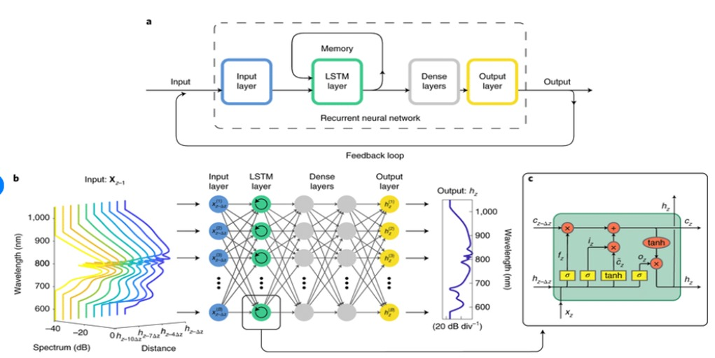

**IMPLEMENTATION AND RESULT**

One of the system's notable achievements is its smooth and intuitive interface, which was made with HTML, CSS, and JavaScript. An easy-to-use interface was offered by the interactive, multi-step booking modal designed with JavaScript. Patients and healthcare professionals alike gave the system's frontend design favourable reviews for being user-friendly and simple to use. The system's adoption of machine learning turned out to be a considerable improvement. By considering factors such as the day of the week and user preferences, the model was successfully trained to predict the ideal time of day for scheduling appointments. The library was used to export the trained model to format, allowing for a seamless integration into the web application. After loading the model into JavaScript, the program used user input to predict the future and show when it would be best to make online appointments. Thanks in large part to this AI component, the system was able to improve service fluidity and prevent traffic, which benefited both the hospital and the patients. To evaluate the effectiveness and functionality of the system, user feedback was gathered. Customers expressed satisfaction with the intuitive interface, complimenting the ease of scheduling appointments and the accuracy of the proposed appointment times. Healthcare professionals acknowledged the system's contribution to reducing scheduling conflicts and allocating resources as efficiently as possible, hence enhancing operational effectiveness. We can correctly anticipate how many patients there will be over the following 30 days by using a previse data collection.

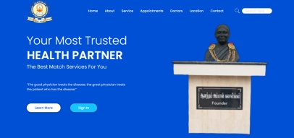

**FIG 01. Front page of a web page**

In this we used FRONT END to create web page for scheduling medical appointments and bookings. The medical appointment web page's sign-in may have features, a username and password. Patients are required to enter their unique username and password to access their account. In case of forgotten credentials, there is an option to reset the password by providing necessary information like email or phone number. It also shows a feature called save password, so that if you want to sign in anytime u can directly sign in.

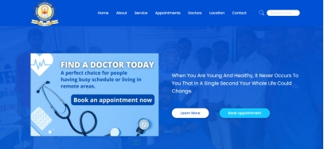

**FIG 02. Booking section in a web page**

Booking appointments is done online through web portals or mobile applications. The appointment booking process begins by selecting the desired date and time from available slots. Patients can usually choose specific healthcare providers or specialists based on their availability and expertise. once the appointment is successfully booked then users get notifications through mails or messages. Users may also receive reminders closer to the scheduled date to ensure they do not miss their appointments. Additionally, this allow patients to view their upcoming appointments and review their medical history within their accounts for easy reference.

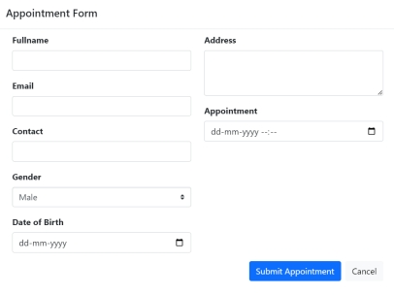

Fig 03:  **Web page appointment section**

The login page of a backend admin is a web page that allows authorized users to access the backend of a website or application's administration panel. The backend administration panel is where users can manage the website or application's settings, content, and users.

To log in, the user enters their username and password in the corresponding fields and clicks the Sign In button. If the user's credentials are correct, they will be logged in and taken to the backend administration panel of the website or application. Otherwise, they will be shown an error message.

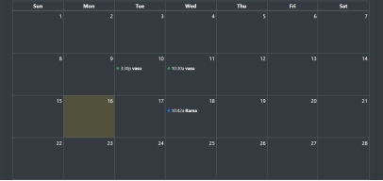

**FIG 04. In this page we can see the number of patients can booked the slots on different dates.**

This means that Rama has an appointment scheduled for 10:42am on the date that the square is highlighted. The fact that the appointment details are visible to the admin in the backend means that the admin has access to all appointment information for all patients.

To allow the admin to reschedule appointments if necessary.To allow the admin to track patient appointments and ensure that they are being seen on time.To allow the admin to generate reports on patient appointments.

In general, it is important for patients to be aware that their appointment information may be visible to the admin. This is especially true if the patient is discussing sensitive information with their doctor. If the patient is concerned about their privacy, they should talk to their doctor about their concerns.

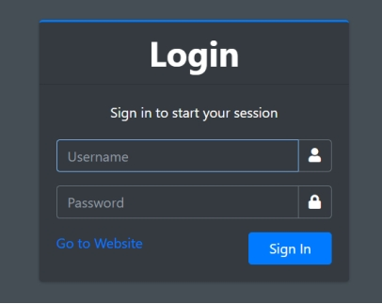

**FIG 05. Backend side admin login page**

To allow the admin to reschedule appointments if necessary.To allow the admin to track patient appointments and ensure that they are being seen on time.To allow the admin to generate reports on patient appointments.

In general, it is important for patients to be aware that their appointment information may be visible to the admin. This is especially true if the patient is discussing sensitive information with their doctor. If the patient is concerned about their privacy, they should talk to their doctor about their concerns.

The admin can see that Rama has an appointment scheduled for 10:42am on the date that the square is highlighted. The admin can also see the patient's name, but they cannot see any other details about the appointment, such as the patient's medical history or the reason for the appointment.

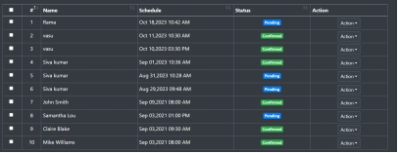

**FIG 06. Booking Status of a patients**

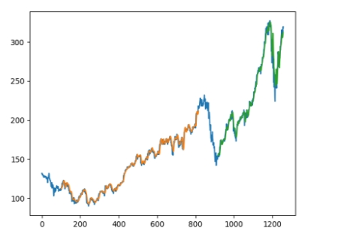Once the model has been trained using the training dataset, it is time to test it using the test dataset. This dataset assesses the model's performance and guarantees that it can generalize successfully to new or unexplored datasets. The test dataset is a different subset of the original data from the training dataset. When the model training is finished, it utilizes it as a benchmark because it has some similar features and a similar class probability distribution. A well-organized dataset called test data provides information for each type of scenario the model might encounter in the actual world. [30] Typically, the test dataset makes up 20–25% of the overall original dataset.

FIG 07. Training data and Testing data

To find out the status of their appointment time, the patient might phone the administrative assistant. The patient must be aware of the status of their scheduled appointment in order to make appropriate plans. For instance, if the patient's appointment time slot has not yet been reserved, they may need to reschedule.

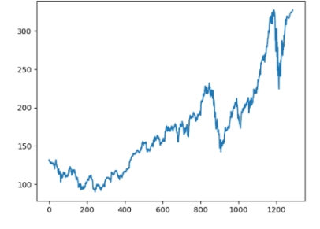The patient is being treated after 30 days. By utilising one of the Deep Learning techniques, we will attempt to forecast whether the result on the 31st day will be high or low. LSTM appears to have been successful in predicting that the patient's outcome on the 31st day would be high based on the graph you gave. This is noteworthy because LSTM can identify long-term dependencies in data even when it is noisy or lacking.

**FIG 07. This Graph include in future predictions of number patients will be increase.**

**CONCLUSION AND FUTURE ENHANCEMENT**

The creation and deployment of an AI-powered hospital appointment booking system is a significant advancement in healthcare technology. Using technologies like PHP, MySQL, HTML, CSS, Python, and JavaScript, we were able to create a user-friendly interface that facilitates simple appointment scheduling and provides improved functionality for patients and the number of patients that will visit in the future. We used a thorough process throughout the entire project, which includes establishing certain requirements and functionality through intensive stakeholder interaction. We were able to establish the system's scope and formulate crucial deployment goals by obtaining input from patients, doctors, and hospital managers. This gave us a thorough grasp of their needs and expectations. A significant accomplishment was the installation of the AI-enabled system in a practical setting. Through rigorous testing, interaction with the hospital's IT staff, and collaboration with the existing infrastructure, we secured a successful deployment that satisfied the specific criteria and successfully managed the challenges encountered in appointment booking processes. The ability of the AI-powered hospital appointment booking system to improve scheduling, user experiences, and operational efficiency has been demonstrated. By using deep learning algorithms, the system predicts the ideal time to schedule appointments based on past client behavior and preferences, greatly enhancing the quality of service. There is always space for improvement and future upgrades in technical projects. The completion of the project heralds the start of an ongoing process of improvement and innovation. The system's capabilities will be improved, it will be able to adapt to changing needs, and it will give users an even better experience thanks to areas for improvement that have been identified based on review and user feedback. The hospital appointment scheduling system powered by AI has enormous potential to revolutionise healthcare services. It allows healthcare organisations to allocate resources more efficiently and streamlines the appointment scheduling procedure. With its successful implementation, the system provides greater patient care, increased operational effectiveness, and a more seamless and customized healthcare experience for all stakeholders.