1.What is the average run rate by over in both innings?

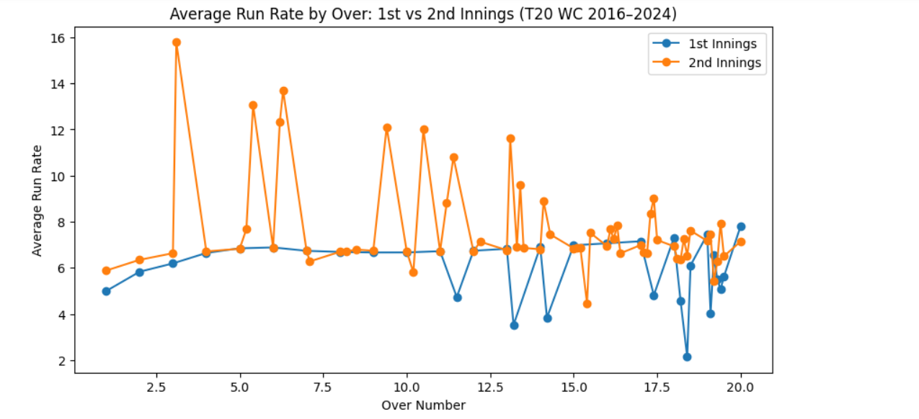
2.What is the average first innings score in a year?
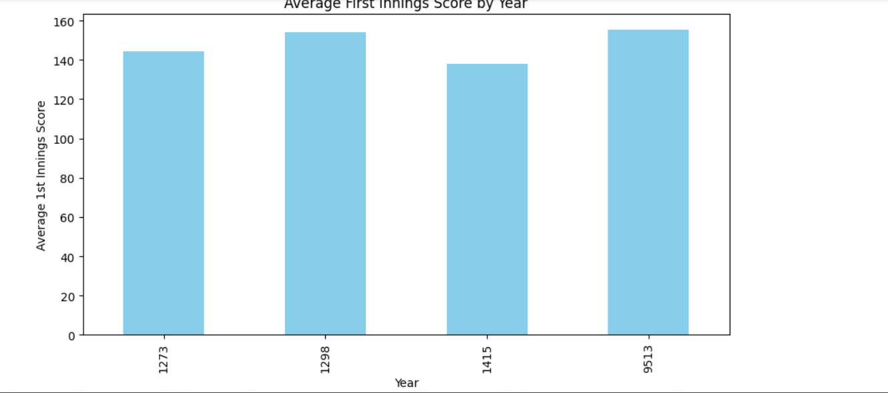

3.What are the top 10 teams by average run rate in 1st innings?
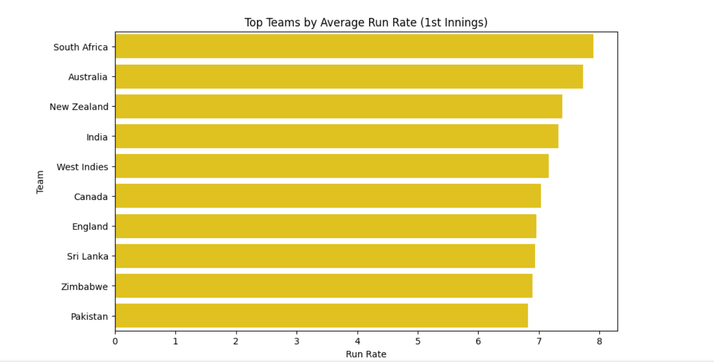
4.What is the winning percentage on chasing?
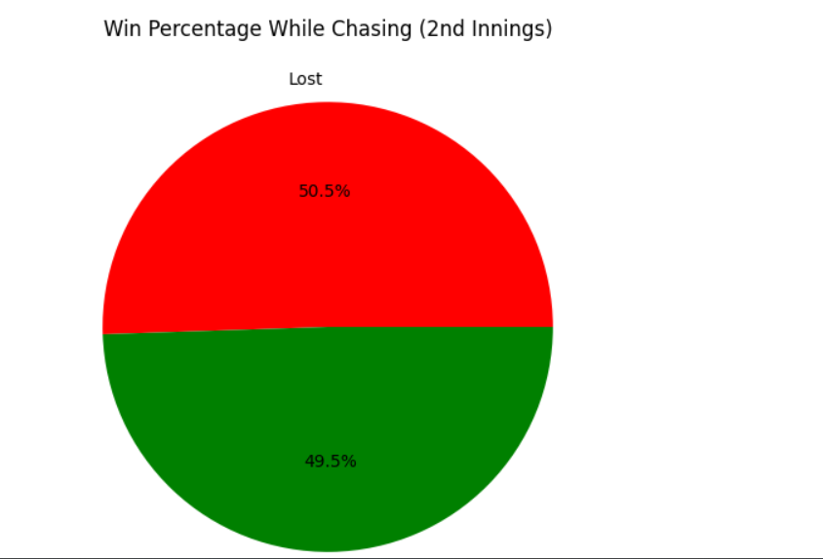
5.Will losing wickets make impact on chasing?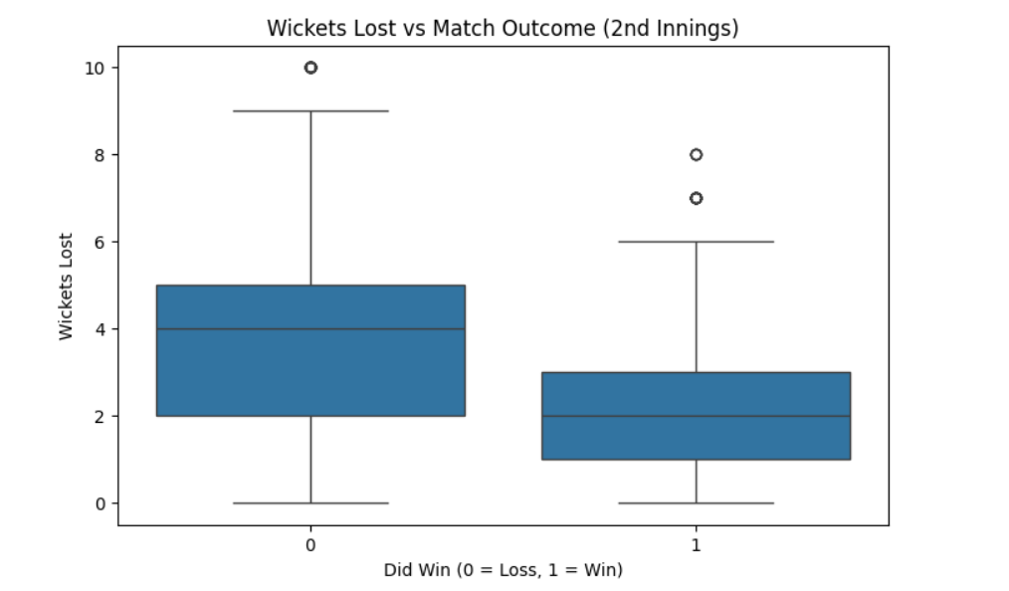

6.What is average runs each over in 1st innings?
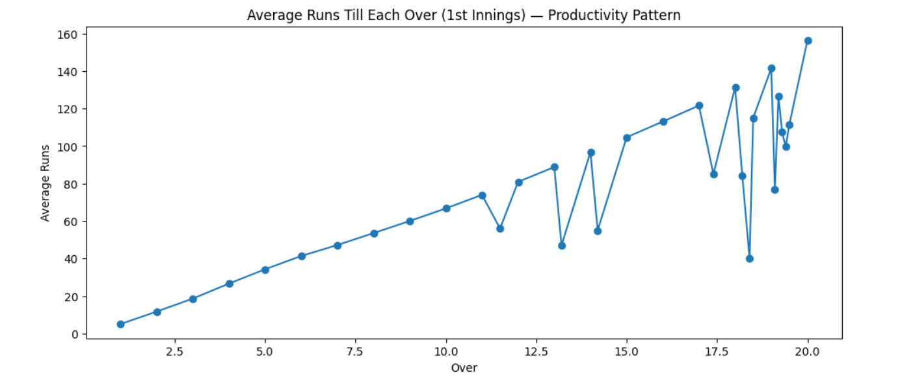

7.What is the winning percentage of teams?
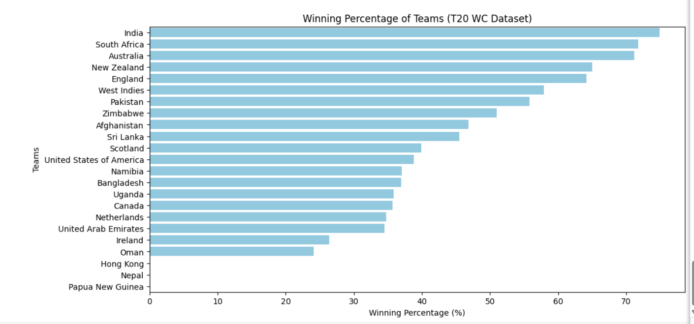

8.Who wins batting first or batting second?

