**Machine Learning for Video Games**

MEL**629T DISSERTATION

Submitted in partial fulfillment of the requirements of the

M.Tech Data Analytics

by

**P. Sivakishore**

**2017HD12517**

Under the supervision of

**Pratibha Mishra**, **Director**

Dissertation work carried out at

Altran technologies, Bangalore

BIRLA INSTITUTE OF TECHNOLOGY AND SCIENCE

Pilani (Rajasthan) INDIA

March 2020

DISSERTATION

(**Machine Learning for Video Games**)

Submitted in partial fulfillment of the requirements of the

**M.Tech Data Analytics**

by

**P. Sivakishore**

**2017HD12517**

Under the supervision of

**Pratibha Mishra**, **Director**

Dissertation work carried out at

Altran technologies, Bangalore

BIRLA INSTITUTE OF TECHNOLOGY AND SCIENCE

PILANI (RAJASTHAN)

(March 2020)

**BIRLA INSTITUTE OF TECHNOLOGY AND SCIENCE, PILANI**

**CERTIFICATE**

This is to certify that the Dissertation entitled **Machine Learning for Video Games**

is carried out and submitted by Mr. **P. Sivakishore** IDNo. **2017HD12517** in partial fulfillment of

the requirements of MEL ZG629T Dissertation, embodies the work done by him

under my supervision.

Place: Bangalore Signature of the Supervisor

Name: **Pratibha Mishra**

Date: Designation: **Director**

**BIRLA INSTITUTE OF TECHNOLOGY & SCIENCE, PILANI**

**FIRST SEMESTER 2019-2020**

MELZG629T **DISSERTATION**

Dissertation Title : Machine Learning for Video Games

Name of Supervisor : Pratibha Mishra

Name of Student : P Sivakishore

ID No. of Student : 2017HD12517

## Abstract

The issue of Video Game industry is to put lot of manpower to test AAA Games to small Indie Games. Therefore, we intended to aid in testing the game using Machine Learning that involves concepts like Neural Networks and Deep Learning. This can be achieved by training Artificial Intelligence using data set generated while playing the game. Then the data set is processed through deep learning and neural networks to generate datasets. Once the Neural Network dataset is generated, this dataset can be feed to Game player so that it can played by itself for maximum profit. By this we can play the game number of times and look for crash and bugs in the gameplay that can be fixed in development stage and thereby reducing the development cost and manpower required for making the game a GOLD BUILD. From this project, we hope to build an alternative way to test Video Game for Game Industry using Machine Learning. For proof of concept we are developing a Tetris game in python and implement Deep Learning and Neural Network that generates the data set that helps the Game to play itself automatically and helps to reproduce the bugs in the game. The project also involves in concept like serialization and deserialization of data.

**Key Words: Neural Network, Machine Learning, Deep Learning**

**List of Symbols & Abbreviations used**

ML Machine Learning

AI Artificial Intelligence

GOLD BUILD Gaming industry term for final release

**List of Tables**

**List of Figures**

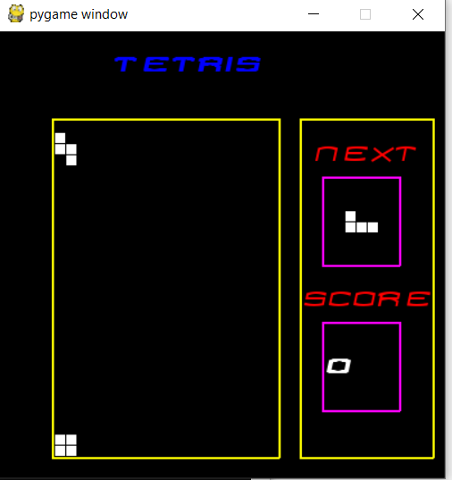

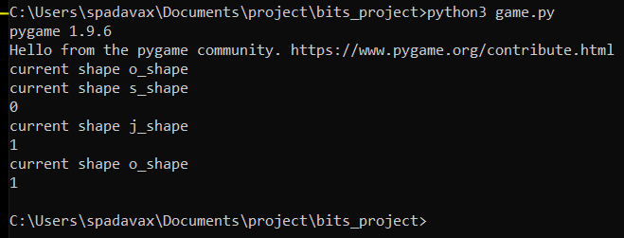

**Table of contents**

**Chapters 1, 2, 3, etc.**

**Conclusions / Recommendations**

**Directions for future work**

**Bibliography / References**

Pytorch <https://pytorch.org/>

Pygame <https://www.pygame.org/news>

**Appendices**

**BIRLA INSTITUTE OF TECHNOLOGY AND SCIENCE, PILANI**

**II SEMESTER 2019- 2020**

**DISSERTATION**

**Dissertation Outline**

**BITS ID No. 2017HD12517 Name of Student: P Sivakishore**

**Name of Supervisor:** Pratibha Mishra

**Designation of Supervisor**: Director

**Qualification and Experience: M. Tech and 20 Years 9 Months**

**E- mail ID of Supervisor:** [pratibha.mishra@altran.com](https://social.intra.aricent.com/People/_layouts/15/EnterpriseProfile/Profile.aspx?accountname=AD\BGH07534)

**Topic of Dissertation**: Machine Learning for Video Games

**Name of First Examiner:** Anil Kumar Jain

**Designation of First Examiner**: Project Manager

**Qualification and Experience: M. Tech and 20 Years**

**E- mail ID of First Examiner:** [anil.jain@altran.com](https://social.intra.aricent.com/People/_layouts/15/EnterpriseProfile/Profile.aspx?accountname=AD\BGH32650)

(Signature of Student) (Signature of Supervisor)

Date:------------ Date:--------------

**Dissertation Outline should contain the following:**

* **Dissertation Topic: Machine Learning for Video Games**
* **Dissertation Title:**
* Design a Neural Network that generates data sets for player inputs to play game automatically.
* **Objectives**:
* Develop a Game from scratch.
* Add serialization of gameplay data to the game
* Generate Datasets by feeding deep learning and Neural networks
* Add functionality to game that can play game by itself from the Neural network generated dataset
* **Scope of work**:
* Understand the Neural Network and Deep Learning concepts to generate a valid game input dataset to play the game automatically
* **Background:**
* Only had background knowledge of game development and python which is used in this project.
* **Methodology**:
* The game is developed in python using game library.

**Detailed Plan of Work** (according to the semester calendar)

|  |  |  |  |
| --- | --- | --- | --- |
| Serial Number of Task | **Tasks or subtasks to be done** (be precise and specific) | Expected date or week of completion | Specific Deliverable in terms of the project |
| 1)  2)  3)  4)  5)  6) | Understanding the concept like Machine Learning and Neural Networks.  Create a git repo and write a game using python  Mid report  Complete game data serialization and finish the training the data set using neural network  Add logic to play game using neural network dataset.  Complete Report preparation | 1-Feb-2020  2-March-2020  11-March-2020  31-march-2020  20 - April-2020  30 – April -2020 | Report.doc  A playable game  Report.doc  Neural Network class in python and executable code  Executable code  Final_report.doc |

**Supervisor’s Rating of the Technical Quality of this Dissertation Outline**

EXCELLENT / GOOD / FAIR/ POOR (Please specify): ________________________

**Supervisor’s suggestions and remarks about the outline (if applicable).**

Date_____________ ___________________ (Signature of Supervisor)

Note: The above 02 pages pertaining to the Dissertation Outline are NOT to be included in the Final Report. They have been included only to make the document a comprehensive one.

**BIRLA INSTITUTE OF TECHNOLOGY & SCIENCE, PILANI**

**WORK INTEGRATED LEARNING PROGRAMMES DIVISION**

**II SEMESTER 2019-2020**

### MEL ZG629T DISSERTATION

**(EC-2 Mid-Semester Progress Evaluation Sheet)**

**NAME OF THE STUDENT:** P. Sivakishore

**ID NO. : 2017HD12517**

**Email Address :** **2017hd12517@wilp.bits-pilani.ac.in**

**NAME OF SUPERVISOR : Pratibha Mishra**

**PROJECT TITLE : Machine Learning for Video Games**

# EVALUATION DETAILS

|  |  |  |  |
| --- | --- | --- | --- |
| **EC No.** | **Component** | **Weightage** | **Marks Awarded** |
| 1 | Dissertation Outline | 10% |  |
| 2. | Mid-Sem Progress  Seminar  Viva  Work Progress | 10%  5%  15% |  |

|  |  |  |
| --- | --- | --- |
|  | **Supervisor** | **Additional Examiner** |
| Name |  |  |
| **Qualification** |  |  |
| **Designation & Address** |  |  |
| **Email Address** |  |  |
| **Signature** |  |  |
| **Date** |  |  |

Note: *Supervisor should announce the Mid-Semester grade to the student directly and send the completed evaluation form (along with the mid- sem report) to the BITS Coordinator on or before the due date.*

*Note: The Mid-Semester Evaluation Form is NOT to be included in the Final Report. This has been included here only to make the document a comprehensive one.*

**BIRLA INSTITUTE OF TECHNOLOGY & SCIENCE, PILANI**

**WORK INTEGRATED LEARNING PROGRAMMES DIVISION**

**II SEMESTER 2019-2020**

### MEL** ZG629T DISSERTATION

**(Final Evaluation Sheet)**

**NAME OF THE STUDENT:**

**ID NO. :**

**Email Address :**

**NAME OF THE SUPERVISOR:**

**PROJECT TITLE :**

***(Please put a tick ( ) mark in the appropriate box)***

|  |  |  |  |  |  |
| --- | --- | --- | --- | --- | --- |
| **S.No.** | **Criteria** | **Excellent** | **Good** | **Fair** | **Poor** |
| 1 | Work Progress and Achievements |  |  |  |  |
| 2 | Technical/Professional Competence |  |  |  |  |
| 3 | Documentation and expression |  |  |  |  |
| 4 | Initiative and originality |  |  |  |  |
| 5 | Punctuality |  |  |  |  |
| 6 | Reliability |  |  |  |  |
|  | Recommended Final Grade |  |  |  |  |

# EVALUATION DETAILS

|  |  |  |  |
| --- | --- | --- | --- |
| **EC No.** | **Component** | **Weightage** | **Marks Awarded** |
| 1 | Dissertation Outline | 10% |  |
| 2 | Mid-Sem Progress  Seminar  Viva  Work Progress | 10%  5%  15% |  |
| 3 | Final Seminar/Viva | 20% |  |
| 4 | Final Report | 40% |  |
| Total out of | | 100% |  |

|  |  |  |
| --- | --- | --- |
|  | **Supervisor** | **Additional Examiner** |
| Name |  |  |
| **Qualification** |  |  |
| **Designation & Address** |  |  |
| **Email Address** |  |  |
| **Signature** |  |  |
| **Date** |  |  |

NB : Kindly ensure that recommended final grade is duly indicated in the above evaluation sheet. **POSTAL ADDRESS FOR ALL FUTURE CORRESPONDENCE. FILL IT UP NEATLY IN CAPITAL LETTER WITH PIN CODE ETC.**

**Address: _____________________________________________________________________________**

**______________________________________________________**

**Pin Code ______________________**

*Note: The Final Evaluation Form should NOT be bound with the report. It has to be submitted separately.*