**Project title:**   customer segmentation using Data Science

**Phase 4:** Development

**Part 2**

In this part you will continue building your project.

Continue building the customer segmentation model by Feature engineering Applying clustering algorithms Visualization Interpretation

**Importing the libraries:**

Import three basic libraries which are very common in machine learning and will be used every time you train a model

* **NumPy:** it is a library that allows us to work with arrays and as most machine learning models work on arrays NumPy makes it easier
* **matplotlib:** this library helps in plotting graphs and charts, which are very useful while showing the result of your model
* **Pandas:** pandas allows us to import our dataset and also creates a matrix of features containing the dependent and independent variable.

**Code:**

import numpy as np

import pandas as pd

import matplotlib.pyplot as plt

import seaborn as sns

**Output:**

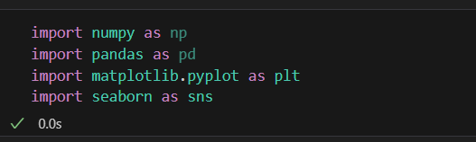

**Load the dataset:**

* Data sets are available in .csv format. A CSV file stores tabular data in plain text.
* Each line of the file is a data record. We use the read_csv method of the pandas library to read a local CSV file as a dataframe.
* Load our customer data from the CSV file

**Code:**

# Try reading the file with different encodings

encodings = ['utf-8', 'latin1', 'ISO-8859-1']

for encoding in encodings:

try:

dataset = pd.read_csv(r'C:\\Users\\ADMIN\Downloads\\archive\\Mall_Customers.csv', encoding=encoding)

print(f"Successfully read with encoding: {encoding}")

break  # If successful, no need to try other encodings

except UnicodeDecodeError:

print(f"Failed to read with encoding: {encoding}")

# Now 'dataset' should contain your data

**Output:**

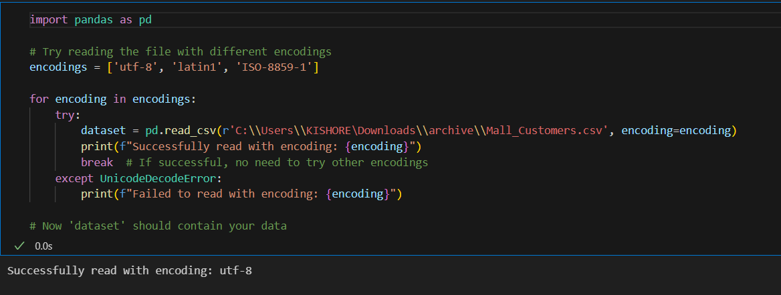

**Head() Function:**

* The head() function is used to get the first n rows.
* This function returns the first n rows for the object based on position.
* It is useful for quickly testing if your object has the right type of data in it.
* If the value of the n is not assigned it returns a default value of first 5 rows

**Code:**

dataset.head()

**Output:**

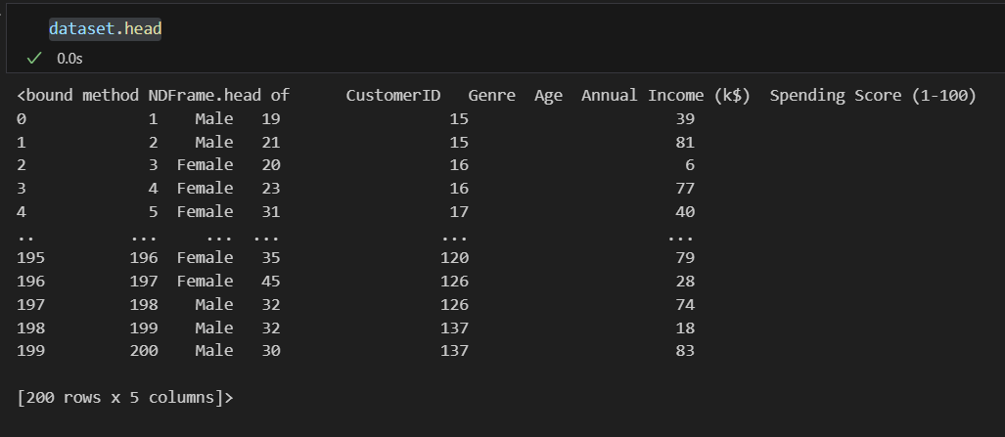

**Info() Function:**

* The info() method prints information about the DataFrame.
* The information contains the number of columns, column labels, column data types, memory usage, range index, and the number of cells in each column (non-nullvalues).

**Code:**

dataset.info()

**Output:**

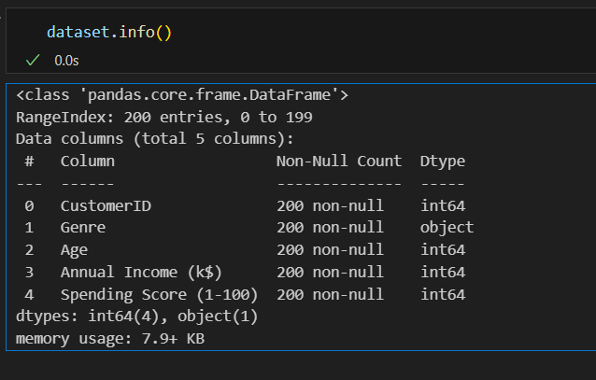

**Df.isnull().sum() Function:**

* This code is used to count the number of missing (null) values in each column of a DataFrame, denoted as df.
* It returns a summary of the missing data for each column, showing how many missing values are there in each column.
* This information is essential in data preprocessing and analysis to identify and handle missing data appropriately.Top of Form

**Code:**

dataset.isnull().sum()

**Output:**

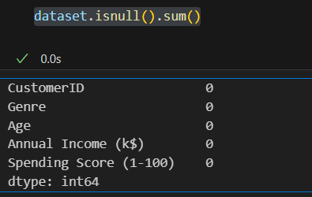

**Describe Function:**

* The describe() function in pandas, a popular Python data analysis library, is used to generate summary statistics of a DataFrame or Series.

It provides a quick overview of the key statistics for numerical data in the dataset, including:

* **Count:** The number of non-null values.
* **Mean:** The average of the values.
* **Standard Deviation (std):** A measure of the spread or dispersion of the data.
* **Minimum:** The minimum value in the dataset.
* **25th Percentile (25%):** The value below which 25% of the data falls (the first quartile).
* **Median (50% or the 2nd quartile):** The middle value when the data is sorted.
* **75th Percentile (75%):** The value below which 75% of the data falls (the third quartile).
* **Maximum:** The maximum value in the dataset.

**Code:**

dataset.describe()

**Output:**

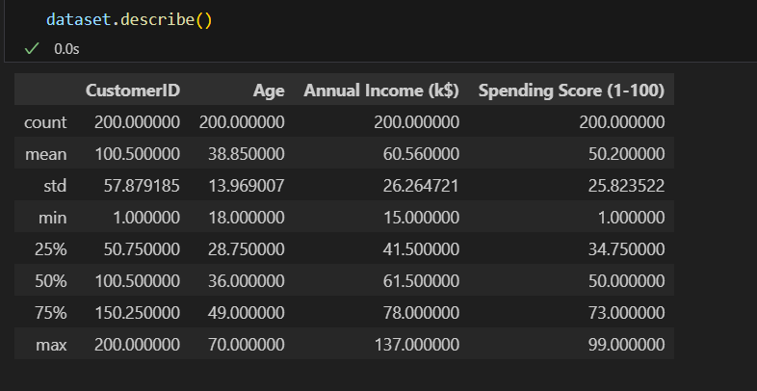

**Data Preprocessing:**

* Data preprocessing is a crucial step within the statistics analysis and gadget gaining knowledge of pipeline.
* It includes a sequence of strategies and operations finished on uncooked statistics to clean, organize, and transform it right into a layout that is suitable for analysis or device mastering version schooling.
* Data preprocessing goals to enhance the first-class of the records, making it greater reliable and conducive to generating accurate consequences.

**Data Cleaning:**

* Handling missing values: Deciding how to deal with missing data, whether by imputing values or removing incomplete records.
* Outlier detection and treatment: Identifying and handling data points that significantly deviate from the norm.

**Data Transformation:**

* **Data normalization:** Scaling numerical features to a standard range (e.g., between 0 and 1) to ensure that they have similar influence in the analysis.
* **Encoding categorical variables:** Converting categorical data into numerical format, such as one-hot encoding or label encoding.
* **Feature engineering:** Creating new features or modifying existing ones to capture more meaningful information from the data.
* **Dimensionality reduction:** Reducing the number of features while retaining essential information, using methods like Principal Component Analysis (PCA).

Here are some common tasks and techniques involved in data preprocessing:

**Outliers:**

* Outliers are data points that significantly deviate from the rest of the data in a dataset.
* They can be exceptionally high or low values compared to the majority of the data.

**Code:**

import matplotlib.pyplot as plt

# Ensure your dataset contains only numerical data for box plotting

numerical_data = dataset.select_dtypes(include='number')

# Transpose the data to prepare for box plotting

data_to_plot = numerical_data.values.T

# Create subplots

fig, axs = plt.subplots(9, 1, dpi=95, figsize=(7, 17))

# Iterate through columns and create boxplots

for i, col in enumerate(numerical_data.columns):

    axs[i].boxplot(data_to_plot[i], vert=False)

    axs[i].set_ylabel(col)

plt.show()

**Output:**

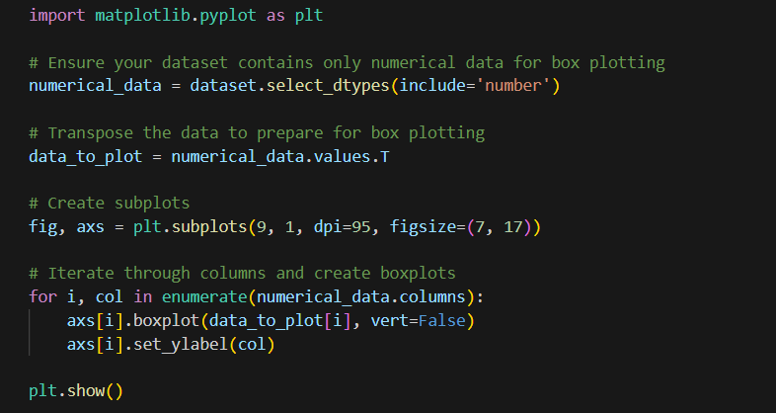

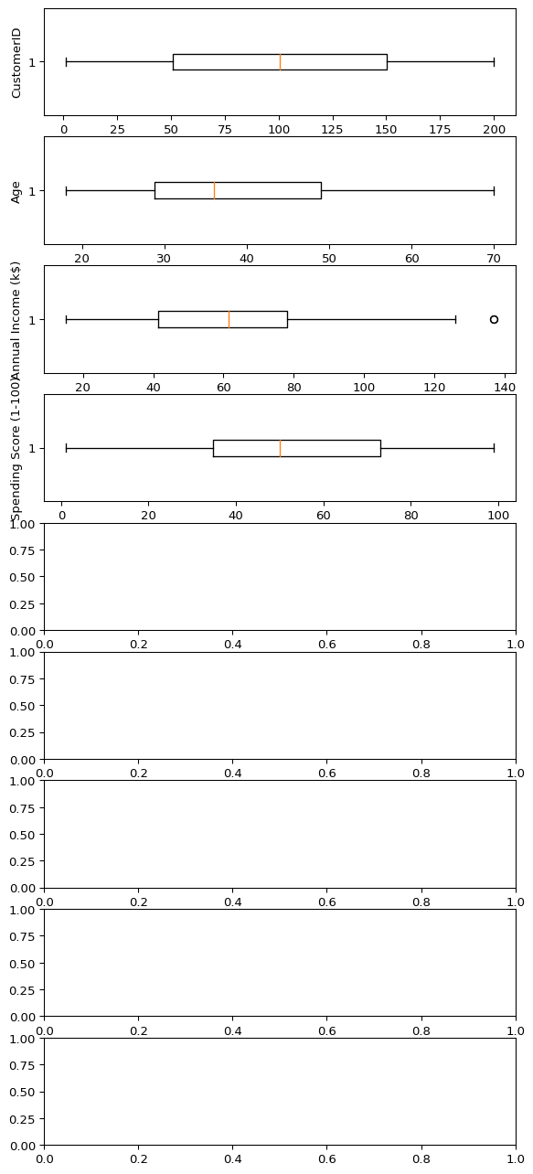

**Corelation:**

* Correlation is a statistical measure that indicates the extent to which two or more variables fluctuate in relation to each other.
* Correlation describes the relationship between variables. It can be described as either strong or weak, and as either positive or negative.

**Code:**

numeric_dataset = dataset.select_dtypes(include=['number'])

corr = numeric_dataset.corr()

import matplotlib.pyplot as plt

import seaborn as sns

plt.figure(dpi=130)

sns.heatmap(corr, annot=True, fmt='.2f')

plt.show()

**Output:**

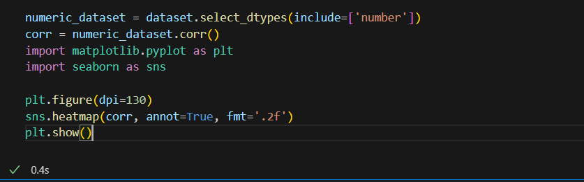

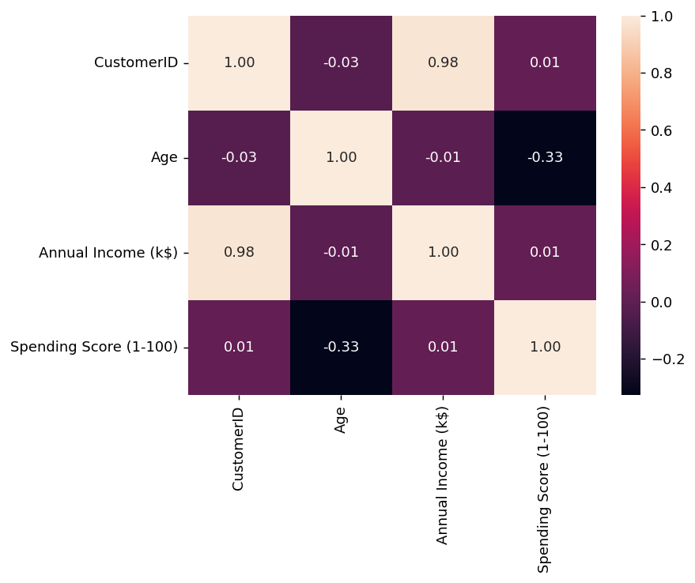

**Normalization**

* MinMaxScaler scales the data so that each feature is in the range [0, 1].
* It works well when the features have different scales and the algorithm being used is sensitive to the scale of the features, such as k-nearest neighbors or neural networks.
* Rescale your data using scikit-learn using the MinMaxScalar.

**Code:**

from sklearn.preprocessing import MinMaxScaler

from sklearn.preprocessing import OneHotEncoder

from sklearn.compose import ColumnTransformer

from sklearn.pipeline import Pipeline

numeric_cols = dataset.select_dtypes(include=['number']).columns

categorical_cols = dataset.select_dtypes(exclude=['number']).columns

numeric_transformer = Pipeline(steps=[

('scaler', MinMaxScaler(feature_range=(0, 1)))])

categorical_transformer = Pipeline(steps=[

('encoder', OneHotEncoder())])

preprocessor = ColumnTransformer(

transformers=[

('num', numeric_transformer, numeric_cols),

('cat', categorical_transformer, categorical_cols)])

X_transformed = preprocessor.fit_transform(dataset)

X_transformed[:5]

**Output:**

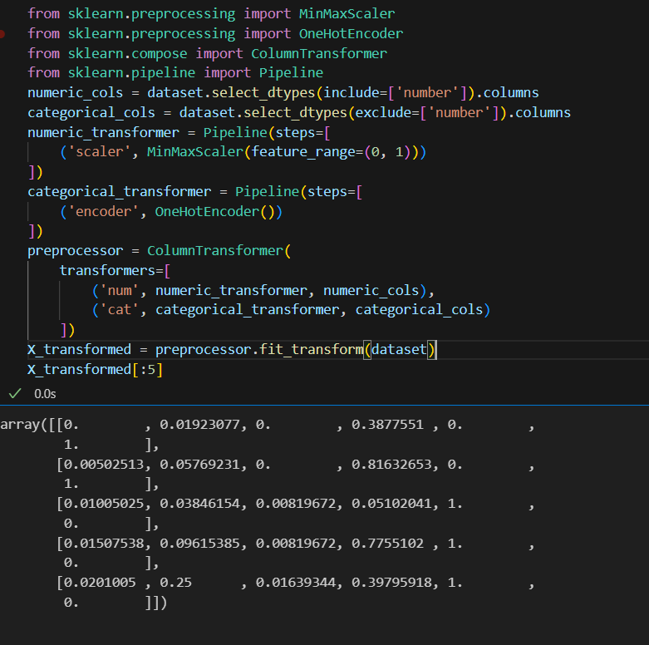



**Data Standardization:**

* Ensuring that data follows a consistent format and structure.
* Date and time format conversion: Converting date and time data into a uniform format.
* Currency conversion: Converting monetary values into a common currency.

**Standardization**

* Standardization is a useful technique to transform attributes with a Gaussian distribution and differing means and standard deviations to a standard Gaussian distribution with a mean of 0 and a standard deviation of 1.
* We can standardize data using scikit-learn with the StandardScalar class.
* It works well when the features have a normal distribution or when the algorithm being used is not sensitive to the scale of the features

**Code:**

from sklearn.preprocessing import StandardScaler

from sklearn.preprocessing import OneHotEncoder

from sklearn.compose import ColumnTransformer

from sklearn.pipeline import Pipeline

numeric_cols = dataset.select_dtypes(include=['number']).columns

categorical_cols = dataset.select_dtypes(exclude=['number']).columns

numeric_transformer = Pipeline(steps=[('scaler', StandardScaler())])

categorical_transformer = Pipeline(steps=[('encoder', OneHotEncoder())])

preprocessor = ColumnTransformer(

transformers=[

('num', numeric_transformer, numeric_cols),

('cat', categorical_transformer, categorical_cols])

X_transformed = preprocessor.fit_transform(dataset)

X_transformed[:5]

**Output:**

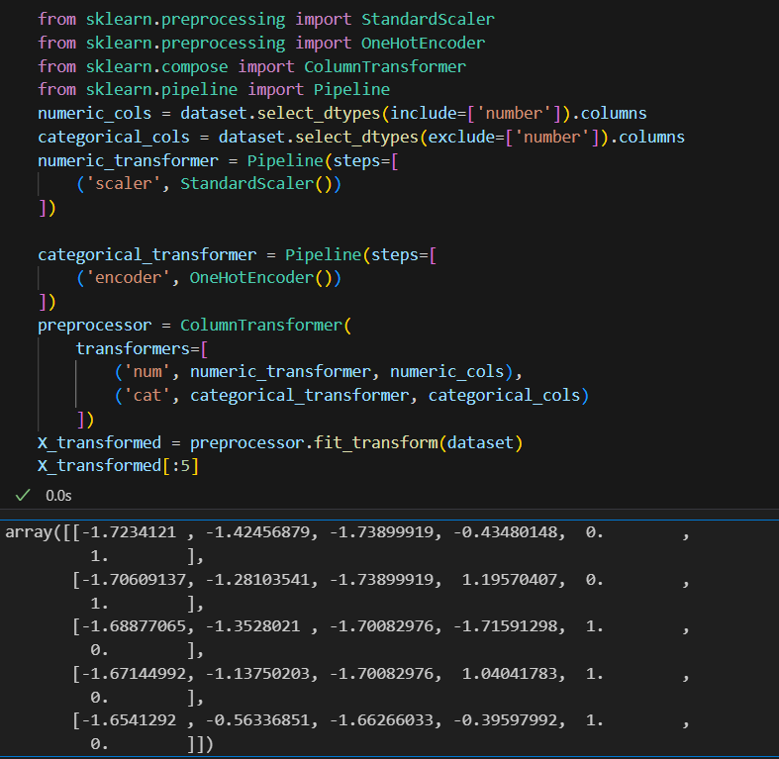

**K-means Clustering Function:**

K-means clustering is a machine learning and data analysis technique used for grouping data points into clusters based on their similarity. It's primarily used for:

* **Unsupervised Learning:** K-means helps identify patterns or structure in data without labelled categories.
* **Segmentation:** It can segment data into distinct groups, making it useful for customer segmentation, image compression, and more.
* **Pattern Recognition:** It's used in pattern recognition tasks, such as image analysis and natural language processing.
* **Anomaly Detection:** It can identify outliers by placing data points that don't fit well into any cluster.
* **Data Compression:** K-means can reduce the dimensionality of data while preserving important information.
* **Recommendation Systems:** It can be applied to recommend items or services based on user preferences.

**Code:**

plt.scatter(x[y_kmeans==0,0],x[y_kmeans==0,1],s=100,c="red",label = "cluster 1")

plt.scatter(x[y_kmeans==1,0],x[y_kmeans==1,1],s=100,c="blue",label = "cluster 2")

plt.scatter(x[y_kmeans==2,0],x[y_kmeans==2,1],s=100,c="green",label = "cluster 3")

plt.scatter(x[y_kmeans==3,0],x[y_kmeans==3,1],s=100,c="cyan",label = "cluster 4")

plt.scatter(x[y_kmeans==4,0],x[y_kmeans==4,1],s=100,c="magenta",label = "cluster 5")

plt.scatter(kmeans.cluster_centers_[:,0],kmeans.cluster_centers_[:,1],s=300,c="yellow",label="centroids")

plt.title("clusters of customers")

plt.xlabel("Annual Income")

plt.ylabel=("Spending Score")

plt.legend()

plt.show()

**Output:**

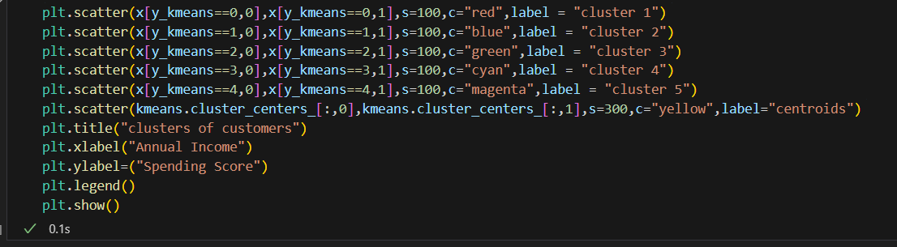

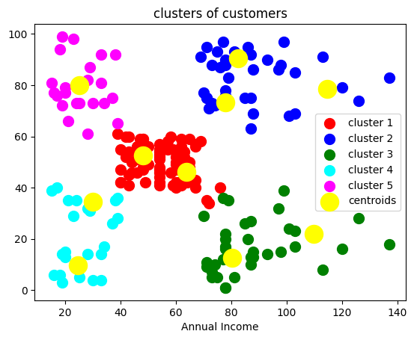

**WCSS Function:**

* WCSS is the sum of the squared distance between each point and the centroid in a cluster.
* When we plot the WCSS with the K value, the plot looks like an Elbow.
* As the number of clusters increases, the WCSS value will start to decrease.

**Code:**

plt.plot(range(1,11),wcss)

plt.title("elbow method")

plt.xlabel("no of cluster")

plt.ylabel("wcss")

plt.show()

**Output:**

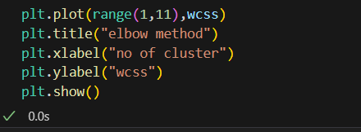

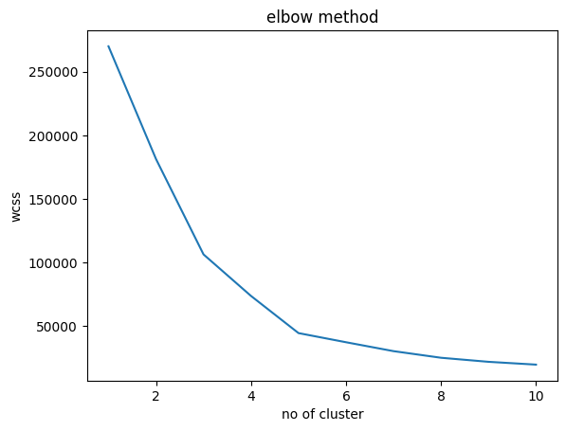

**Dataset.columns :**

* We can use the loc and iloc functions to access columns in a Pandas DataFrame.
* for example the Grades column, we could simply use the loc function and specify the name of the column in order to retrieve it.

**Code:**

dataset.columns

**Output:**

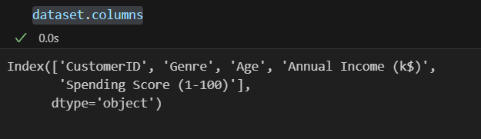

**Memory Function:**

* Pandas**dataframe.memory_usage()** function return the memory usage of each column in bytes.
* The memory usage can optionally include the contribution of the index and elements of object dtype. This value is displayed in DataFrame.info by default.

**Code:**

memory = dataset.memory_usage()

print(memory)

print("Total Memory Usage = ",sum(memory))

**Output:**

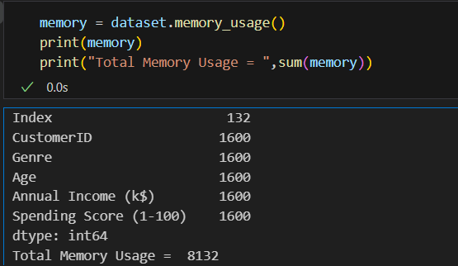

**Dropna() Function:**

* dropna() is a function used in data preprocessing, often in the context of data analysis and cleaning, to remove or drop rows or columns with missing (NaN or null) values from a dataset.
* It's a method to eliminate incomplete or unreliable data from your dataset, which can be important to ensure the quality of your analysis or machine learning models

**Code:**

print("Size before dropping NaN rows",dataset.shape,"\n")

nan_dropped = dataset.dropna()

print(nan_dropped.isnull().sum())

print("\nSize after dropping NaN rows",nan_dropped.shape)

**Output:**

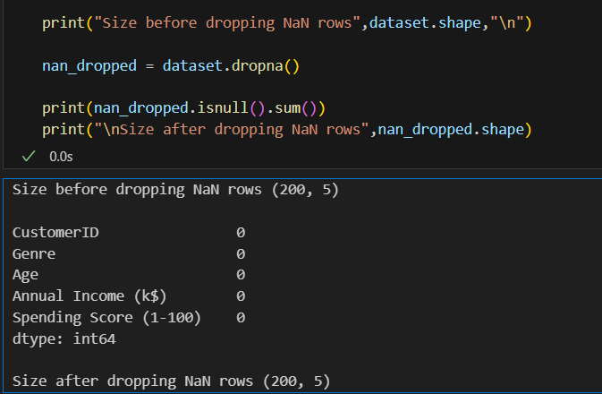

**Iloc() Function:**

The iloc() function is a method in pandas, a popular Python library for data manipulation and analysis. It is primarily used to select and access data in a DataFrame by integer-based indexing.

* Select specific rows and columns from a DataFrame using integer-based indexing.
* Provide a way to slice and filter data by row and column positions.

**Code:**

X = dataset.iloc[:,:-1].values

Y = dataset.iloc[:,3].values

print ('X: %s'%(str(X)))

print ('-----------------------------------')

print ('Y: %s'%(str(Y)))

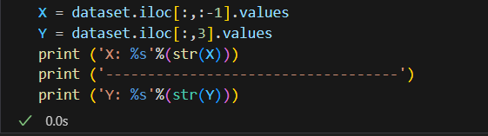**Output:**

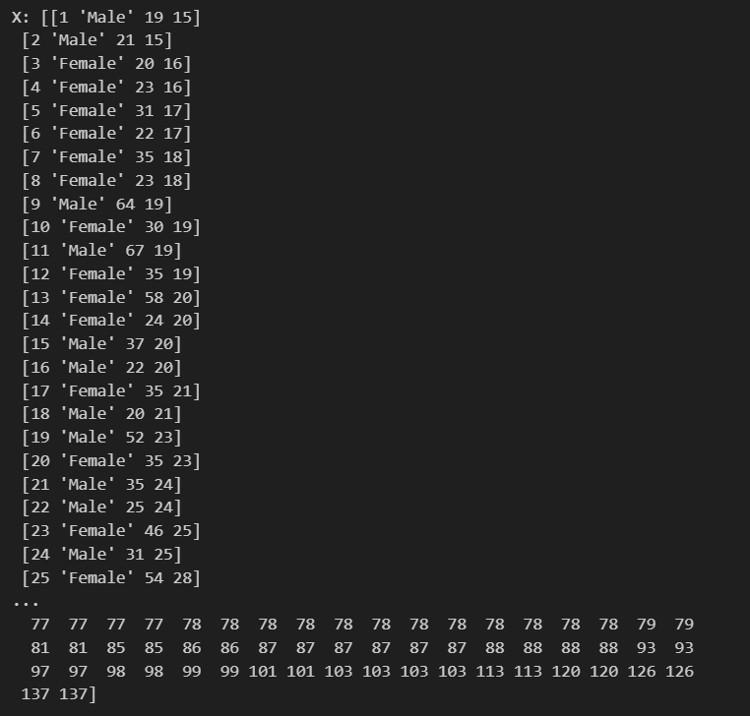

**Subplots Function:**

* Subplots are a feature in data visualization that allow you to create multiple smaller plots within a larger figure.
* They are useful for displaying multiple related visualizations side by side, making it easier to compare and analyze data.
* subplots help you arrange and present multiple charts, graphs, or plots in a single figure, improving the overall clarity and readability of your data visualizations.

**Code:**

fig, axs = plt.subplots()

sns.boxplot(data=dataset,orient='h',palette="Set2")

plt.show()

**Output:**

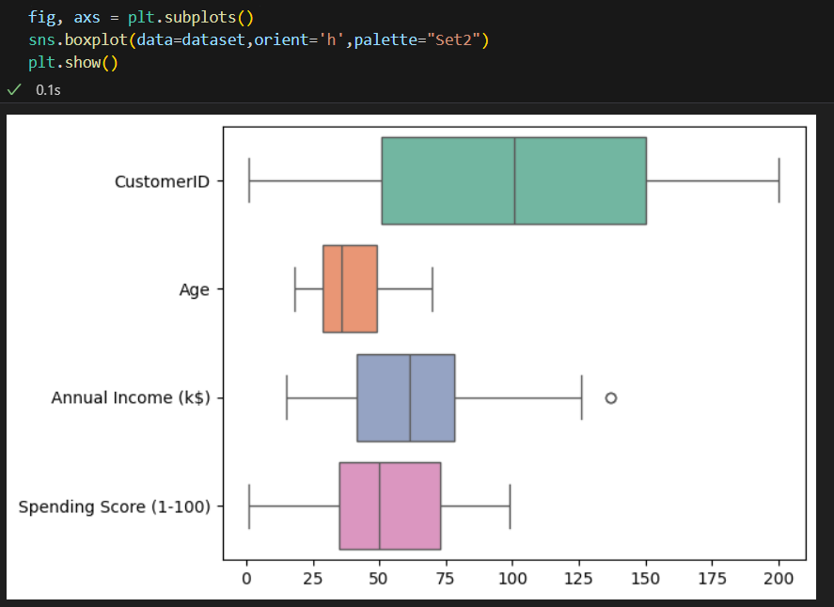

**Missingno Function:**

* "missingno" is a Python library used for visualizing and analyzing missing data in a dataset.
* It provides various visualization tools to quickly understand and identify missing values in your data, allowing you to make informed decisions on how to handle or impute missing data.

Code:

import missingno as msno

msno.matrix(dataset)

plt.figure(figsize = (15,9))

plt.show()

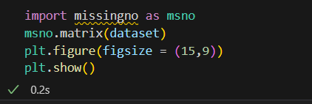Output:

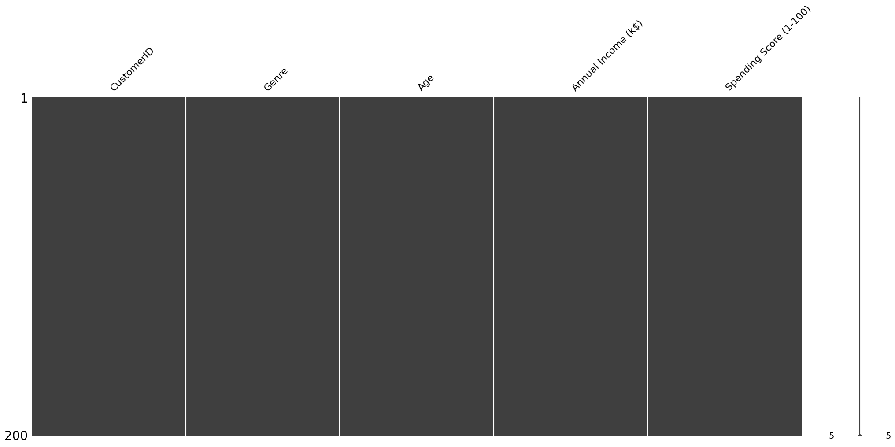

**Code:**

msno.heatmap(dataset, labels = True)

Output:





**Data Scaling:**

* Data scaling, also known as feature scaling or data normalization, is a crucial preprocessing step in data analysis and machine learning.
* It involves transforming the values of different features (variables or columns) in your dataset to a common scale. Here are some important notes about data scaling:
* Data scaling is important because many machine learning algorithms are sensitive to the scale of input features. Rescaling the data helps these algorithms perform better.
* It can help prevent features with larger scales from dominating or biasing the learning process.

**Importing the required libraries:**

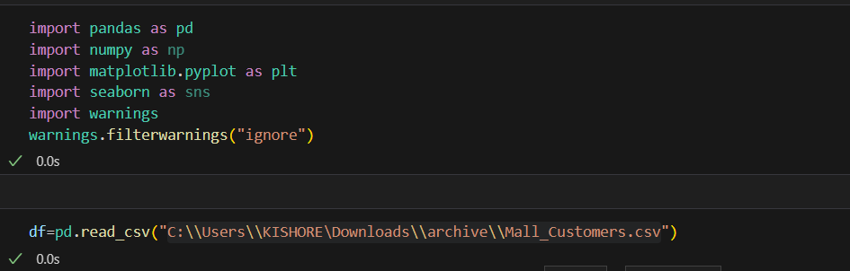

**Code:**

import pandas as pd

import numpy as np

import matplotlib.pyplot as plt

import seaborn as sns

import warnings

warnings.filterwarnings("ignore")

df=pd.read_csv("C:\\Users\\KISHORE\Downloads\\archive\\Mall_Customers.csv")

**Standardization**

* Standardization is a scaling technique where the values are centered around the mean with a unit standard deviation.
* This means that the mean of the attribute becomes zero and the resultant distribution has a unit standard deviation.

**Code**:

import pandas as pd

from sklearn.preprocessing import MaxAbsScaler

# Read the data

df = pd.read_csv("C:\\Users\\KISHORE\\Downloads\\archive\\Mall_Customers.csv")

# Drop the 'Age' column

df.drop("Age", axis=1, inplace=True)

# Select only the numeric columns for scaling

numeric_columns = [ 'Annual Income (k$)', 'Spending Score (1-100)']

numeric_data = df[numeric_columns]

# Apply MaxAbsScaler to the numeric data

maxabsscaler = MaxAbsScaler()

scaled_data = pd.DataFrame(maxabsscaler.fit_transform(numeric_data), columns=numeric_columns)

# Combine the scaled numeric data with the non-numeric data

df = pd.concat([df.drop(numeric_columns, axis=1), scaled_data], axis=1)

ax=df.plot.scatter(x="Spending Score (1-100)",y="Annual Income (k$)",marker="*",label="Before-Scaling",color="red")

df.plot.scatter(x="Spending Score (1-100)",y="Annual Income (k$)",marker="+",label="After-Scaling",ax=ax)

plt.axhline(0, color='red',alpha=0.2)

plt.axvline(0, color='red',alpha=0.2);

plt.show()

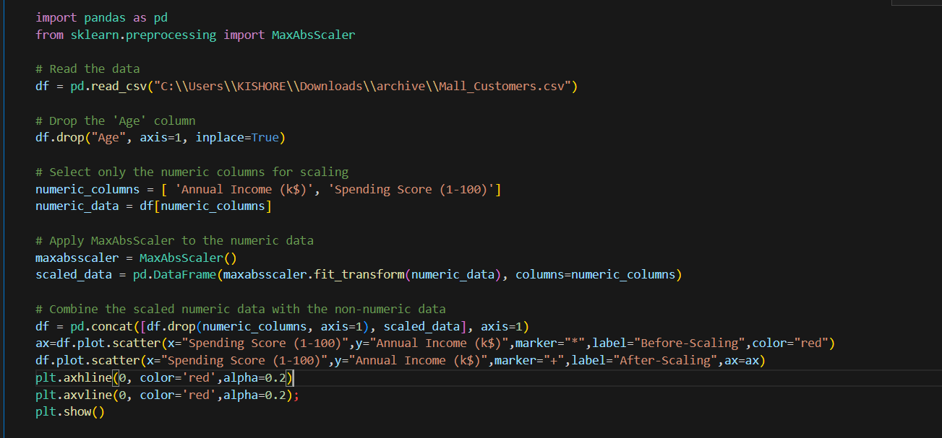**Output**:

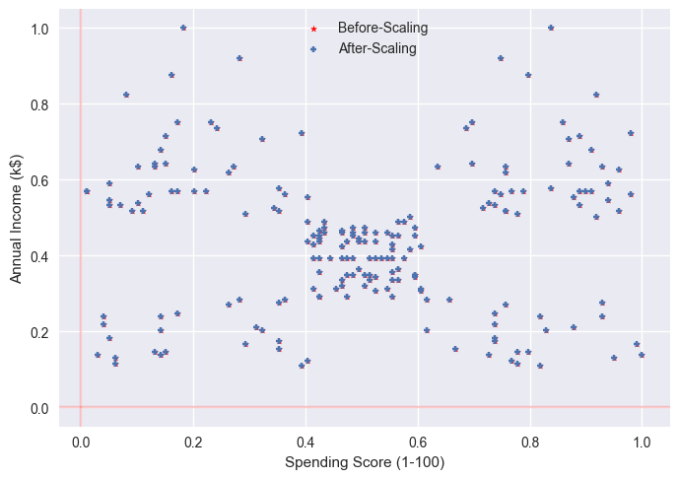

**Scatter plot standardization:**

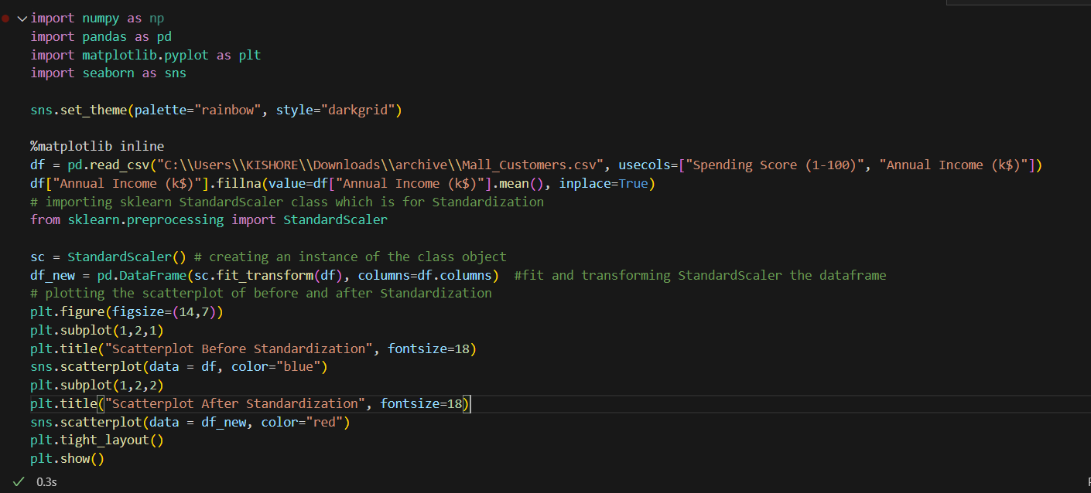

**Output**:

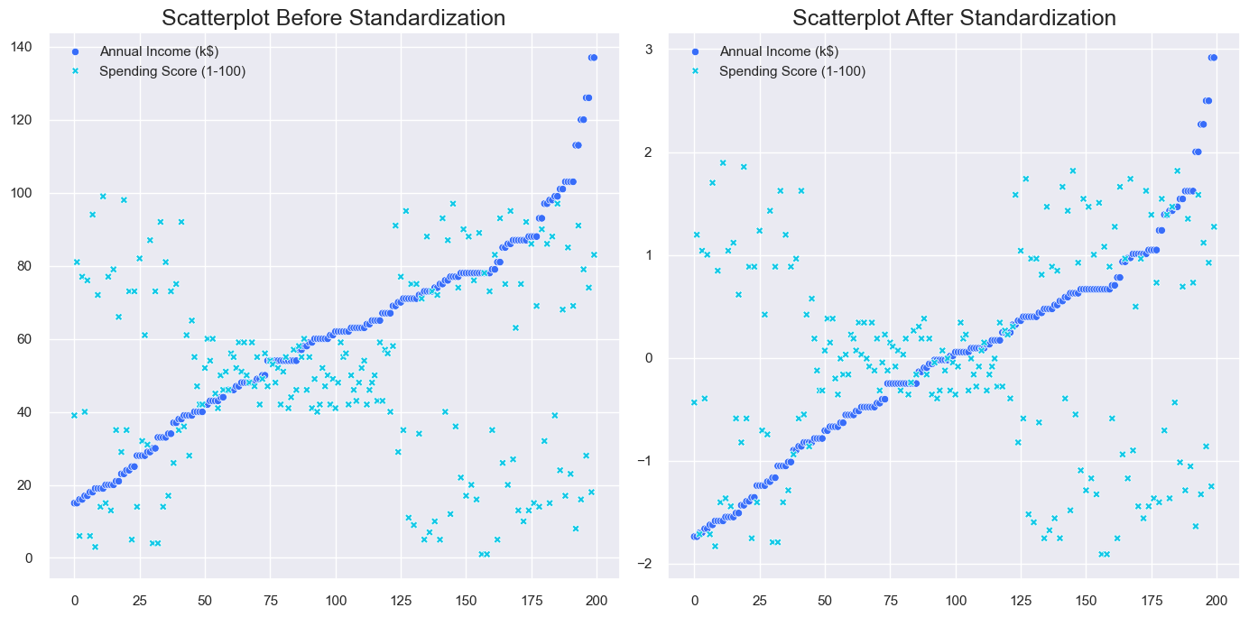

**PDF standardization:**

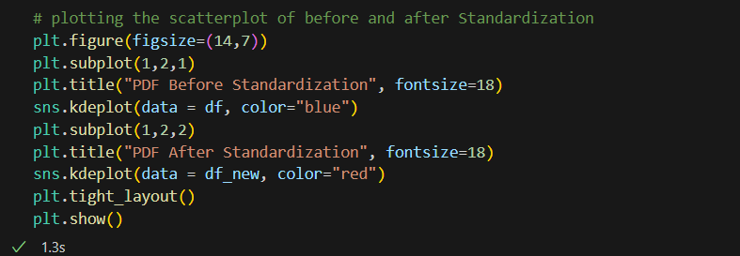

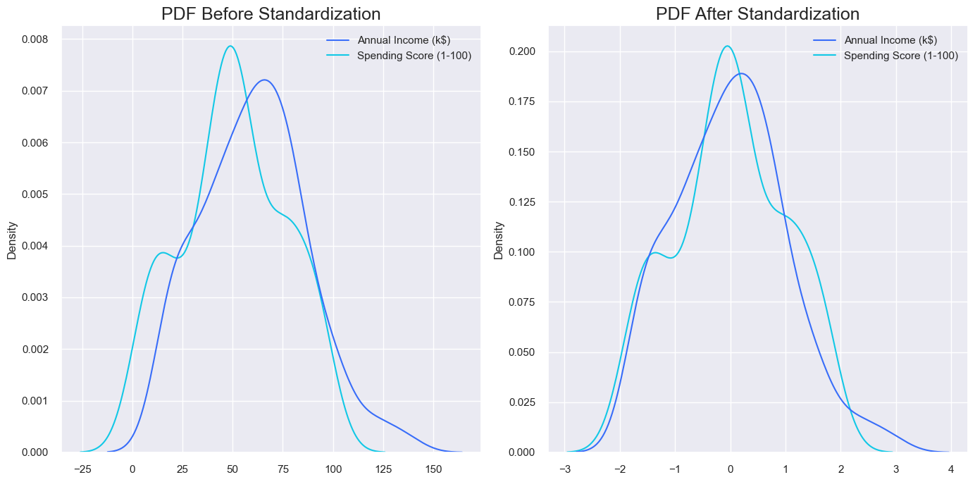**Output:**



**Normalization**

* Normalization is a technique often applied as part of data preparation for machine learning.
* The goal of normalization is to change the values of numeric columns in the dataset to use a common scale, without distorting differences in the ranges of values or losing information.

**Min Max Scaling**

* Min-max normalization is one of the most common ways to normalize data.
* For every feature, the minimum value of that feature gets transformed into a 0, the maximum value gets transformed into a 1, and every other value gets transformed into a decimal between 0 and 1.

**Scatter plot Min Max Scaling**

**Code:**

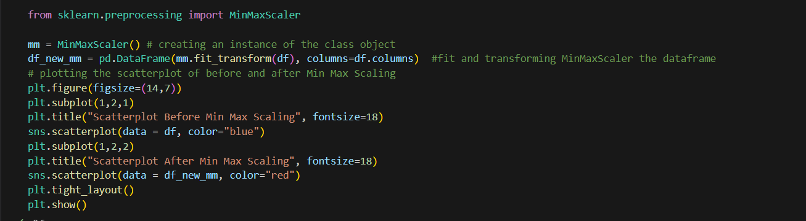

**Output**

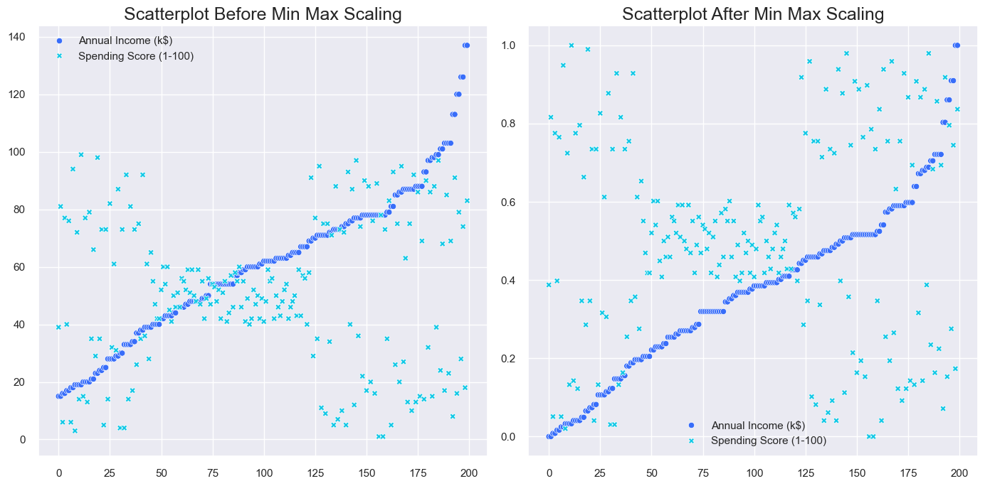

**PDF Min Max Scaling:**

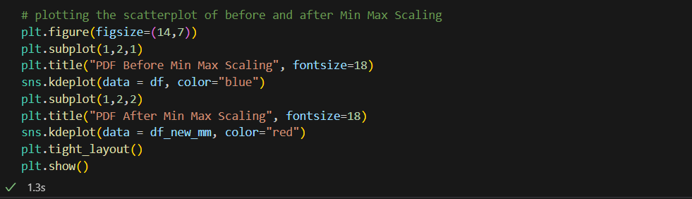**Code:**

**Output:**

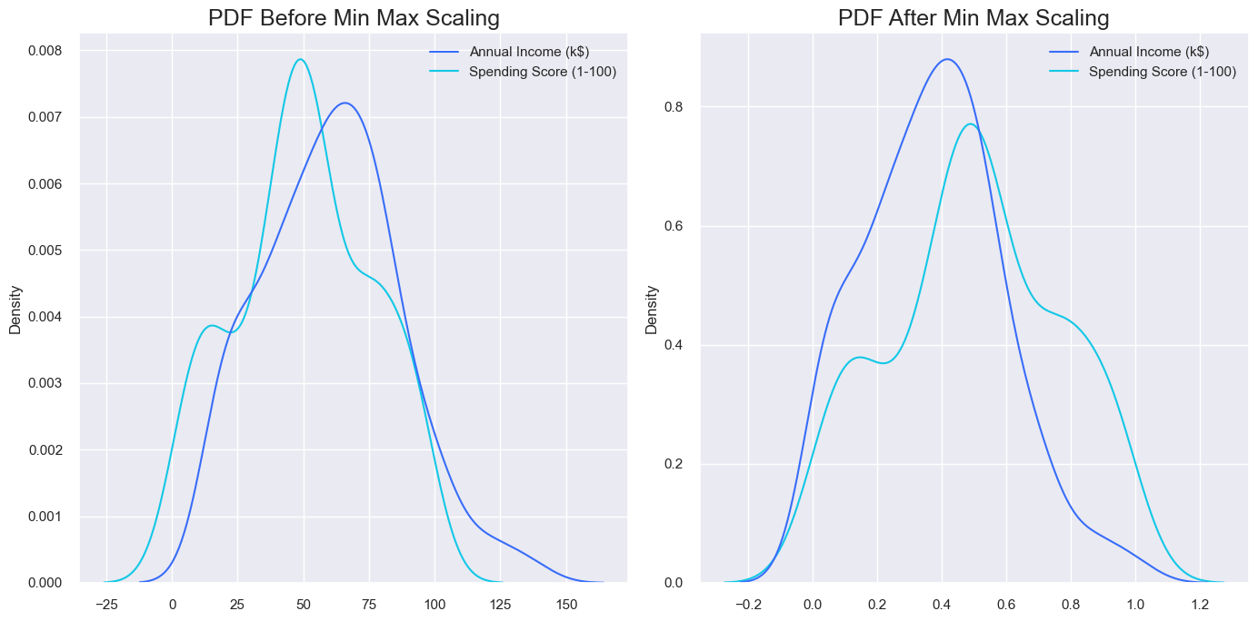

**Max Absolute Scaling**

* Scale each feature by its maximum absolute value.
* This estimator scales and translates each feature individually such that the maximal absolute value of each feature in the training set will be 1.0.
* It does not shift/center the data, and thus does not destroy any sparsity.
* This scaler can also be applied to sparse CSR or CSC matrices.

**Scatter Plot Max Absolute Scaling:**

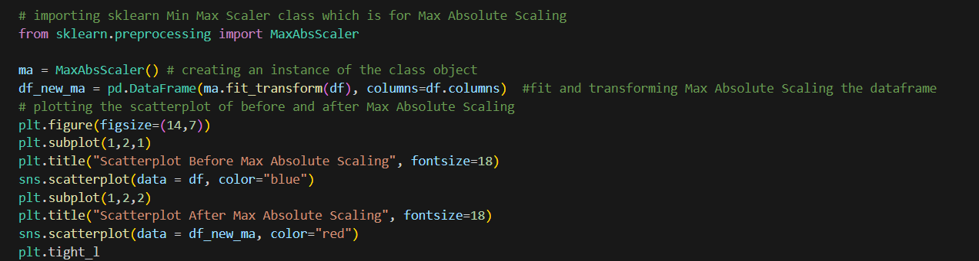**Code:**

**Output:**

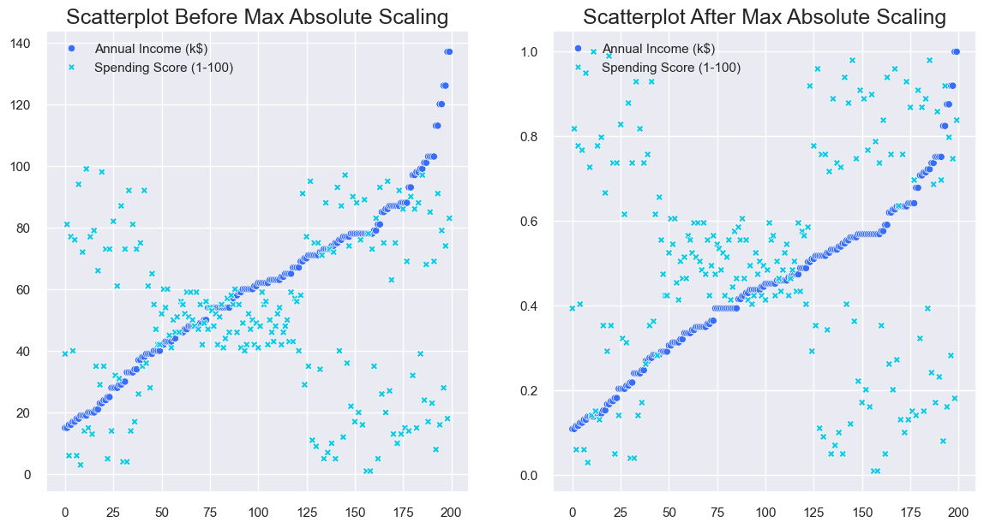

**PDF Max Absolute Scaling:**

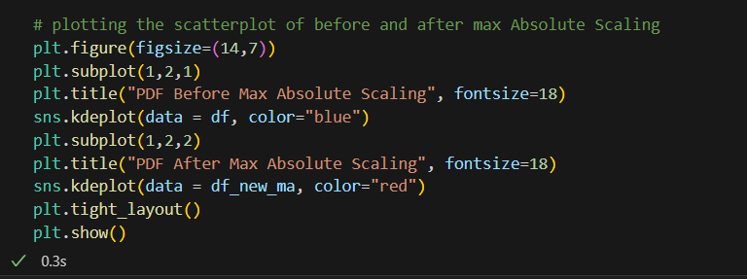

**Output:**

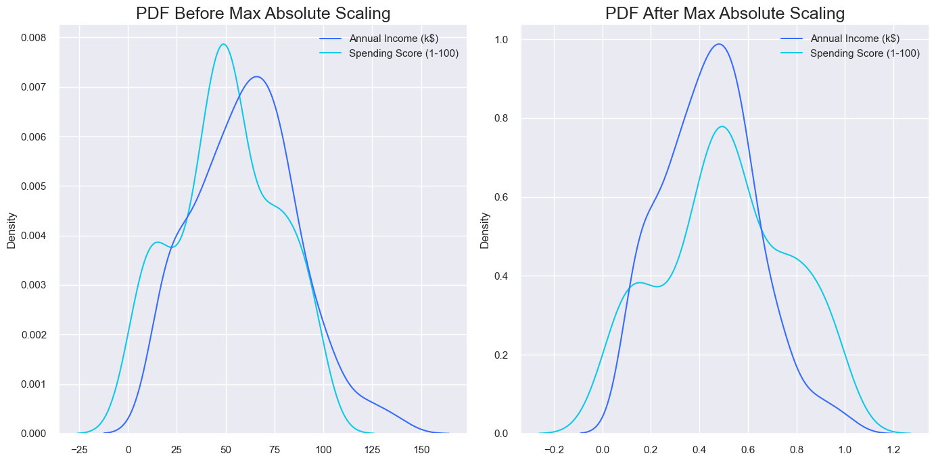

**Robust Scaling**

* This Scaler removes the median and scales the data according to the quantile range (defaults to IQR: Interquartile Range).
* The IQR is the range between the 1st quartile (25th quantile) and the 3rd quartile (75th quantile).

**Scatter Plot Robust Scaling**

**Code**:

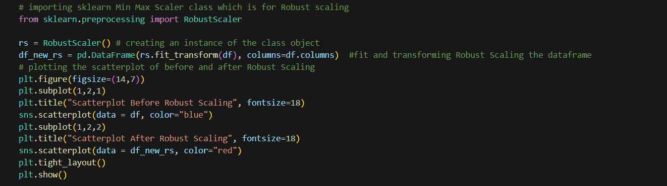

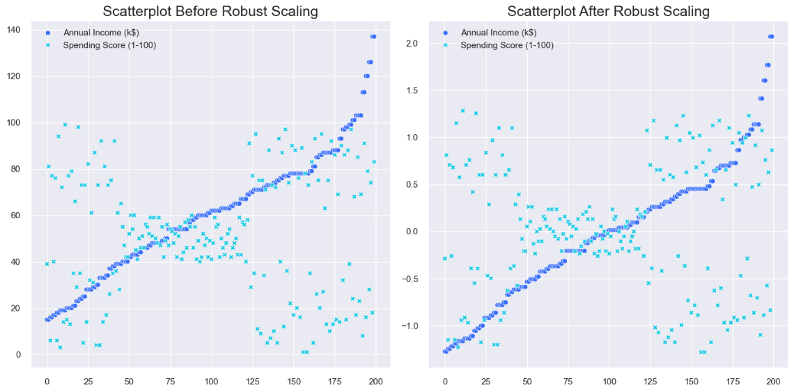

**PDF Robust Scaling**

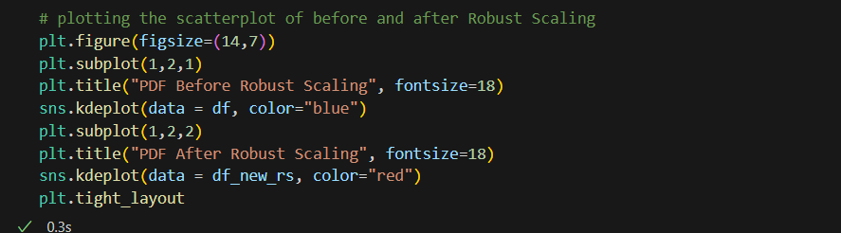

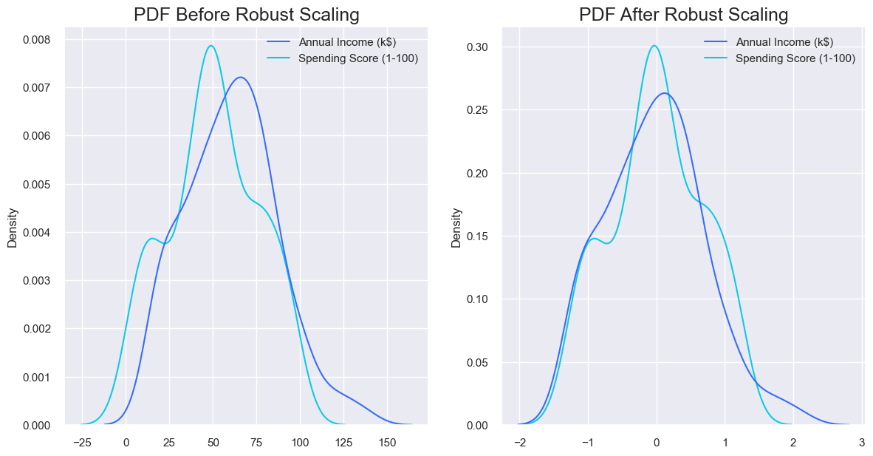

**Splitting the Data set:**

* A train test split is when you split your data into a training set and a testing set.
* The training set is used for training the model, and the testing set is used to test your model.
* This allows you to train your models on the training set, and then test their accuracy on the unseen testing set.
* There are a few different ways to do a train test split, but the most common is to simply split your data into two sets.
* For example 80% for training and 20% for testing. This ensures that both sets are representative of the entire dataset, and gives you a good way to measure the accuracy of your models.

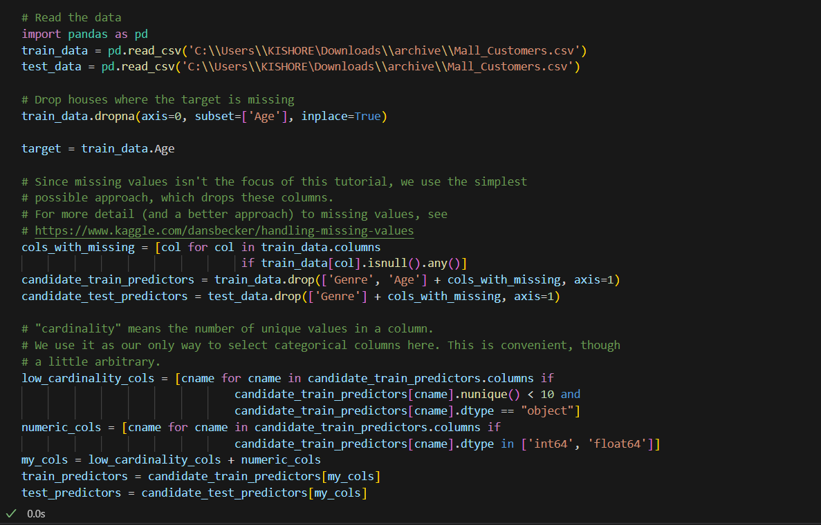**Code:**

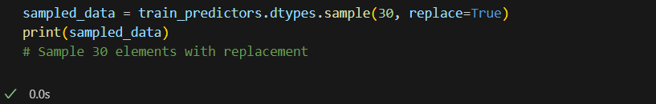

**Output:**

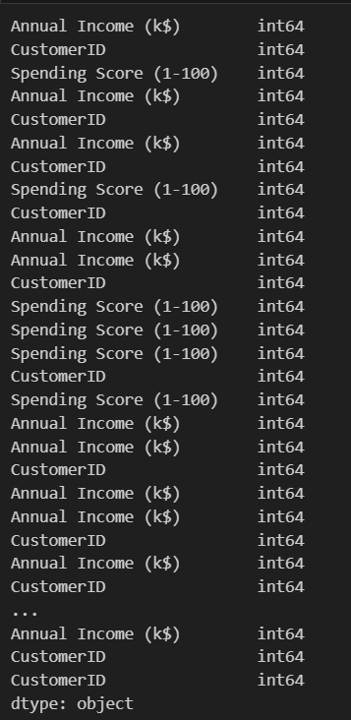

**Reading the Trained dataset:**

* The head() function in R is used to display the first n rows present in the input data frame.
* In this section, we are going to get the first n rows using head() function

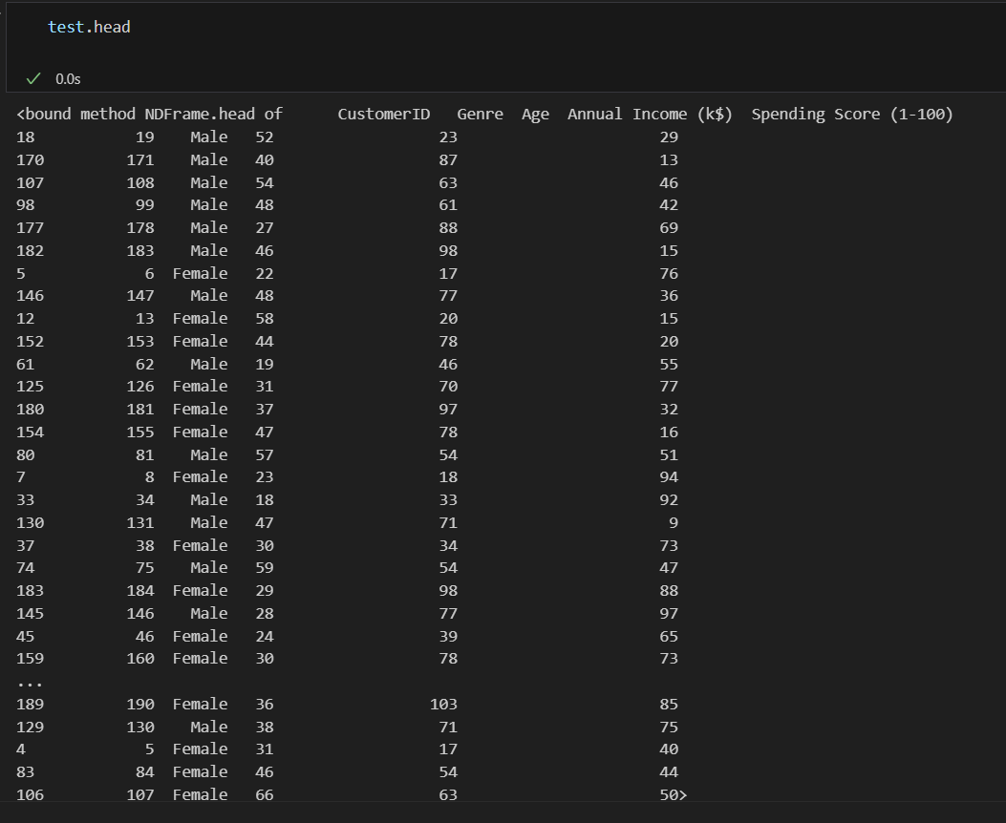

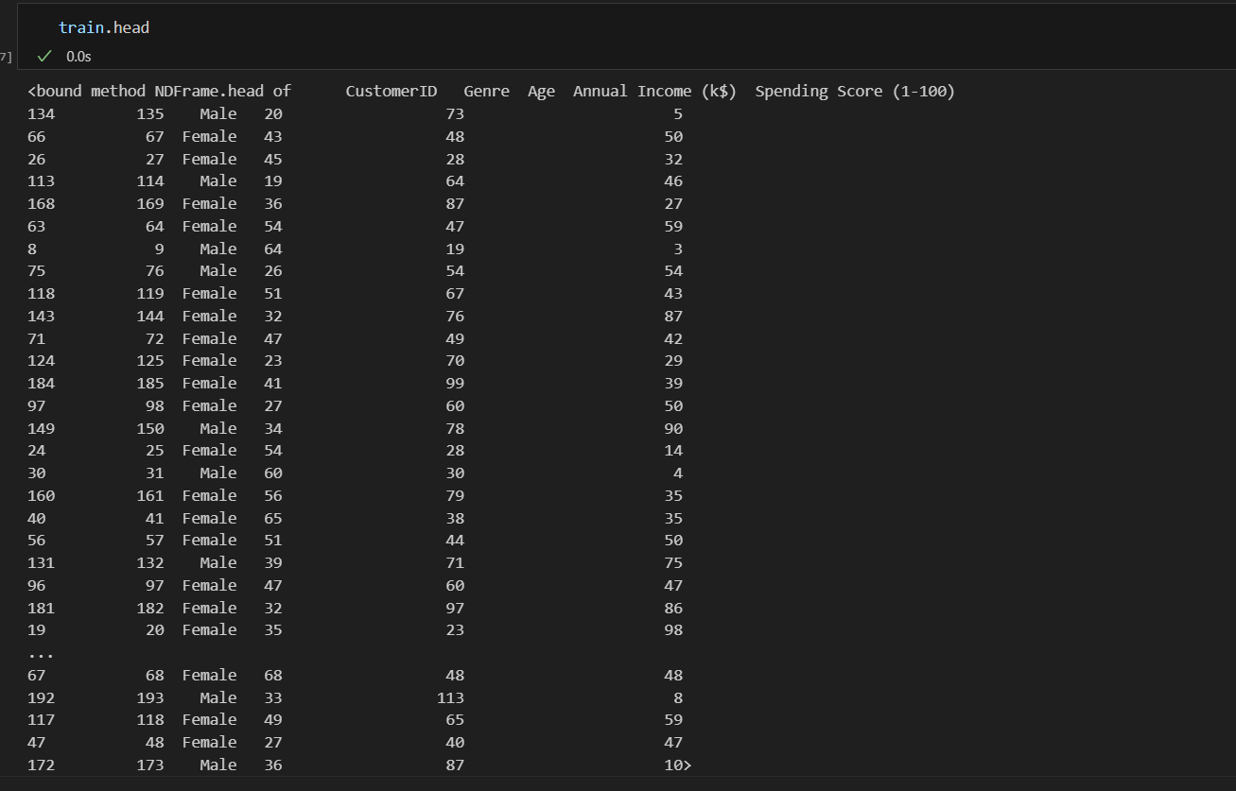

**Info()**

* To get the Information of the trained dataset

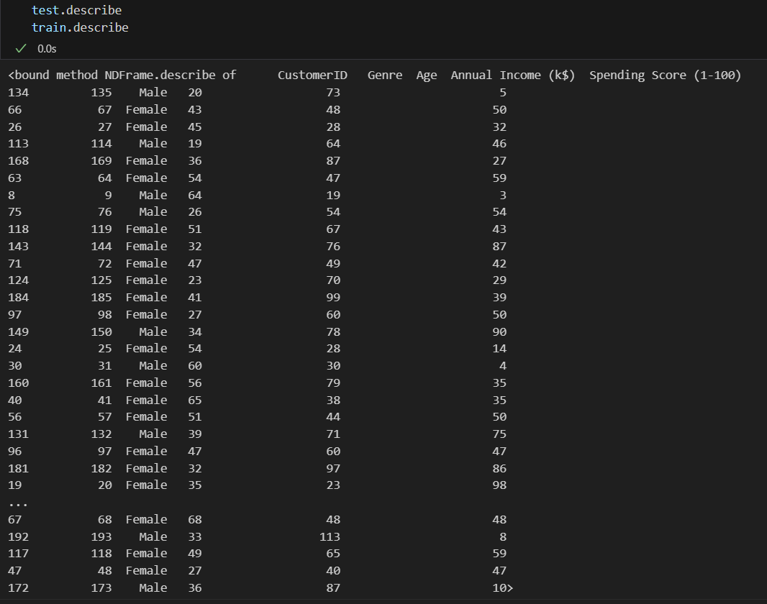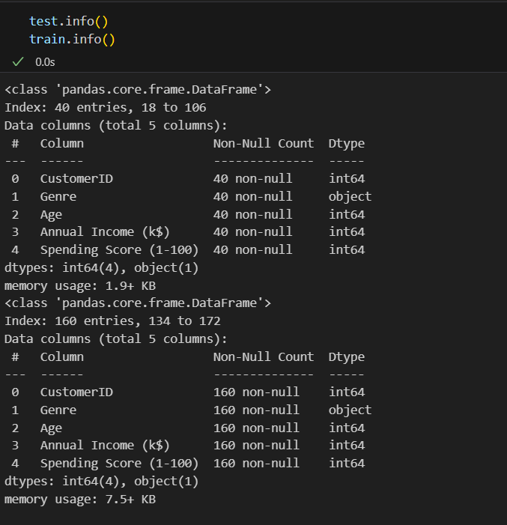

**One-hot encoding**

* One-hot encoding can be used to transform one or more categorical features into numerical dummy features useful for training machine learning model.
* 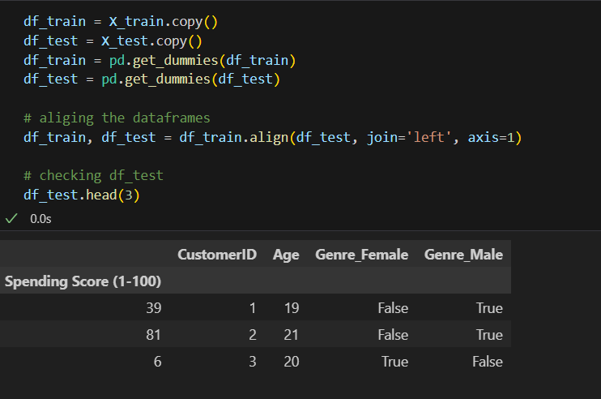One-hot encoding is also called dummy encoding due to the fact that the transformation of categorical features results into dummy features. OneHotEncoder class of sklearn