ASSINGMENT-10.6-

1. Write a pig script to find the minimum temperature observed in a given weather station in a particular year.

Code

A = load ‘temerature’ using PigStorage(‘,’) as (code:chararray, date:chararray, type:chararray,temp:int);

B = FILTER A by type == ‘TMIN’;

C = group B by code;

D = foreach C generate (group,MIN(B.temp));

Dump D;

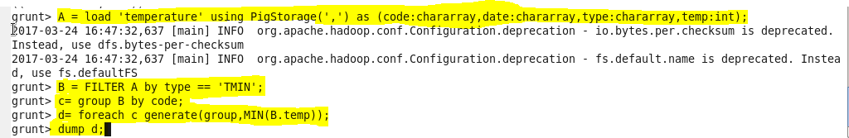

Output-

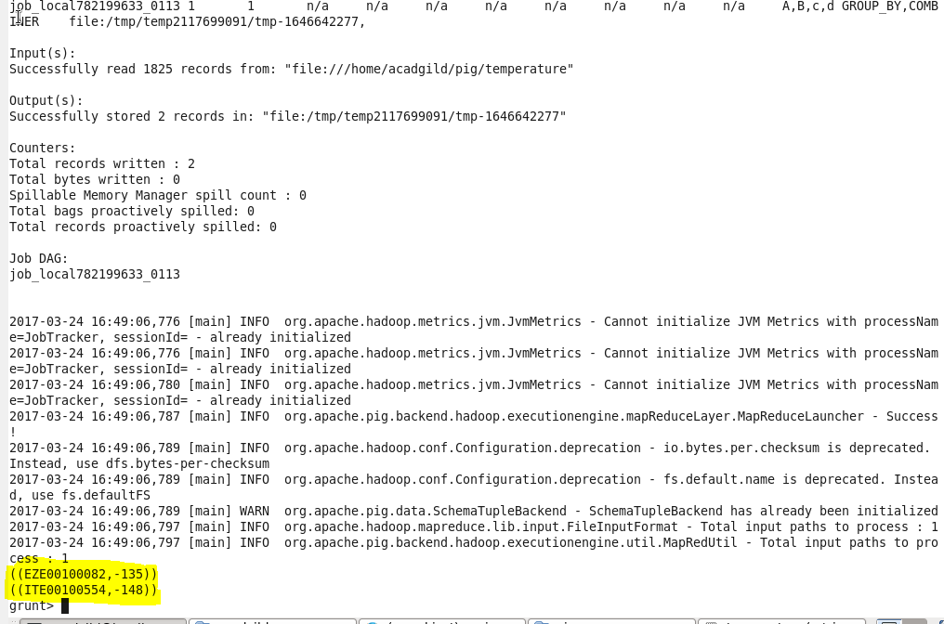

1. Write a pig script to find the maximum temperature observed in a given weather station in a particular year.

Code-

A = load ‘temperature’ using PigStorage(‘,’) as (code:chararray,date:chararray,type:chararray,temp:int);

B = FILTER A by type == ‘TMAX’;

C = group B by code;

D = foreach C generate(group,MAX(B.temp));

dump D;

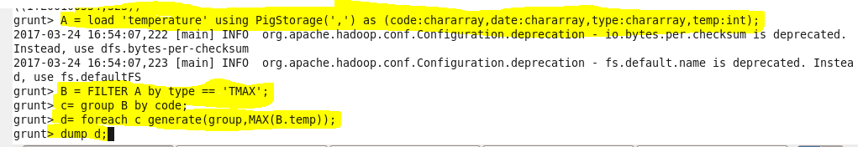

Output-

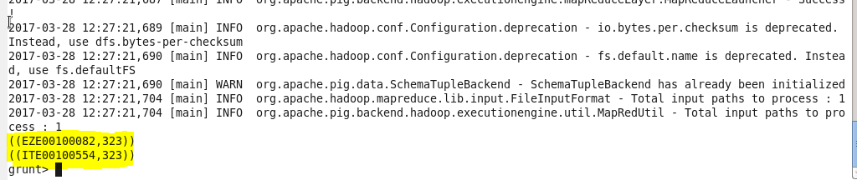

1. Write a pig script to find the number of readings given by each weather station according to the dataset.

**Code-**

A = load ‘temperature’ using PigStorage(‘,’) as (code:chararray,date:chararray,tepe:chararray,temp:int);

C = group A by code;

D = froeach C generate(group,COUNT(A.temp));

Dump D;

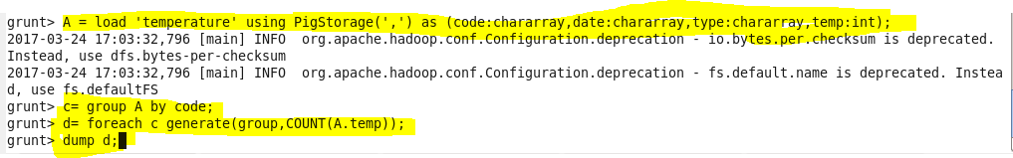

**Output-**

