**QUE-11.3- Write a Pig UDF To find the tweets posted by @realDonaldTrump from the given dataset.**

**ANS-11.3-**

**UDF CODE-**

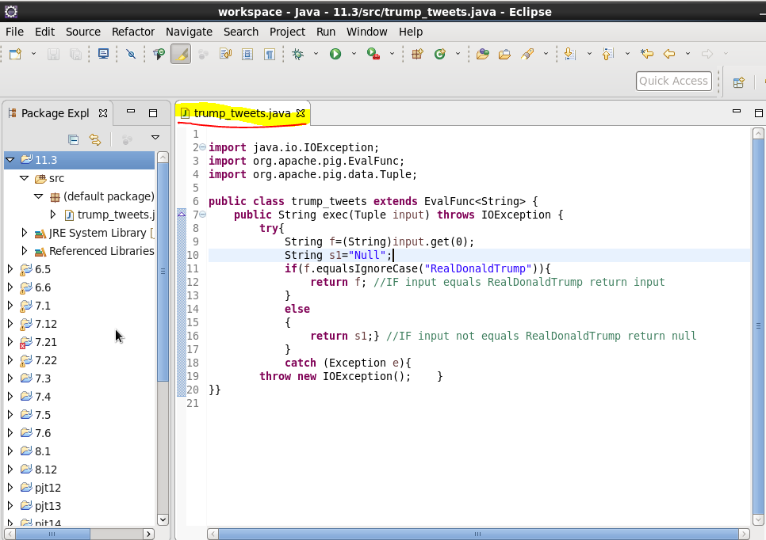

**.**

**Pig code -**

**UDF jar file-**



**LOAD COMMAND-**

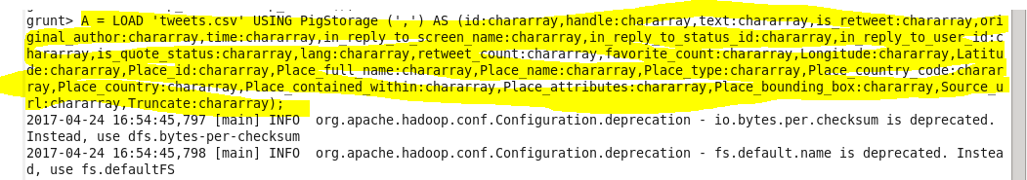

**COUNT FUNCTION-**

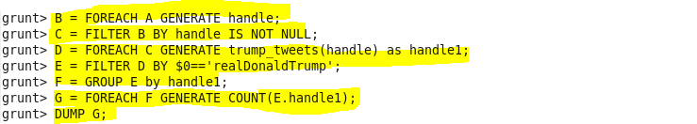

**OUTPUT -**

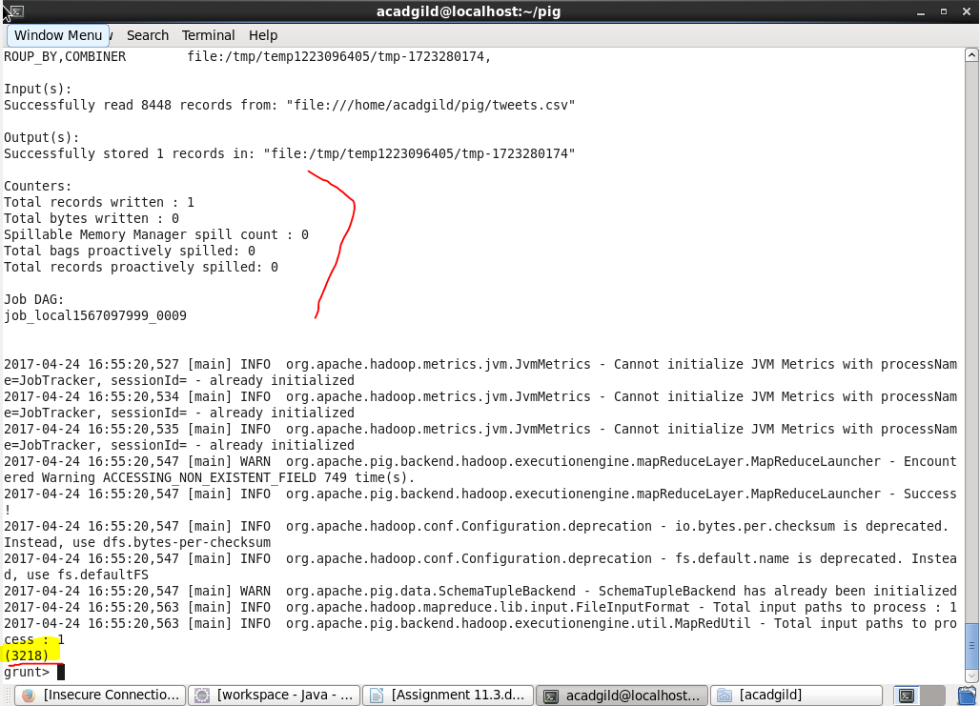

**So total tweets from RealDonaldTrump =3218.**