**QUE-11.4- Twitter data analysis Write a pig script to find the count of each Hashtag in the dataset. You can download the twitter data from the below link**

**ANS-11.4-**

**Dataset -**

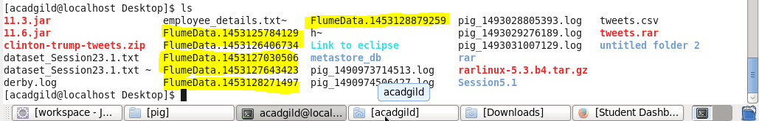

**pig script-**

1. **For file FlumeData.1453125784129**

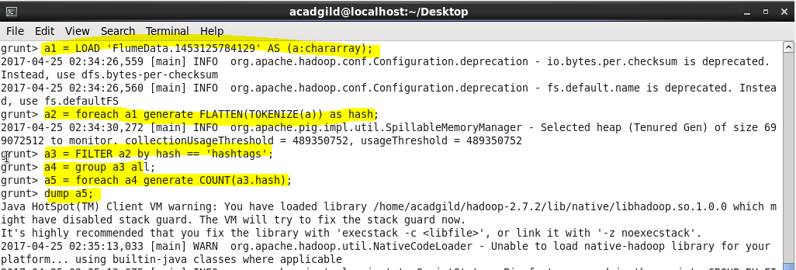

**Output -**

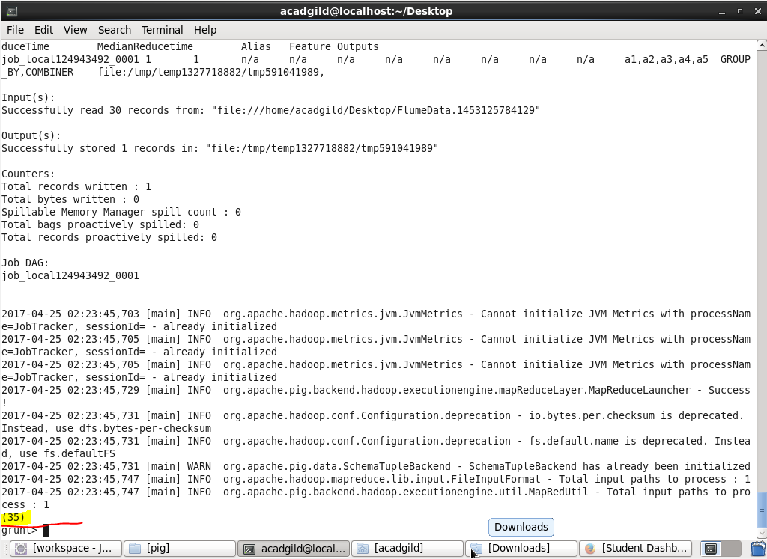

**So total hashtags in file 1=35.**

1. **For file FlumeData.1453126406734**

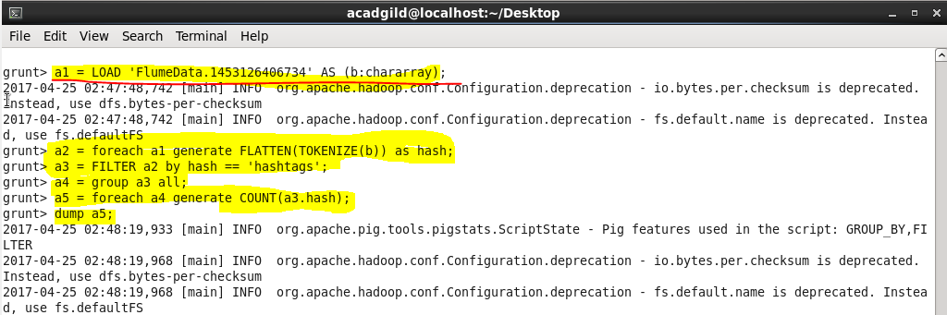

**Output -**

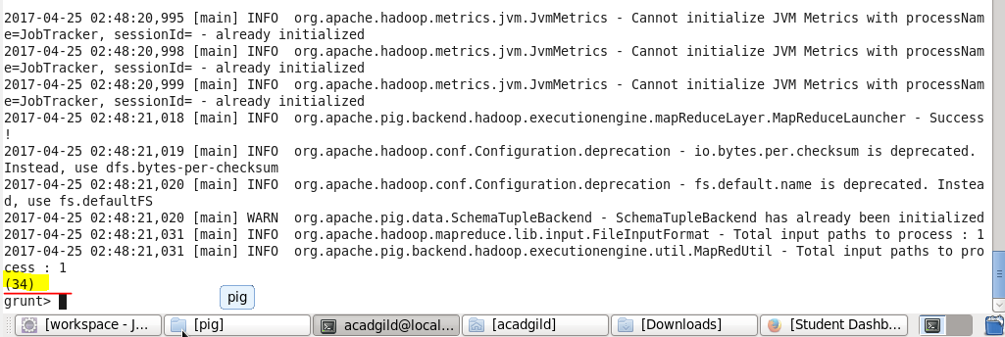

**So total hashtags in file 2=34.**

1. **For file FlumeData.1453127030506**

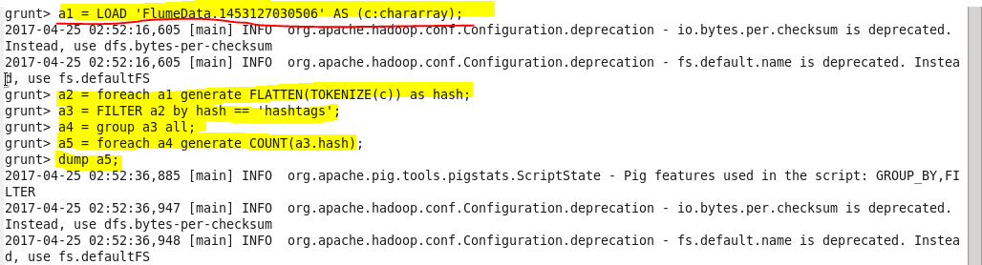

**Output -**

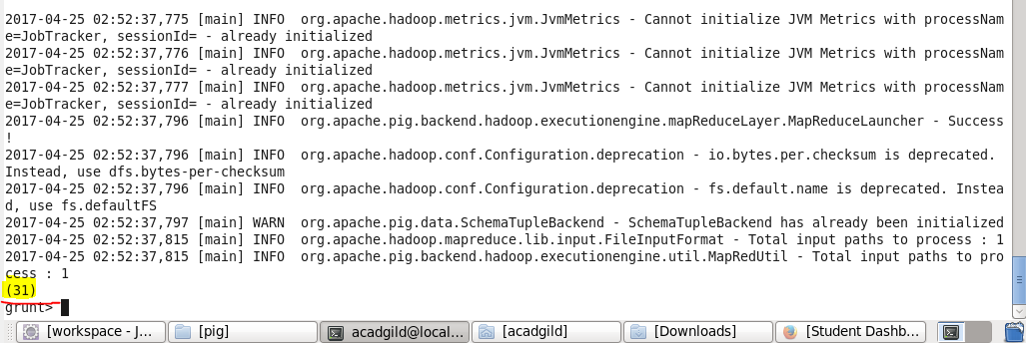

**So total hashtags in file 3= 31.**

1. **For file FlumeData.1453127643423**

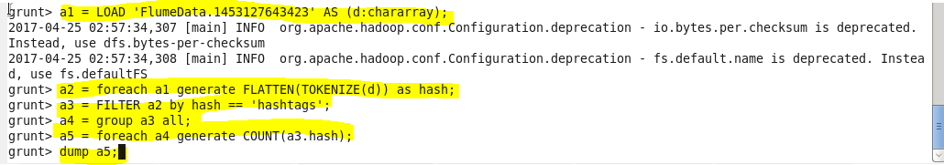

**Output -**

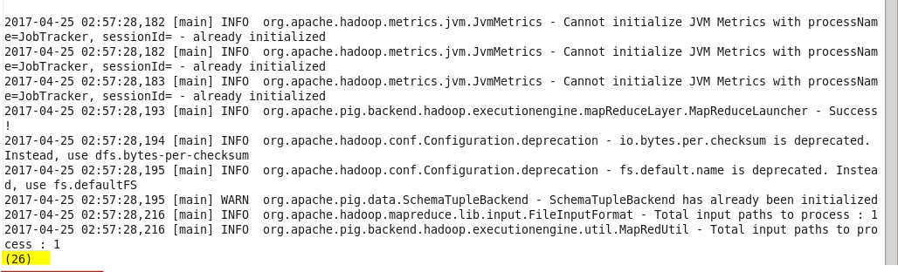

**So total hashtags in file 4 =26.**

1. **For file FlumeData.1453128271497**

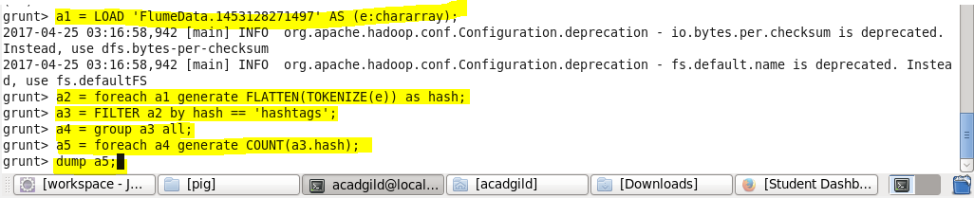

**Output -**

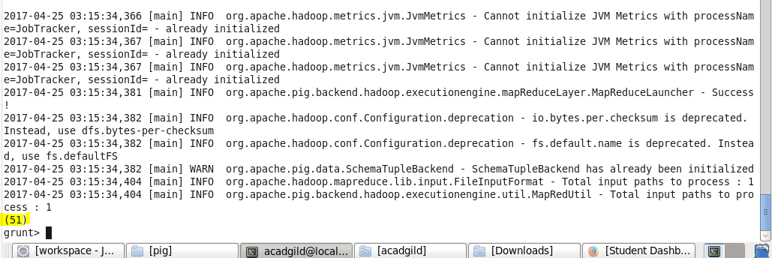

**So total hashtags in file 5=51.**

1. **For file FlumeData.1453128879259**

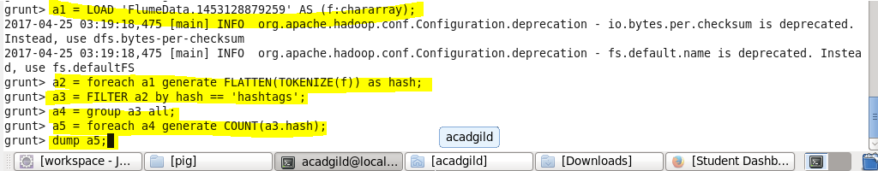

**Output -**

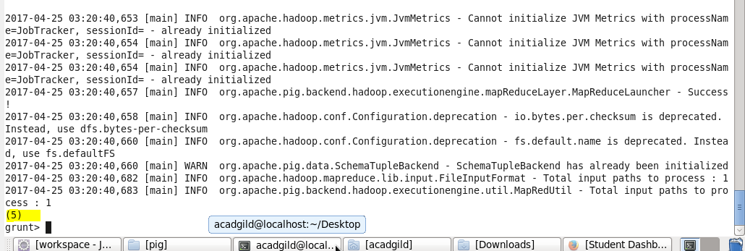

**So total hashtags in file 6 = 5**