**QUE-11.6- Find the top five kinds of GoogleKnowlege_Occupation people who were guests in the show, in a particular time period i.e., between '1/11/99' and 6/11/99. You need to write an UDF to compare the dates**

**ANS-11.6-**

**UDF-**

**CODE -**

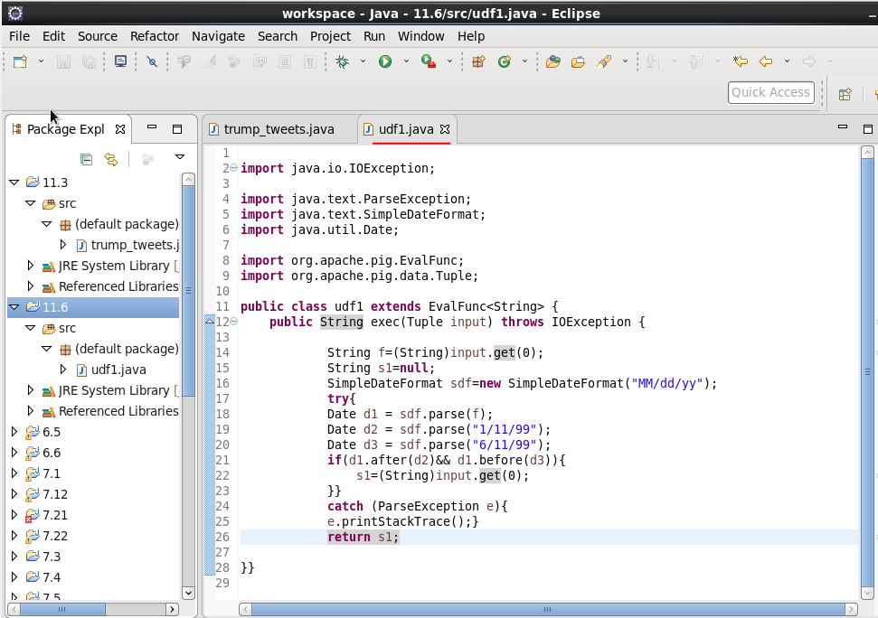

**PIG COMMANDS-**



**LOAD command-**

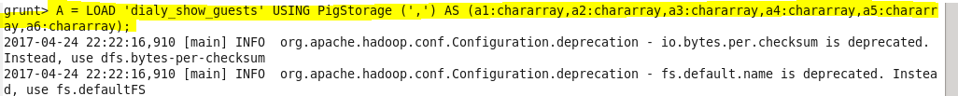

**COUNT FUNCTION-**

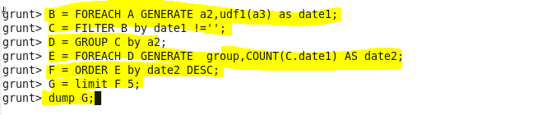

**OUTPUT -**

