**QUE-20.1- Enhance the MapReduce program of Task 8 (refer session 19, assignment 3) to use multiple reducers for sorting. The driver should accept three additional values: the minimum units sold, the maximum units sold and number of reducers to use.**

**ANS-20.1-**

**DRIVER CLASS-**

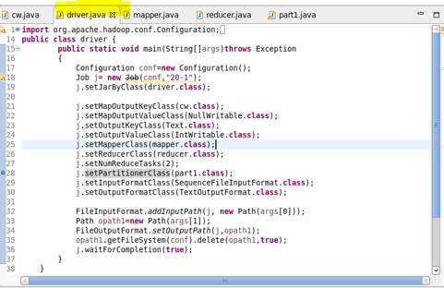

**MAPPER CLASS-**

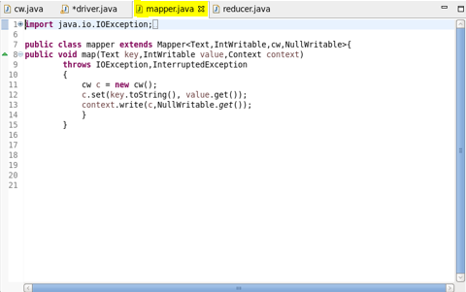

**REDUCER CLASS-**

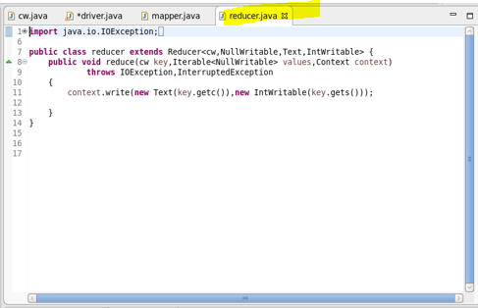

**CUSTOM_KEY CLASS-**

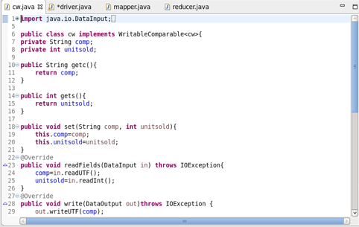

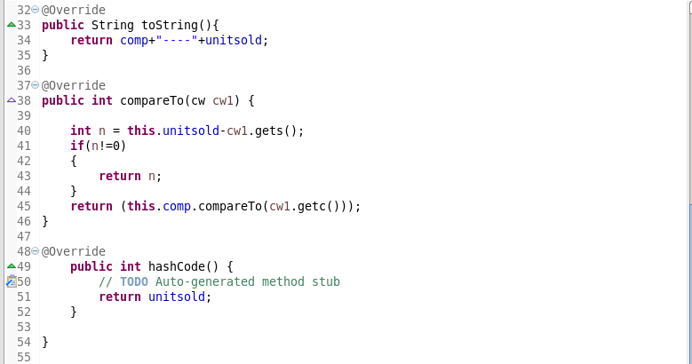

**PARTITIONER CLASS-**

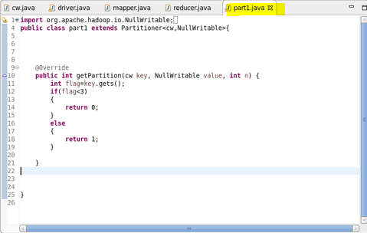

**EXECUTION COMMAND-**

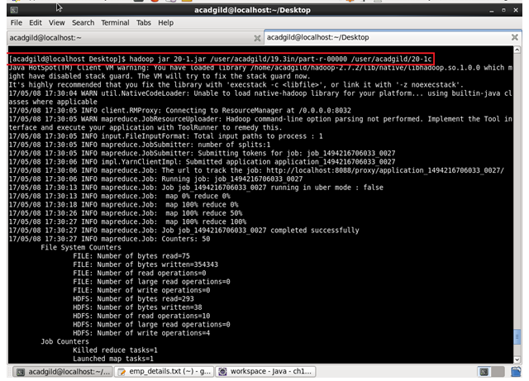

**OUTPUT-**

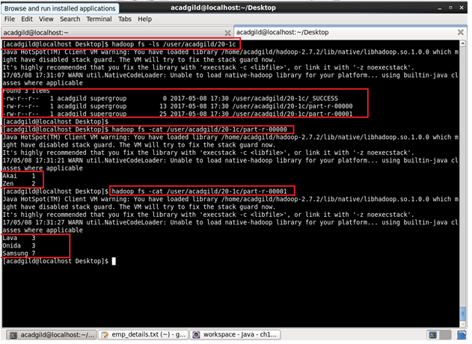

**DATASET-**

