**QUE-29.1- Write a hive UDF that implements functionality of string concat_ws(string SEP, array). This UDF will accept two arguments, one string and one array of string. It will return a single string where all the elements of the array are separated by the SEP.**

**ANS-29.1-**

**Java code to return all elements of the array separated by separator.**

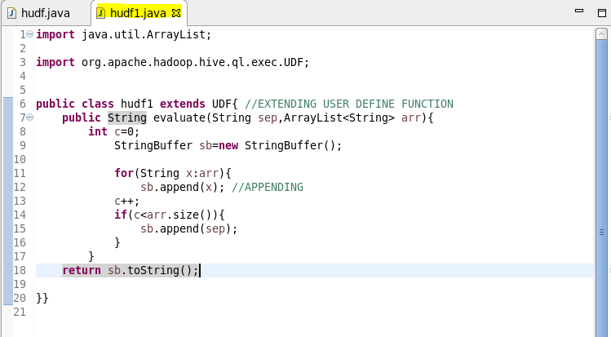

**Adding the jar file-**

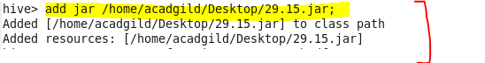

**Creating a table -**

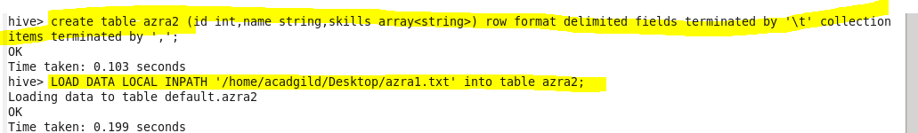

**Creating temporary function ‘conc5’- **

* **Describing the table-**

**Performing basic select operation.**

**Describe table we created for the given problem using desc and then using select all we can show the data in our table.**

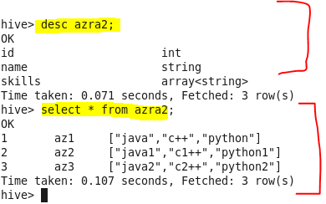

**Retrieving data using temporary function we created-**

