**QUE-33.1- Write Java client API to perform following operations:**

**● Create the method name get record and use get class to retrieve one record at a time record from company table.**

**● Create the method name display and use scan class to display all records from company table.**

**ANS-33.1-**

**Here is the Java code-**

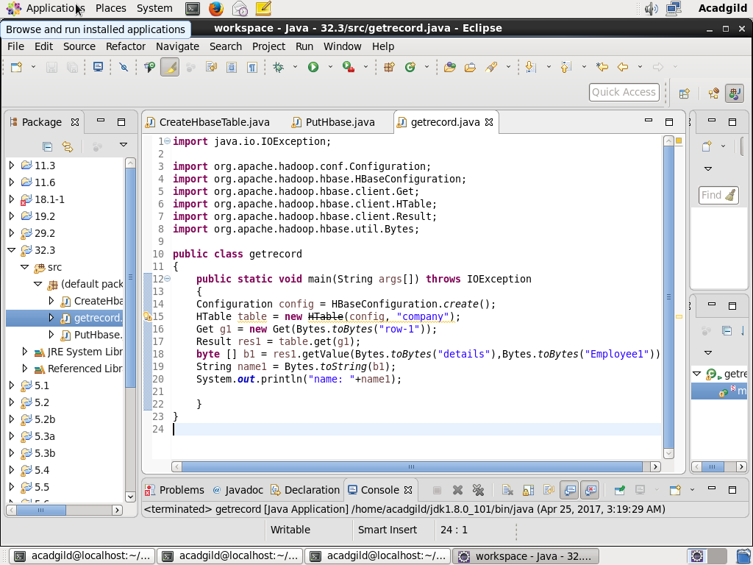

**output-**

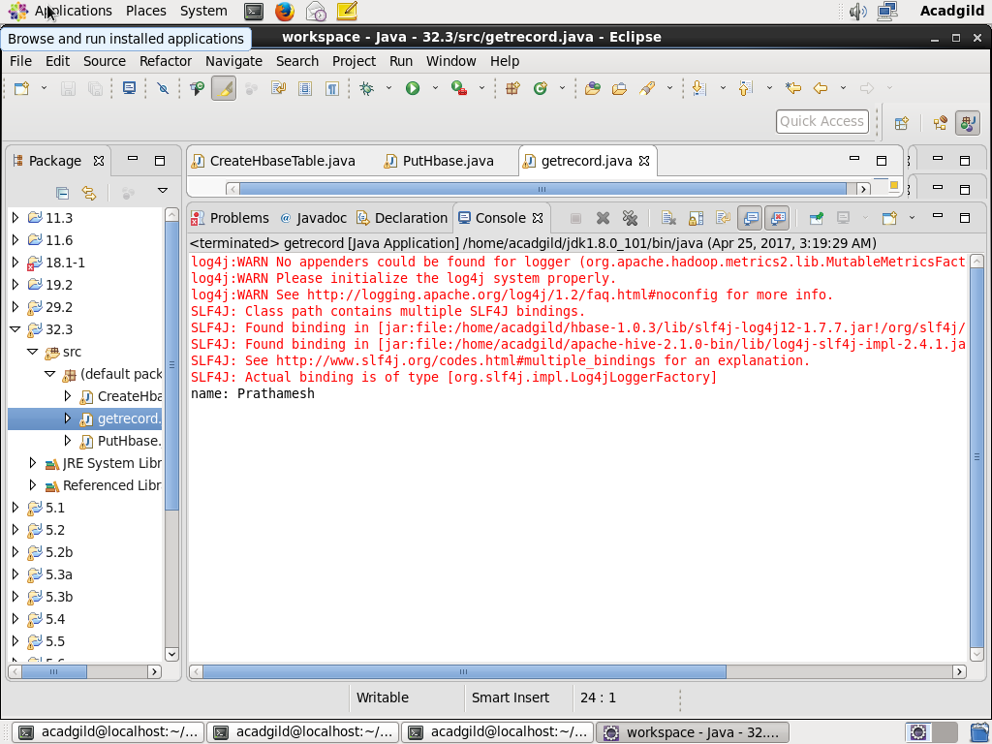

**Checking contents of company table using scan command-**

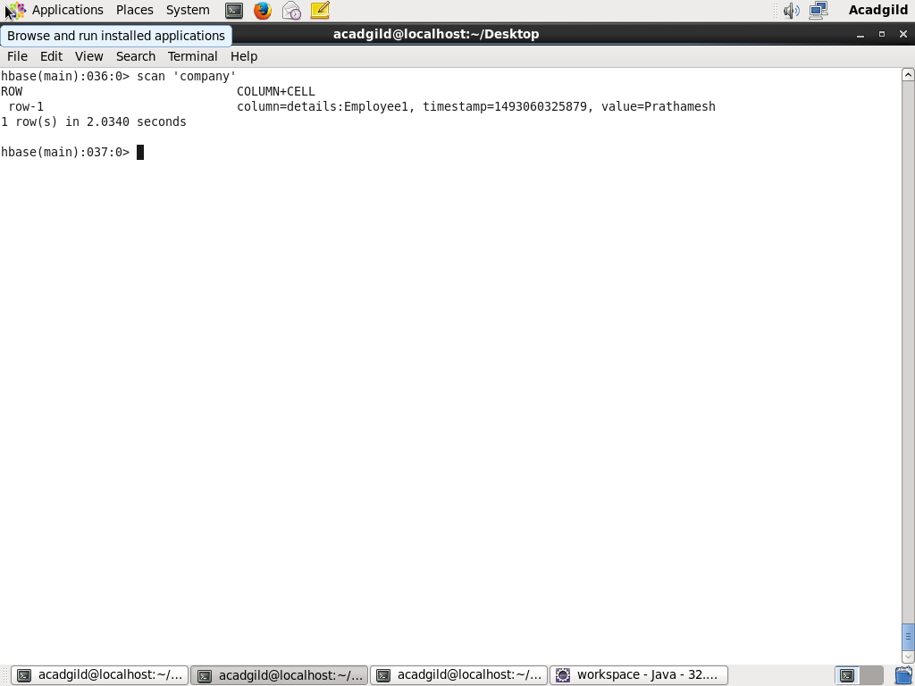

● Create the method name display and use scan class to display all records from company table.

**Java code-**

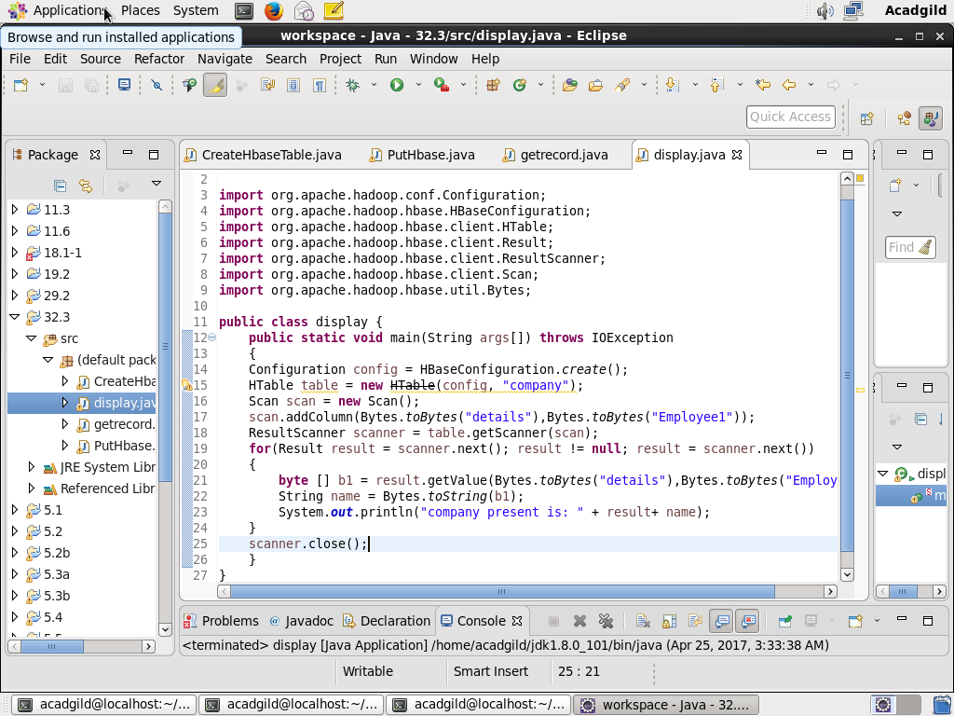

**Output-**

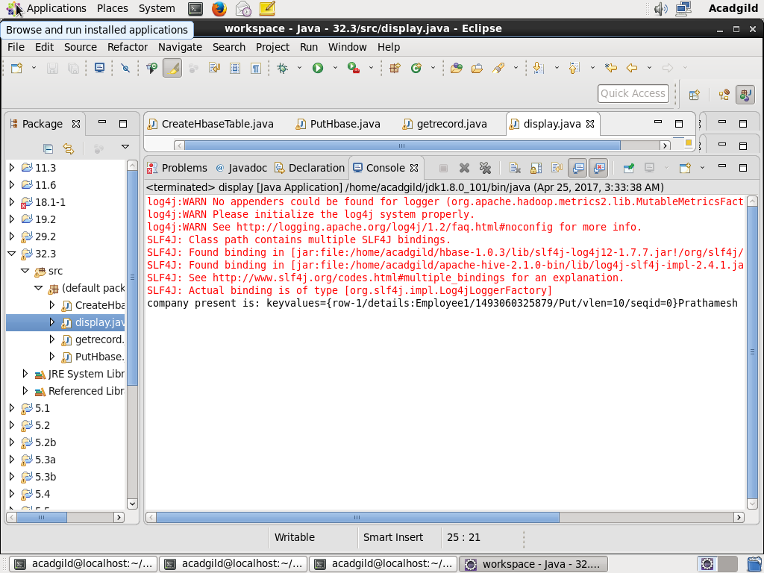

**Checking contents of company table using get command-**

