**QUE-15.1- Perform wordcount operation in local mode .Share the code, explain the execution steps, and attach the output screenshot**

**ANS-15.1-**

**CODE-**

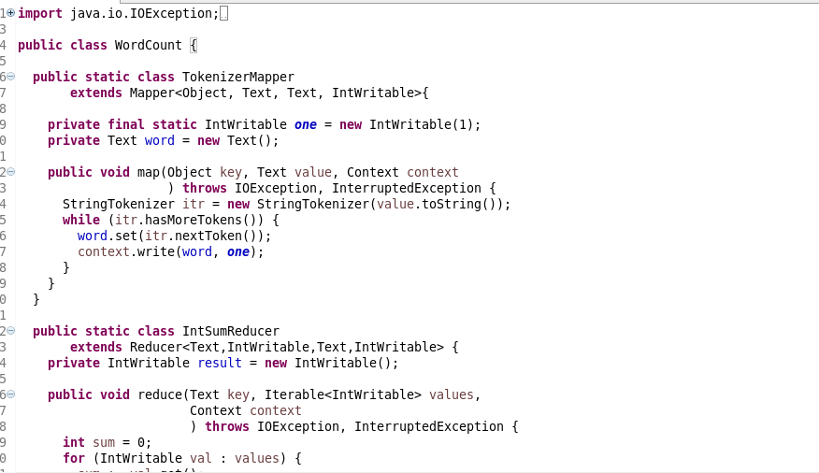

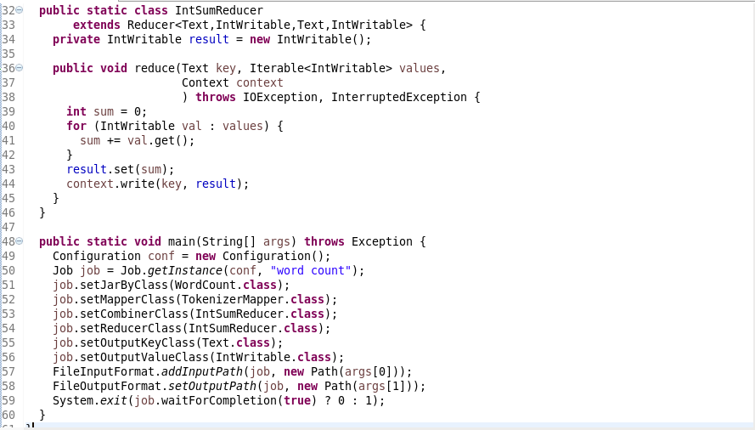

**STEPS-**

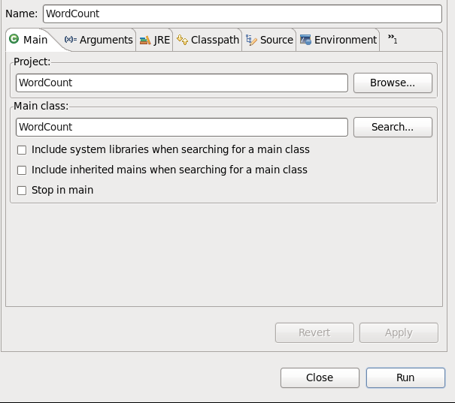

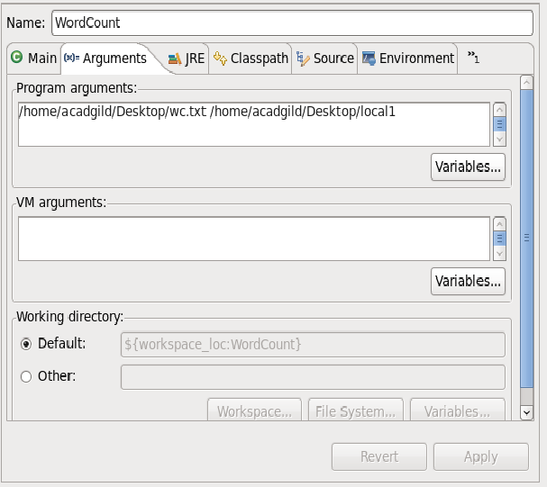

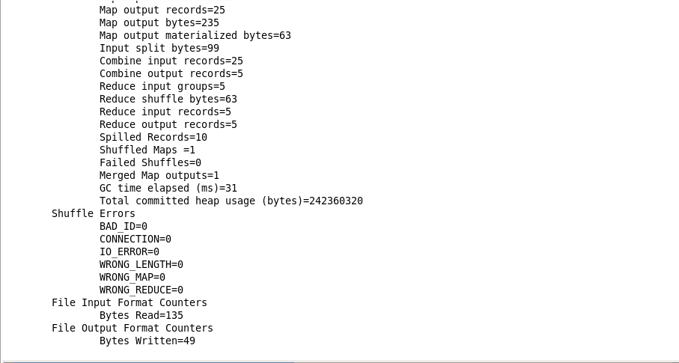

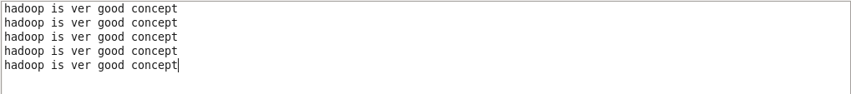

**OUTPUT-**

