**QUE-15.5- Build and Deploy hadoop word count program using SBT.**

**ANS-15.5-**

**CREATING SBT FOLDER-**

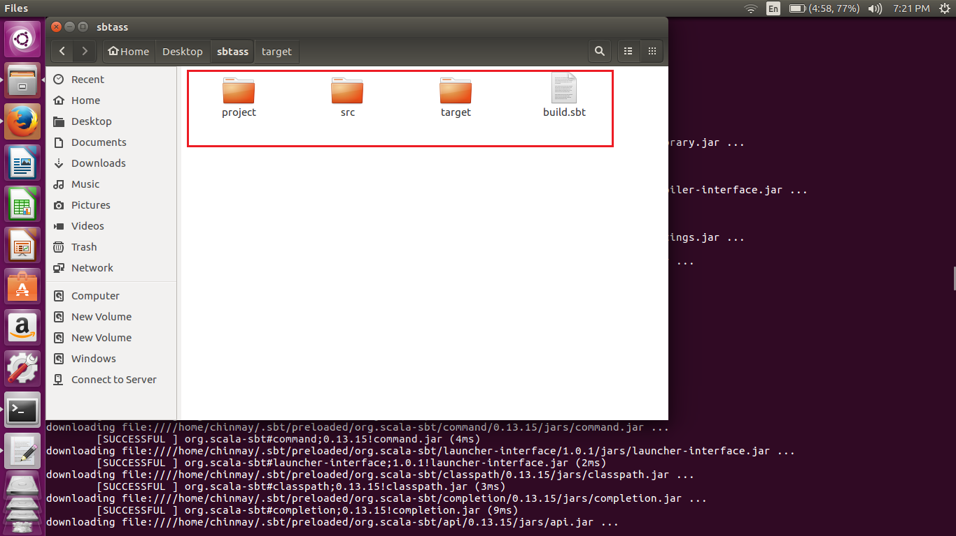

We have created the sbtass folder in which /src/main/java folders have been created.

After that I have taken an error free word count programs java class and pasted it in the java folder.

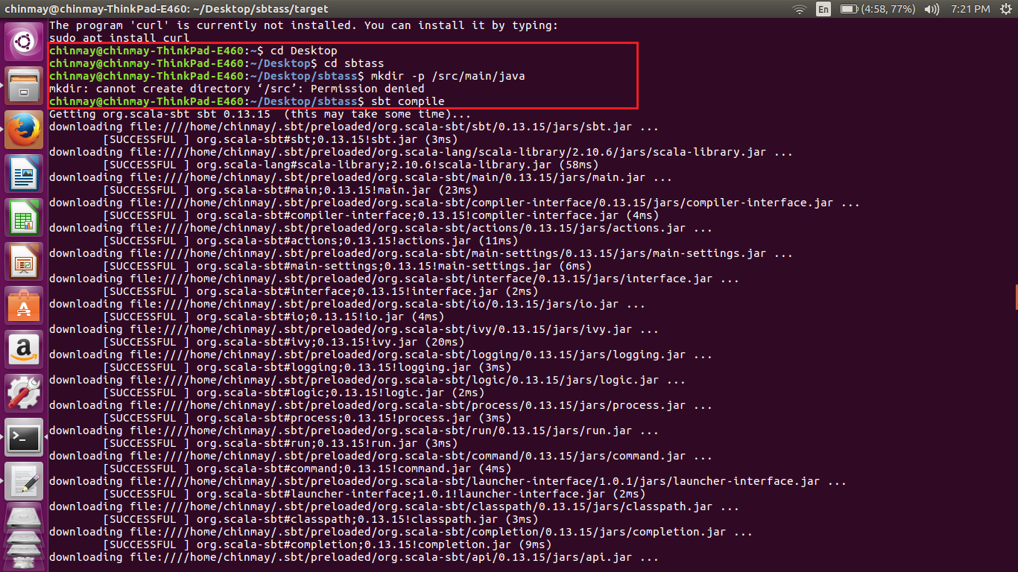

Now change the directory to the one where you have created the src/main/java. In the above case it is sbtass. Now implement command “sbt compile”.

Sbt will compile and arrange for all the imports for the given program and generate the jar file in the target folder.

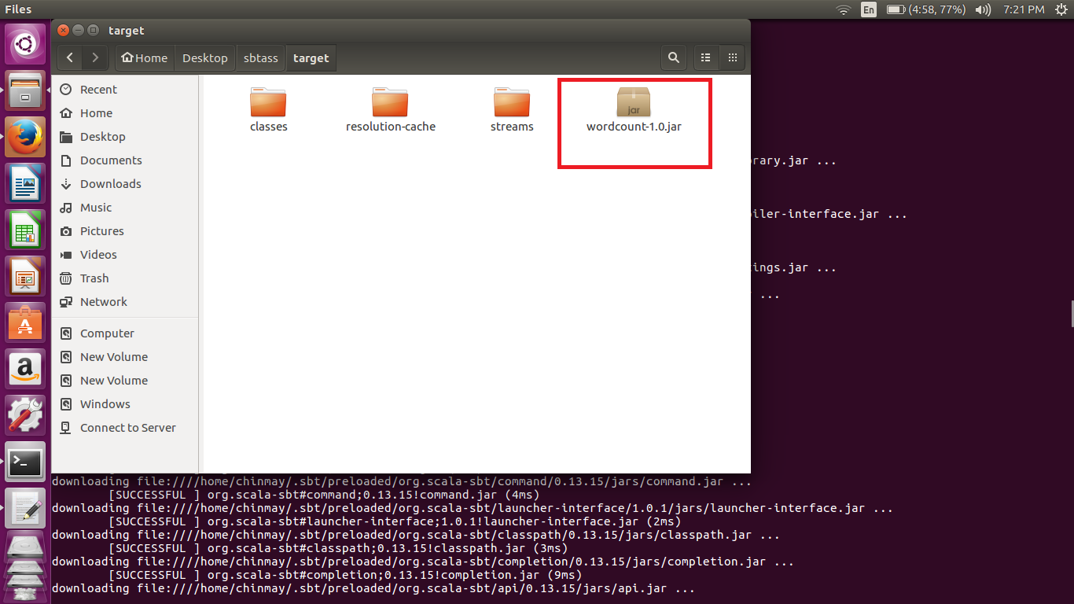

Now we run this jar file to test if the word count program is running fine or not.

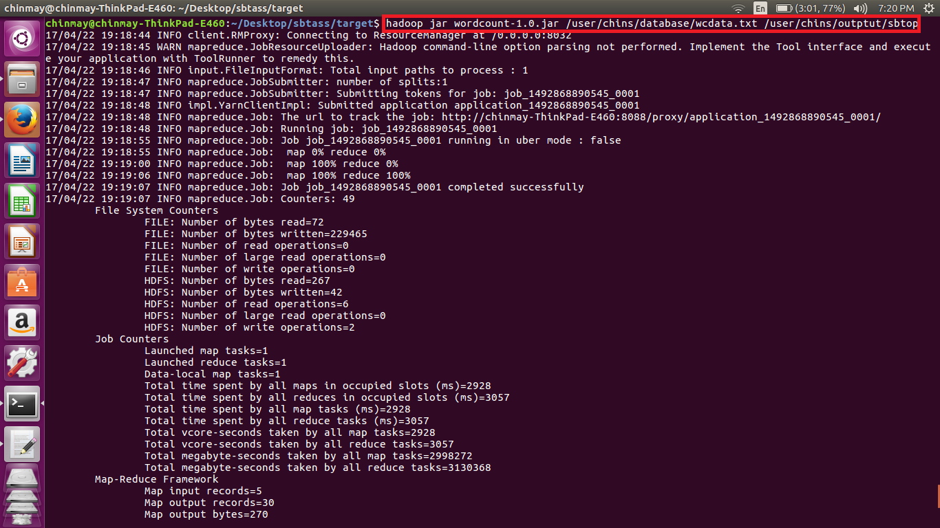

We have given the input file and output file as the arguments and executed the jar file.

**Output-**

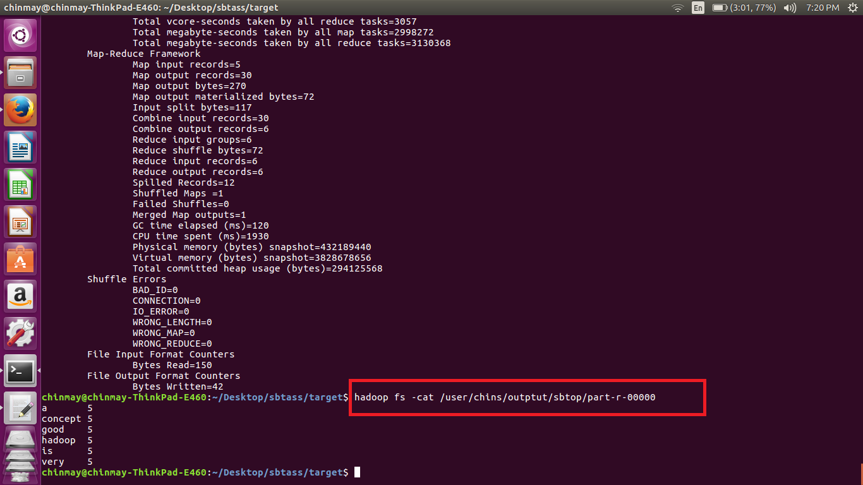

The input file had the given line -

***Hadoop is a very good concept***

***Hadoop is a very good concept***

***Hadoop is a very good concept***

***Hadoop is a very good concept***

***Hadoop is a very good concept***

**WORD COUNT PROGRAM-**

