**Que-15.6- Build and Deploy hadoop word count program using Gradle.**

**ANS-15.6-**

For implementing Hadoop using gradle we need to first install the gradle using

***sudo apt-get install gradle.***

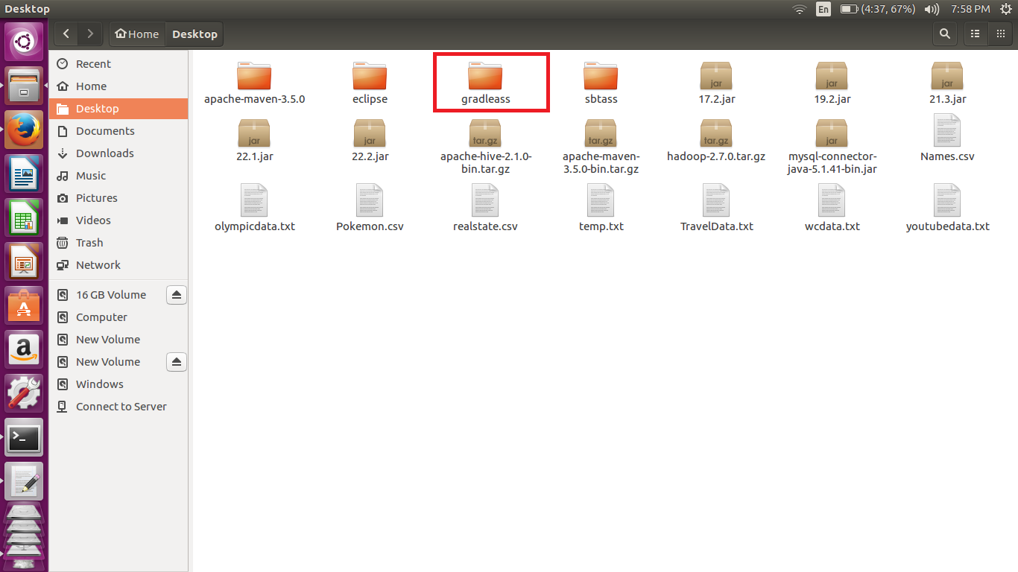

we have created the gradleass folder in desktop and in that we have created the src/main/java folders.

we have copied the the .java file into java folder that we have created.

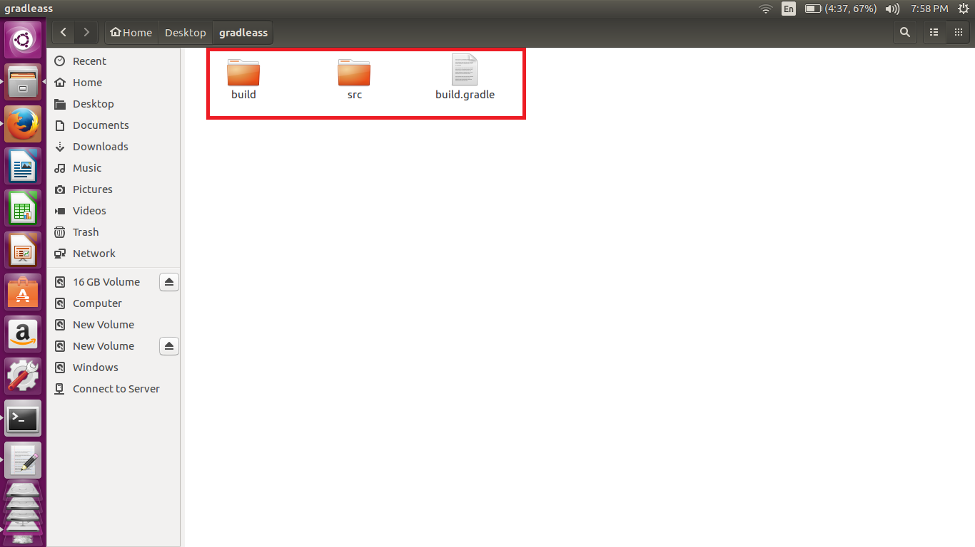

**GRADLE BUILD-**

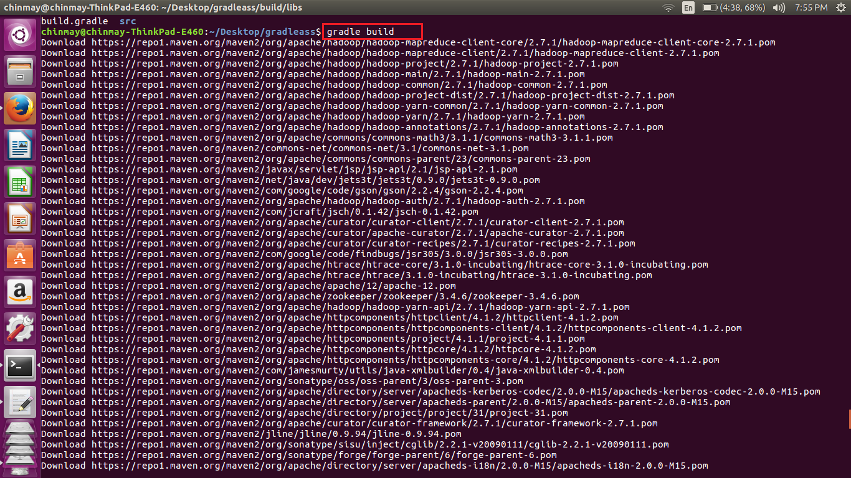

Now changing the directly where we have created the gradleass folder execute the command ***gradlebuild .***This will generate a jar file in the target folder.

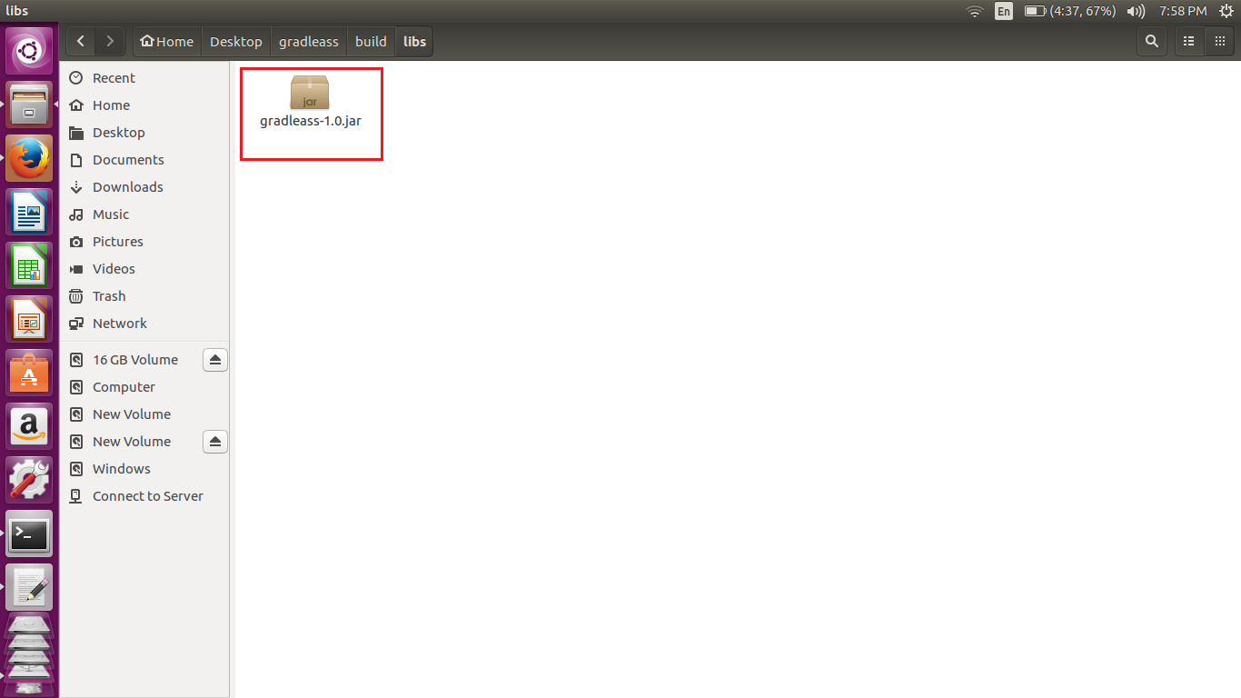

We have created the jar file we can run the jar file

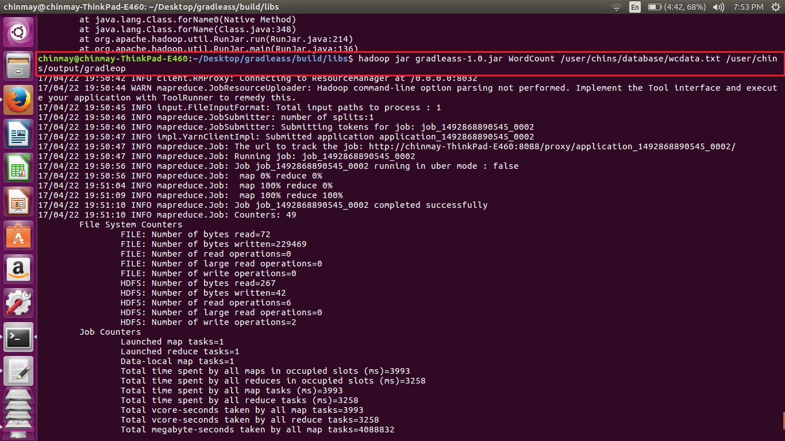

Here we have mentioned the input and the output path.

**Output-**

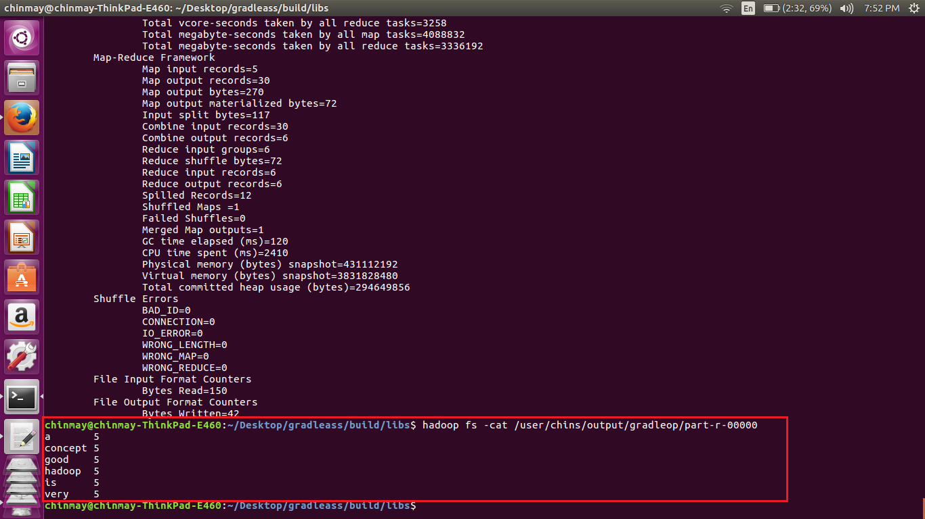

The input file had the given line -

***Hadoop is a very good concept***

***Hadoop is a very good concept***

***Hadoop is a very good concept***

***Hadoop is a very good concept***

***Hadoop is a very good concept***

**WORD COUNT PROGRAM-**

