**QUE-16.1- Here, we have the temperatures collected every minute, from 20 top buildings all over the world.**

**ANS-16.1-**

**Driver class-**

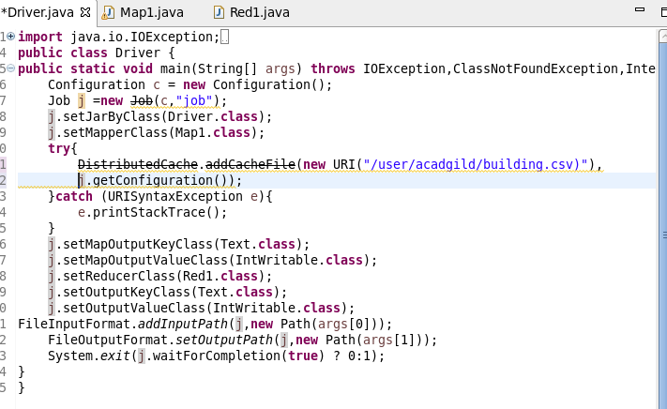

**Mapper Class-**

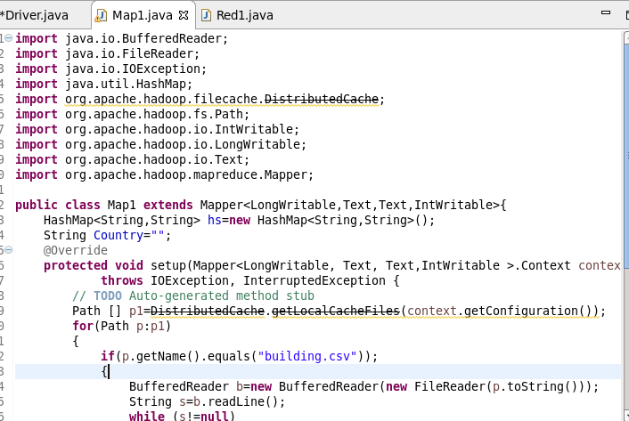

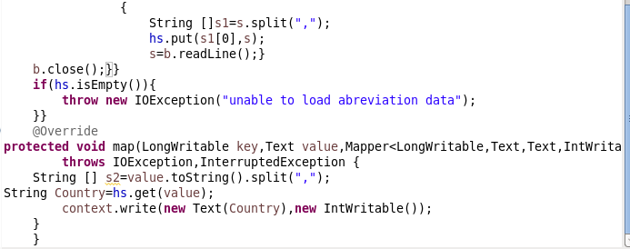

**Reducer class-**

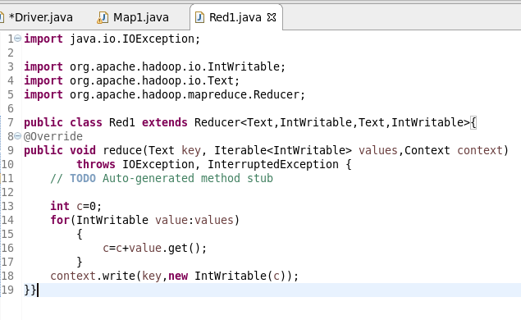

**Output-**

**After creating 16.1opb jar file -**

