**QUE-16.5- Write a map reduce program to join the below given two datasets using map side join.**

**ANS-16.5-**

**DRIVER-**

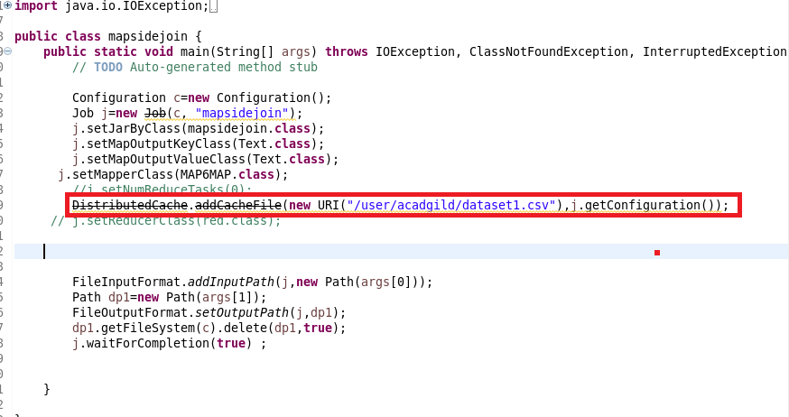

**MAPPER-**

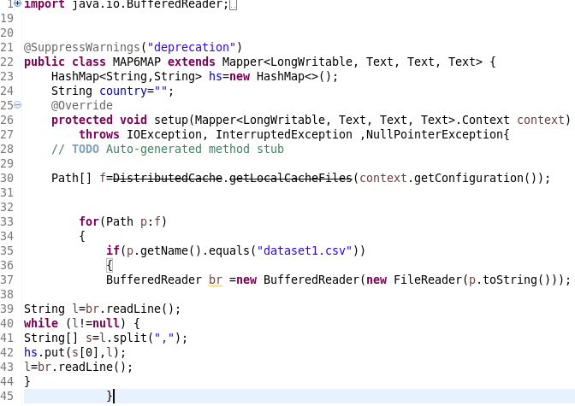

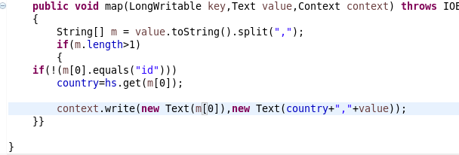

**RUNNING JAR-**

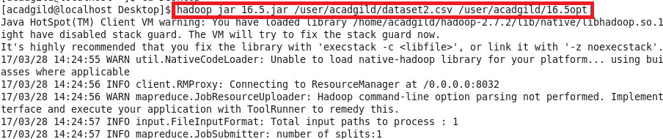

**OUTPUT-**

