**QUE-17.2- Write a secondary sort program to generate the top 2 maximum temperatures corresponding to every year from the temperature dataset.**

**ANS-17.2-**

**Driver-**

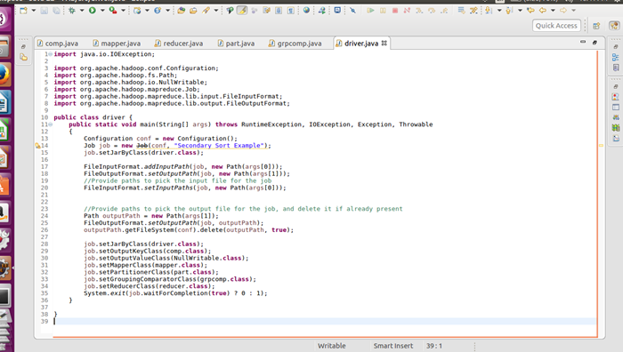

**Mapper-**

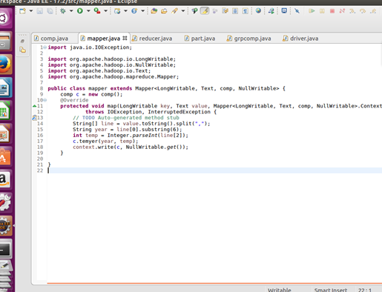

**Comparable writable-**

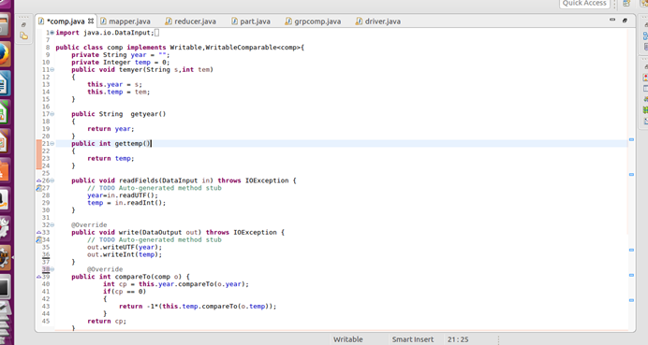

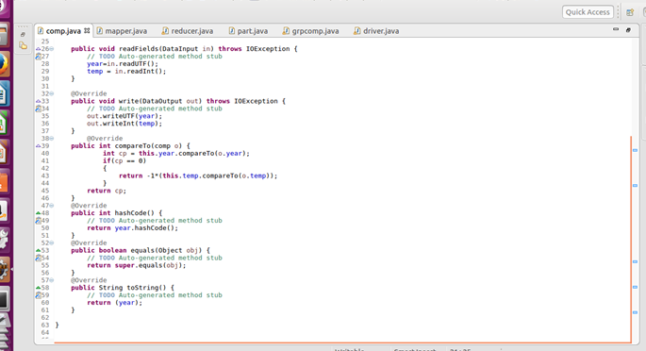

**Partitioner-**

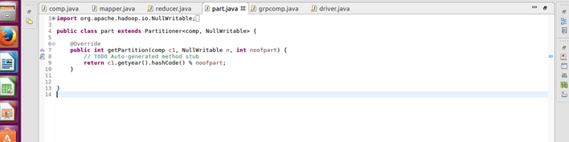

**Group comparator-**

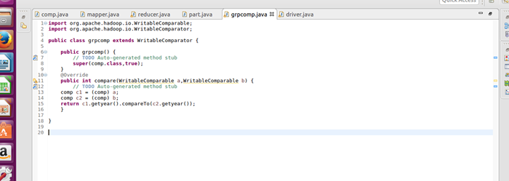

**Reducer -**

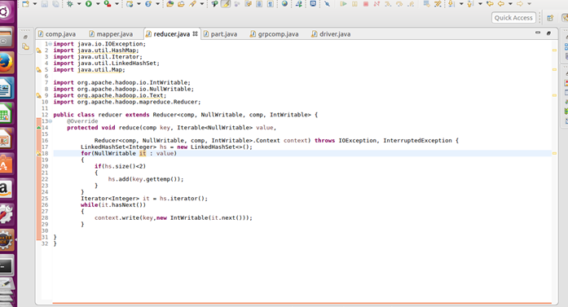

**Output-**

