**QUE-17.3-**

**Write a mapreduce job that takes configuration from command line (min.word.count). Based on the configuration, it should perform count of words from a document and produce only those words in the output whose count is greater than or equal to the configuration.**

**ANS-17.3-**

**Driver Class-**

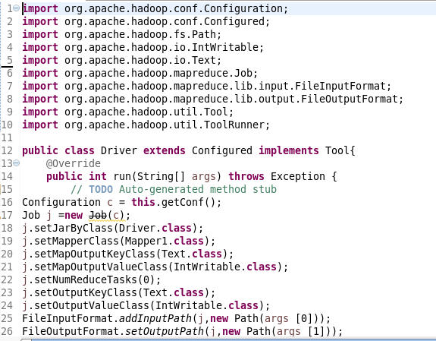

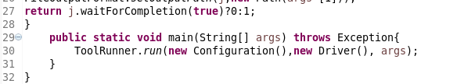

**Mapper Class-**

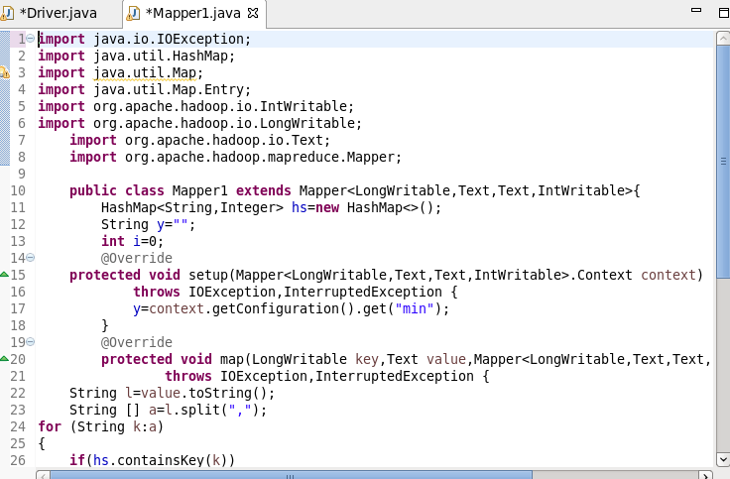

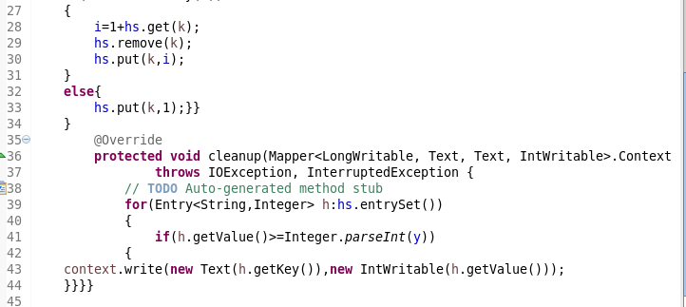

**RUNNING JAR-**

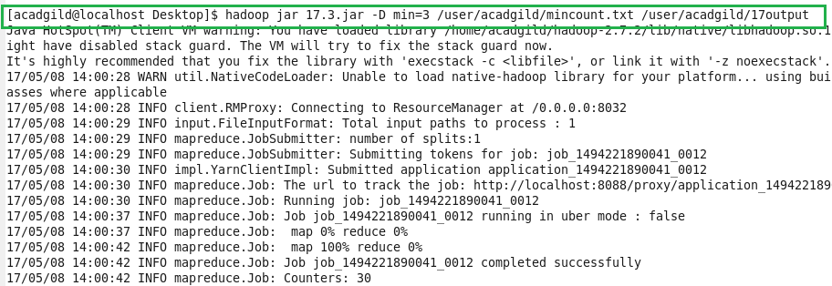

**Input-**

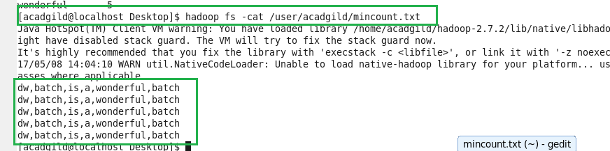

**Output-**

