**QUE-19.3- Write a MapReduce program that takes the output of Task 5 (refer session 7, assignment 1) as input, and produce output which is sorted on the total units sold. You may use a single reducer for the sorting. Use Sequence File formats as an output of Task 5 and as input for this task.**

**ANS-19.3-**

**Driver-**

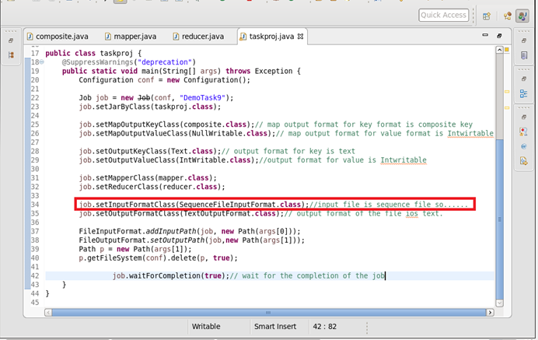

**Mapper-**

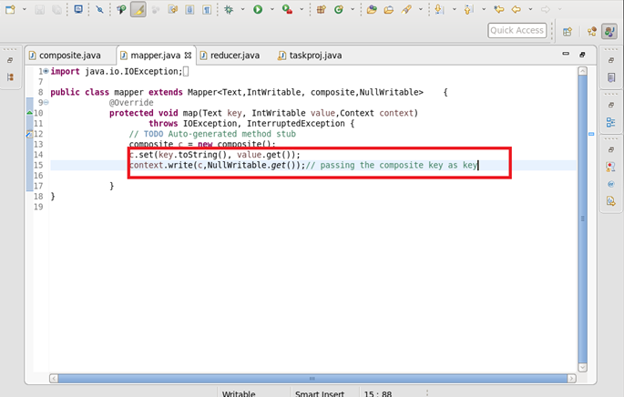

**Reducer-**

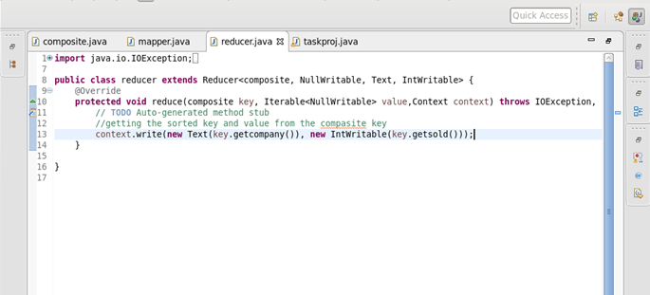

**Composite key-**

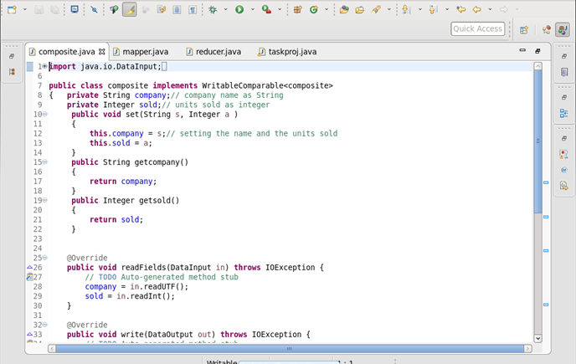

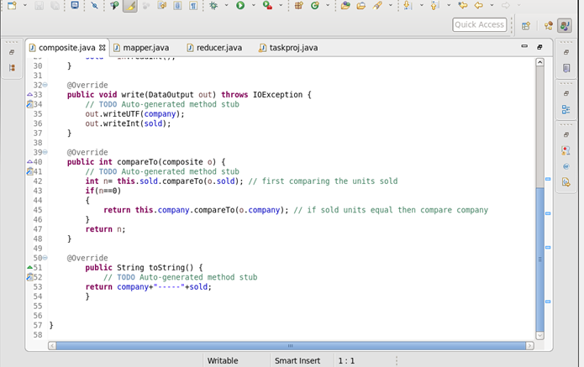

**Output-**

