**QUE-21.3- This dataset consists of two columns i,e., first_name & last_name &city use custom input format to read the key as the combination of first_name and last_name and arrange the output of the program should be the key sorted by last_name.**

**ANS-21.3-**

**Driver-**

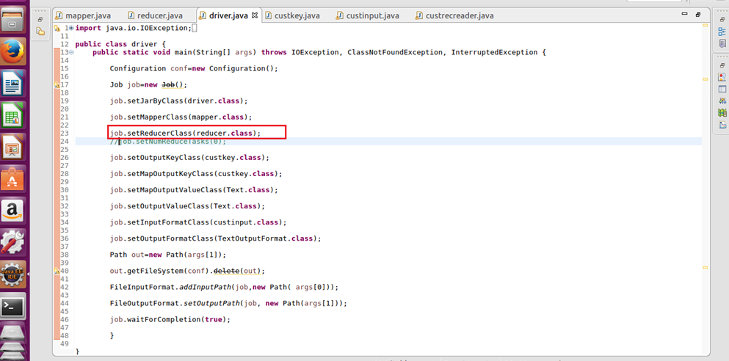

**Mapper-**

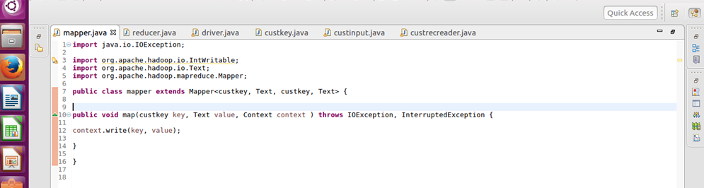

**Reducer-**

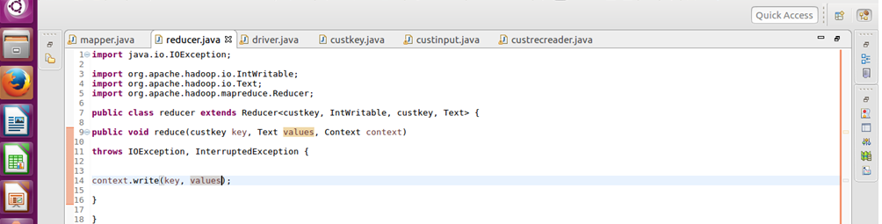

**Custom key-**

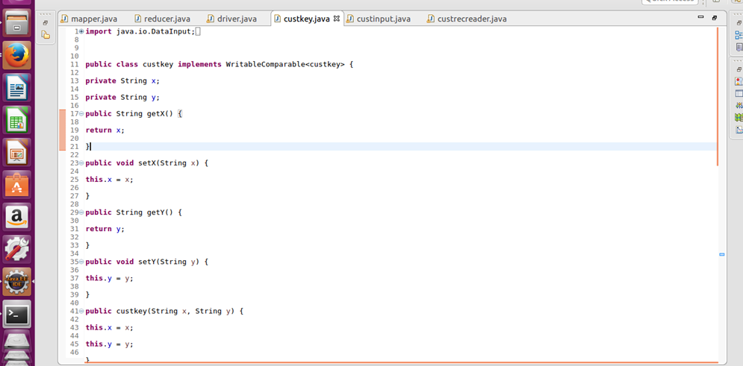

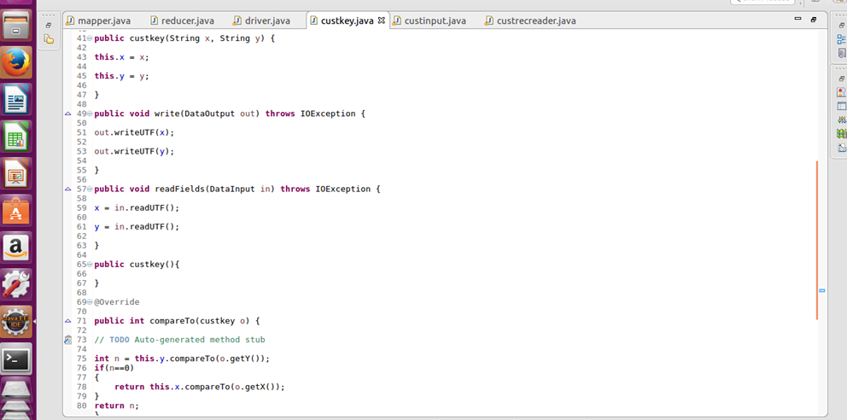

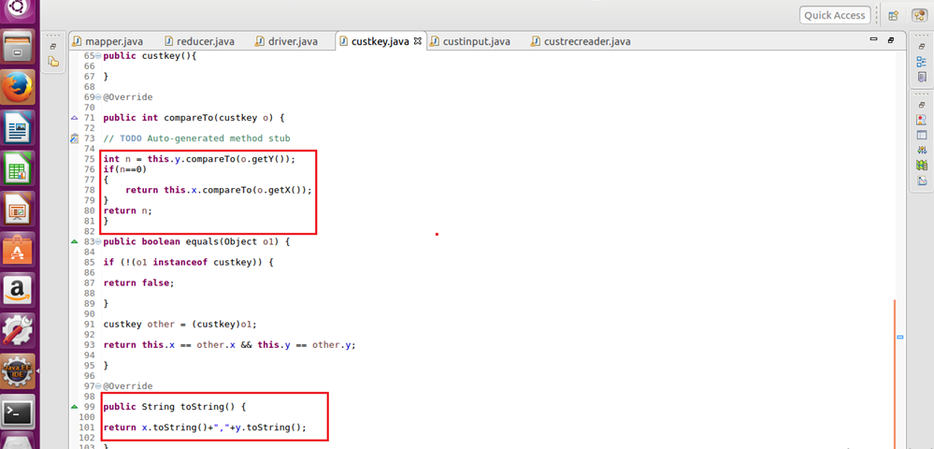

**Custom file format-**

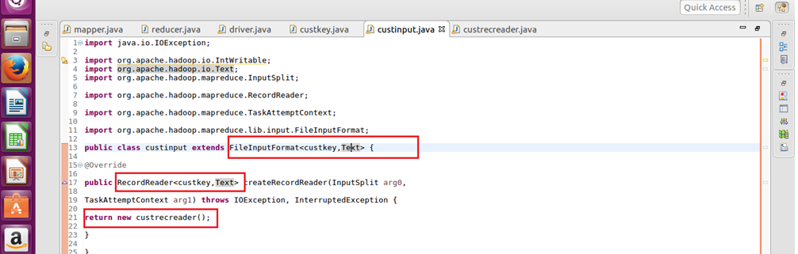

**Custom record reader-**

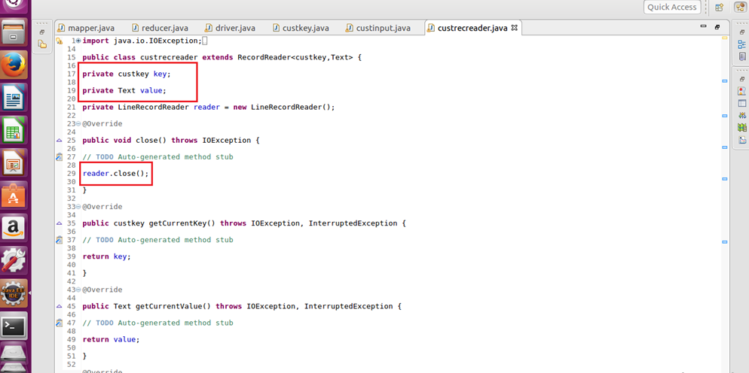

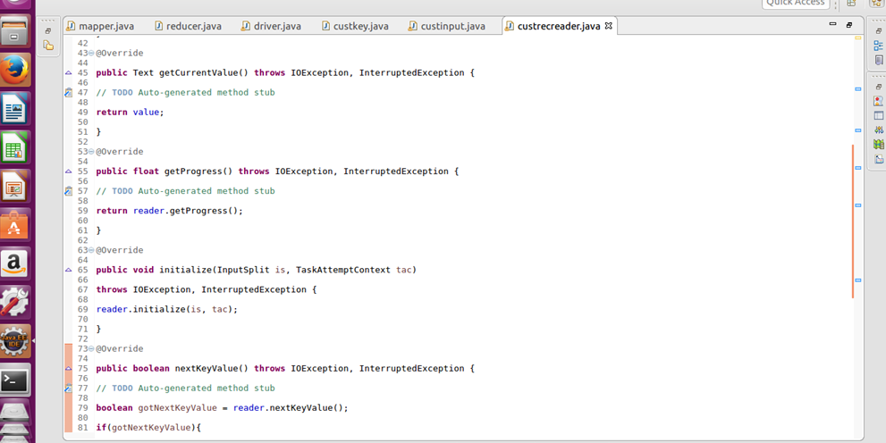

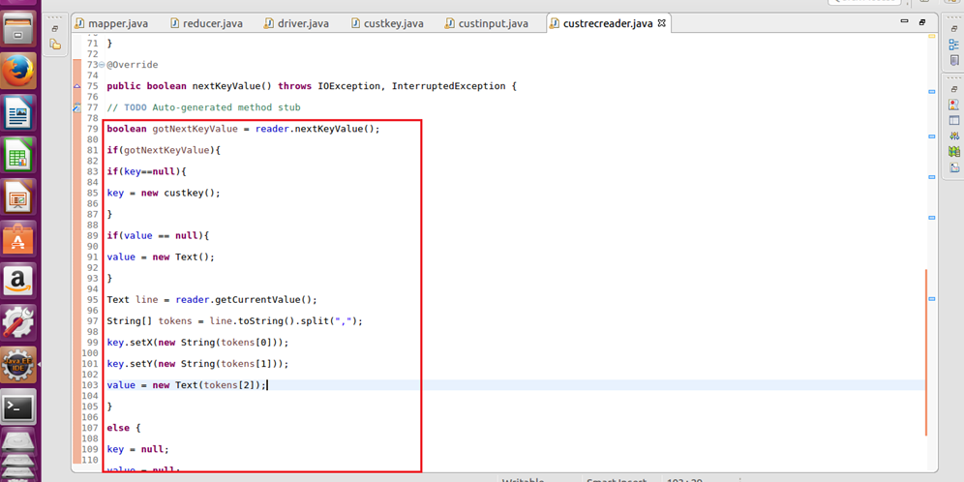

**Output-**

