**QUE-16.2- Use reduce side join to join the two datasets and find What kind of problems are prevalent, and in which state?**

**ANS-16.2-**

**Driver class-**

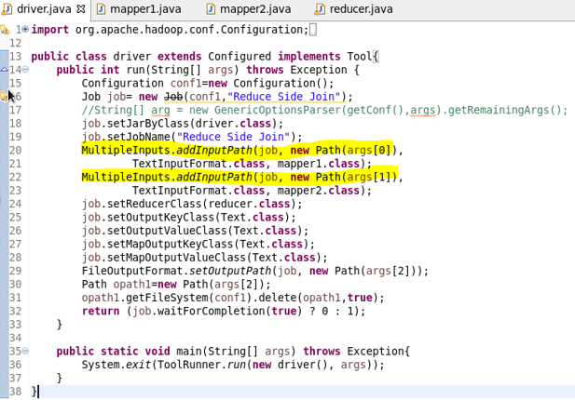

**Mapper1 class-**

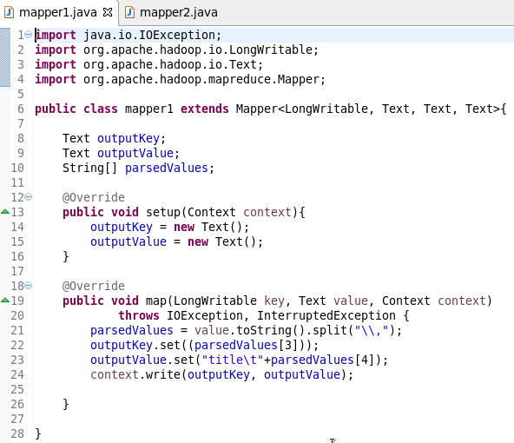

**Mapper2 class-**

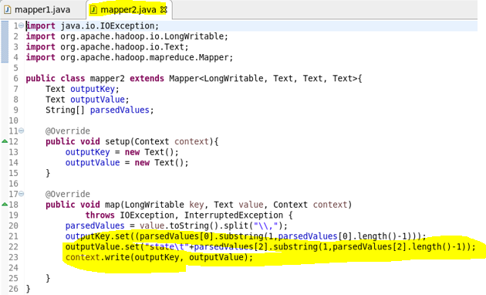

**Reducer class-**

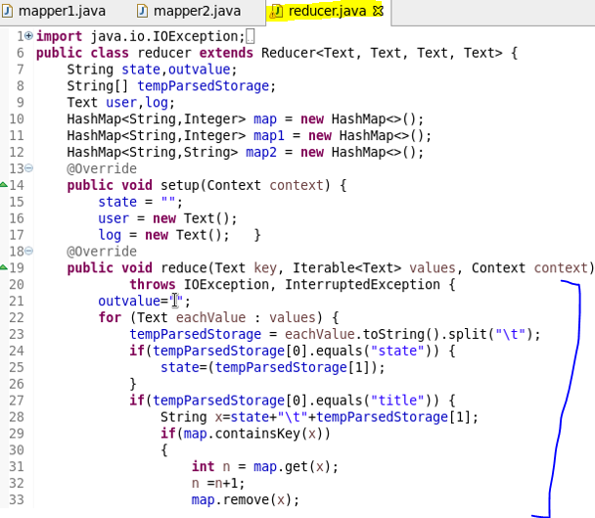

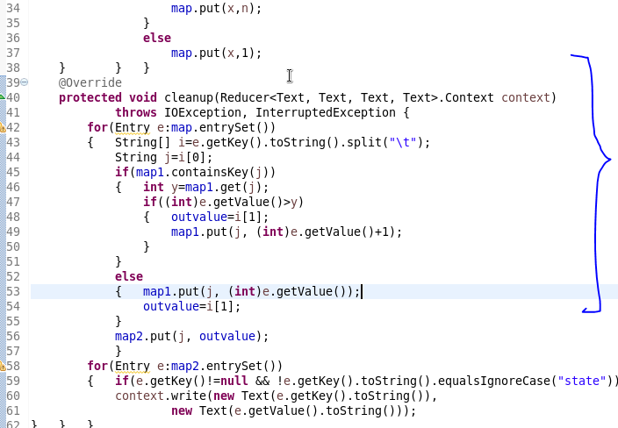

**Running jar-**

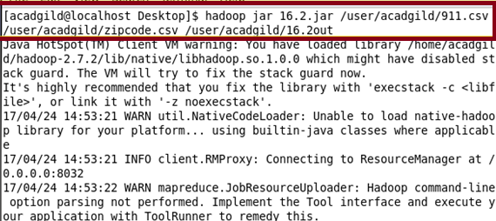

**Output-**

