**QUE-22.2.1- Find out what are the top 5 categories with maximum number of videos uploaded.**

**ANS-22.2.1-**

**Driver-**

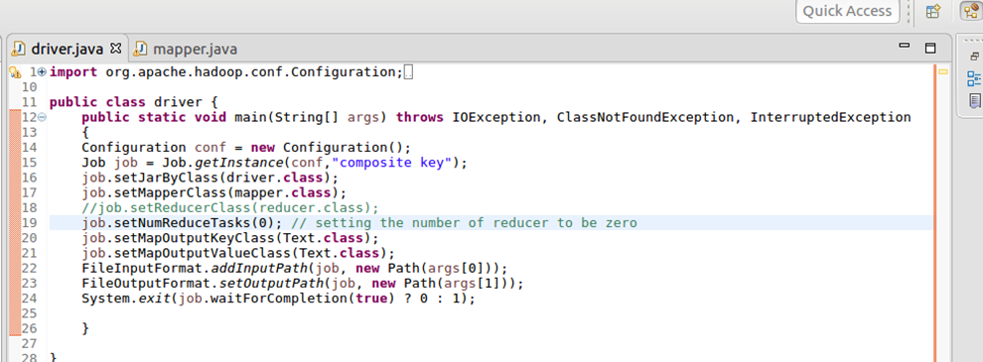

**Mapper-**

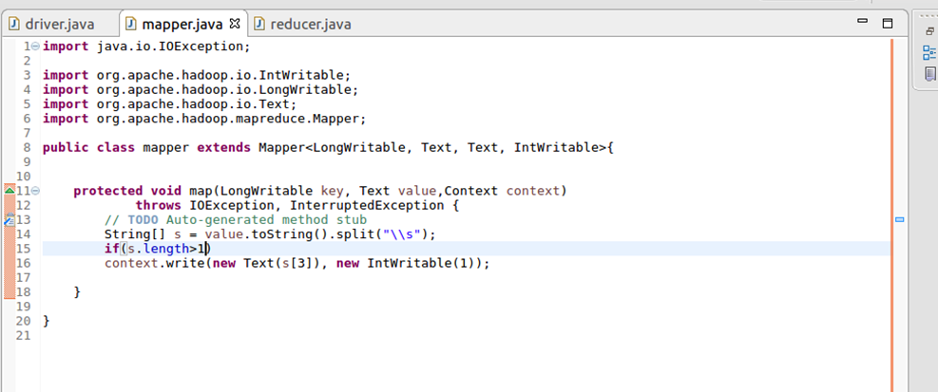

**Reducer-**

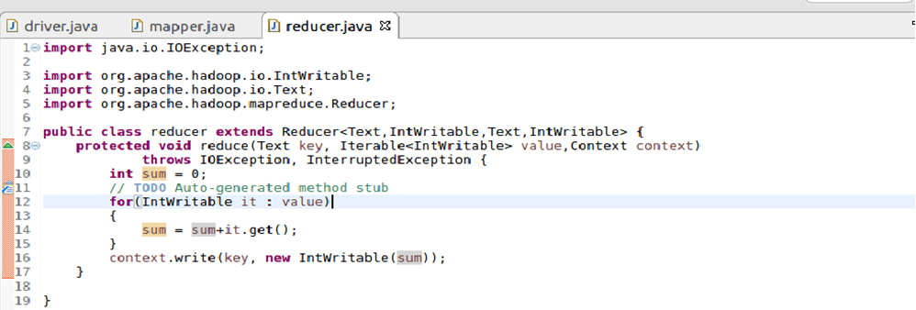

**Output-**

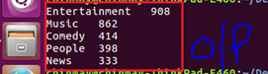

**QUE-22.2.2- Find the top 10 rated videos in youtube.**

**ANS-22.2.2-**

**Driver-**

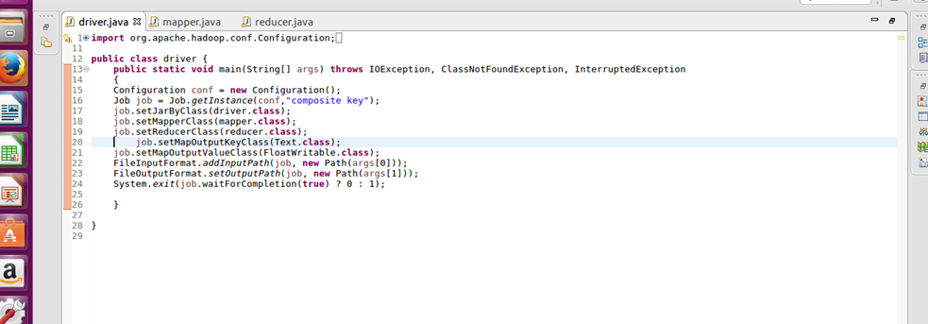

**Mapper-**

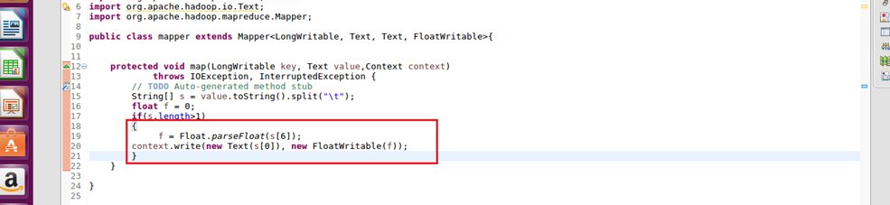

**Reducer-**

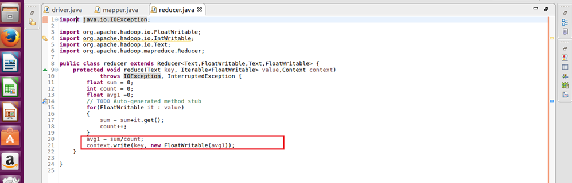

**Output -**

