**QUE-20.2- the task 8 (refer session 19, assignment 1) to calculate the top 3 state-wise sales for each company. You may use multiple reducers for this activity.**

**ANS-20.2-**

**DATASET-**

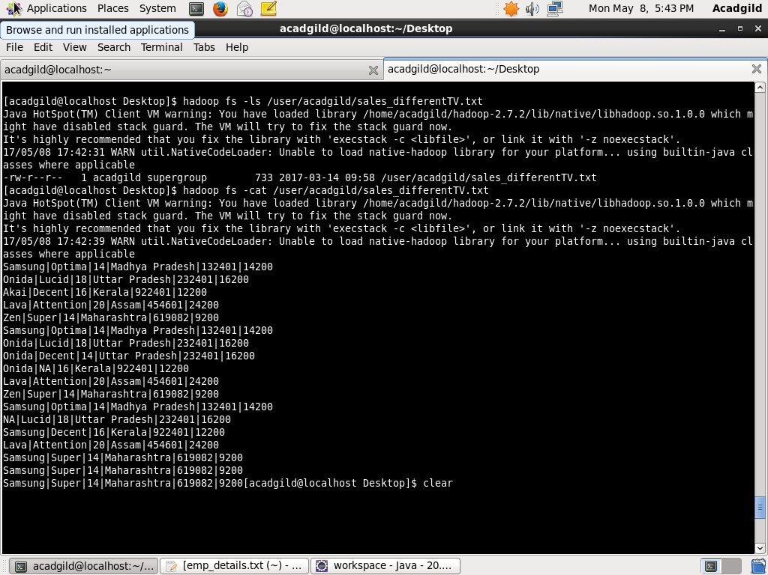

**PROGRAM-**

**DRIVER CLASS-**

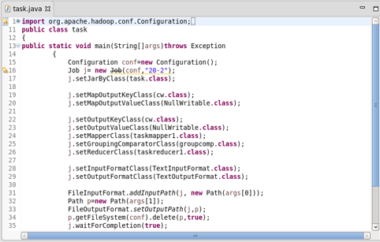

**MAPPER CLASS-**

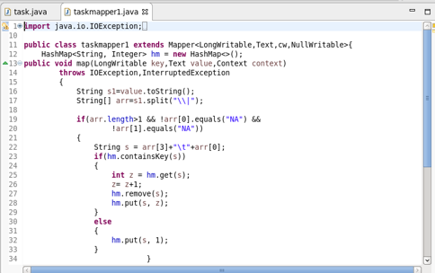

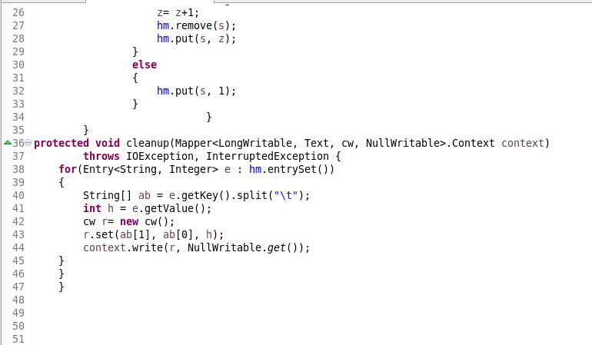

**CUSTOM_KEY CLASS-**

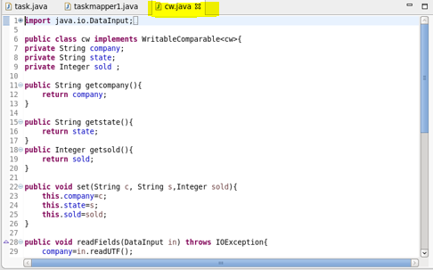

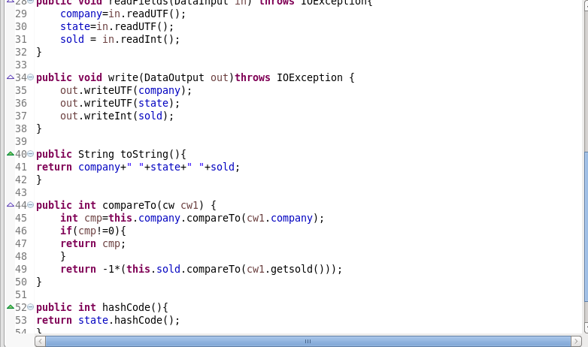

**GROUP COMPARATOR CLASS-**

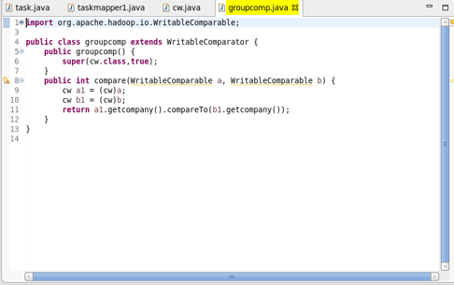

**PARTITIONER CLASS-**

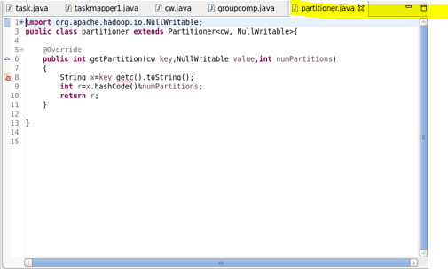

**REDUCER CLASS-**

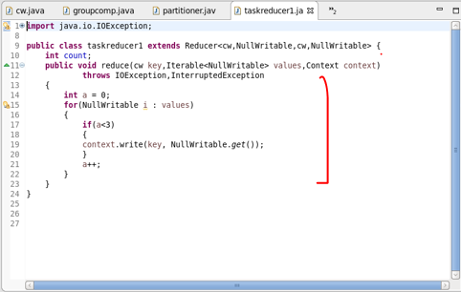

**OUTPUT-**

