**QUE-30.2- Write a java program to read data from hive.**

**ANS-30.2-**

**In order to read data from hive using java we should first add sql connector jar and sl4j binding jar and in order to connect to hive we must start hiveserver2 which will BE Used for connecting hive through JDBC**

**Input to be Read-**

**I am Having arry_table as shown below which I am going to read**

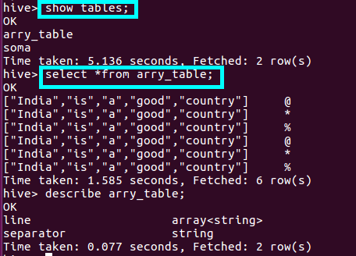

**JAVA PROGRAM-**

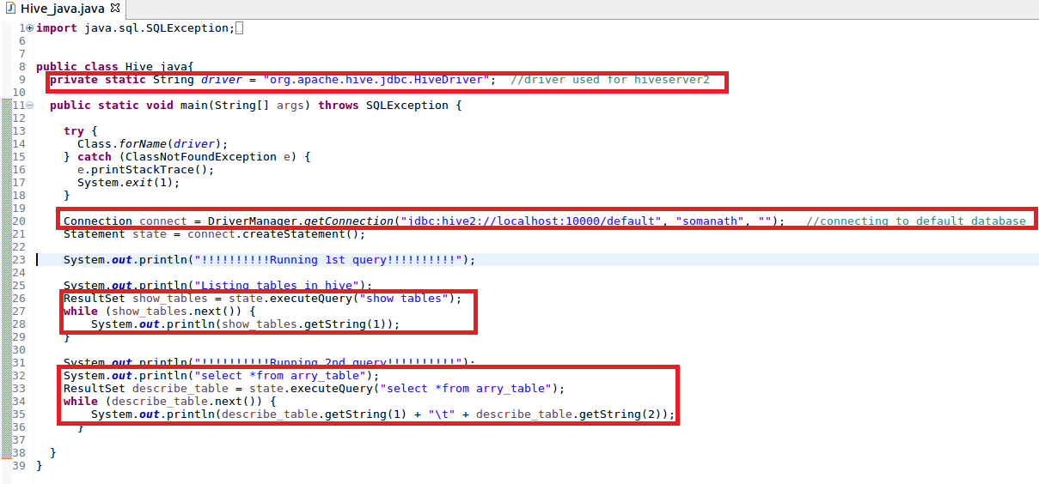

**Output-**

**We have successfully read data from Hive**

