**QUE-33.2- Integrate Hbase with Hive**

**● Load Data (Bulk Load) from Hive table to Hbase Table**

**● Explain the procedures and code implemented with screenshots.**

**ANS-33.2-**

**Load Data (Bulk Load) from Hive table to Hbase Table-**

**Why do we need to integrate Hive with Hbase?**

Hive can store information of hundreds of millions of users effortlessly, but faces some difficulties when it comes to keeping the warehouse up to date with the latest information. Hive uses HDFS as an underlying storage which come with limitations like append-only, block-oriented storage. This makes it impossible to directly apply individual updates to warehouse tables. Up till now the only practical option to overcome this limitation is to pull the snapshots from MySQL databases and dump them to new Hive partitions. This expensive operation of pulling the data from one location to another location is not frequently practiced.(leading to stale data in the warehouse), and it also does not scale well as  the data volume continues to shoot through the roof.

**Creating the HBase Table-**

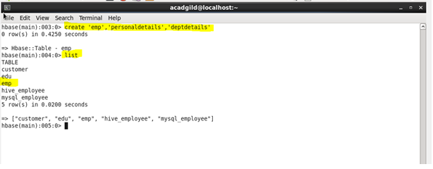

**Insert the data into HBase table-**

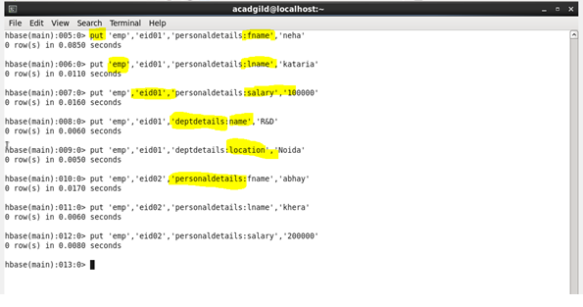

**Creating the Hive table pointing to HBase table-**

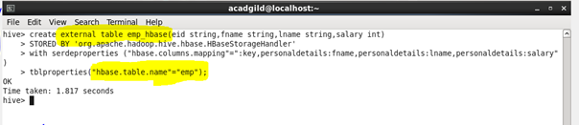

**Output -**

