**QUE-24.3- Calculate the number of employees corresponding to each skill from the table 'employee' which is loaded in the Demo.**

***ANS-24.3-***

**TABLE CREATION-**

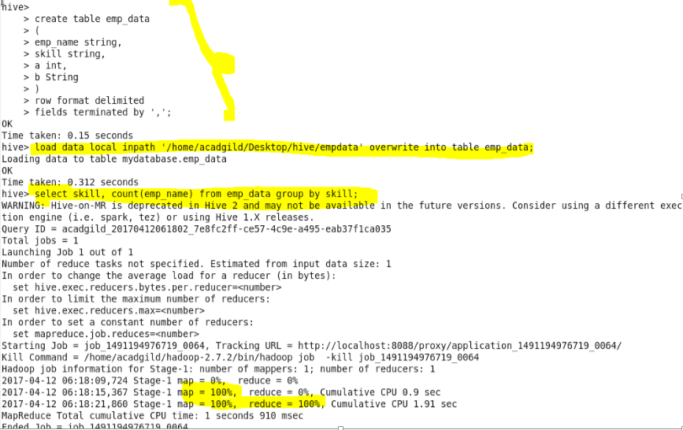

***OUTPUT-***

