**ASSINGMENT-24.5-**

**TABLE CREATION-**

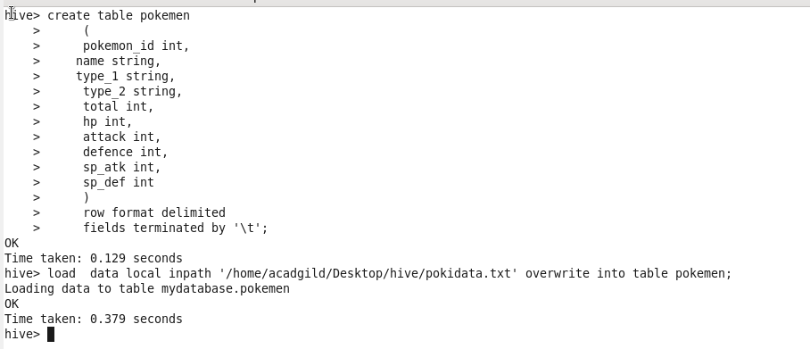

**QUE-24.5.1- Find out the average HP (Hit points) of all the Pokémons**

**CREATING VIEW-**

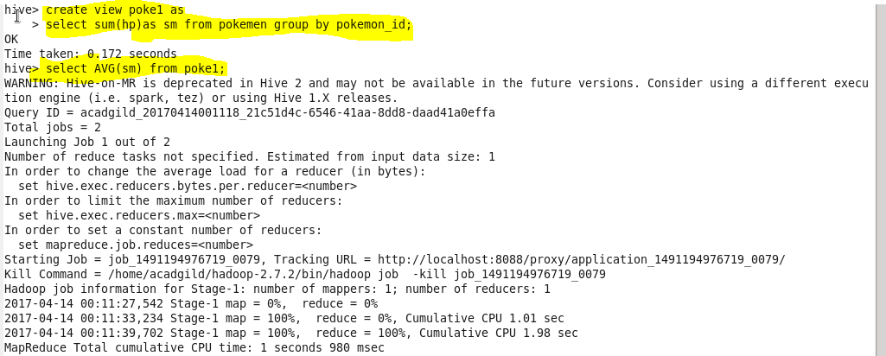

**OUTPUT-**

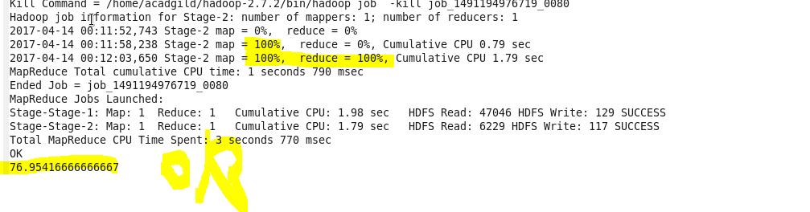

**QUE-24.5.2- Find out the average Defense of all the pokemon**

**CREATING VIEW-**



**OUTPUT-**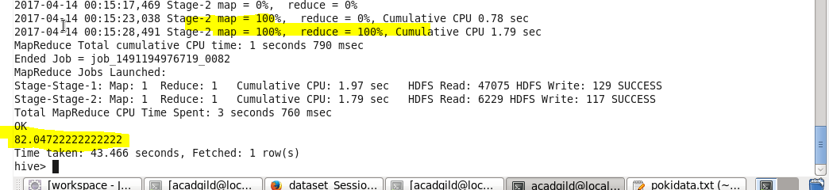

**QUE-24.5.3- Find out the average Sp.Atk of all the pokemons**

**CREATING VIEW-**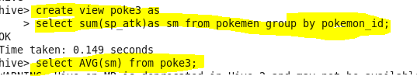

**OUTPUT-**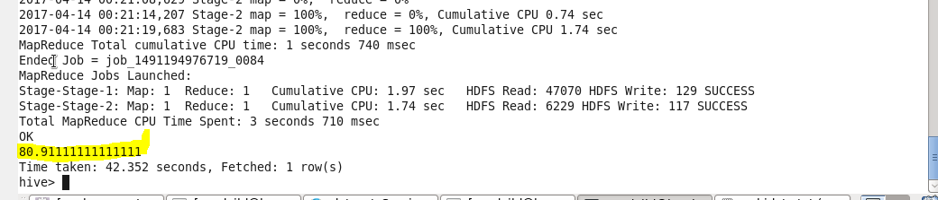

**QUE-24.5.4- Find out the average sp.Def of all the pokemons**

**CREATING VIEW-**

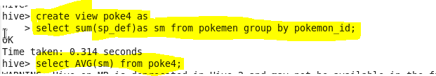

**OUTPUT-**

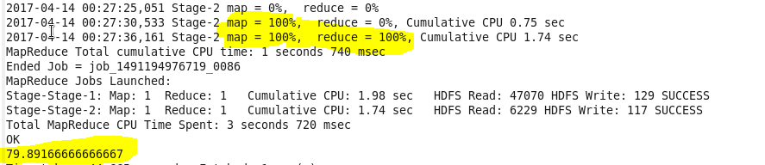

**QUE-24.5.5- Find out the average Speed of all the pokemons**

**CREATING VIEW-**

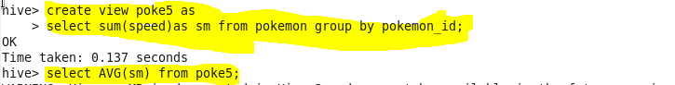

**OUTPUT-**

