***ASSINGMENT-24.6-***

***TABLE CREATION AND LOADING THE FILE-***

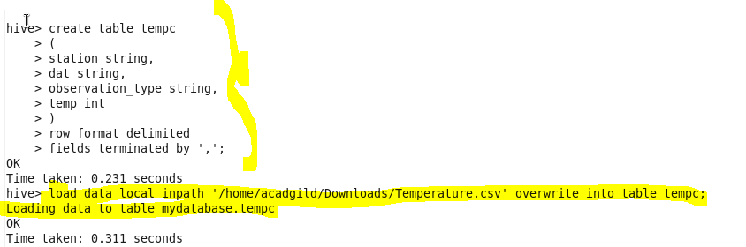

**QUE-24.6.1- Write a hive query to find the minimum temperature observed in a given weather station in a particular year.**

***QUERY-***

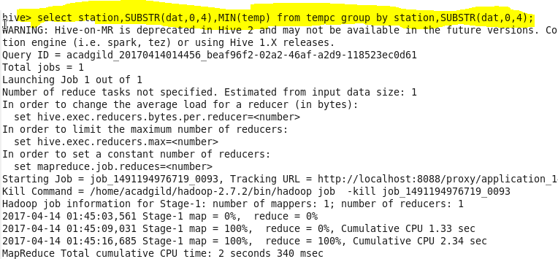

***OUTPUT-***

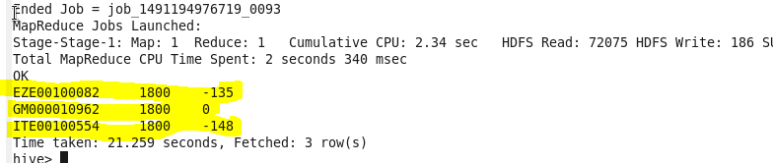

**QUE-24.6.2- Write a hive query to find the maximum temperature observed in a given weather station in a particular year.**

***OUTPUT-***

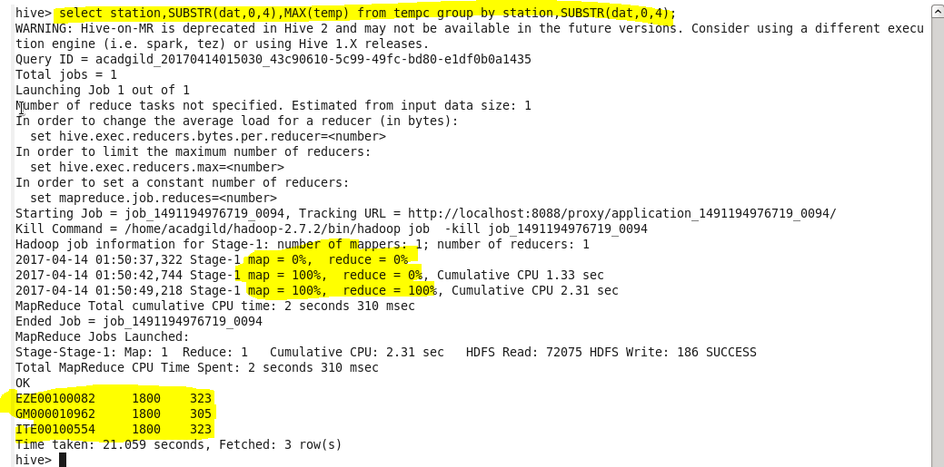

**QUE-24.6.3- Write a hive query to find the number of readings given by each weather station according to the dataset.**

***OUTPUT-***

