**ASSINGMENT-25.1-**

**CREATING A TABLE-**

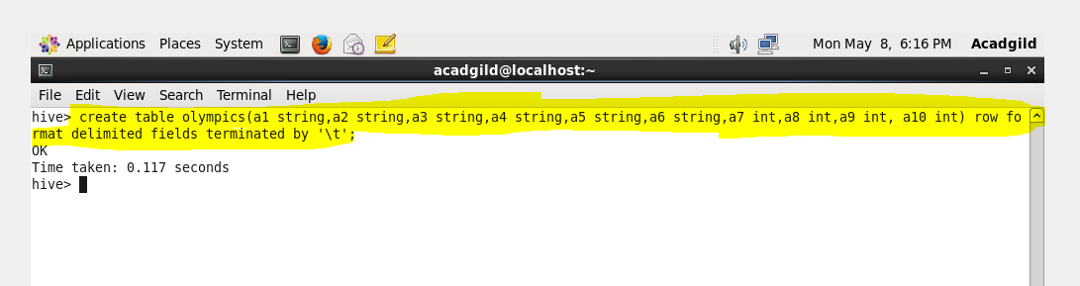

**LOADING A FILE IN THE TABLE-**

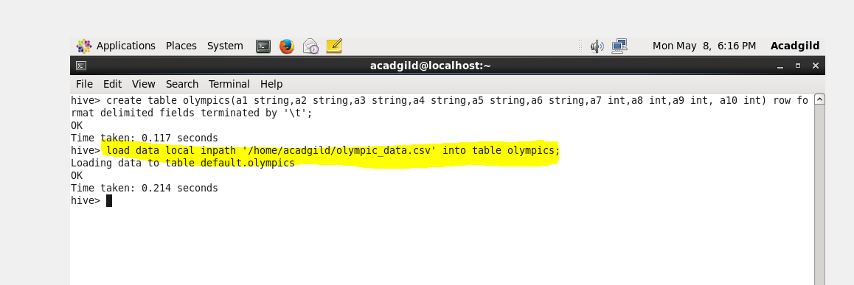

**INPUT DATA-**

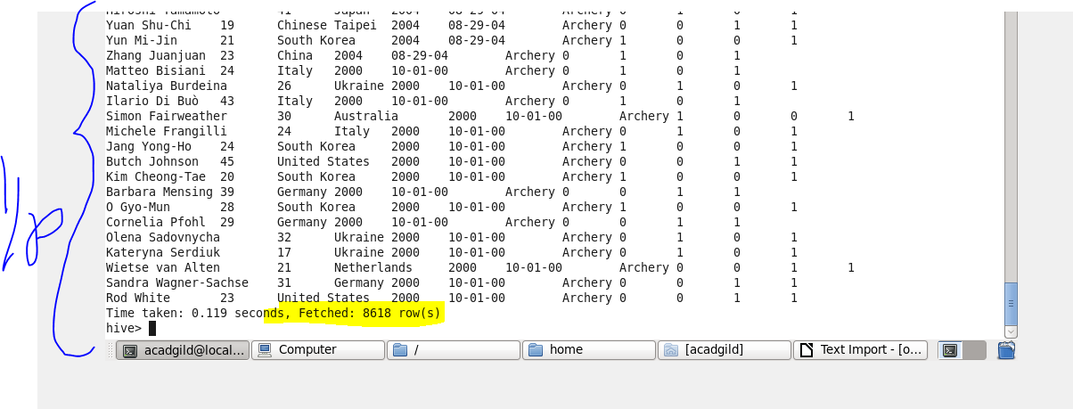

**Problem Statement-**

**QUE-25.1.1- Write a Hive program to find the number of medals won by each country in swimming.**

**COMMAND-**

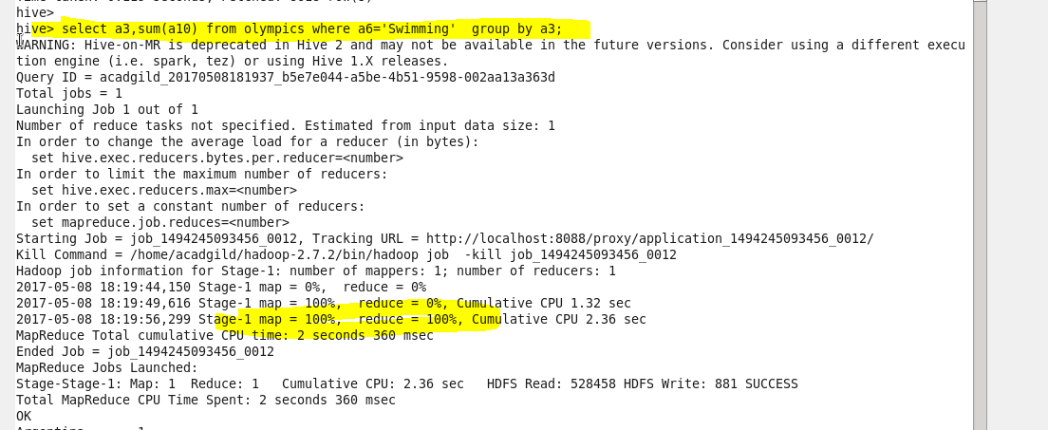

**OUTPUT-**

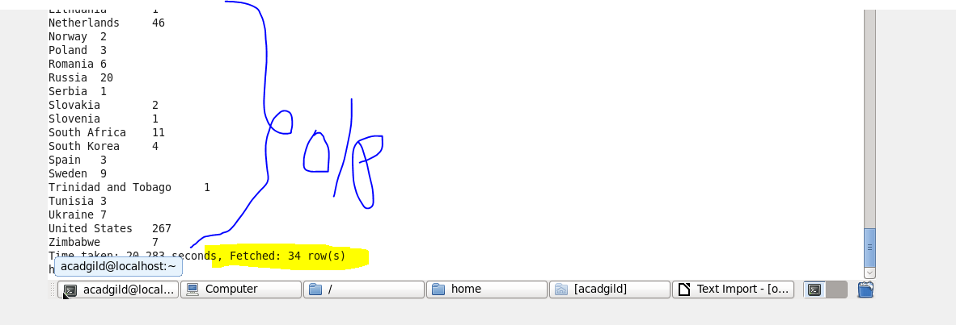

**Problem Statement-**

**QUE-25.1.2- Write a Hive program to find the number of medals that India won year wise.**

**OUTPUT-**

