**ASSINGMENT-25.2-**

**CREATING A TABLE-**

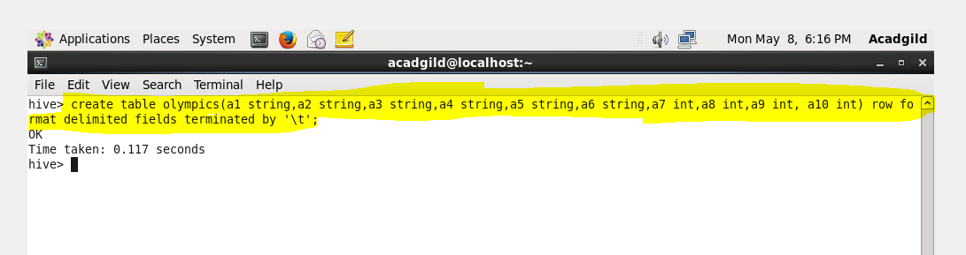

**LOADING A FILE IN THE TABLE-**

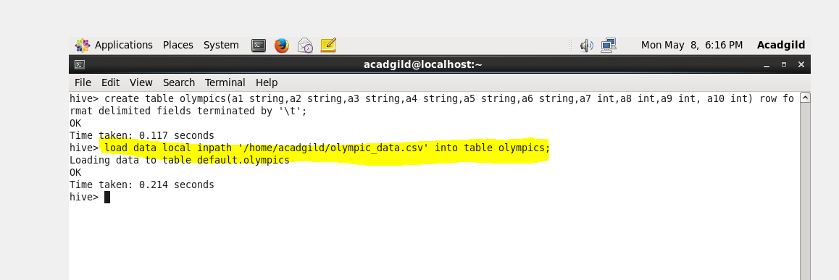

**INPUT DATA-**

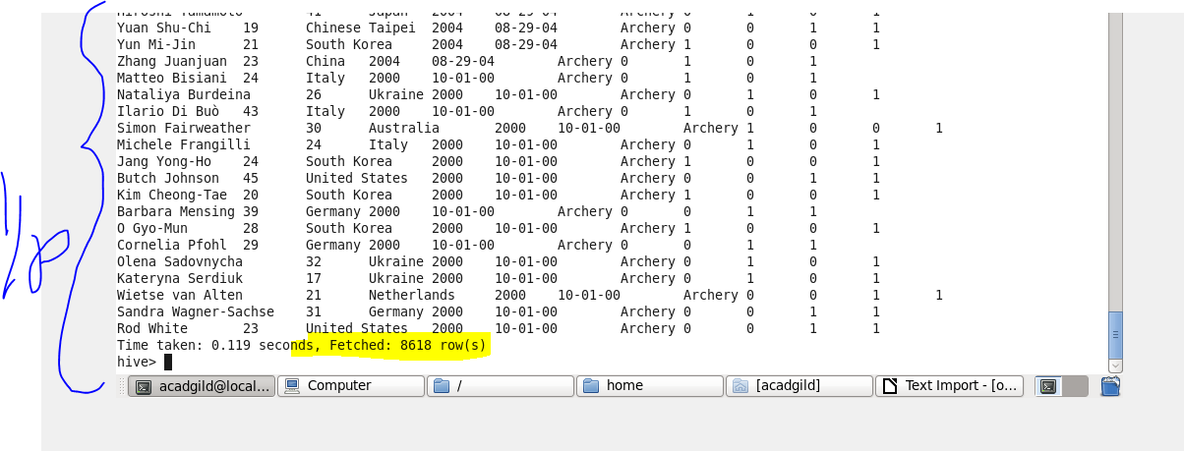

**Problem Statement-**

**QUE-25.2.1- Write a Hive Program to find the total number of medals each country won**

**COMMAND-**

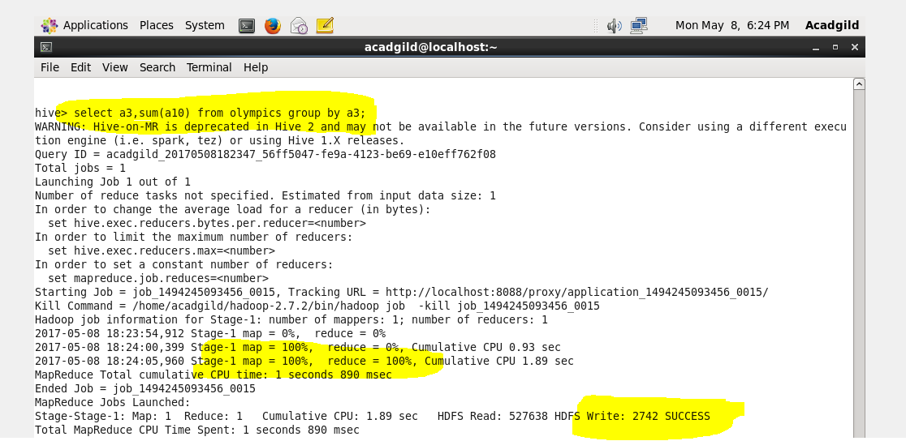

**OUTPUT-**

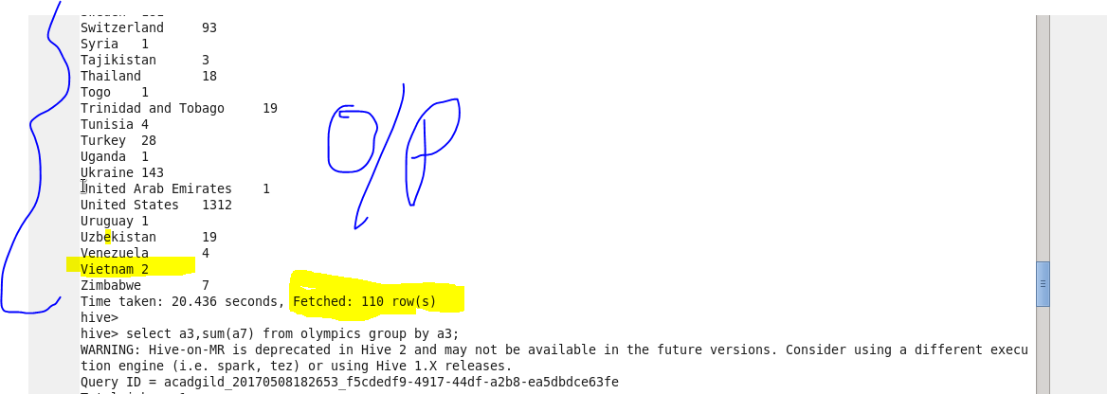

**Problem Statement-**

**QUE-25.2.1- Write a Hive program to find the number of gold medals each country won**

**COMMAND-**

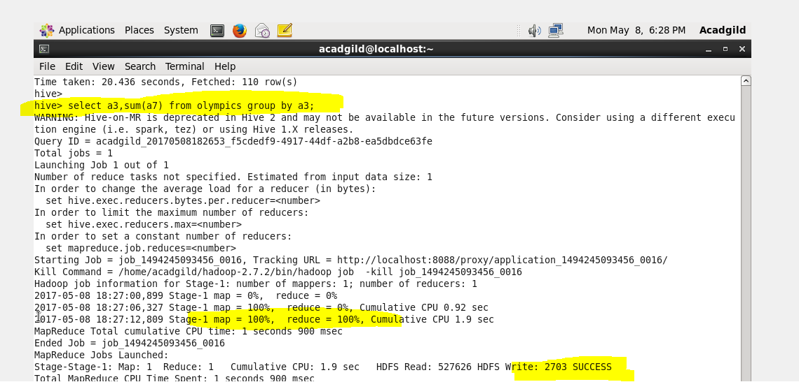

**OUTPUT-**

