ASSINGMENT-25.3-

**QUE-25.3.1- Get a list of employees who receive a salary less than 100, compared to their immediate employee with higher salary in the same unit**

**Query & Output-**

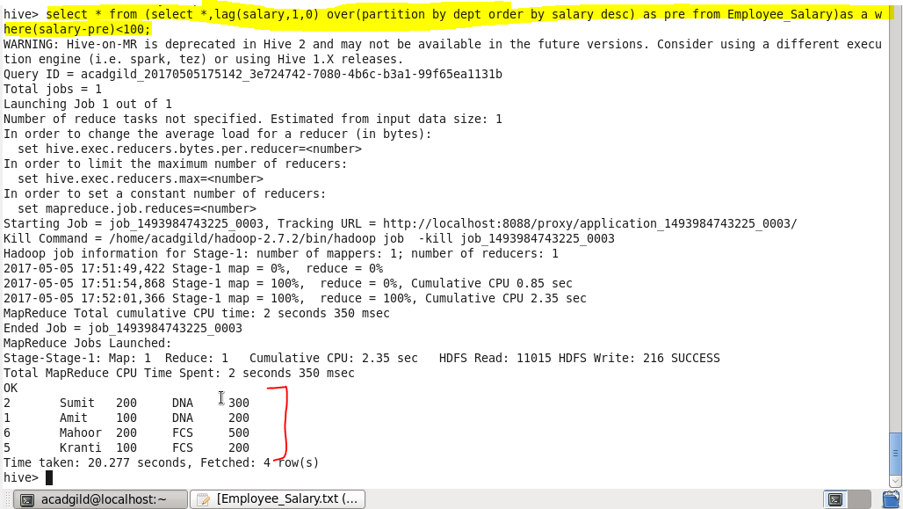

**QUE-25.3.2-** **List of all employees who draw higher salary than the average salary of that department**

**Query & Output-**

