**ANS-27.4-**

**Running parallel jobs in hive-**

**Input files-**

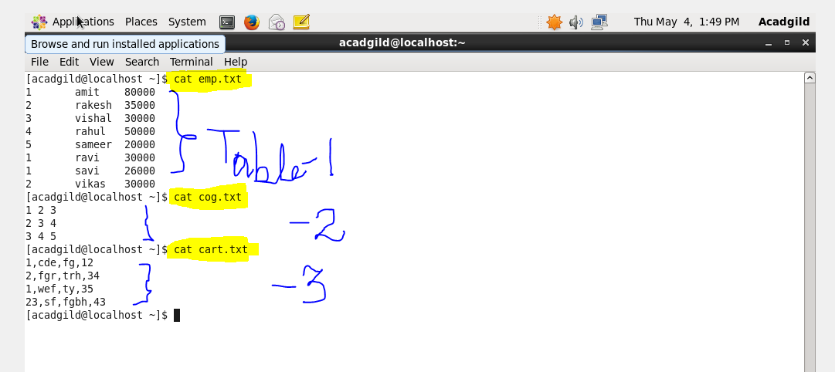

**Creating & loading the file emp-**

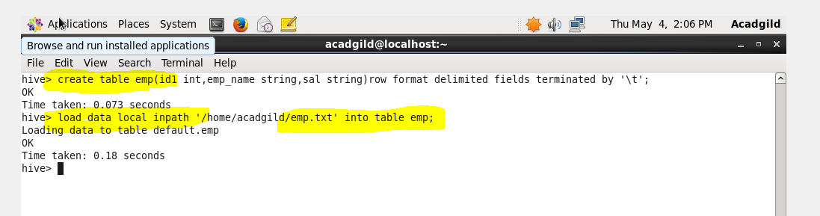

**Creating & loading the file cog-**

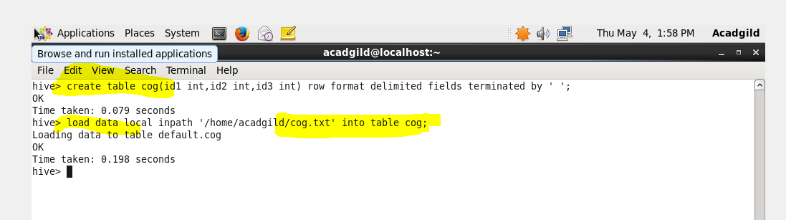

**Creating & loading the file cart-**

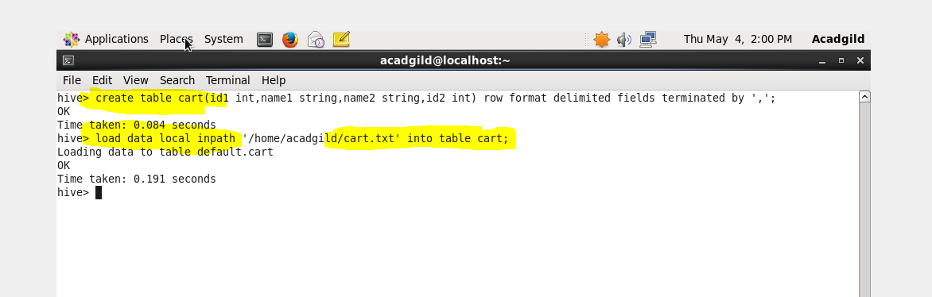

**Setting the parallel configurations in hive command line-**

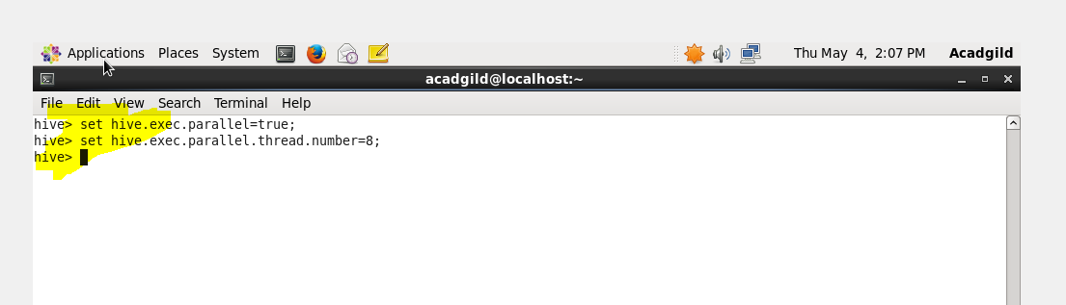

**Query -**

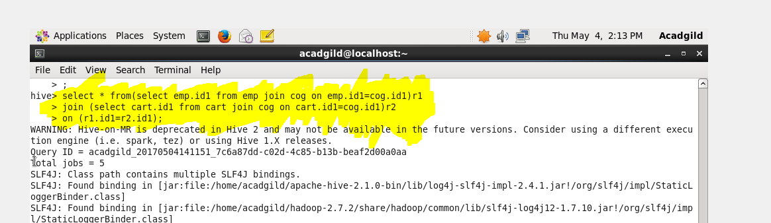

**Output -**

