**ASSINGMENT-27.6-**

**Give a demo on the below joins in hive.**

**Input Dataset 1-**

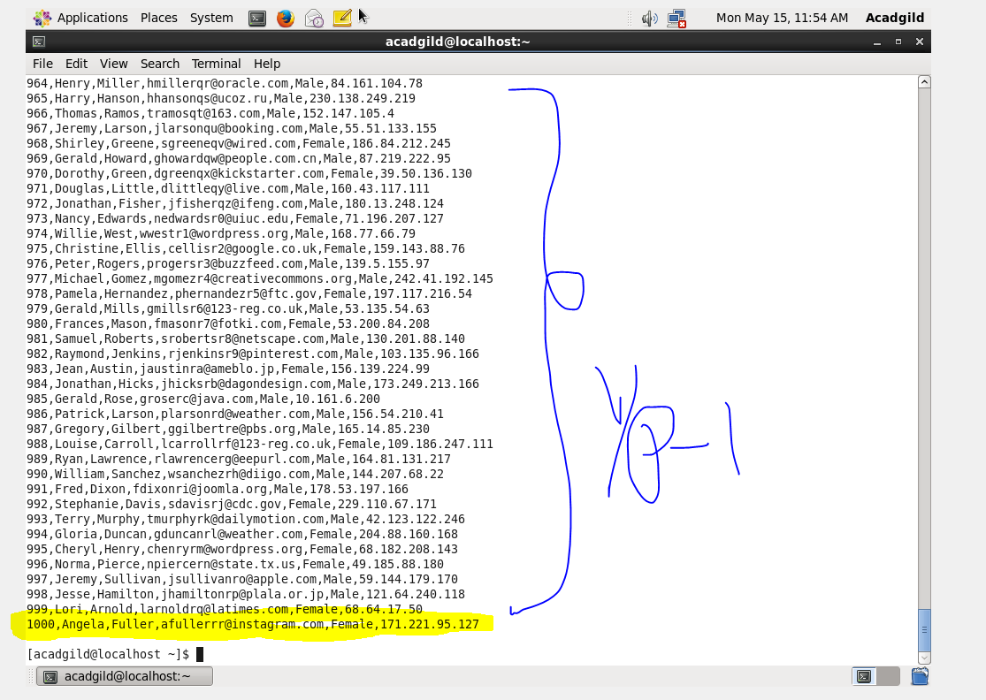

**Input Dataset 2-**

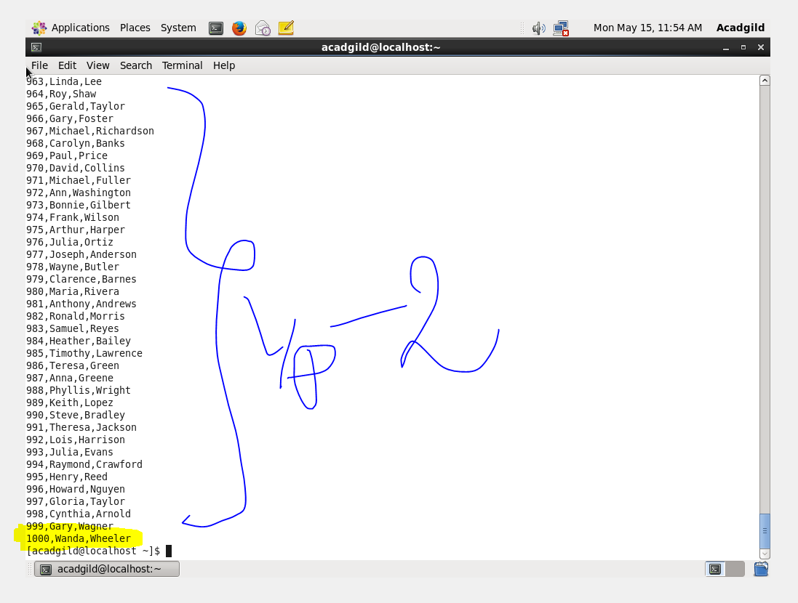

**Creating a table & loading the dataset1-**

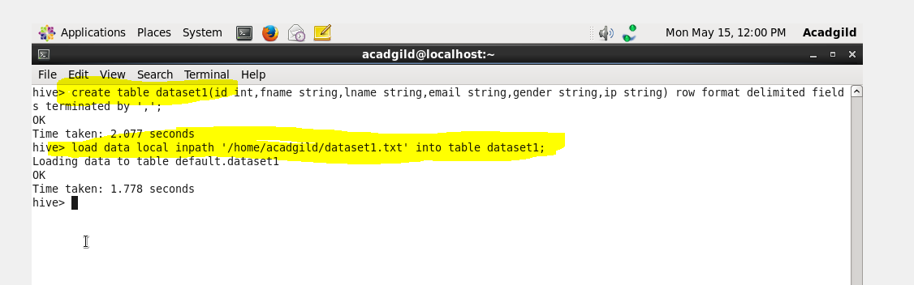

**Creating a table & loading the dataset2-**

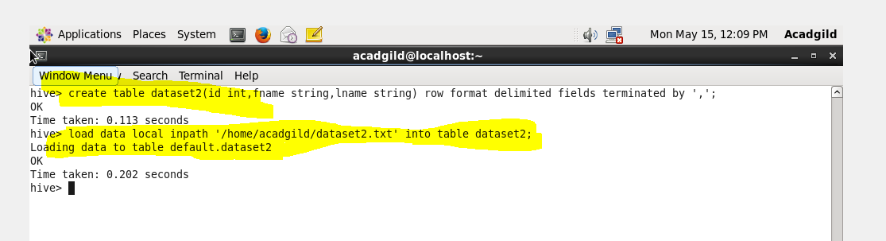

**Creating a bucket1 and inserting dataset1-**

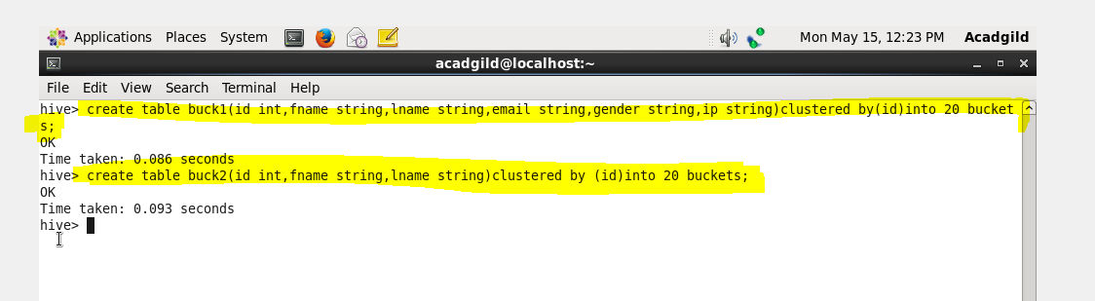

**Output -**

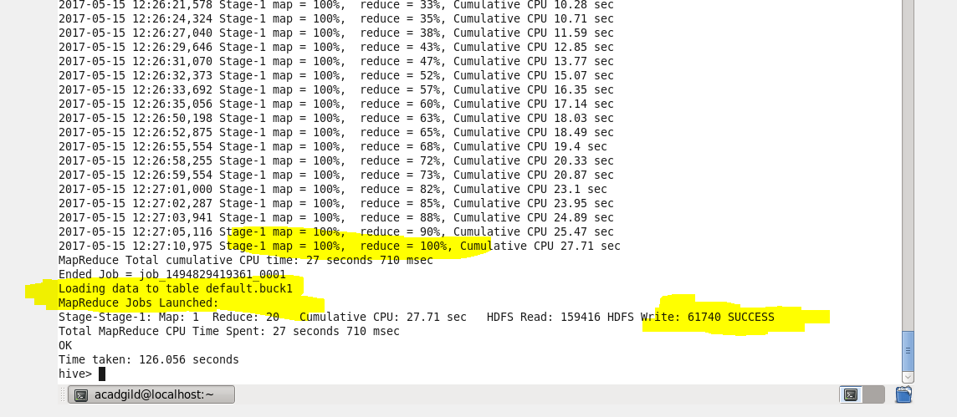

**Creating a bucket2 and inserting dataset2-**

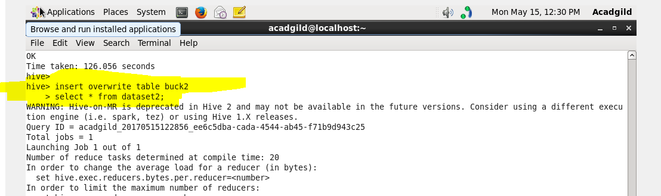

**Output -**

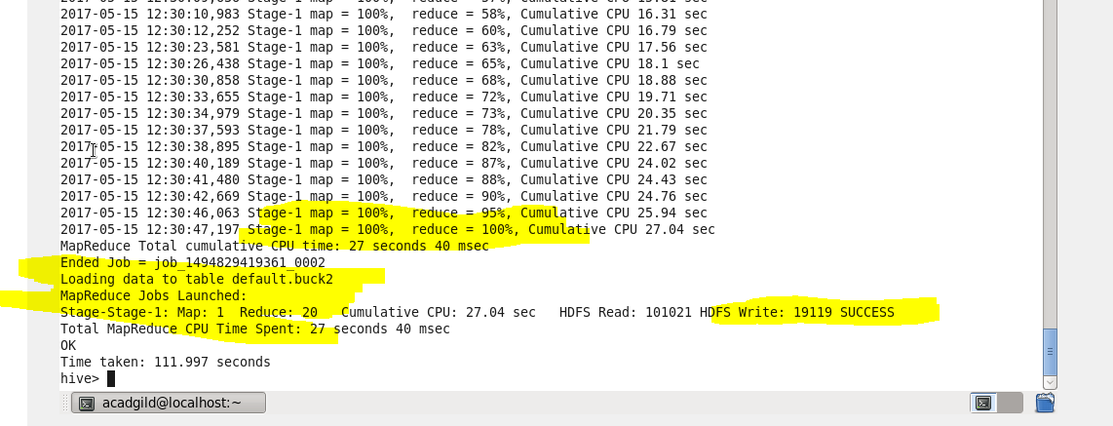

**Bucket Map join -**

* Total table/partition size is big, not good for mapjoin
* Non-sorted the same
* Bucketd the same
* Joining on the sort/bucketing on the multiple columns

Pointers:

* set hive.optimize.bucketmapjoin; If true  then Bucket Map Join is activated

**Commands -**

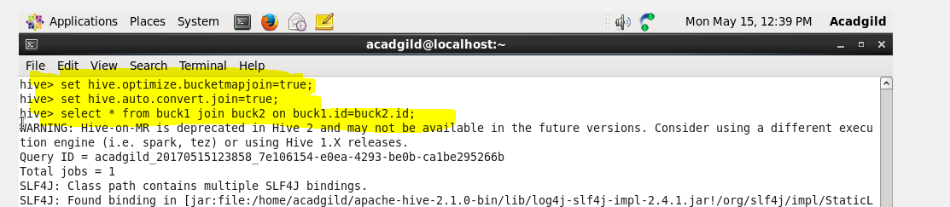

**Output -**

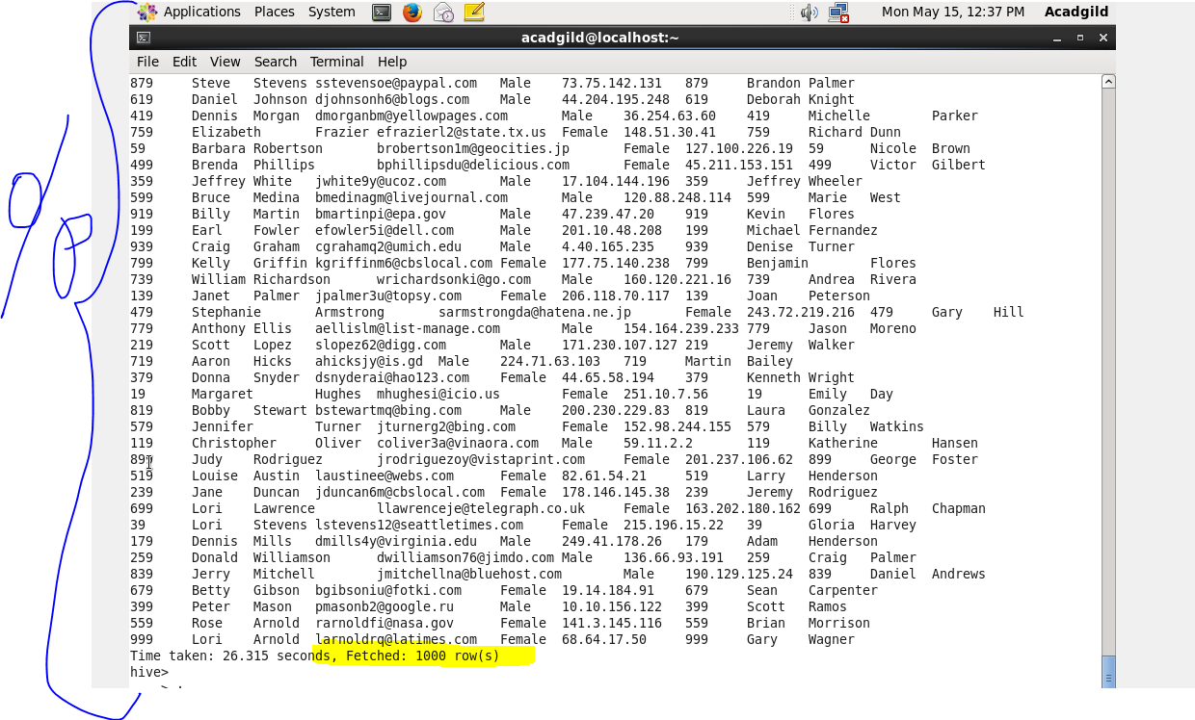

**Sort-Merge Bucket join-**

* Sorted the same
* Bucketed the same
* Joining on the sort/bucket on the same/equal columns

Pointers:

* Very efficient if applicable
* Both Mapt & Reduce task are used
* set hive.auto.convert.sortmerge.join=true
* set hive.optimize.bucketmapjoin = true
* set hive.optimize.bucketmapjoin.sortedmerge = true

**Commands-**

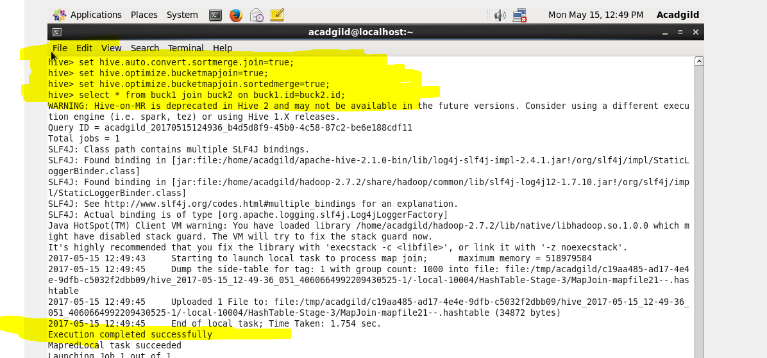

**Output -**

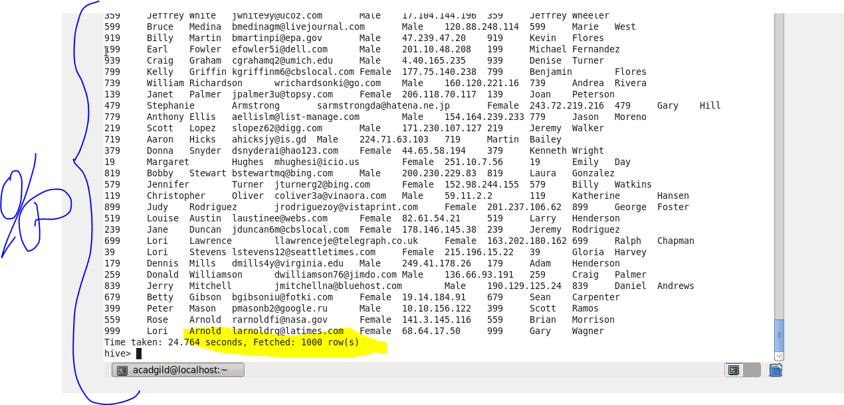

**Sort-Merge Bucket Map join-**

* Sorted the same
* Bucketed the same
* Joining on the sort/bucket on the same/equal columns
* No limit on file/partition/table size

Pointers-

* set hive.auto.convert.sortmerge.join=true
* set hive.optimize.bucketmapjoin = true
* set hive.optimize.bucketmapjoin.sortedmerge = true
* set hive.auto.convert.sortmerge.join.bigtable.selection.policy=org.apache.hadoop.hive.ql.optimizer.TableSizeBasedBigTableSelectorForAutoSMJ

**Commands-**

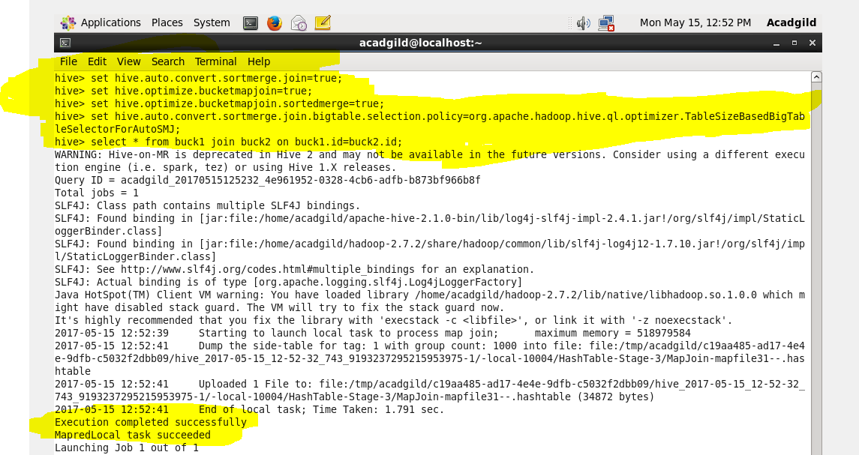

**Output -**

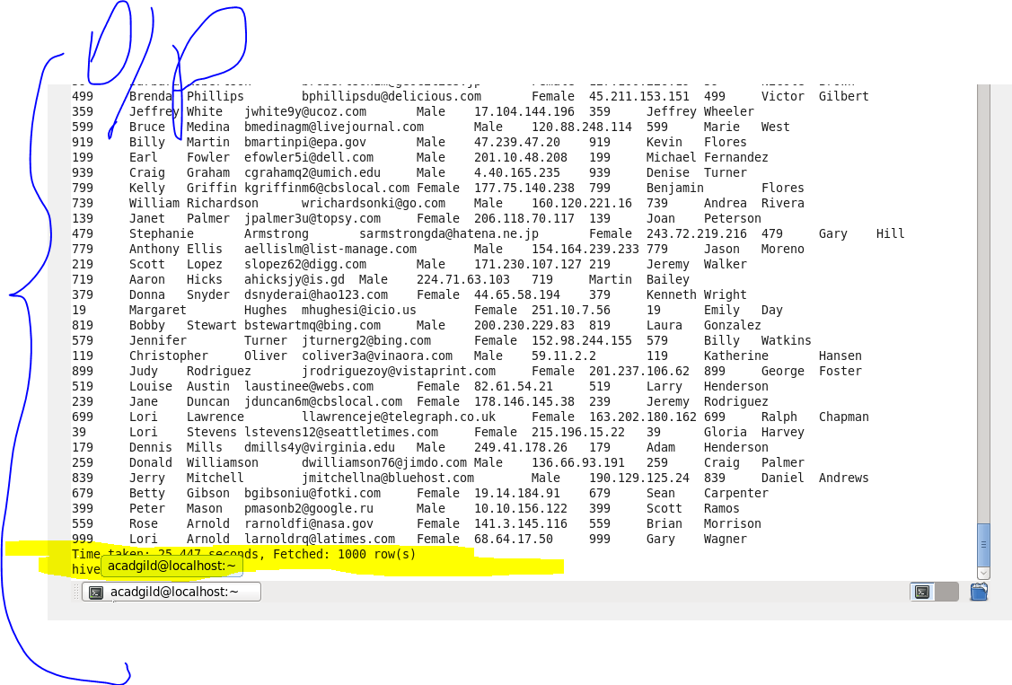

**Left semi join-**

* To have functionality of IN/EXISTS subquery semantics

Pointers:

* Right hand side table should only be reference with ON clause, not with WHERE/SELECT clause
* Right semi-joins are not supported in Hive

**Commands-**

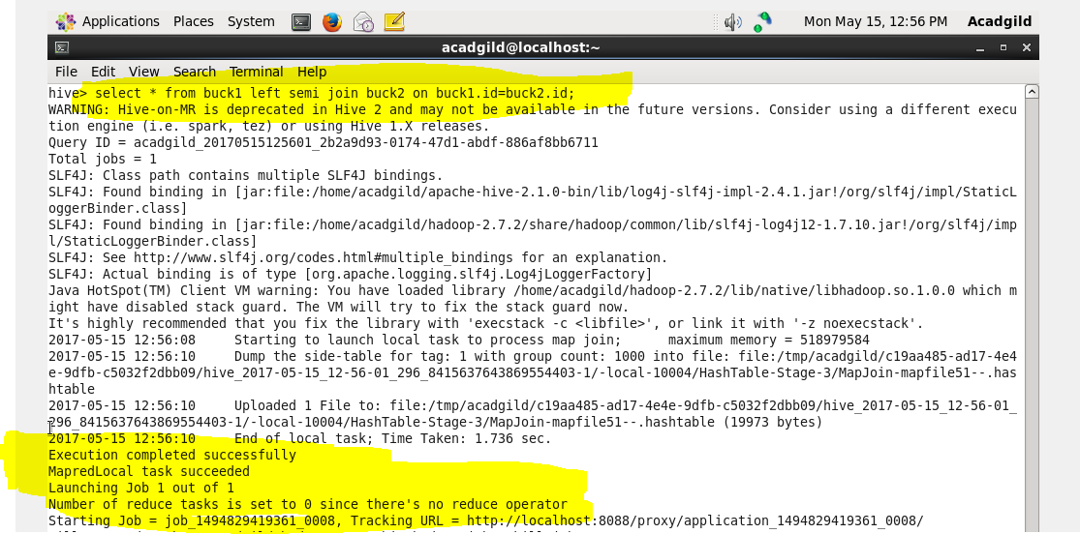

**Output -**

