**QUE-28.3-**

**ANS-28.3-**

**create table employee using create command -**

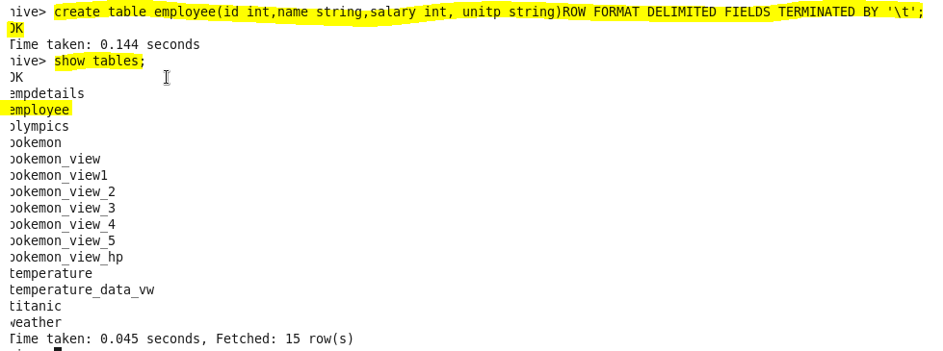

**load our datasetemployee.txt using LOAD command-**

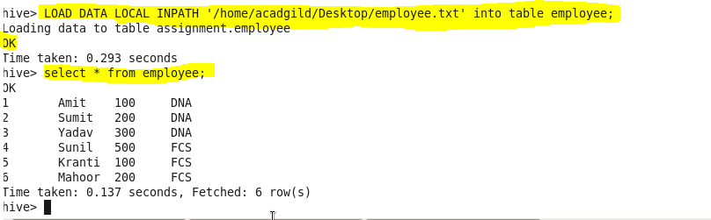

1. **Get a list of employees who receive a salary less than 100, compared to their immediate employee with higher salary in the same unit**

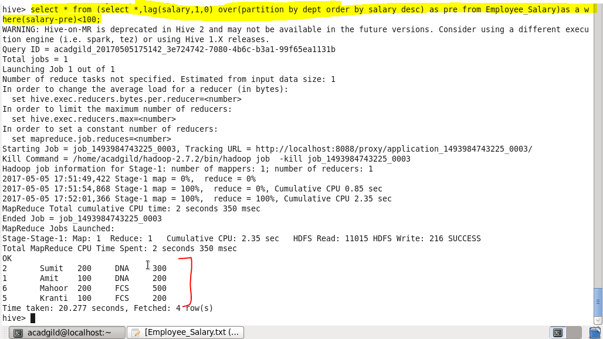

**2. List of all employees who draw higher salary than the average salary of that department.**

* **In this particular problem we will check for the employees whose salary is greater than average salary of that department using avg function for that we will select name from a subquery I that we will select name,salary and average salary from the same table and will filter by salary should greater than average salary.**

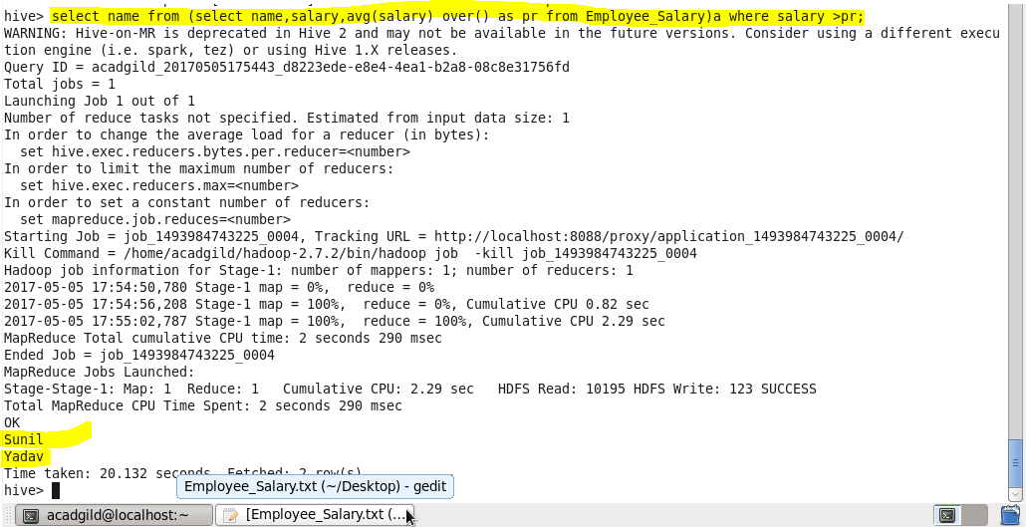

**Problem Statement: Link: olympic_data.csv Store the above dataset into the following file formats.**

**● SEQUENCEFILE-**

* **Creating table in sequencefile format**
* **Describing the contents of it**
* **Loading dataset into file**
* **Displaying all the data using ‘select’ keyword.**

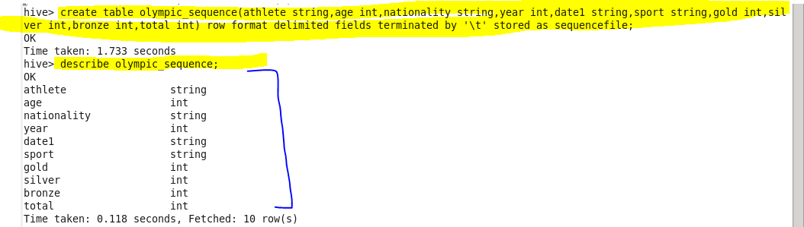

**Insert data -**

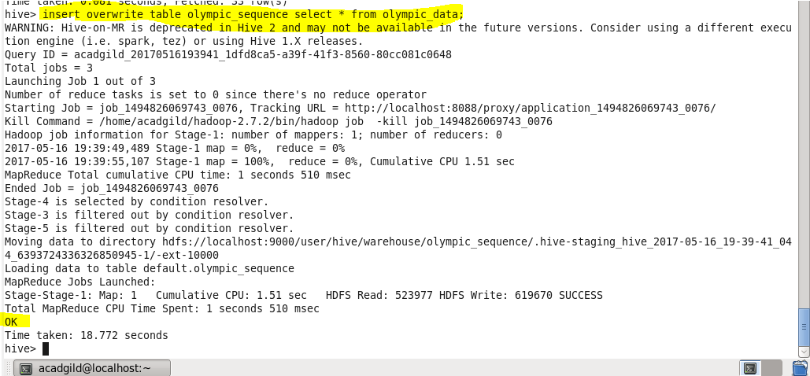

**Showing result -**

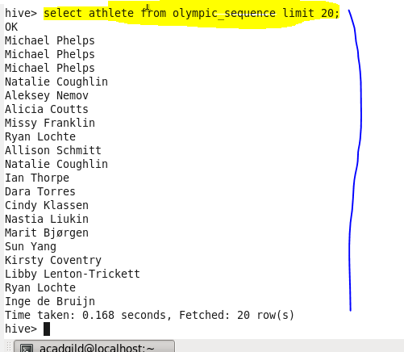

**● RCFILE -**

* **Creating table in rcfile format.**
* **Describing the contents of it.**
* **Inserting the data into created table.**
* **Displaying all the data using ‘select’ keyword.**

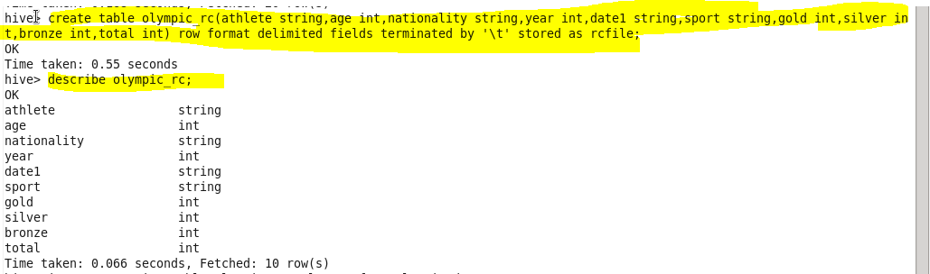

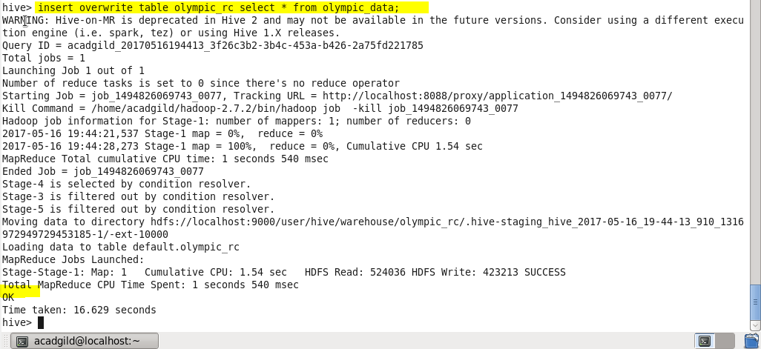

**Showing result-**

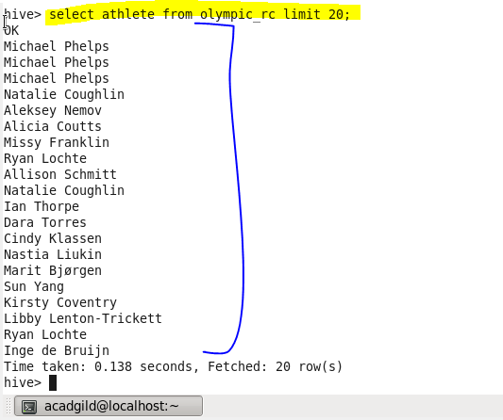

**● ORC FILE -**

* **Creating table in orcfile format.**
* **Inserting the data into created table.**
* **Displaying all the data using ‘select’ keyword.**



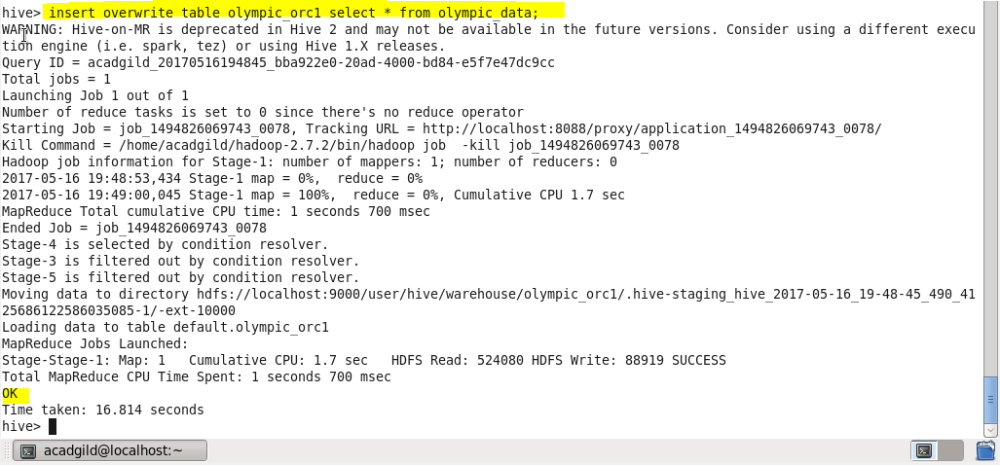

**Showing result-**

