**QUE-29.2-** Write a hive UDAF to find the largest integer in a column. Use your own dataset for the above problem statement and attach the steps performed, codes used with the result.

**ANS-29.2-**

**HIVEUDAF (USER DEFINED AGGREGATE FUNCTION)-**

It works on a entire column and perform operation.

**Input -**

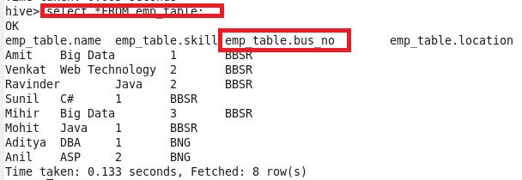

**Code-**

Since we are creating Udf we create a **hivemax class** that extends UDAF where the output variable is defined

then we are creating static class maxIntUDAFEvalator implements UDAFEvaluator(The actual class for doing the aggregation.

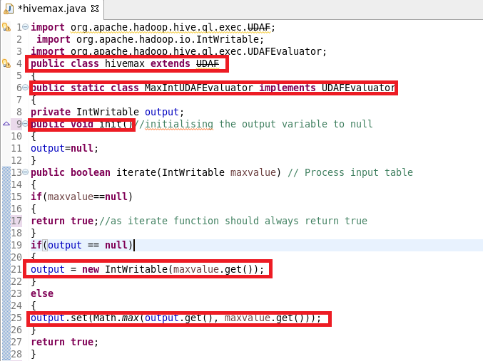

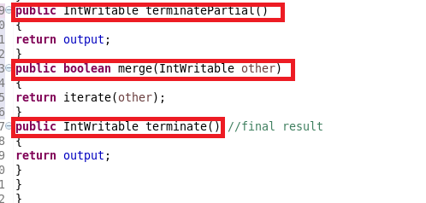

**Registering JAR-**

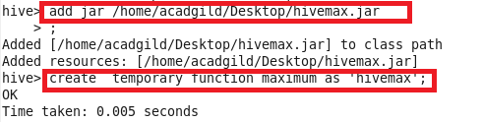

**OUTPUT-**

