**QUE-16.3- Execute Session 16 - Assignment 1 (Machine and Sensor data analysis) using Reduce side join and compare which join is faster in normal conditions**

**ANS-16.3-**

**Driver class-**

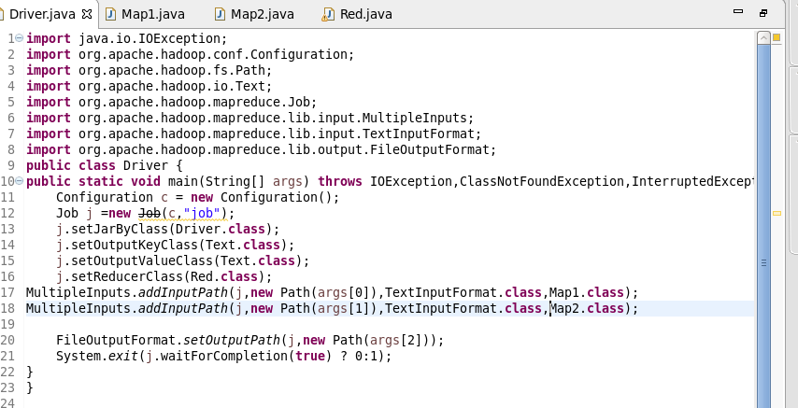

**Mapper1 Class-**

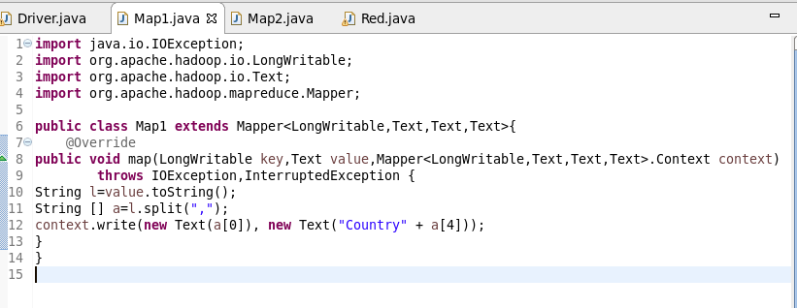

**Mapper2 Class-**

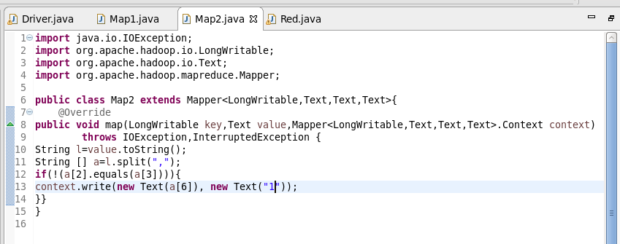

**Reducer Class-**

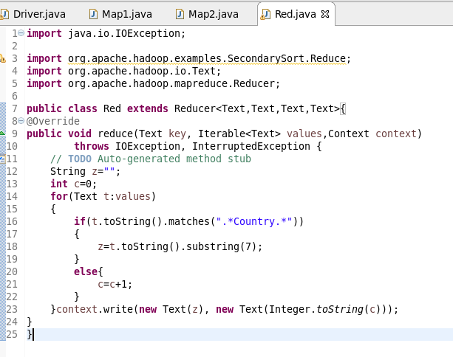

**Running Jars-**

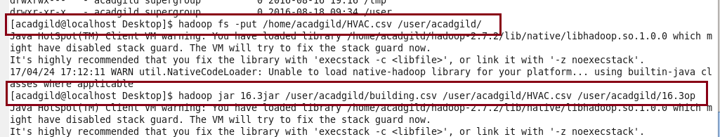

**OUTPUT-**

