**QUE-30.3-Write a java program to write data into an hive table.**

**ANS-30.3-**

**In order to write data from hive using java we should first add sql connector jar and sl4j binding jar and in order to connect to hive we must start hiveserver2 which will BE Used for connecting hive through JDBC**

**Logic: In order to write I am creating a “hivewrite_table” and writing data using executeUpdate() Method**

**JAVA PROGRAM-**

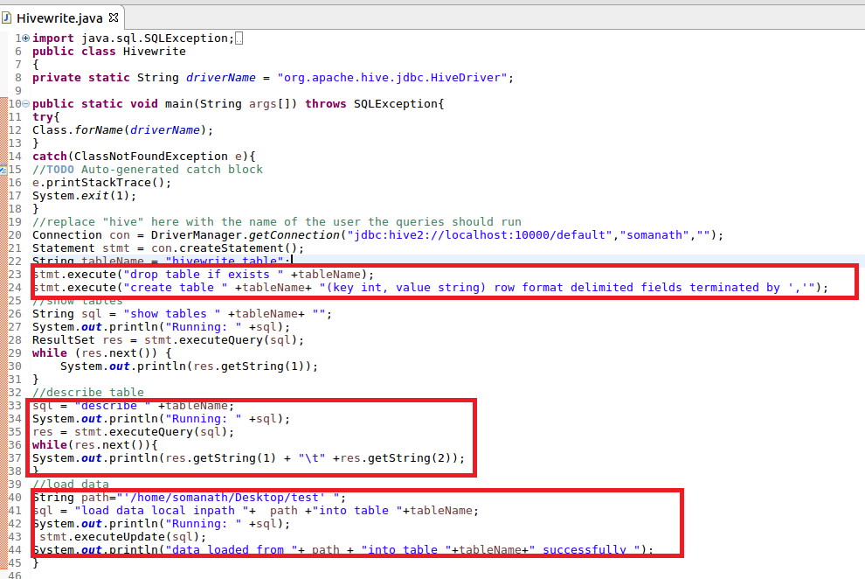

**Output-**

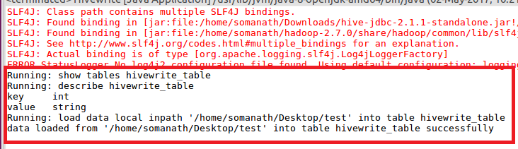

**Verifying that the table is created and data is loaded -**

