**QUE-32.3-**

**● Write a Java client API to perform following operations:**

**● Use HBaseAdmin class and create the table named company with one column family name details.**

**● Create the method name insert and use put class to insert records to company table.**

**ANS-32.3-**

**A JAVA CODE TO CREATE A TABLE IN HBASE-**

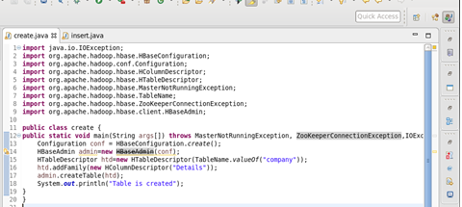

**TABLE IS CREATED IN HBASE BY RUNNING THE JAVA CODE (RUN AS APPLICATION) IN ECLIPSE**

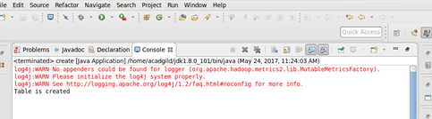

**USING ‘LIST’ COMMAND , SHOWING THE TABLES IN HBASE-**

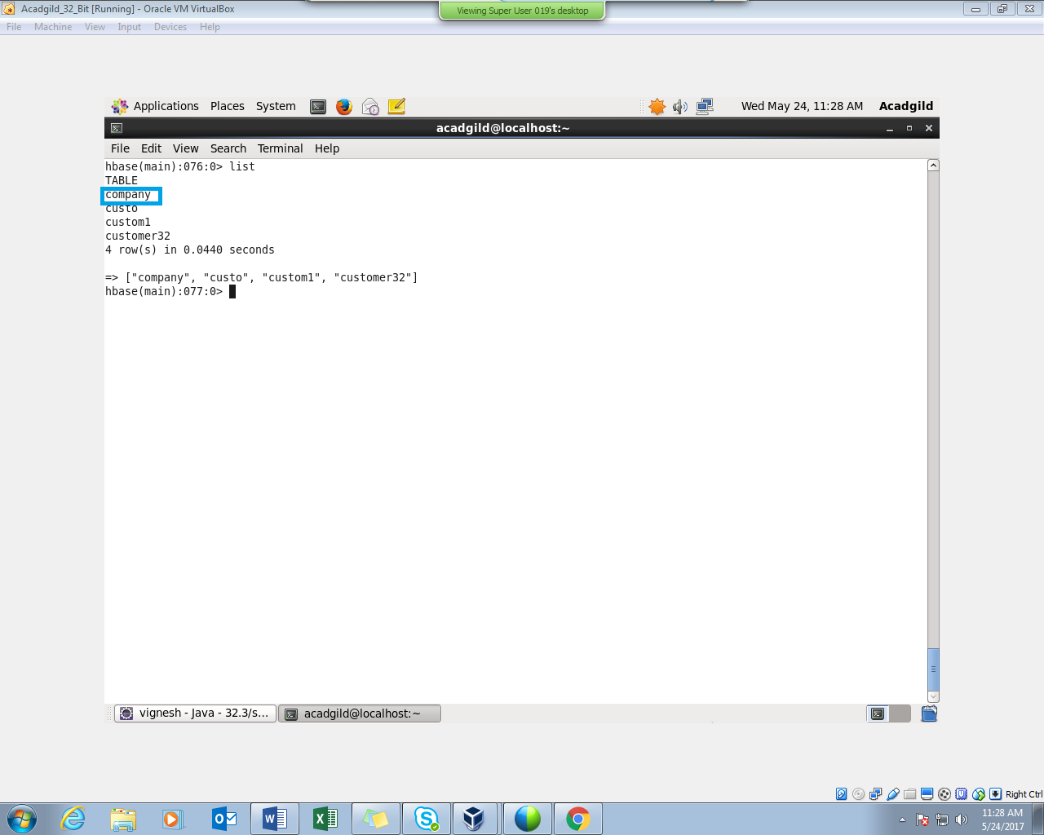

**JAVA CODE TO INSERT DATA INTO THE TABLE “COMPANY” -**

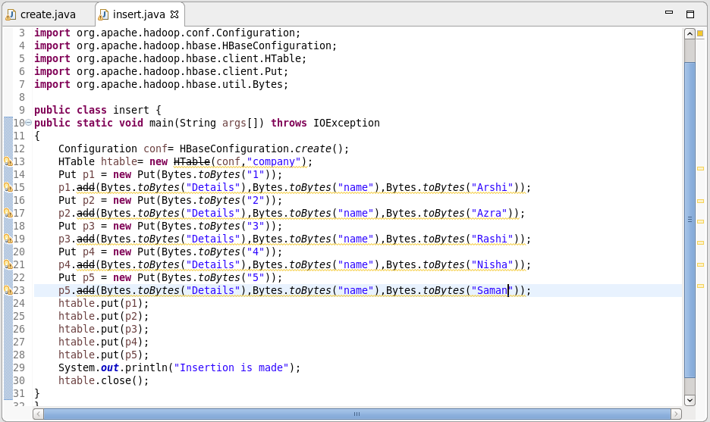

**INSERTION IS MADE BY RUNNING THE JAVA CODE IN ECLIPSE (RUN AS APPLICATION)**

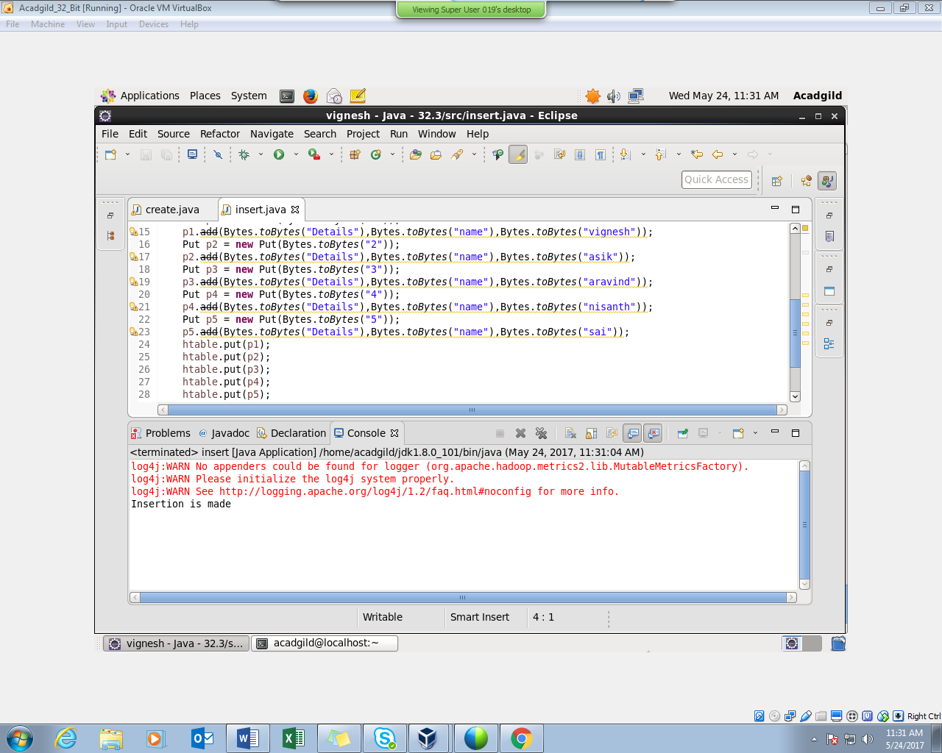

**INSERTION WAS SUCCESSFUL**

**PERFORMING SCAN COMMAND -**

