**QUE-33.3-**

**● Integrate Hbase with Pig**

**● Load Data (Bulk Load) from HDFS to Hbase Table using Pig.**

**● Explain the procedures and code implemented with screenshots**

**ANS-33.3-**

**Input File-**

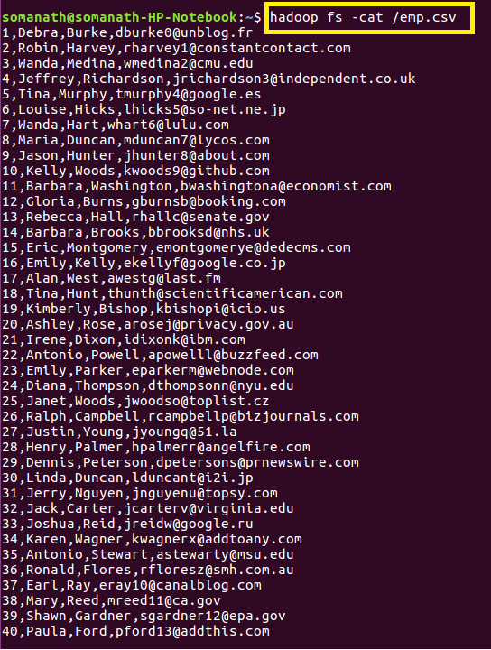

**Step 1- Since we want to load the data into Hbase we will create a Table “pig_employee” with column family “employee_details” where the data will be loaded**

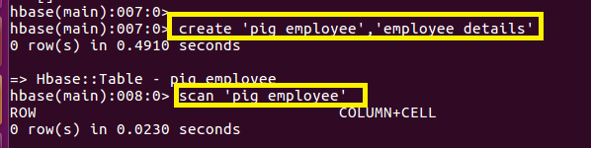

**Step 2-Open pig grunt shell in Map reduce mode and Loading the data from Hdfs into pig_input as shown**

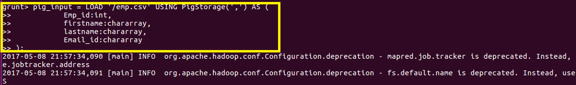

**Step 3-Storing the data into Hbase**

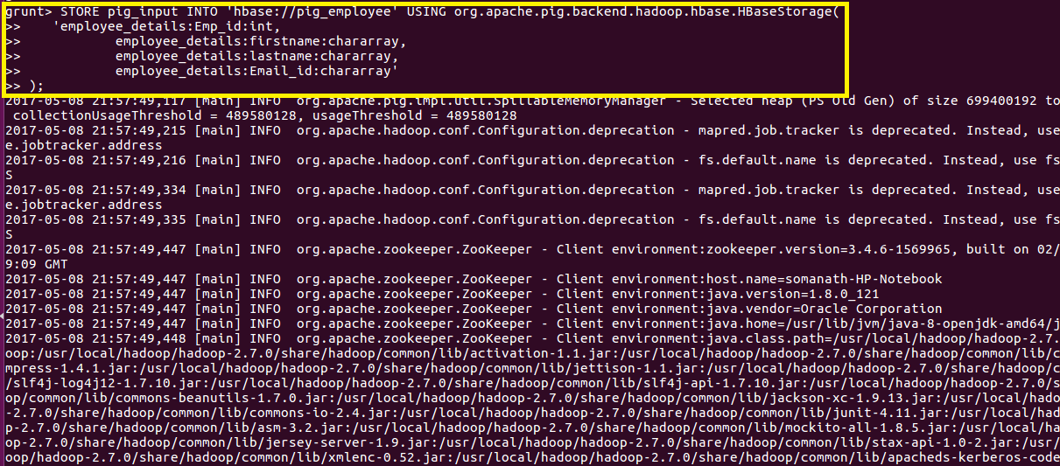

**File is successfully stored in Hbase as shown below-**

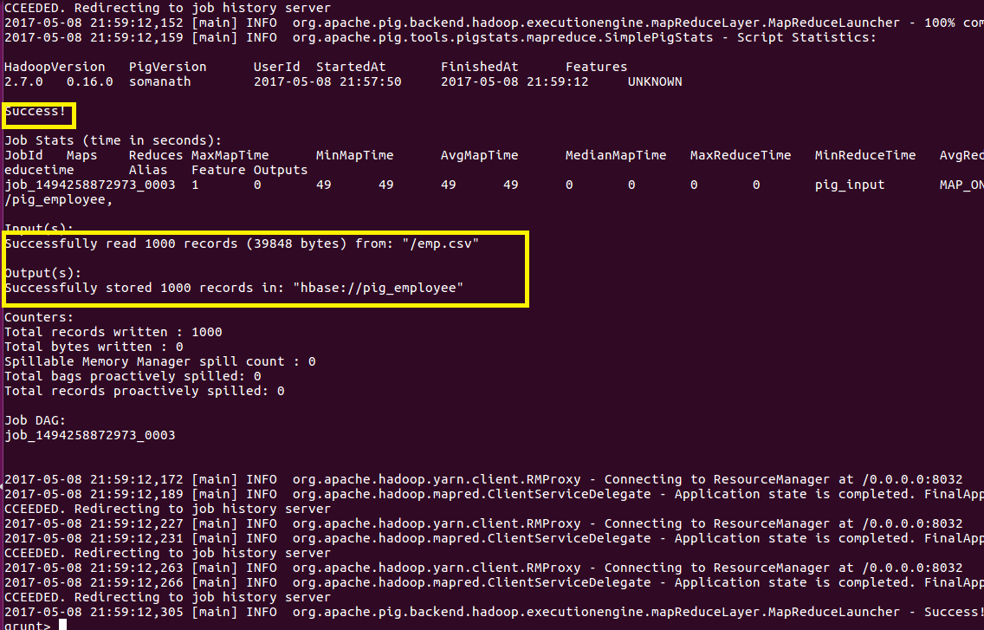

**Step 4-Output Verification**

**Scan “pig_employee” is used to verify that the data is loaded into Hbase**

