**QUE-35.2- Explain and perform Sqoop Incremental Import operation to load data from MysqlTo HDFS using Sqoop.**

**ANS-35.2-**

**Employee table-**

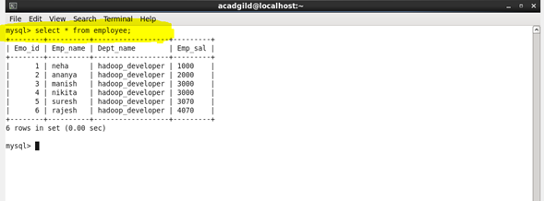

**Incrementing the rows in employee table**

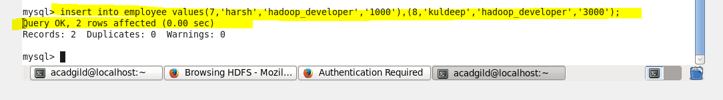

**Output of incrementing rows in mysql-**

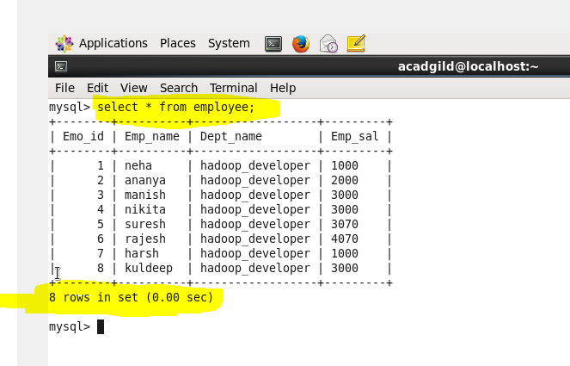

**Data already in hdfs-**

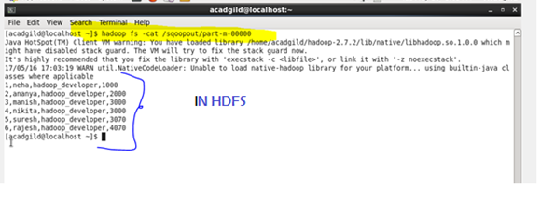

**Importing data from mysql to hdfs-**

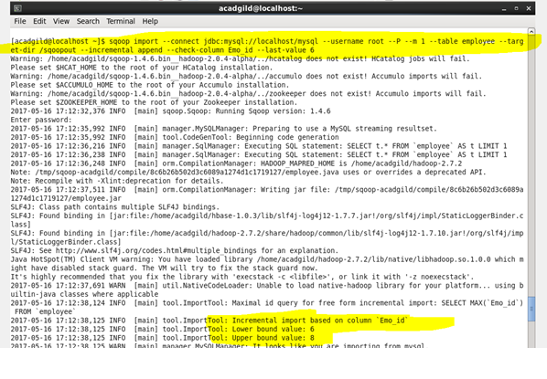

**Completed successfully-**

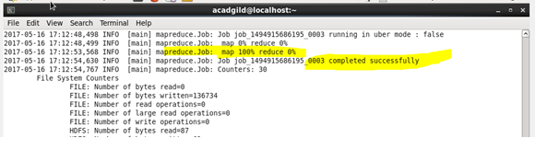

**Increment import completed-**

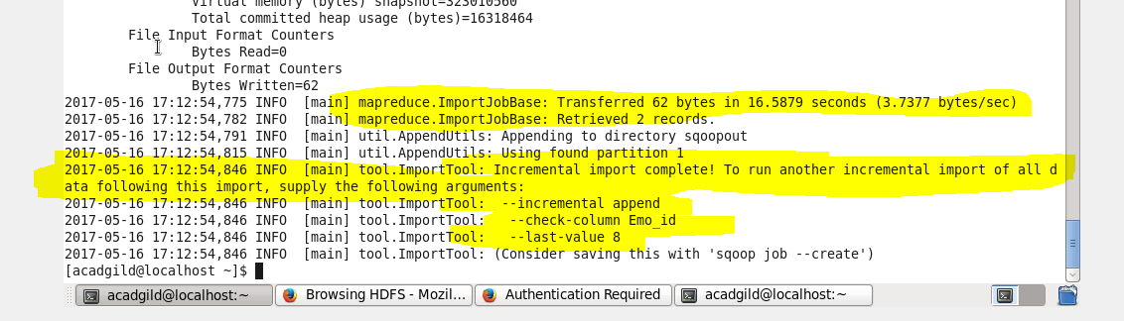

**Output (in HDFS)-**

