**QUE-16.4- Write a mapreduce program use map side join to join the two datasets and find What kind of problems are prevalent, and in which state?**

**ANS-16.4-**

**Driver class-**

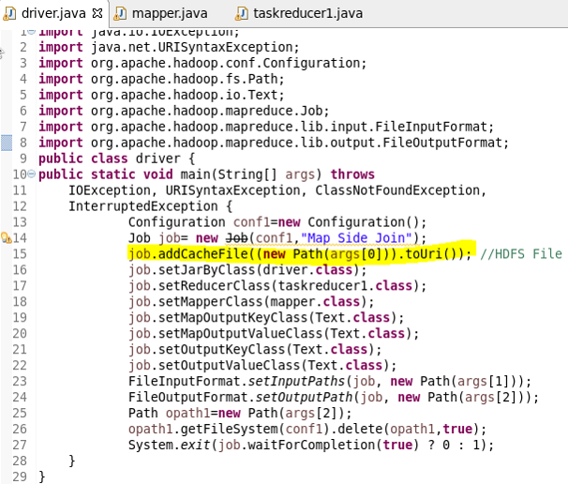

**Mapper class-**

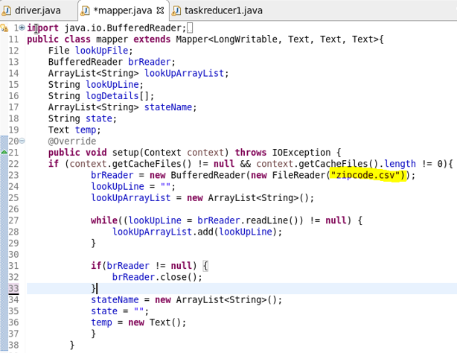

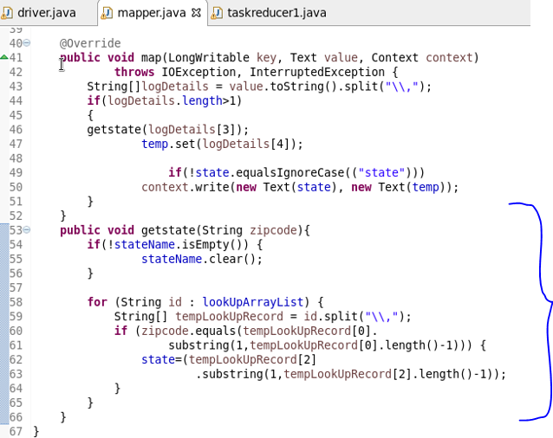

**Reducer class-**

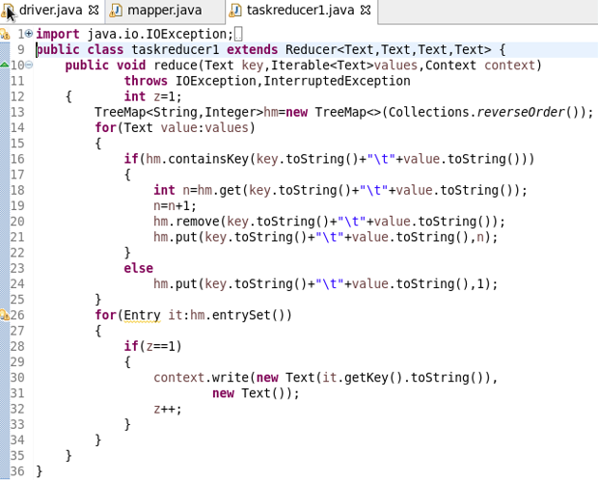

**Running jar-**

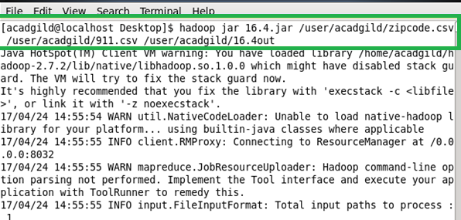

**Output-**

